Basic tutorial for beginners on R

- Start the program R (in the classroom W036. On your computer you may have different configuration).
Start - All programs - Teaching - Math - R 2.7.0

To have a folder for R exercises inside your "My Documents" folder and therefore visible from all the computers on the campus do the following.

Open "My Documents".

Create a new folder inside "My Documents", say "R tutorial", and open it.

Copy the address. For example, my was "\\userFS\staffFS\aal104\w2k\R tutorial". The following R command assigns this address as the R working directory,
setwd("\\\\userFS\\staffFS\\aal104\\w2k\\R\ tutorial")

Note double backslashes instead of single backslashes and a backslash before the space. This is because both the space and the backslash are special symbols for R. The space is a word separator and the backslash is a special symbol cancelling the special meaning (if any) of the next symbol.

Your address will be different from the one above, but hopefully the same for all the computers on the campus.

Check that the working directory is set correctly,
getwd()

This setup will be needed to read/write files and to save your R-sessions.

- R help

Open the help window by typing
help.start()

"An Introduction to R" is what you will need for learning the general concept of the R-language. More information can be found using "Search Engine & Keywords".

To open a help page on a particular R command type ? followed by the name of the command. For example,
?getwd
?setwd
It is a good idea to read the help page before using the command for the first time.

- Simple assignments
Make a vector of length 11 and assign values from 0 to 10
a = 0:10
a

Assign list of values to a vector
b = c(1,2.5,5.0,0.0,-1.0,2.0)
b

Here, a and b are shortcuts to print(a) and print(b) with default options.

- Simple operations and plots
Type the following and analyse what is going on
a = a/10
a
x = exp(a)
x

Most of the operations in R are vectorised, so is the plot command,
a=2*pi*1:100/100
plot(a,sin(a))
plot(a,sin(a),type='l')

Plot appears in a separate window. You can save it. Click on the window with the plot, then click on file, save as and then choose one of the formats. I find png format more convenient because of its portability,

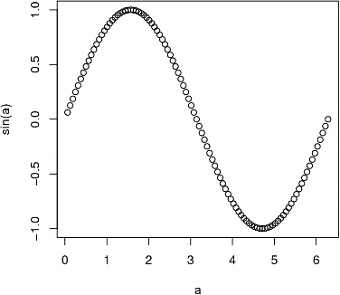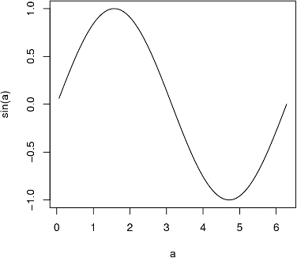

- Reading data
Open a text editor and type in some data. This should be a table, for example:
1 2 3 4 5
2 1 5 3 4
3 4 2 5 1
4 5 3 1 2
Save the table as a text only file in your "R tutorial" folder. To read the file with R, append an extension ".txt" to the file name. For example, if the table was saved as "tab1", then
c = read.table("tab1.txt")

To make sure that everything is fine print or write the table to the terminal,
c
write.table(c)

To write the table into a text only file "tab2", define the file name as the second argument,
write.table(c,"tab2.txt")

Check the structure of the object c,
str(c)
It is a data.frame, an object type, which will be most frequently used in our course. There is also a command data.frame used to generate data.frame objects from simpler objects. Help on this command works as usual
?data.frame

The command read.table is not efficient for large data sets. The command scan is another option meant to be more efficient. To read more about these commands type:
?read.table
?scan

- Handling data sets from R packages.
Type
data()
to see the list of available data sets. Help is available on each of them, for example,
?chickwts

Declare this data set and attach it:
data(chickwts)
attach(chickwts)

The last command puts chickwts in the search path. To see the entire search path and, in particular, all attached objects, type
search()

An attached object can be detached,
detach(chickwts)
search()

Do not forget to attach chickwts again,
attach(chickwts)

To see elements of the attached object use ls or objects. For example,
ls("chickwts")
or
ls(2)
The argument 2 is the position of an object in the search path. (By default, a new object is attached at the position 2, and the old positions 2, 3, ... are incremented by 1)

If data set is attached, its columns can be accessed directly, without reference to the data set. For example, print the elements of chickwts,
feed
weight

The command ls without arguments shows the global environment, which occupies the position 1 in the search path and contains objects created by a user,
ls()
ls(1)
ls(".GlobalEnv")

Use rm() to cleanup the environment. For example, to remove the objects a and x created previously, type
rm(a,x)
and see that a and x no longer exist
ls()

- Specialised plots

The output of the plot command depends on the object the plot is operating on. You have already drawn a plot from two vector arguments. Try now the following,
plot(weight)

In addition, there are several specialised plotting commands, for example,
boxplot(weight)
boxplot(weight[feed=="casein"],weight[feed=="soybean"])

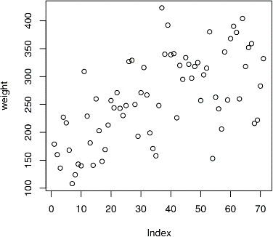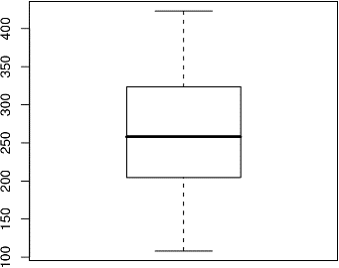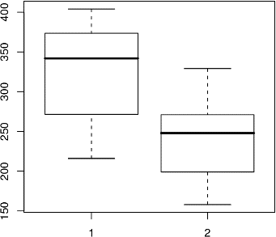

Other useful plot commands are hist, qqplot, qqnorm. Try
hist(weight)
qqnorm(weight)
plot(feed,weight)

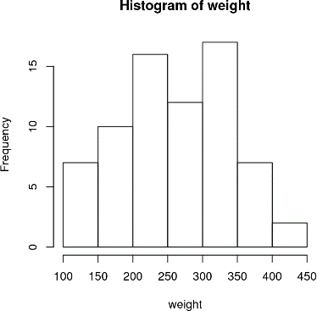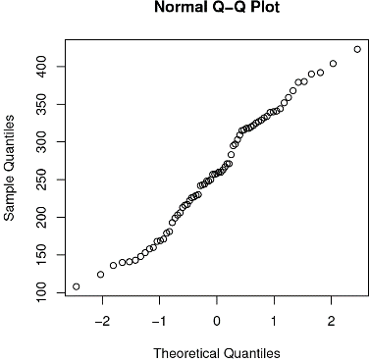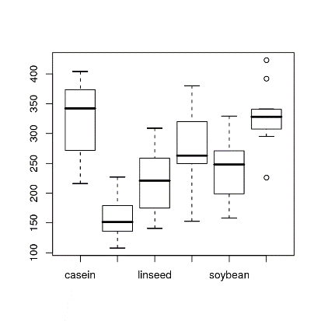

- Simple statistics
Try the following commands
a = weight[feed=="casein"]
mean(a)
var(a)
sd(a)

summary(weight[feed=="casein"])
summary(chickwts)

t.test(weight)
t.test(weight[feed=="casein"],weight[feed=="soybean"])
and analyse the results.

- Random number generators and distributions
Using build-in random generators you can sample from, for example, uniform distribution,
a = runif(1000)
hist(a)

normal distribution,
a = rnorm(1000)
hist(a)

exponential distribution,
a = rexp(1000)
hist(a)

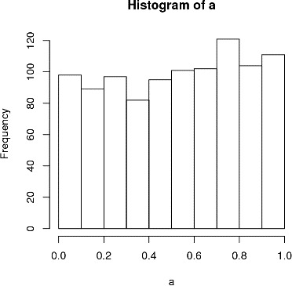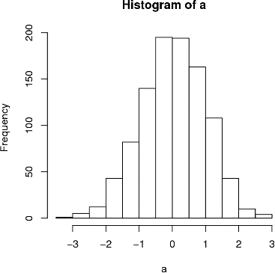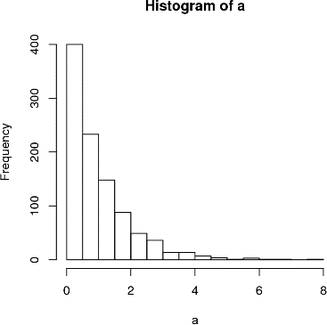

Other possibilities can be found in the section "9. Probability distributions" of "An Introduction to R". Also, you can search for "Distribution" in the "Search Engine & Keywords".

- Saving R session.
If you want to interrupt your R session and to resume it later, you need to save the workspace image. To do so, quit your R session by typing
q("yes")

Alternatively,
q()
and yes when prompted.

To resume the saved session, go to the working directory (folder), which you have previously defined with the command setwd. Double-click on the icon of the workspace image. If R does not start, Open With − browse − R − R-2.7.0 − bin Rgui − Open − OK. Next time the double-click on the icon will hopefully work.

Use
history()
and
ls()

to see the latest commands of the previous session and the objects you have previously created. Note that data sets are detached.

