Abandoned and inactive mines (AIMS) database
Version
2

Region 3 and 10
User Guide

User Guide
USDA Forest Service
Southwestern Region
517 Gold Avenue, SW
Albuquerque, New Mexico 87102-0084
Phone 505.842.3829
Revised December 1999

Table of Contents

Chapter 1
Introduction and Purpose 1
Potential Uses for the AIMS Database 1
Field Forms & Site Numbers 2
Data Entry 2
Database Managers 2
Chapter 2
Getting Started 3
Basic System Requirements 3
Installation of the AIMS Database 3
Chapter 3
Using the AIMS Database 4
How to use the Menu 4
How to use the Switchboard 5
View a Record 6
Query for Information 11
Query for Criteria 11
How to work the Criteria Query 12
Query for Mine Site Number 13
Return to Main Switchboard 14
Preview Reports 14
Preview Summary Reports 14
Preview the Query for Mine Site 15
Exit this Database 16

INDEX 17
Frequently asked Questions 18
Summary Report Sample 19
Search Report Sample 21
Installation of WINZIP 23

Introduction and Purpose
Chapter
1
In early 1996, Region 3 began to inventory abandoned mines on National Forest System Lands, per a National Directive. The main purpose of this inventory was to locate and characterize abandoned and inactive mines that potentially pose environmental threats to forest resources. US Bureau of Mines, National Park Service, Contractors and Forest Service personnel began by looking at U.S. Bureau of Mines Mineral Industry Location Systems (USBM MILS) databases. Sites that were unlikely to pose environmental problems, such as gravel pits, rock quarries, sand pits, etc. were screened out. Field personnel visited sites were not screened out. Field Forms were completed by providing description of the site, sketches of the site, photographs of the site, and when appropriate, water samples, conductivity, and temperature.
This resulted in a significant amount of data, all in field forms. This data needed to be compiled and stored digitally for reference by many potential users. To meet this need, a database was developed by Laura Shepherd in the Southwestern Regional Office. This database is in Microsoft Access®, which was chosen for its features, including user friendliness and its capability to handle complex data interrelationships and it’s SQL compliance, which allows flat file use with Oracle® and ArchInfo®. This Abandoned and Inactive Mine Sites (AIMS) database contains most of the information found in the field forms. Photographs and sketches are among the information not contained, due to the time required for scanning them in. It is anticipated that this information may be added in the future.

Potential Uses for the AIMS Database
A primary use for this database is to identify potential sites for environmental cleanup under the Comprehensive Environmental Response, Compensation and Liability Act (CERCLA), or the Clean Water Act (CWA). Each year, the Regional Office asks Forests for projects to be submitted for funding towards cleanup. This database provides Forests with potential sites to submit.
Wildlife biologists, interested in finding bat habitat, which might include mines, can also use the database. Watershed personnel may use this information for water quality issues and Clean Water Act activities. Forest and District Staff may use this database to identify mines that need to be closed to public entry because of safety hazards.

Field Forms & Site Numbers
The field forms, including photographs and sketches, are contained in binders for each Forest. For some Forests, there are many binders, requiring significant storage space. The database has been downloaded to a CD ROM, supplementing those binders. The binders are still available for site-specific study. The field forms are cross-referenced to database sites by unique site numbers.
The unique site numbers contain Region (03 or 10), Forest (xx), District (xx), and a four-digit unique site number (xxxx). For example: 03 02 07 1077 is Jay Hawk Mine on the Questa Ranger District, Carson National Forest, R3. The full 10-digit number is the site number in the database. The last four digits (unique site number, in this example 1077) is the number on the site forms in the Forest binders.

Data Entry
The CD-ROM on which the database is presented is a “Read Only” version of the database. This means that the database is “locked’ for data entry. If Forests or Districts have additional sites or site information that they would like entered into the database, their database manager for the Region has the Master Read/Write version on Microsoft Access® and will enter the data, once provided to them.

Database Managers
Current (December 1999) Database Mangers are:
- R-3: Bobbie Baca, Regional Office, 505-842-3829, bbaca/r3
- R-10: Kathy Adam, Regional Office, 907-586-8835, kadam/r10

Getting Started
Chapter
2
Before loading the database onto the PC, make sure Version (or existing) copies of the AIMS database have been remove from the computer.

Basic System Requirements:
(The same requirement as for Microsoft Access® 2000 for Windows ® 95 or 98)
Computer Processor: Personal or Multimedia computer with a 486 or higher processor.
Memory: On Windows® 95 or 98, 12MB of memory required. On Windows NT Workstation® 16 MB of memory required. More memory may be required to run additional applications simultaneously.
Hard Disk: 25 MB required for typical installation.

Additional Hardware: CD-ROM drive

Display: VGA or higher-resolution video adapter (Super VGA, 256-color recommended). A 16 inch monitor is suggested to view all forms in their entirety (it is possible to use smaller monitors, but scrolling will be required).

Operating System: Microsoft Windows® 95 or 98 operating system or Microsoft Windows NT Workstation® 3.51 Service Pack 5 or later (will not run on earlier versions).

Installation of the AIMS Database:
- Insert CD-ROM
- From Programs open WINZIP® (If WINZIP® is not locate on the system see page 23)
- Select Open then locate the file (Region3user.zip or Region10user.zip) on the CD-ROM
- Once the file appears, click on the file and then select Extract
- Select the location where the file should be on the hard drive.
- Click Extract and on the bottom right side of the screen a green button will indicate when file has been extracted.
- Select File and exit
- From Programs open Access 2000®.
- From File chose Open then select the location where the file is located.
- Select Region3user.mdb or Region10user.mdb and select open.
- A switchboard will appear and guide you through the database.
Using the AIMS Database
Chapter
3
This Main Switchboard is the opening screen:
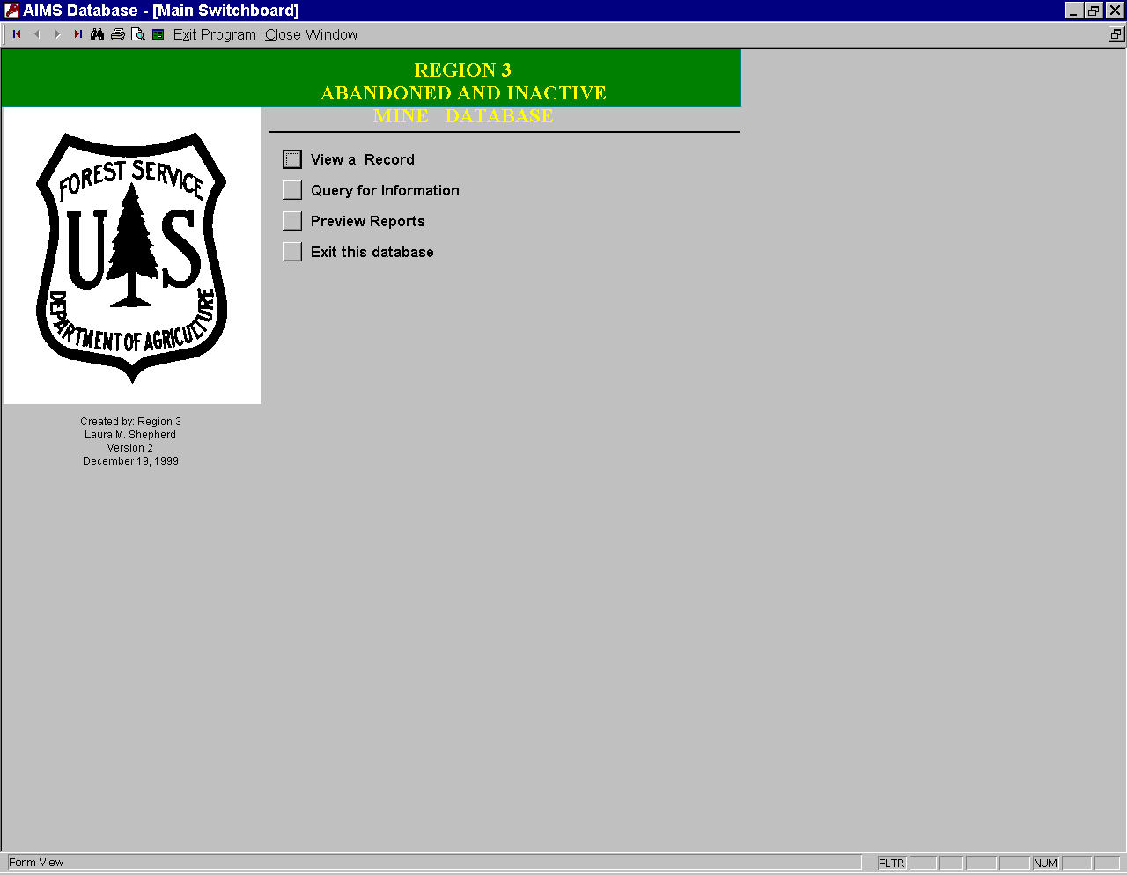
MENU
SWITCHBOARD BUTTONS

How to use the Menu:
The menu is always located at the top of the screen on a grey bar.
The Menu Buttons Operate as follows:
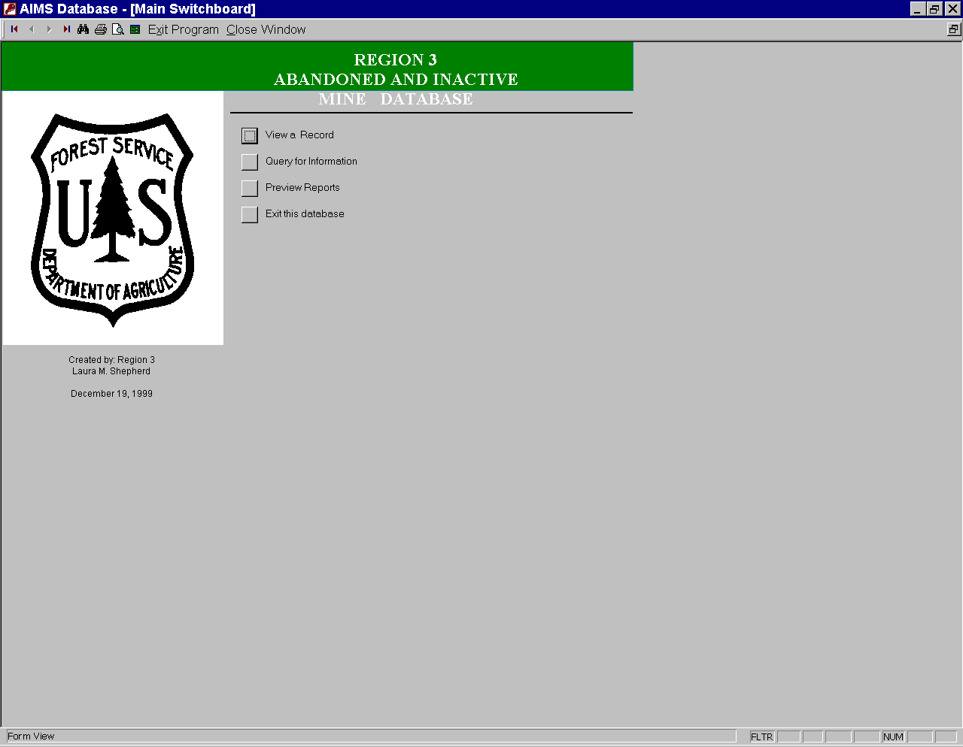
Open First Record: This button allows the user to view the first record after the user opens the database. This function will be covered in View Record section.
Open Previous Record: This button allows the user to go back to the previous record in the database. This function will be covered in View Record section.
Open Next Record: This button allows the user to view the next record in the database. This function will be covered in View Record section.
Open Last Record: This button allows the user to view the last record in the database. This function will be covered in View Record section.
Find: Once the database has been opened, it is possible to use this tool to find records that match data in a specific field (e.g., mine site number), as selected by the user.
Print: Prints any current screen.
Print Preview: Shows the user what the current screen will look like when it is printed.
Switchboard: Opens the Switchboard.
Exit Database: Exits the database.
Close Window: Closes the current window.

How to use the Switchboard:
The Main Switchboard is the main screen that allows the user to access records, queries, and reports. The window also allows the user to exit the database.
The following buttons are on the Switchboard:
- View a Record
- Query for Information
- Review Reports
- Exit this Database
Each of these will be described in detail in the following sections.

- View a Record
This button sends the user to information pertaining to specific sites. Once the View Record button is selected, the following screen is displayed:
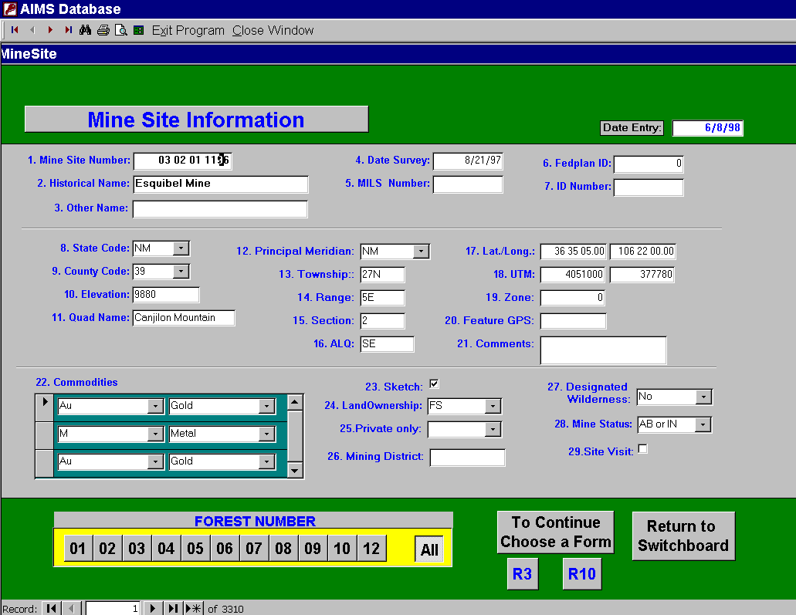
This is the Mine Site Information window. In order to find a specific record in this window, place the cursor in the mine site number field and then select the binoculars (find button) from the menu bar at the top of the screen. Another select window will appear requesting a mine site number. Enter the appropriate mine site number in the following format: aa bb cc dddd (where “aa” is region number, “bb” is forest number, “cc” is ranger district number , and “dddd” is a unique mine site identifyer by Forest). Another way to find a site is to select a forest number by using the yellow bar with grey buttons on the lower left hand corner of the screen. Selecting the Forest in this way allows the user to scroll through the mine sites in that Forest by mine site number. The menu contains navigational tools to assist the user. The first button on the left is a first record button. This button allows the user to view first mine site record in the corresponding forest dataset. The next button allows the user to view the previous mine site record. The third button will send the user to the next record in the forest dataset. The fourth button allows the user to select the last record in the forest dataset. By using these menu keys, the user can browse the entire database.
To obtain more information about a field that has an downward arrowhead next to it, select the arrow head and hold down the left mouse button to see the other choices that are possible for this field. Often, if there is an abbreviation used to fill in the field, then the pull down arrow will describe the abbreviations.
Another button in the lower right hand corner permits the user to choose a region. This button takes the user to the next screen of environmental conditions related to the sites. This screen will look different depending on which region you have selected.
If examing Mine Site within R10, the following screen will be displayed:
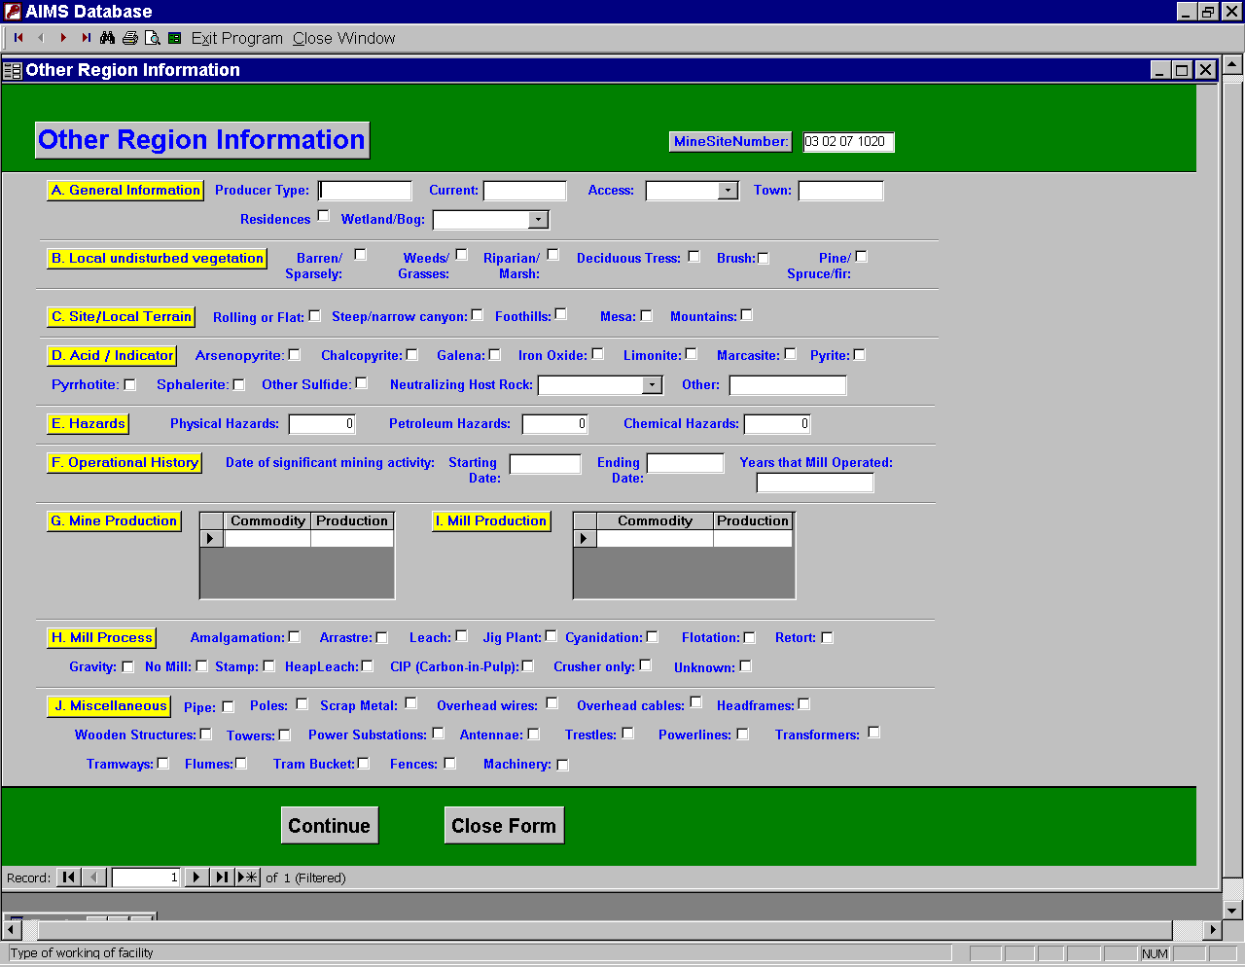
This is the Other Region Information screen. If no inforamtion appears on the screen then no information was recorded for this mine site.
The “Continue” button, located at the bottom of this screen will send the user to the Abandoned and Inactive Information screen. You also can “Close Form” if you do not want to continue on.
If Examing mine site within R3, the following screen will be displayed:
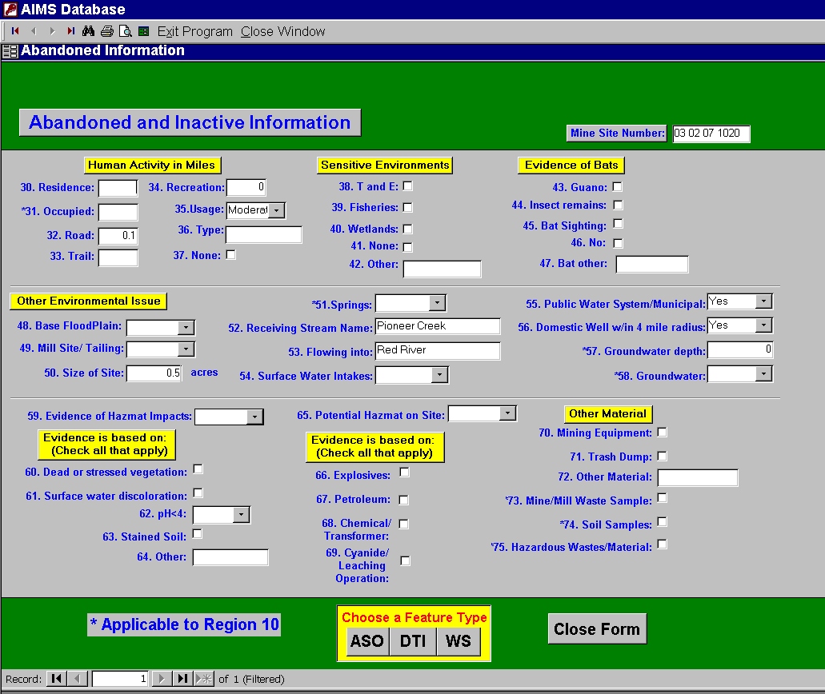
This is the Abandoned and Inactive Information screen. If no inforamtion appears on the screen then no information was recorded for this mine site.
Many fields on the Abandoned and Inactive Information screen pertain only to Region 10 and are marked with asterisks.
Once the user has the Abandoned and Inactive Information screen open, there is a yellow box with grey buttons in it labeled "Choose a Feature Type". The options are: ASO (Adits, Shafts, and Other Openings), DTI (Dumps, Tailings, and Impoundments), and WS (Water Sample).
Selecting the ASO (Adits, Shafts, and Other Openings) button will send the user to this screen:
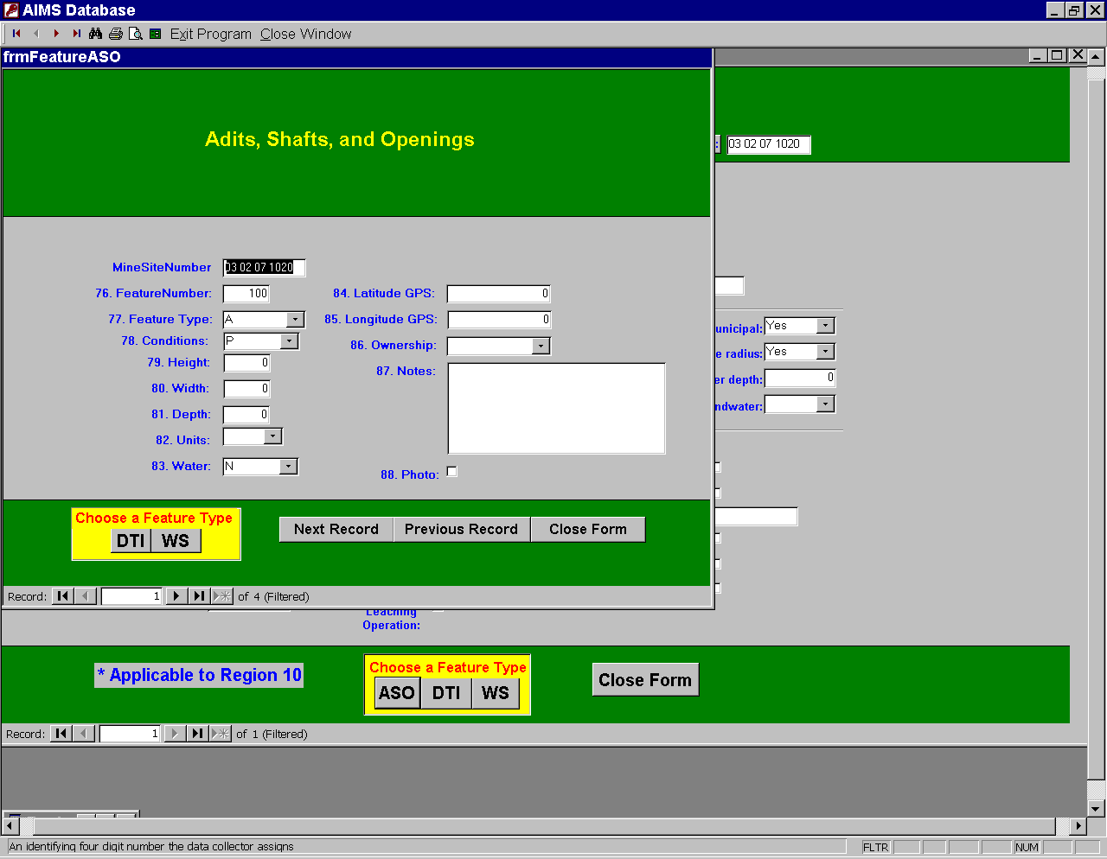
The user can change “Feature Types” by clicking in the yellow box label “Choose a Feature Type”
Selecting the DTI (Dumps, Tailings, and Inpoundments) button will send the user to this screen:
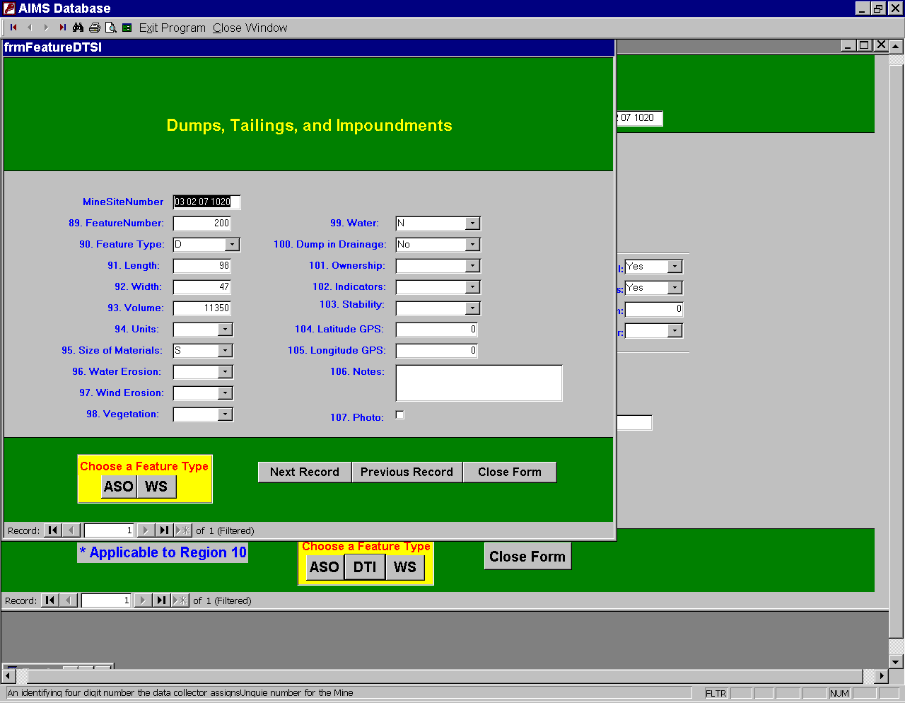
The user can change “Feature Types” by clicking in the yellow box label “Choose a Feature Type”
Selecting the WS (Water Sample) button will send the user to this screen:
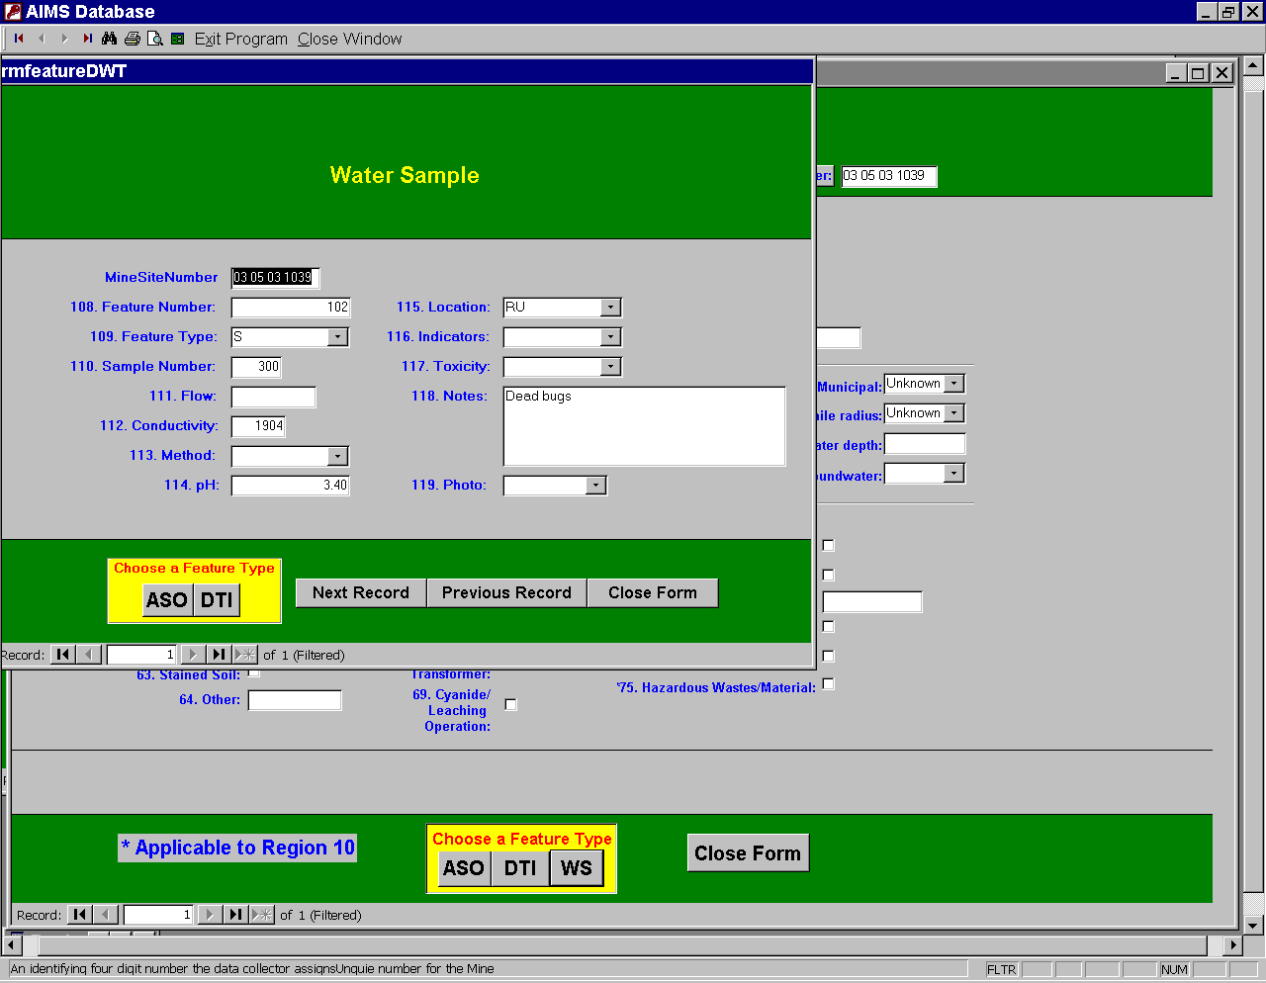
The user can change “Feature Types” by clicking in the yellow box label “Choose a Feature Type”
If no information appears in any of the three “Feature Type” screens then no information was recorded for this mine site.
Each of these forms contains information. At the bottom of the screen in the yellow box label “Choose a Feature Type” are buttons to go to any of the other feature screens listed above. There are also three buttons to the right of them for going to the next feature within the screen selected or going to the previous screen selected or to close this screen and go back to the Abandoned and Inactive Information screen.
- Query for Information
This button sends the user to the query switchboard and it looks like this:
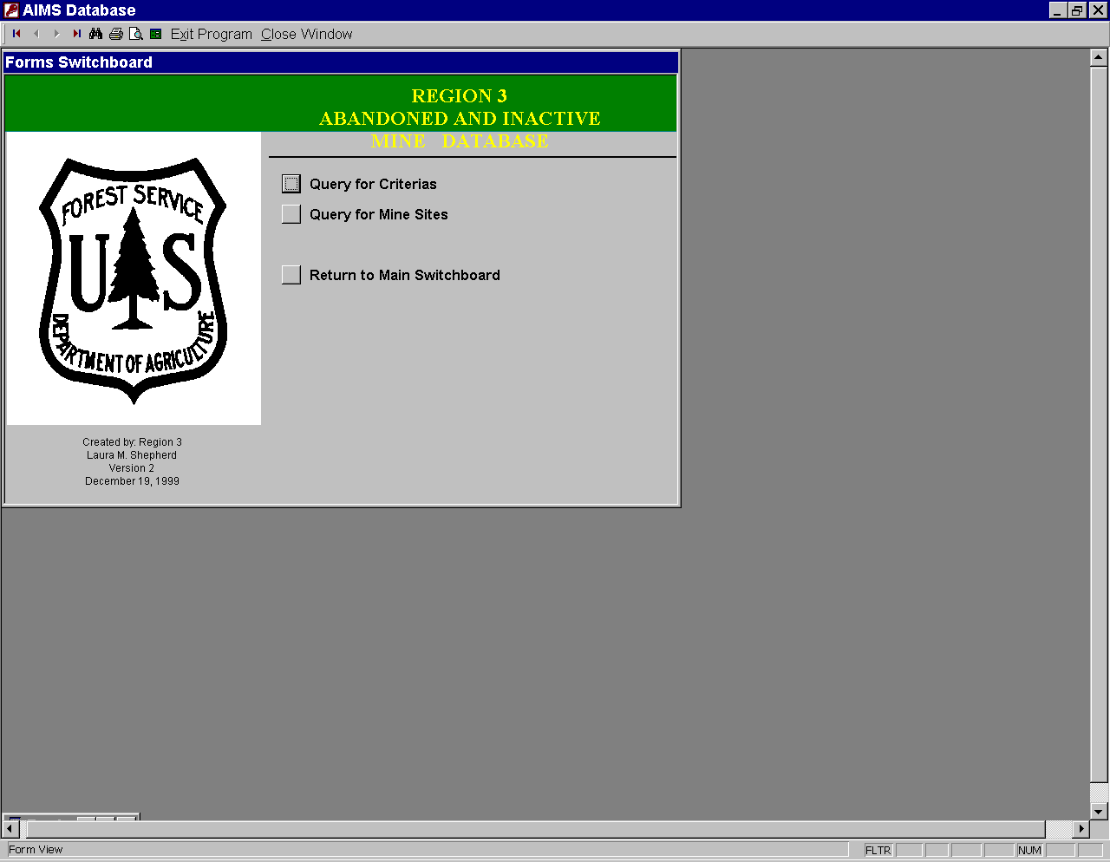

Query for Criteria:
This button sends the user to the “Criteria” screen. From this screen, the user selects a combination of information for review. This form can view multiple mine sites information for easy comparison.
The query of “Criteria” looks like this:
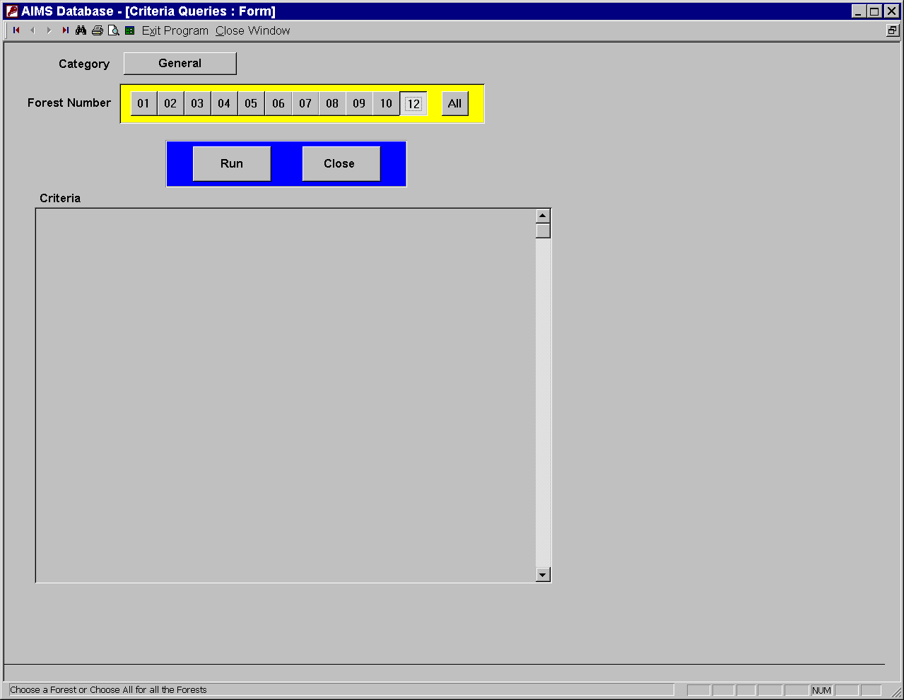
No Criteria has been selected.
Note: User must choice the “General” Button to obtain criteria questions.

How to work the Criteria Query:
To use the “Criteria” query, the user should enter the desired “Forest Number” or “All” button located in the yellow box then select criteria and subsequently select the “Run” button.
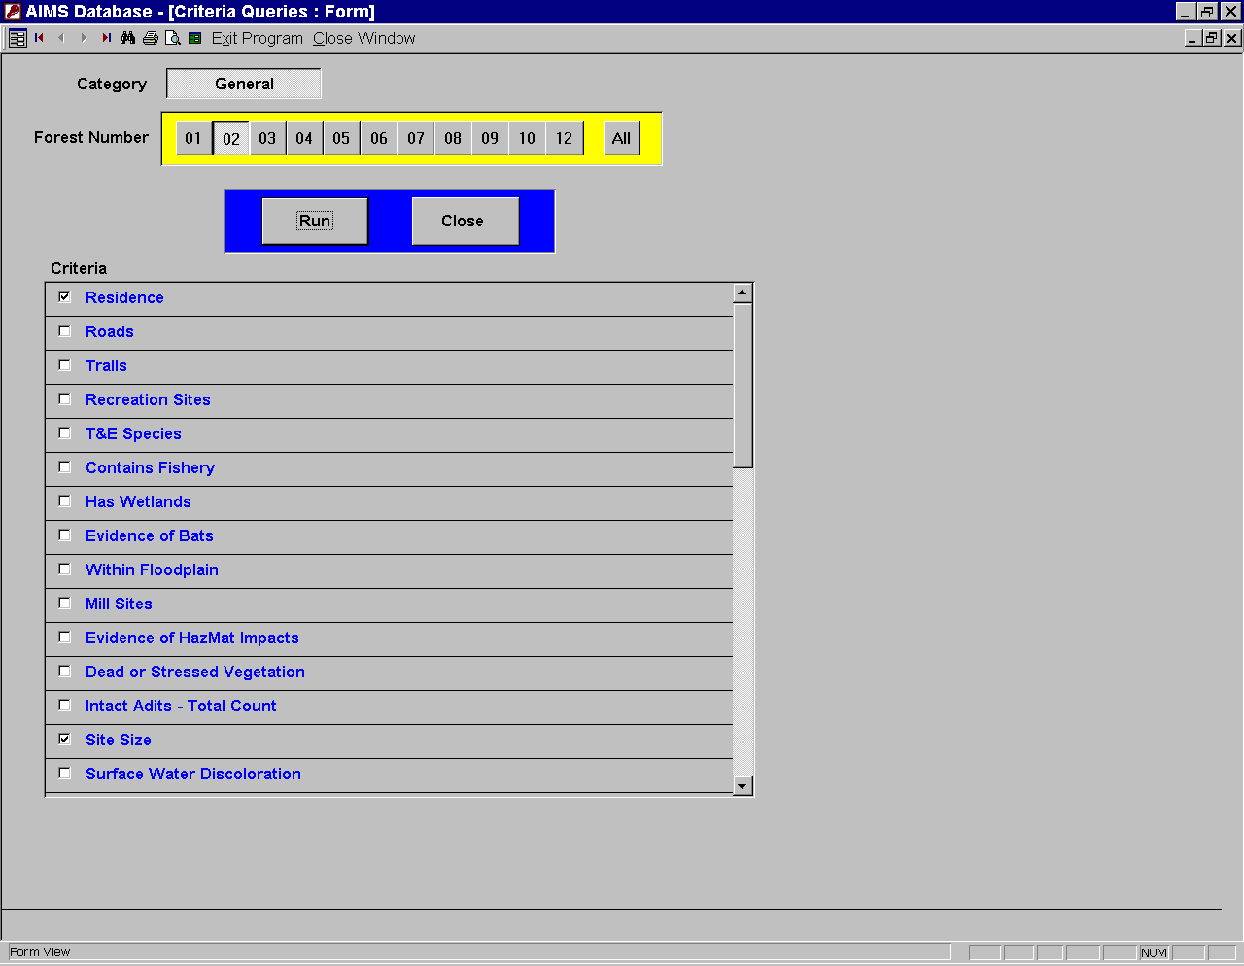
Criteria Questions
Typical output from this type of query is as follows.
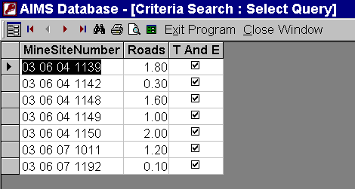
MENU
The user can print a query window with the “Print” button in the menu. In order to exit from this screen, use the “Close Window” button from the menu bar. This will take the user back to the “Criteria” query window. To make a new selection, the user must unclick all the boxes chosen from the last query. Then make new selections and select Run again. When the user is done with the “Criteria” query, just click on the “Close” button and the user returns to the switchboard.

Query for Mine Site:
After selecting this button, the Enter Parameter Value window appears. This has the following appearance:
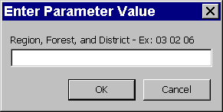
This window requires the user to enter the entire mine site number, or some fraction depending upon how broad the user would like to make the search. For example, to see all of the mines that are within a region, the user would enter the first two Regional numbers and then select enter. To see all mines within a particular forest, the user should enter the Region number, followed by one space and then the Forest number. To see the Ranger District, the user would enter the Region with one space after, Forest with one space after, and then the Ranger District number. The proper format is always required in this field (xx xx xx xxxx). Finally, the user may type in the full ten-digit number to view a specific mine site for information. After entering the number into the Enter Parameter Value window and selecting the “OK” button, the Search for Mines window opens and will appear as follows:
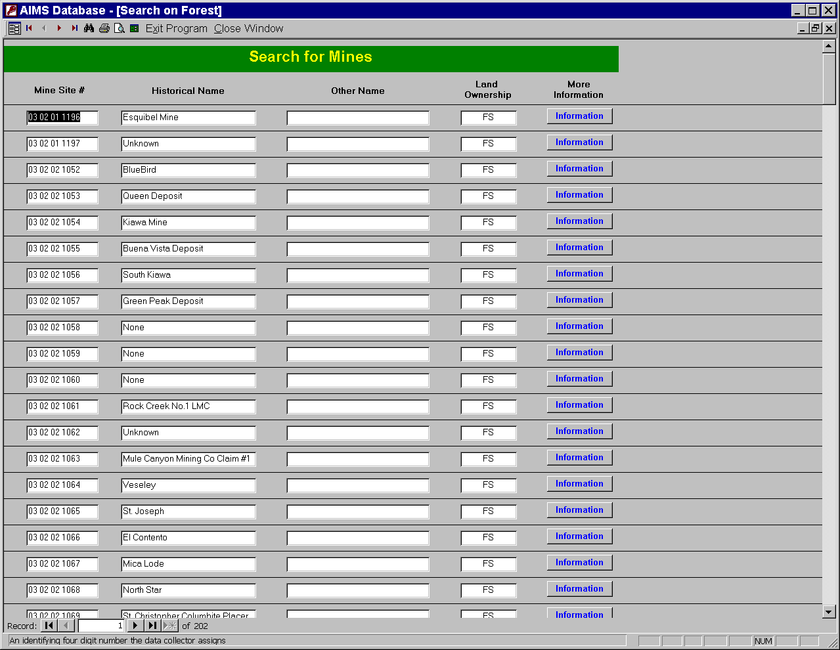
The following information may be viewed in this manner: Mine Site Number, Historical Name, Other Name, Land Ownership, and More Information.
This window allows the user to view more data on a particular site by clicking on the “Information” button under the heading “More Information”. The information button sends the user straight to the Mine Site Information screen for the individual mine site that was selected. (See Page 6)

Return to Main Switchboard:
Returns the user to the Main Switchboard, which appears at the beginning of the program.
- Preview Reports
Sends the user to the Reports Switchboard. The Reports Switchboard appears as follows:
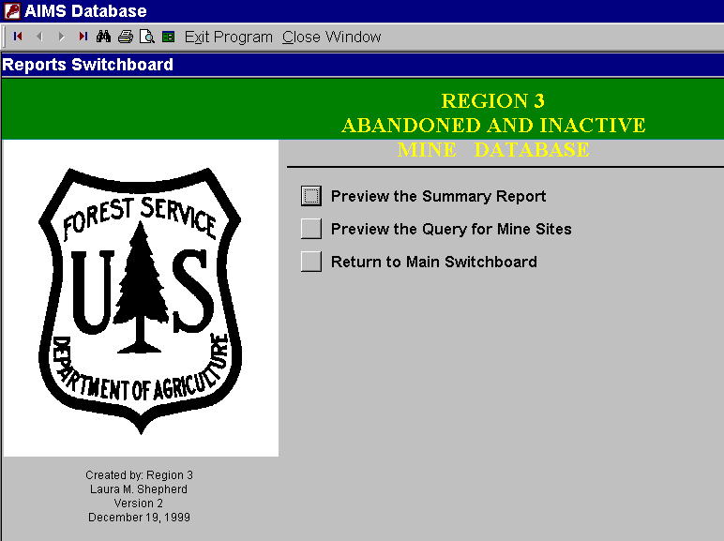

Preview Summary Reports:
Allows the user to create brief summary reports that cover general information about each mine site. After selecting this button, an Enter Parameter Value window appears. The same logic that applied to the Query for Mine Site Number button above (See page 14) applies to the number entered into this window. After entering the appropriate number select “OK”. The next screen will show a report of the following format:

Typical output from this type of Summary Report is as follows:
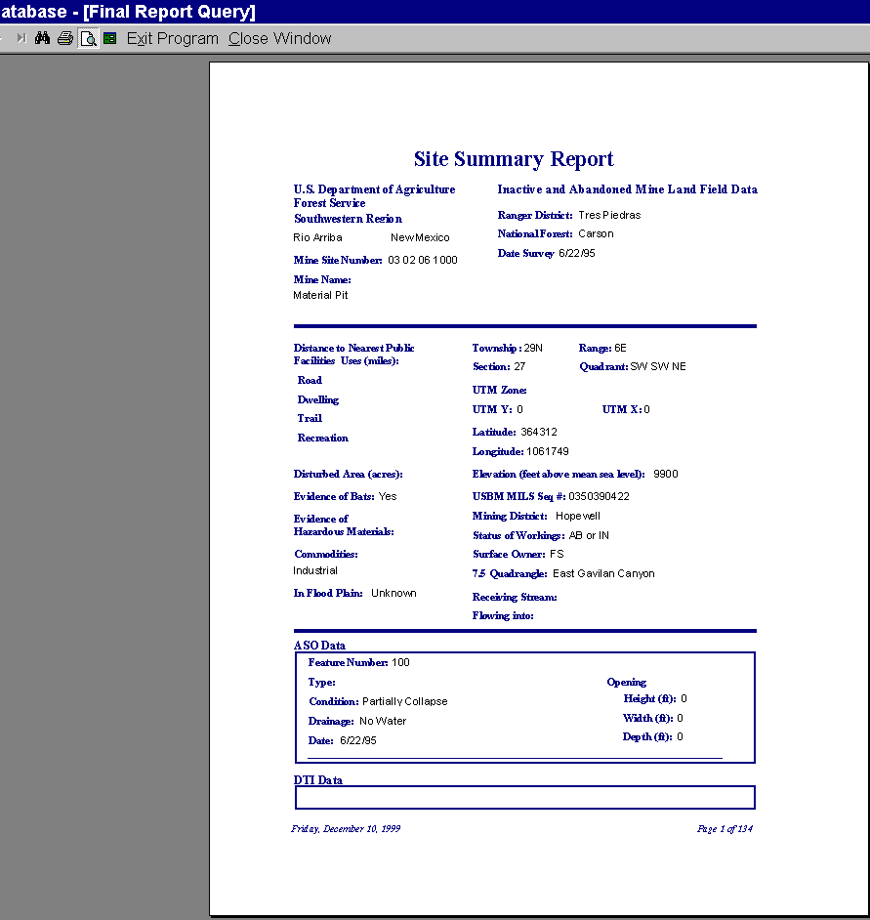
Sample printouts of these reports are included in the back of this guide.
The user can print the report by clicking the “Print” button in the menu. In order to exit from this screen, the user clicks the “Close Window” button from the menu bar

Preview the Query for Mine Sites:
This button sends the user to an Enter Parameter window where the user can enter specific mine site data (e.g. region number, region and forest numbers, or region, forest, and ranger district information) and create a tabular report. A report generated in this manner will contain the following fields: Mine Site Number, Historical Name, Other Name, Land Ownership, and Date Survey.
The Region 3 Forest Search Report is shown in the window below:
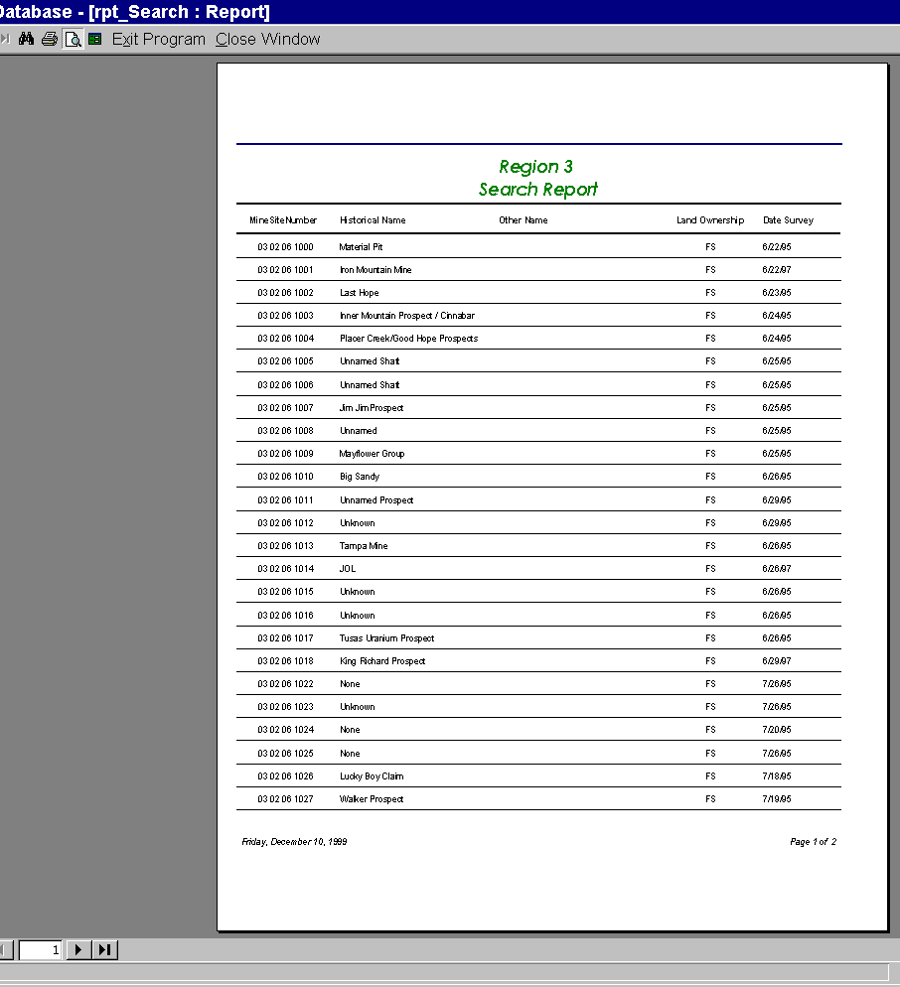
A sample printout of this report is located at the end of this manual.
The user can print the report by clicking the “Print” button in the menu. In order to exit from this screen, the user clicks the “Close Window” button from the menu bar

- Exit this database
This button allows the user to exit the program. The user will still be in Access 2000 and will need to go to file and then exit.

Index

A
Abandoned and Inactive Information, 9
Adits, Shafts, and Other Openings. See ASO
ArchInfo®, 1
ASO, 9, 10
C
CERCLA, 1
Clean Water Act, 1
Close Window, 6, 16, 17
Criteria, 12
CWA, 1
D
Data Entry, 2
Database Mangers, 2
DTI, 9, 10
Dumps, Tailings, and Impoundments. See DTI
E
Exit Database, 6, 17
F
Feature Type, 11
Field Forms, 1, 2
Find, 6
Format, 14
I
Installation of file, 3
M
Memory, 3
Menu, 5
Microsoft Access®, 1, 3
Mine Site Information, 7
O
Open First Record, 5
Open Last Record, 6
Open Next Record, 6
Open Previous Record, 5
Oracle®, 1
Other Region Information, 8
P
Photographs, 2
Print, 6, 16, 17
Print Preview, 6
Q
Query, 12
R
Read Only, 2
Reports, 15, 16, 17
S
Site Numbers, 2
Sketches, 2
Switchboard, 6, 15
U
Unique site numbers, 2
US Bureau of Mines, 1
V
View Record, 7
W
Water Sample. See WS
WS, 9, 11

Frequently Asked Questions (FAQ’s)

Q: How can I enter a new site into the database?
A: Information must be sent to the database managers who will then enter the new information.
Q: How can I make changes if I find some new information about one of my sites?
A: The user cannot make any changes to the data. All changes must be sent to the database managers.
Q: What do I do if the database freezes up?
A: Hold down the following keys simultaneously to shut down the AIMS database: ALT+CTR+Delete.
Q: What if I mistakenly delete something?
A: The user should not be able to delete anything. If somehow data is lost, the database manager has a the database back up and can replace the user copy.
Q: What if I lose the Switchboard?
A: On the menu bar there is a button that can be clicked to retrieve the Switchboard.
Q: What if I what to print to another printer?
A: You must set up your default printer to the one you want to print too before printing anything from the database.
Q: What if the file will not open up in Access?
A: First make sure you are in the right version of Access. The database only runs in Access 2000. If you are in the right version of Access contact your Database Manager, to request another copy of the database.

Installation of WINZIP:

1. Insert CD-ROM
- From Start select Run
- Select Browse and locate the CD-ROM drive then select WINZIP95
- Select Open and then OK
- Setup will begin and follow the instructions on the screen.
You can choose Express Setup or Custom Setup. It is recommended that you use Express Setup; however, you can use Custom Setup if you are and experienced user.

