J Scott Poole & Associates
J Scott Poole & Associates
728 St. Charles
Rapid City, SD 57701
(605) 342-2191
.
.
.
.
.
.
.
.
.
.

Mine Information System
A Software Application for Microsoft Access 2.0

January 1997

Application Overview
The Mine Information System was originally developed as a Foxpro 2.6 application in 1993 as a way to record information about abandoned mines in the Black Hills Region. To facilitate reporting the findings to the United States Forest Service, the structure of the data tables used is identical to a similar application used internally by the USFS. Since that time, many mines have been visited and their attributes are stored in the original FoxPro application.
The State of South Dakota would also like to view information about these mines. South Dakota, however, has standardized upon Microsoft Access as their database platform. This version of the Mine Information System is designed to provide an avenue of access to the original data for the State while at the same time allowing the existing FoxPro application to be used indefinitely.
In addition, over one thousand additional mines have been added to the Mine Information System from a similar project being performed by Colin J. Paterson at the South Dakota School of Mines. The following sections give a detailed guide on how to use the Access v2.0 version of the Mine Information System and expands upon the process of integrating Dr. Paterson's data into the database.
Please note that at the end of this paper is an important section pertaining to the structure of the database tables.

Loading the Mine Information System for Access v2

System Requirements
The Mine Information System requires that a complete installation of Access version 2.0 or higher reside on your computer. The application does not provide a runtime version of the Access application.
Any computer which meets Microsoft's guidelines for running Access 2.0 will be able to run the Mine Information System. In addition, the application requires that the FoxPro 2.6 data access driver be installed. This driver is installed by default on Access 2.0 installations.

Determination of Your Situation
The live copy of the Access 2.0 version of the Mine Information System is located at the South Dakota School of Mines and Technology on their campus PC network. If you are running the application on a computer connected to the SDSM&T network, follow the directions in the next section. If you have received an export disk and will be running the program on your local hard drive, refer to the section entitled Running MIS from a Floppy Disk on the next page.

Starting the Program on the SDSM&T Campus
If an icon has been set up on the Windows desktop running on the computer that you are using, simply double click on that icon. If not, begin by loading Microsoft Access. This can be accomplished by double-clicking the Access icon in Windows. Next, select File Open from the pull-down menu at the top left of the Access screen. Open the filename F:\PROGRAMS\DEPT\CHEM\MIS\MIS.MDB. The program will load and display the opening screen.

Running MIS from a Floppy Disk
If you are running the application from a local hard drive, you will need an export disk created from a computer at the SDSM&T campus. This disk contains a compressed copy of the MIS database application and a copy of the data files which the application refers to.
Before you can run the application, you must first install it on the local hard drive. This process requires:
- Approximately 2-3 megabytes of local hard drive space. The installation disk will automatically recreate the same directory structure on your hard drive as is used on the computers at the SDSM&T campus. All files will be contained in C:\PROGRAMS.
- A complete installation of Access 2.0 or equivalent runtime. Due to its size, the runtime is not included on the export disk.
To install the export disk from a DOS prompt, make your default drive the floppy by typing
A: <Enter>
If your 3 1/2 inch floppy is your B: drive, type
B: <Enter>
Begin the installation process by typing
INSTALL <Enter>
The disk will create the program's directory structure, copy the files to the hard drive, and decompress them when finished.
You may alternatively run the installation program from within Windows by selecting File Run from the Program manager screen and entering A:INSTALL
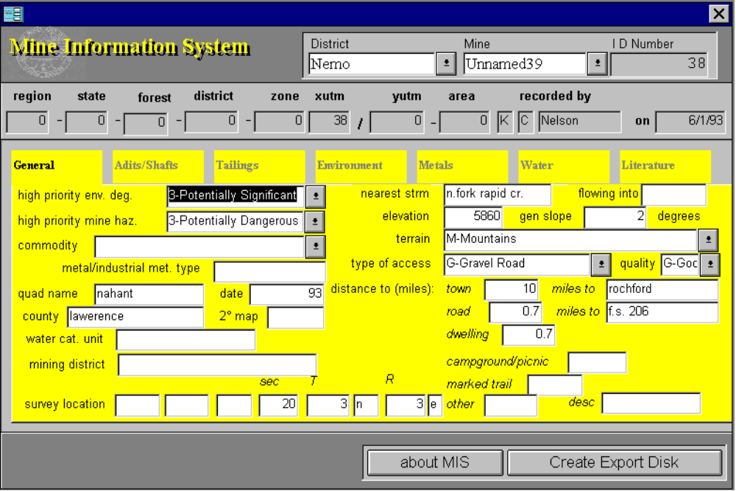
Once the installation process has completed, load Microsoft Access. This can be accomplished by double-clicking the Access icon in Windows. Next, select File Open from the pull-down menu at the top left of the Access screen. Open the filename C:\PROGRAMS\DEPT\CHEM\MIS\MIS.MDB. The program will load and display the opening screen, shown below:

Using the Program

Finding a Specific Mine

The MIS application has essentially one view. From the opening screen, you can navigate between different districts, view mines within each district, and view all of the information recorded for each mine.
Two screen controls at the top right of the screen allow you to quickly find the mine that you want to view. The District control lets you limit the mines listed in the Mine screen control to those found in a single district. To select between only mines found in the Custer district, for example, click the down arrow just to the right of the district control. Using the up and down arrows to the right of the list that appears, move through the list until the Custer district name becomes visible. Click on the name "Custer" to complete the operation.
Once you have selected a district to view, you can use that same technique to view all of the mines that are located in that district. Click the down arrow to the right of the Mine screen control to display the list of mines. Use the up or down arrows to move through the list if the mine that you want to see is not displayed. Click on the mine's name to display information about that mine.

Viewing Mine Information
Each mine has a large amount of information associated with it. To effectively display all of a mine's records, the information has been divided into seven groups. Each group of information directly corresponds to the groups used by the United States Forest Service. To display a specific group of information about a mine, select the tab that corresponds to that group's title. For example, to view the pertinent literature for the displayed mine, click on the Literature tab at the far right.
Several of the groups contain samples information. The Adits/Shafts, Tailings, Metals, and Water groups all display screens that can contain multiple records. The Adits/Shafts screen is shown below:
The information shown in the example represents a single adit or shaft record. To view information about other adits or shafts, use the left and right arrows at the lower left of the screen. The screen will display your current record number and the total number of records. All four of the multiple record screens work in a similar manner.
