**The Prescriptions-R-X chain of pharmacies**

**GROUP 1                                                                                                    ASSIGNMENT 2**

**Problem Statement**

The Prescriptions-R-X chain of pharmacies has offered to give you a free lifetime supply of medicines if you design its database. Given the rising cost of health care, you agree.

· Patients are identified by an SSN, and their names, addresses, and ages must be recorded.

· Doctors are identified by an SSN. For each doctor, the name, specialty, and years of experience   must be recorded.

·         Each pharmaceutical company is identified by name and has a phone number.

·         For each drug, the trade name and formula must be recorded. Each drug is sold by a given pharmaceutical company, and the trade name identifies a drug uniquely among the products of that company. If a pharmaceutical company is deleted, you need not keep track of its products any longer.

·         Each pharmacy has a name, address, and phone number.

·         Every patient has a primary physician. Every doctor has at least one patient.

·         Each pharmacy sells several drugs and has a price for each. A drug could be sold at several pharmacies, and the price could vary from one pharmacy to another.

·         Doctors prescribe drugs for patients. A doctor could prescribe one or more drugs for several patients, and a patient could obtain prescriptions from several doctors. Each prescription has a date and a quantity associated with it. You can assume that if a doctor prescribes the same drug for the same patient more than once, only the last such prescription needs to be stored.

·         Pharmaceutical companies have long-term contracts with pharmacies. A pharmaceutical company can contract with several pharmacies, and a pharmacy can contract with several pharmaceutical companies. For each contract, you have to store a start date, an end date and the text of the contract.

Pharmacies appoint a supervisor for each contract. There must always be a supervisor for each contract, but the contract supervisor can change over the lifetime of the contract.

**Software Requirement Specifications:**

**Perspectives:**

This system can store the following information:

**Patient Information:** This records the information about patients who have consulted doctors. Information include SSN number, first name, last name, address (street, city, pin code), age, contact number and email-id.

**Doctor Information:** The details of the doctors are also stored, which include the SSN number, first and last names, specialization, years of experience, registration number, contact number, email-id.

**Pharmaceutical company Information:** The details of the pharmaceutical company manufacturing drugs is recorded in the system. Information include Name of Company, Contact number, License Number.

**Drug Information:** Information about the drug such as the trade name of the drug, the pharma company that manufactured the drug, Formula will be stored in the system.

**Pharmacy Information:** The details of the pharmacies selling drugs is recorded in the system. Information include Unique Id of pharmacy, address (street, city, pin code), Contact number, Zone (e.g. North, South, East West)

**Prescription Information:** The details of the prescriptions are recorded in the system. Information include Patient SSN, Doctor SSN, Drugs prescribed, quantities, date.

**Contract Information:** The details of the contract between pharmaceutical companies and the pharmacies are recorded in the system. Information include date of commencement of contract, end date, text of contract, contract registration number.

**Features, User classes and Characteristics:**

Every patient has a primary physician. Every doctor has at least one patient.

Each pharmacy sells several drugs and has a price for each. A drug could be sold at several pharmacies, and the price could vary from one pharmacy to another.

Doctors prescribe drugs for patients. A doctor could prescribe one or more drugs for several patients, and a patient could obtain prescriptions from several doctors. Each prescription has a date and a quantity associated with it. You can assume that if a doctor prescribes the same drug for the same patient more than once, only the last such prescription needs to be stored.

Pharmaceutical companies have long-term contracts with pharmacies. A pharmaceutical company can contract with several pharmacies, and a pharmacy can contract with several pharmaceutical companies. For each contract, you have to store a start date, an end date and the text of the contract.

Pharmacies appoint a supervisor for each contract. There must always be a supervisor for each contract, but the contract supervisor can change over the lifetime of the contract.

**Using this system, the users can perform tasks stated below:**

**Reports to be generated**

1) Generate a report listing the names, registration numbers, years of experience of doctors of a particular specialization. As for example a report may be needed to be generated listing the nameserver no, years of experience of all cardiologists.

2) Generate a report listing the names of pharmacies in a particular zone of city. As for example, the names of all pharmacies in North Kolkata or say East Kolkata Township.

3) Generate a report listing the sale proceeds of a particular branch in the last x months( where x is an user input maybe say 48 months or 24 months)

4)  Generate a report listing the names of drugs having maximum or minimum demand in the last x months( where X is an user input).  As for example the pharmacies might want to generate a list of all those drugs which has the maximum selling in the last 48 months.  Or we might have to generate a report listing the names of drugs which was sold released in the past 6 months.

5)  Generate a report listing the trade names of drugs having a particular formula that is produced by different pharmaceutical  companies. as per example the drug having chemical formula Paracetamol is sold under various trade names like Parasafe,Calpol,Crocin etc.The pharmacist may want to the find the trade names of drugs having formula Paracetamol.

 6)  Generate report listing the contract registration number pharmaceutical company date of commencement of contract and the ending date of contract for the purpose of renewal of contract.  example a pharmacy may need to find out the contracts with the pharmaceutical companies that are going to end in the near future and would like to renew them.

7)  Generate a report listing the supervisors for the respective contracts.

8)  Generate a report of the stocks and prospective demand of drugs at the end of the day.

9)  Generate a report listing the names of drugs in a particular pharmacy that have surpassed the date of expiration.

10) Generate a report for the trade names of drugs produced by pharmaceutical companies that are least prescribed by doctors in the last x months where x  is an user input. Say a pharmacy we need to find out the trade names of drugs which were prescribe by doctors in the past 6 months.

11)  Generate a report of the most consultant doctors of a particular specialisation in the past x months ( where x is an user input maybe say 48 months or 24 months). Say we  need to find out the name of the cardiologist who was consulted the most by the patients in the past 6 months.

**ENTITY RELATIONSHIP DIAGRAM**

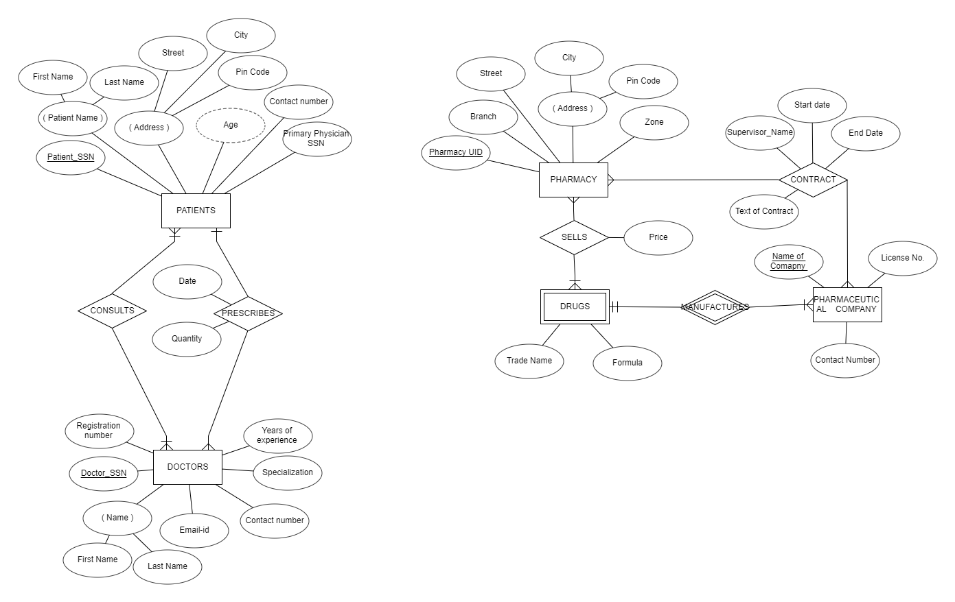

**RELATIONAL SCHEMA**

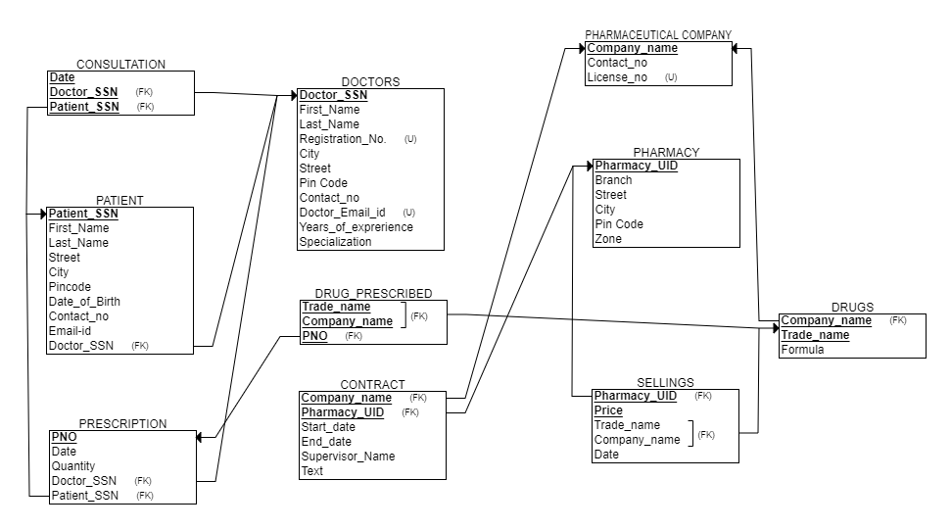

**Operating Environment:**

This system on the client will be web based and can run on any browser.

The system on the server side will run on php and the database will be MySQL.

**External Interfaces:**

The external interface,which will be a web page containing _____ number of pages.