**Screenshot of Azure Account showing username**

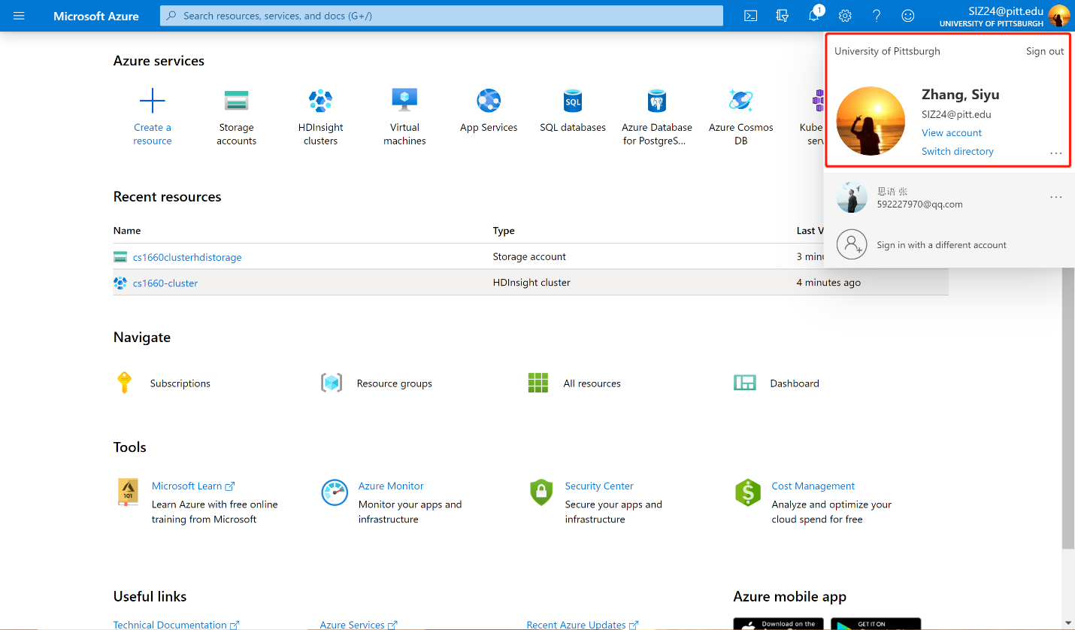

**Screenshot of your implementation of Word Count on Azure**

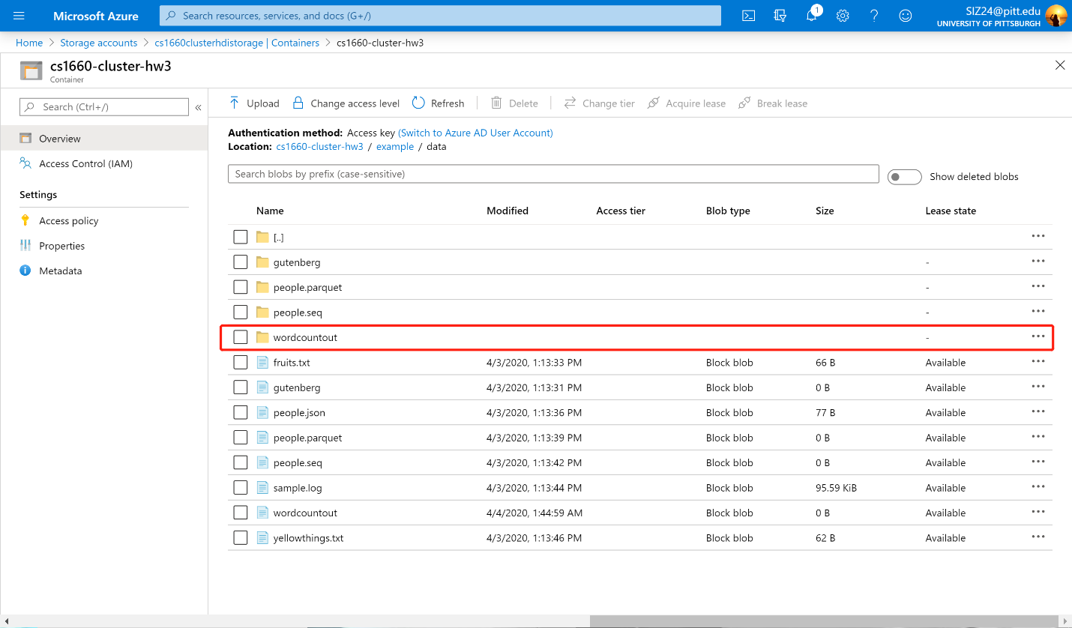

**My input data file (Uploaded to OneDrive)**

[**https://1drv.ms/t/s!Aov0m369Nhu-n3RBf97tgsg_AvWM?e=hCWbmo**](https://1drv.ms/t/s!Aov0m369Nhu-n3RBf97tgsg_AvWM?e=hCWbmo)

**Screenshot of the Word Count Output**

