## Conceptual Studies for the Hadronic Calorimeter

### ABSTRACT

The neutral pion’s properties and the additional strange quark in the kaon are opportune to study the proton’s substructure through General Parton Distributions (GPDs), which describe the movements, placements, and momenta of the quarks inside the proton. In pion or kaon electroproduction where a beam of high energy electrons, powered via Jefferson Laboratory’s particle accelerator scatters off a stationary proton target, a neutral pion or kaon is produced. The neutral pion has a very short mean lifetime and decays into two real photons. The kaon decays into a Λ or a Σº particle. To study the structure of the proton, we have to analyze the neutral pion and the kaon and their decay products. For the analysis of these particles we need dedicated detectors. Since the neutral pion quickly decays into two photons, a hadronic calorimeter can be placed in the photons’ trajectory. The calorimeter can measure the photons’ energy, and thus the pion’s energy and momentum, as energy and momentum are both conserved. For the kaon reaction, the most efficient detection method is an aerogel Cerenkov detector. Both cases rely on detector performance, and thus it is important to evaluate the conceptual design and all components of the detector carefully. In this presentation I will present results of conceptual design studies for the π˚ hadron calorimeter, specifically the study of necessary calorimeter accuracy in the identification of an undetected particle in hard scattering, and of a new method based on biological techniques to evaluate the aerogel material index of refraction for the kaon detector.

### INTRODUCTION

Scientists have long been studying matter in a universal ambition to understand our universe, and thus the make-up of everything we know to exist: all matter. In order to understand matter, and even the human structure, physicists have looked deeper and deeper into the composition of what they had thought to be fundamental particles. From Dalton discovering the atom in early 1800s as the smallest building block, to Thompson finding the electron in 1897 and Rutherford determining the charged atomic nucleus in 1910, scientists have been searching for answers to the ultimate question, which has concerned humans from the very beginning of their existence: “What is the world composed of?” As the atomic model of protons, neutrons, and electrons became more and more complete, scientists went deeper into the microscopic realms of particles. In the early 20th century, the discovery of a whole zoo of particles was unleashed unto the world, including the findings of the positron, the neutrino, and the photon, one of the most important particles; it explained the structure and behavior of light. As photons were found to carry the electromagnetic force, the three other forces, gravity, weak, and strong forces were also found to have their own force carrier particles: the graviton (so far hypothetical), the W and Z bosons, and gluons, correspondingly. The formation of the Standard Model in the 1970s united all these particle physics findings into the most comprehensive theory to describe fundamental particles and their complex interactions; it stated that twelve particles and four forces make up every bit of matter in the universe! According to this theory, six of these particles are called quarks and have six flavors (types); up, down, top, bottom, strange, and charm. Each of these has a corresponding anti-quark, are opposite in all properties but mass. Quarks constitute every neutron and proton. The other six particles are called leptons; the electron, the muon, the tau carry a negative charge, differing in mass and have corresponding neutrinos, electrically neutral, nearly massless particles.

### THEORY

The Catholic University Nuclear Physics group is studying the quarks and the strong force of this Standard Model, desiring to understand the proton’s substructure made of three (up, up, down) quarks, as well as the interaction of these quarks through the strong force, via gluons. Since it is impossible to isolate and dissect subatomic particles, the team plans to scatter a high energy electron beam off a proton target at a powerful, almost one mile long particle accelerator at the Thomas Jefferson National Accelerator Facility (Jefferson Laboratory) in Virginia. By analyzing the formed and scattered particles’ kinetic energy, momentum, and other factors, the physicists will collect information that will allow them to compare the new data of one of the resulting particles, the neutral pion, to other particle systems, like the charged pion The charged pion, virtual at that stage, is initially located around the proton. Because it blinks in and out of existence, so rapidly, it seems like it gets its energy from nowhere. However, it does not violate the principles of conservation of energy, due to the Heisenberg Uncertainty Principle, ( ) where the uncertainty in a particle’s energy multiplied by the uncertainty of time is equal or greater than Planck’s reduced constant. A virtual particle can thus acquire a mass (or energy) if it exists for only a short time. The electron beam then scatters off the proton and one of the virtual pions, giving it energy to exist. As shown in Fig.1, the neutral pion originates from the proton, and is the focus of the experiment.

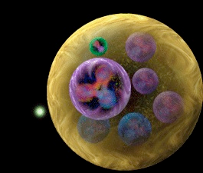

Neutral Pion

Neutral ionPioPion

Proton with Quarks

Incoming Electron

Beam

Other Protons in Target Chamber

i

*Fig. 1 Schematic of Proton and its Constituents*



One of the ways to study protons through this experiment is by using the information obtained from the pi0 meson to create General Parton Distributions (GPDs), mathematical models that show the movement, momenta, and placement of the quarks inside a proton (see Fig.2).

*\* The x variable is the fraction of the momentum of the quark over the momentum of the proton.*

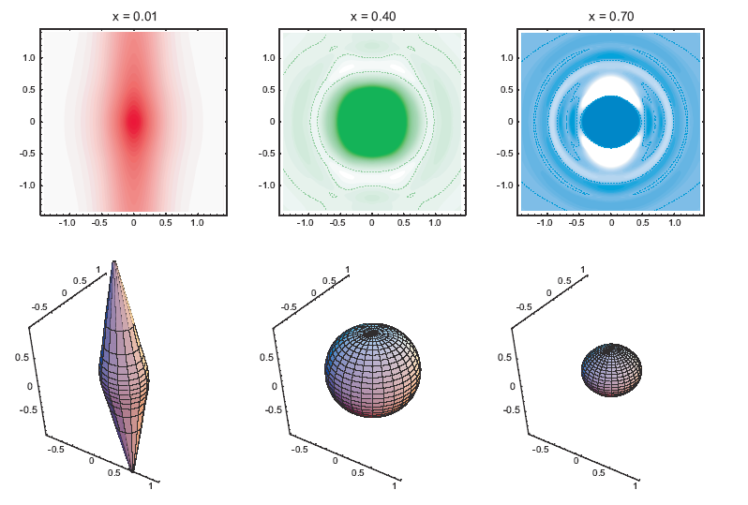

ii

*Fig 2: Example of a GPD model calculation*

#### IDENTIFYING THE UNDETECTED

There are numerous possible reactions that can occur when an electron beam is targeted at a stationary proton target. However, the focus of this investigation is strictly the electroproduction of a pi0 meson by an electron beam scattering of a pion cloud around the target proton, where the proton recoils. The electroproduced pion decays shortly after into two photons, in contrast to the proton the pi0 meson has a very short lifetime! (see Fig. 3).

In this scattering process, all particles [electron beam and the pion (through its decay photons)] but the recoiling proton is detected. The recoiling and undetected proton must be identified through the conservation of energy and momentum; in general terms, the recoiling particle’s mass, calculated from energy and momentum, is calculated by subtracting all the detected energies and momenta from the original, total energy and momenta of the system. If this “missing” or undetected mass is approximately 0.938 GeV, then the undetected particle can be said to be a proton. If the missing mass is not close to that number, other particles have been produced, in a reaction that does not pertain to the goal of this experiment. Hence, the calorimeter’s measurements of the pion’s decay photons must be accurate enough to differentiate between particles of similar masses: a proton and a delta, for example.

**π0**

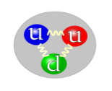

**π0**

**π0**

Virtual photon emitted by ebeam

**π0** decays into 2 photons



electron beam

E’

scattered pion

**Recoiled proton (UNDETECTED)**

de

*Fig. 3 Feynman Diagram of Pion Electroproduction*

iii

### PROCEDURE: Finding the Right Calorimeter Accuracy

First, an Excel program, based off an existing Fortran code for calculating kinematics (quantities like velocity, momentum, resolution, and energy) of charged pion electroproduction, was created to calculate approximately fifty quantities needed for the final missing mass equation (from the user’s input of the center of mass energy and the resolution):



where Ep and Pp is energy and momentum of the proton, respectively. After that, the three values (in separate columns) that would be detected by the calorimeter, pion energy, angle, and momentum were inversely distributed; as each value has one answer in a perfectly hypothetical world, there was a need to simulate real life results. Any measurement has associated with it an intrinsic uncertainty. For instance, if we make a measurement with a ruler, we can only quote our results to an accuracy of xyz mm. However, for most purposes this is sufficient. A detector is typically designed, so that one can make the best measurement possible within the desired uncertainty. Like in the case with the ruler there will be an intrinsic uncertainty and to make the best measurement possible it is important to understand these. The actual calorimeter will thus not detect perfect (the computed) values (which assume a perfect detector!)! The intrinsic uncertainty of the calorimeter depends on how well one can measure, for instance, the momentum or energy of a particle. The inverse distributions allowed the creation of a dataset of varying numbers with the same average and standard deviation (user-inputted), for each calorimeter detected value. This dataset of the now different calorimeter detected pion values resulted in a set of different missing mass values (they are calculated from the pion values). The set of varying missing mass values were then Gaussian distributed. The Gaussian Distribution function is a way to show the probability of a proton to be calculated to have a certain mass for varying (imperfect), detected pion values (or for various calorimeter accuracies). The peak of the Gaussian bell curves is the average value, the perfect or hypothetical number. The median width of the curve from the center of the curve is the standard deviation, showing possible masses calculated for a particle for a certain calorimeter accuracy.

### RESULTS (Gaussian Distributions)

The graph of Calorimeter Accuracy of 0.1 GeV shows how suitable the calorimeter accuracy or resolution is suitable for the identification of the proton pion (blue bell curve); particles, with similar masses, have distinguishable peaks. As the mass of the proton is 0.938 GeV, the Delta’s is 1.2 GeV, and the Eta’s is 0.15 GeV, the missing mass maximum uncertainty can be +/- 0.14 GeV; With maximum error, the undetected proton mass will be calculated as 1.078 GeV or 0.798 GeV. As shown on the chart below, the identification can become difficult if a missing mass value around 1 GeV is detected; as the pion and delta curves overlap in that value range.

*Fig. 4 Simulated Missing Mass Distribution for a Calorimeter Resolution of 0.1 GeV*

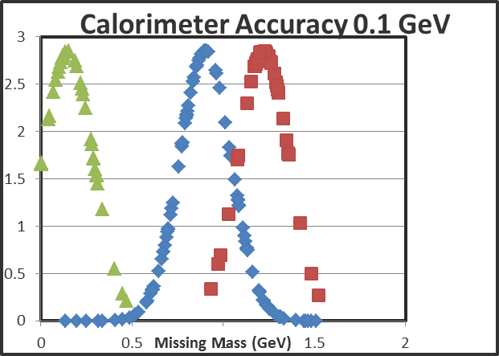

iv

**Proton mass Mean:** 0.938 GeV

**Calorimeter STDEV**: 0.1 GeV

**Proton Missing Mass STDEV**: 0.14 GeV

**Eta mass mean: 0.15** GeV

**Delta mass mean: 1.2** GeV

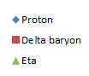

However, if the calorimeter accuracy is increased to 0.05 GeV, the distributions of the proton and other possible occurring particles (in the reaction) become distinguished from each other. The missing mass accuracy is then +/- 0.068 GeV: Max error, the proton detected as 1.01 GeV or 0.87 GeV. This is better; there is less uncertainty to our identification of a particle with that mass range, as a proton.

**Proton mass Mean:** 0.938 GeV

**Calorimeter STDEV**: 0.05 GeV

**Proton Missing Mass STDEV**: 0.068 GeV

**Eta mass mean: 0.15** GeV

**Delta mass mean: 1.2** GeV

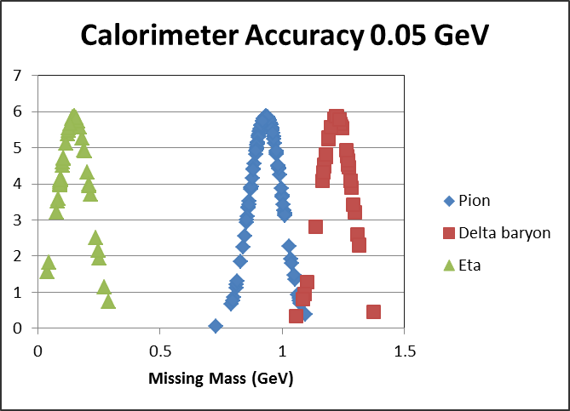

*Fig.5 Simulated Missing Mass Distribution for a Calorimeter Resolution of 0.05 GeV*



v

Note Fig. 6 shows that the calorimeter accuracy has a linear relationship with the missing mass accuracy [or how accurately the mass of the undetected particle can be calculated from the calorimeter detected (with some error) pion values]. This relationship in Fig. 6 does not seem to be linear due to rounding issues and the random part of the inverse distribution function.

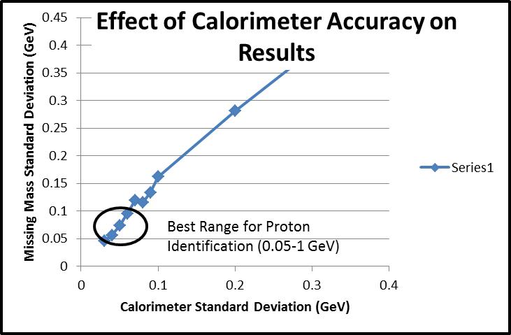

vi

*Fig. 6 Effect of Calorimeter Resolution on the Simulated Missing Mass Distribution*

### CONCLUSION/OUTLOOK

Analytical kinematic calculations have shown that the optimal accuracy of our calorimeter needs to be 0.05 GeV for the confident and correct identification of the undetected proton from other particles, such as delta and eta. While the 0.1 GeV calorimeter accuracy, reached with the lead glass, is also acceptable; the 0.05 GeV accuracy may be realized, by using a special material, for instance, lead tungstate (PBWO4). In the nearby future, other design aspects of the hadronic calorimeter will have to be simulated through programs, such as SimCerenkov, a Fortran program that tests parameters and dimensions of particle detectors, in order to find the optimum (efficient) design characteristics. These calorimeter properties include the block size of the material of lead tungsten, and the size, gains, and placement of photomultiplier tubes in the detector. Finding the suitable accuracy through hypothetical equations and Gaussian distributions, of the hadronic calorimeter is an important step towards creating the pion detector, and thus, understanding the proton’s mysterious and complex substructure.

### KAON DETECTOR STUDIES

The development of particle detectors has a broad field of standards. There is a universal approach, beginning with designing and testing the detector through mathematical studies, such as with the calorimeter pion detector described in the previous section of this article and then the simulation and examination of detector properties in programs like Monte Carlo. After this, detector prototypes are built, and specific properties and responses of the detector are evaluated. Dr. Horn’s and her team of undergraduates are studying and experimenting on prototypes and simulations of the Cerenkov aerogel detector. To acquire a broader view of particle physics, I conducted a small study on the aerogel component of this detector. As a kaon (up, anti-strange quark), the charged particle studied by the CUA team, passes through the aerogel, faster than light in a vacuum, a flash of light is emitted. Aerogel has the least density of any known porous solids and is made from Silica Oxide. One of the uses of Aerogel tiles comes from the fact that it can have different indices of refraction (this is a measure of the speed of light in a substance). Different particles, having their own unique masses and thus momenta, will only emit light in certain indices of aerogel, (making aerogel an opportune particle detector). My task was to verify the labeled indices of the aerogel tiles, shipped from the Bates MIT Laboratory, and thus possibly misplaced in labeled boxes. For example, the kaon’s momentum range requires the chosen indices are 1.03 and 1.015 for Cerenkov radiation, for a measurable flash of light (photo-electrons) to be emitted. One must measure the density of the tile, p, to calculate the index, n though the equation:

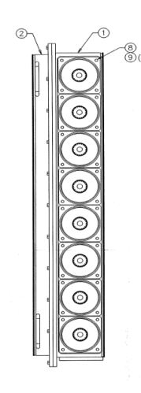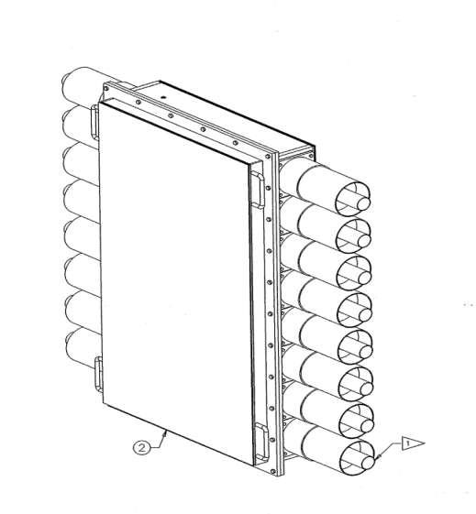

PMTs

Aerogel Panels

Front View

*Fig 7: Schematic of the Aerogel* Detector

vii

n=1 +0.21p

The conventional, simple method of measuring the width, length, and height of the tiles to find the volume is not accurate enough, for the tiles are irregular, fragile and often chipped. In the determination of the indices of aerogel tiles, each tile was photographed from the top view beside a drawn square with a known area, after being weighted. Then, the photographs were opened in Adobe Photoshop, and the top of the tile was selected through the marquee tool. After that, the selection was analyzed with the statistics histogram tool; the number of selected pixels (the tile’s top) was found. Finally, to convert pixels into metric units the drawn square was selected and its pixel number was recorded. The known drawn square’s metric dimensions were combined with its pixel number; this ratio was used as a conversion factor from the aerogel’s pixel number to its metric (cm^2) dimensions. As, the width of each tile was fairly uniform, it was measured with a basic ruler. Density, and thus the index, could be then calculated accurately:

p=(top of tile x width)/weight

This method, based on biological techniques1 of measuring leaf area in plant growth analysis, thus reduced index uncertainty, and successfully accounted for chips and other aerogel deformities.

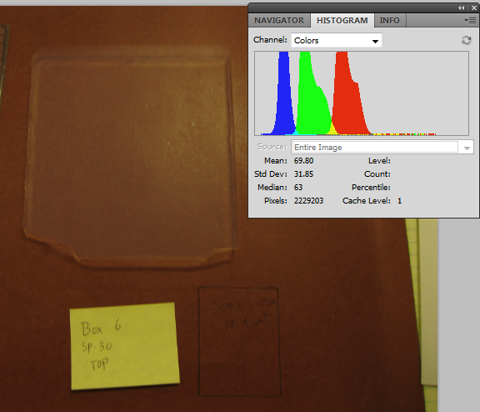

Aerogel Top

Pixel Num.

Drawn Square

17.9 cm2

viii

*Fig. 8 Determining the Index of Refraction of Aerogel using Biological Techniques*

### NOTES

I J. Griffin/Jefferson Lab

ii Nathaniel Hlavin, “Computational Design for Aerogel Kaon Cherenkov Detector” (unpublished paper, Catholic University of America, Washington DC, August 2010, p.2

iii Author’s graph (Excel)

iv Author’s graph (Excel)

v Author’s graph (Excel)

vi Author’s graph (Excel)

vii Nathaniel Hlavin, “Computation Design for Aerogel Kaon Cherenkov Detector” (unpublished paper, Catholic University of America, Washington DC, August 2010

viii Author’s photo

### BIOGRAPHY

*The Particle Adventure*. Web. 19 Aug. 2011. <http://particleadventure.org/>.

"Transparent Nuclei." *Physical Review Focus*. Web. 19 Aug. 2011. <http://focus.aps.org/story/v20/st22>.

Web. <http://public.web.cern.ch/public/en/science/StandardModel-en.html>.

Cottingham, W. N., and D. A. Greenwood. *An Introduction to Nuclear Physics*. Cambridge: Cambridge UP, 2001. Print.

Das, Ashok, and Thomas Ferbel. *Introduction to Nuclear and Particle Physics*. River Edge, NJ: World Scientific, 2003. Print.

1"Measuring Leaf Area with Adobe Photoshop CS3 :: ChloroFilms :: Plant Biology Videos on YouTube." *Welcome to ChloroFilms! :: ChloroFilms :: Plant Biology Videos on YouTube*. Web. 30 Aug. 2011. <http://www.chlorofilms.org/index.php/crpVideo/display/videoid/46>.

### ACKNOWLEDGEMENTS

I thank Dr. Tanja Horn for introducing me to nuclear physics, answering all my questions, giving me generous aid with my work, as well as allowing me to have the opportunity of working at a physics laboratory and being introduced to scientific research in the laboratory.

I would also like to thank Laura Rothgeb, Nathaniel, Hlavin, Michael Metz, Dr. Liam Casey, Kevin Wood, and Robert Macedo.