

HydroDesktop

Version 1.4  
Quick Start Guide

**A guide to using this free and open source application for discovering, accessing, and using hydrologic data**

February 8, 2012

by:

Tim Whiteaker

Center for Research in Water Resources

The University of Texas at Austin

Distribution

HydroDesktop and all associated source code and documentation are available at <http://www.hydrodesktop.org/>.

HydroDesktop is provided free of charge under the Berkeley Software Distribution (BSD) license. Please see the following license information:

Copyright © 2011, Consortium of Universities for the Advancement of Hydrologic Science, Inc.

All rights reserved.

Redistribution and use in source and binary forms, with or without modification, are permitted provided that the following conditions are met:

* Redistributions of source code must retain the above copyright notice, this list of conditions and the following disclaimer.
* Redistributions in binary form must reproduce the above copyright notice, this list of conditions and the following disclaimer in the documentation and/or other materials provided with the distribution.
* Neither the name of Consortium of Universities for the Advancement of Hydrologic Science, Inc. nor the names of its contributors may be used to endorse or promote products derived from this software without specific prior written permission.

THIS SOFTWARE IS PROVIDED BY THE COPYRIGHT HOLDERS AND CONTRIBUTORS "AS IS" AND ANY EXPRESS OR IMPLIED WARRANTIES, INCLUDING, BUT NOT LIMITED TO, THE IMPLIED WARRANTIES OF MERCHANTABILITY AND FITNESS FOR A PARTICULAR PURPOSE ARE DISCLAIMED. IN NO EVENT SHALL THE COPYRIGHT OWNER OR CONTRIBUTORS BE LIABLE FOR ANY DIRECT, INDIRECT, INCIDENTAL, SPECIAL, EXEMPLARY, OR CONSEQUENTIAL DAMAGES (INCLUDING, BUT NOT LIMITED TO, PROCUREMENT OF SUBSTITUTE GOODS OR SERVICES; LOSS OF USE, DATA, OR PROFITS; OR BUSINESS INTERRUPTION) HOWEVER CAUSED AND ON ANY THEORY OF LIABILITY, WHETHER IN CONTRACT, STRICT LIABILITY, OR TORT (INCLUDING NEGLIGENCE OR OTHERWISE) ARISING IN ANY WAY OUT OF THE USE OF THIS SOFTWARE, EVEN IF ADVISED OF THE POSSIBILITY OF SUCH DAMAGE.

Disclaimers

Although much effort has been expended in the development and testing of HydroDesktop, errors and inadequacies may still occur. Users must make the final evaluation as to the usefulness of HydroDesktop for their application.

Funding for HydroDesktop and this document are provided by the Consortium of Universities for the Advancement of Hydrologic Science, Inc. (CUAHSI) under National Science Foundation Grant No. EAR-0622374. In addition, much input and feedback has been received from the CUAHSI Hydrologic Information System development team. Their contribution is acknowledged here.

Support

For the latest downloads, documentation, discussion forum, and an issue tracker where bugs or feature requests can be posted, please use the HydroDesktop website at <http://www.hydrodesktop.org/>.

Table of Contents

Introduction 1

Installation 2

Installing HydroDesktop 2

Uninstalling HydroDesktop 2

Walkthrough - Downloading Streamflow Data 3

Opening HydroDesktop 3

Searching for Hydrologic Data 4

Viewing Downloaded Time Series 7

Exporting Data to a Text File 8

Summary 9

# Introduction

HydroDesktop is a free and open source Geographic Information Systems (GIS) application that helps you discover, use, and manage hydrologic time series data. The GIS components are built from the open source DotSpatial library, while the time series components utilize web services designed by the CUAHSI Hydrologic Information System (CUAHSI-HIS) project (see related links below). The result is a spatially-enabled system for downloading observational data describing the water environment.

**This document briefly introduces HydroDesktop and includes a simple walkthrough for downloading time series data.** If you’re ready to start some hands-on training, skip to the walkthrough section. Otherwise, continue reading this introductory section as we answer a few common questions about HydroDesktop.

**Who would use HydroDesktop?**

Basically, anyone who wants to download hydrologic time series data and use it. While the hydrologic research community is one target audience for HydroDesktop, we hope that students in science classes, educators, and professionals will also find HydroDesktop easy-to-use and helpful in their search for hydrologic data.

**Why use HydroDesktop?**

There is A LOT of hydrologic observations data freely available on the Internet. However, the plethora of websites and data formats makes it difficult to find, get, and use the data you want. CUAHSI-HIS changed that by inventing a standard web service design called WaterOneFlow for accessing hydrologic data. This means that no matter from whom you’re getting data, the way you get the data is the same, as long as they are using WaterOneFlow to share their data. HydroDesktop is built from the ground up with the ability **to interact with WaterOneFlow web services, connecting your computer with data from the dozens of agencies and universities who are already publishing their data using this standard.**

**What are web services?**

Web services are like programs that you access on the Internet, which typically have one distinct “service” that they provide to you. WaterOneFlow is a web service whereby you provide a location, a variable of interest (e.g., streamflow), and a time period, and it returns a time series of data. The output format from WaterOneFlow is standard language called WaterML that includes both the time series data and also the metadata to fully describe the data. Confused at all of these new terms? It’s OK. HydroDesktop knows how to request data from a WaterOneFlow web service and translate the WaterML response into your local database so that you can get on with your analysis. It handles this web service mumbo jumbo so that you don’t have to!

**What operating system do I need?**

HydroDesktop is built for Windows computers. However, the code is designed to be compatible with the Mono Framework to support Mac and Linux, although formal testing in this regard has yet to be done.

**Related Links:**

**HydroDesktop Source Code -** <http://www.hydrodesktop.org/>

**CUAHSI Hydrologic Information System -** <http://his.cuahsi.org/>

**DotSpatial -** <http://dotspatial.codeplex.com/>

# Installation

## Installing HydroDesktop

To install HydroDesktop:

1. Navigate to <http://www.hydrodesktop.org/>.
2. Click the **Download** link on the right side of the page to get the latest installer.

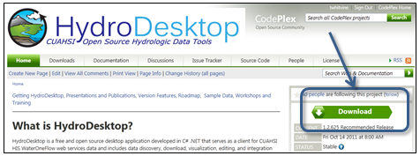

Figure HydroDesktop can be downloaded from <http://www.hydrodesktop.org>

1. Read the license and agree to it.
2. Save and run the installer. The installer will guide you through the rest.

**Note**Because HydroDesktop functionality continues to grow, the installer is periodically updated. Check back often for the latest version of HydroDesktop.

## Uninstalling HydroDesktop

HydroDesktop can be uninstalled like other Windows programs. For example, on Windows 7:

1. Click the Windows **Start** button.
2. Type **Programs and Features** and press ENTER.
3. Select **HydroDesktop** from the list of programs.
4. Click **Uninstall**.

# Walkthrough - Downloading Streamflow Data

This section leads you through HydroDesktop’s most commonly-used functionality, namely: data search, visualization, and export. In this walkthrough, you’ll be working with streamflow data in Travis County, Texas, during the major flooding event in October, 1998. Once you have installed HydroDesktop, this walkthrough should take about 15 minutes to complete.

## Opening HydroDesktop

Let’s get familiar with HydroDesktop.

1. Open HydroDesktop.
2. In the Welcome screen, click **OK** to create a new project from the North America template.
3. Take a moment to explore the user interface.

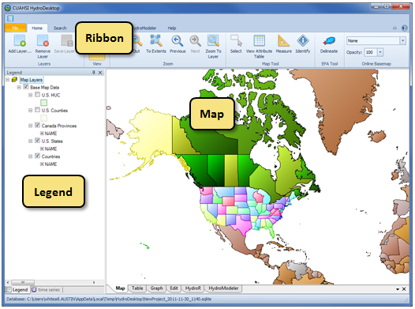

Figure HydroDesktop user interface

As you can see, HydroDesktop looks much like typical GIS applications. It supports complex layer symbologies, adding your own shapefiles to the map, and even custom programmed tools and plugins. What sets HydroDesktop apart is the ability to query for hydrologic time series data.

## Searching for Hydrologic Data

When searching for data in HydroDesktop, you can specify the following filters: area of interest, parameter keywords, time range, and data sources (**Error! Reference source not found.**). When the search results are returned, you can further filter the results and then choose which data you want to actually download.

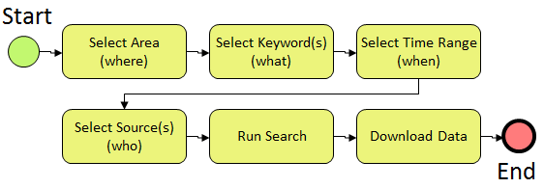

Figure Workflow for search

This workflow is initiated using the Search tab of the HydroDesktop ribbon (Figure 4). The panels in this tab are arranged in the same order as the workflow above.

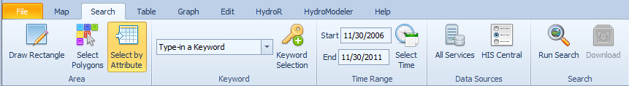

Figure Search Tab

Let’s practice this workflow by searching for streamflow data in Travis County during the 1998 Texas flood.

1. Set the context with an online basemap.
   1. On the **Map** tab, in the **Online Basemap** panel, choose a basemap such as **ESRI World Topo**.
   2. In the **Online Basemap** panel, set the **Opacity** of the basemap to **50**.
   3. In the **Legend**, uncheck the **U.S. States** layer to hide that layer.
2. In the ribbon, click the **Search** tab.
3. Select Travis County as the area of interest.
   1. In the **Legend**, left-click on the layer name **U.S. Counties** to select that layer. If the layer is not visible, click to place a check mark in the box next to the layer name.
   2. In the **Area** panel on the ribbon, click **Select by Attribute**.
   3. Select **Travis, TX**, from the list of counties.
   4. Click **OK**.
   5. In the **Legend**, right-click the layer name **U.S. Counties**, point to **Selection**, and click **Zoom to Selected Features**.

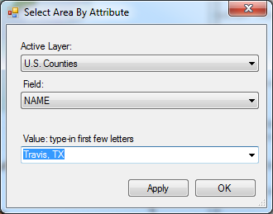

Figure Selecting an area of interest

1. In the box within the Keyword panel on the ribbon, type **Streamflow**. The box autocompletes to a valid search term from the list of parameter keywords that CUAHSI maintains.
2. In the Time Range panel, change the start date and end date to **10/1/1998** and **10/31/1998**, respectively.

By default, HydroDesktop searches across all data sources. To demonstrate that you can restrict the search to a subset of all data sources, you will instruct HydroDesktop to only search the USGS National Water Information System archive of daily summary values (NWIS Daily Values).

1. In the **Data Sources** panel, click **All Services**.
2. In the dialog that opens, select only NWIS Daily Values.
   1. Click **Select None**.
   2. Place a check next to **NWIS Daily Values** in the list of services.
   3. Click **OK**.

Notice how the ribbon reflects your search parameters.

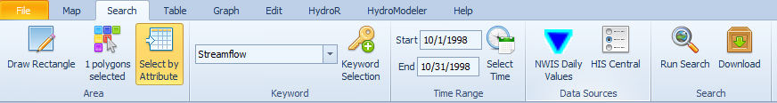

Figure 6 The Search tab displays your search criteria as you enter them

1. In the **Search** panel, click the **Run Search** button.

As HydroDesktop queries HIS Central for locations of time series that match your search criteria, a progress dialog is shown.

1. Once the search has completed, click to **Hide** the progress dialog.

Locations of time series that match your search criteria are shown as points in the map, with the points symbolized according to data source (only NWIS Daily Values in this exercise). Remember that you haven’t downloaded and time series yet. You are just viewing locations of time series that you might be interested in.

You’ll now try out a couple of ways of selecting and downloading time series from the search results.

1. Hover your mouse over a site in the map to see pop-up with more details about the location.

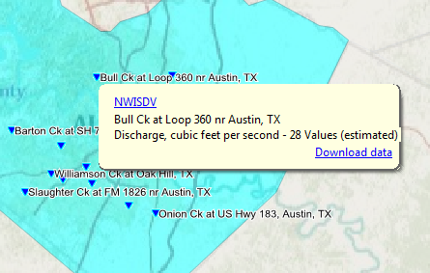

Figure 7 Pop-up windows provide a quick look at search results

1. In the pop-up window, click the **Download data** button to download the time series.

As HydroDesktop downloads time series, it displays a Download Manager to track progress. If any errors occur during the download, you can click to view the error details or attempt to re-download the series. You can also copy the error log so that you can post it to the HydroDesktop issue tracker, thereby alerting the development team to potential issues with the system.

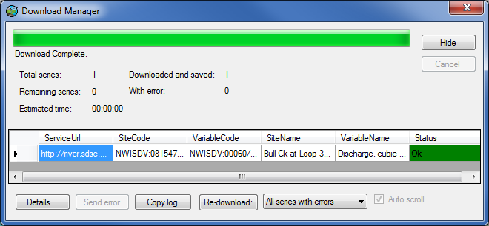

Figure 8 Download Manager

1. When the download completes, click to **Hide** the Download Manager.

If you want to download multiple time series, it’s easier to select them and download them all at once.

1. In the **Legend**, click the **NWIS Daily Values** layer to select it.
2. In the **Map** tab, in the **Map Tool** panel, click the **Select** tool to activate it.
3. In the map, click to draw a box around some sites of interest.

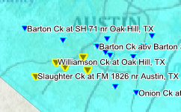

Figure 9 Selected sites are highlighted in the map

1. In the **Search** tab, in the **Search** panel, click the **Download** button. Hide the dialog once it has finished.

Now that you have downloaded time series data, you can visualize, analyze, and export the data.

## Viewing Downloaded Time Series

Let’s have a look at the downloaded data in tabular and graph form.

1. In the Ribbon, click the **Table** tab.
2. In the time series selector on the left, place a check next to a time series to see the time series values in a table.

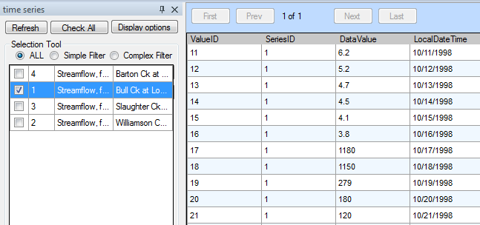

Figure 10 Table View

You can experiment with showing all fields in sequence or just values in parallel, to give you different views on the tabular data. You can also check additional boxes to show more than one time series at a time. However, for this walkthrough, let’s go ahead and plot a graph.

1. In the Ribbon, click the **Graph** tab.
2. Place a check next to more than one time series to show that multiple time series can be displayed in the same graph.

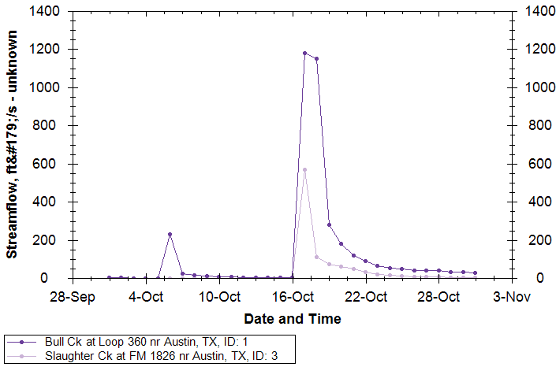

Figure 11 Graph of Streamflow for Multiple Sites

1. Click on other plot types such as Probability and Histogram to see what they look like.

As you explore time series in HydroDesktop, you may find data that you want to export for use in other programs. In the next section, you’ll export all of the data to a text file.

## Exporting Data to a Text File

There are several ways in which you can export data from HydroDesktop. In this part of the walkthrough, you will export all time series to a text file using the Data Export tool.

1. In the Ribbon, click the **Table** tab.
2. In the **Data Export** panel, click **Export**.

This tool exports all data in a theme to a delimited text file. This makes it easy for other programs to import data that you acquired using HydroDesktop. Notice how HydroDesktop automatically grouped your time series data into a theme called NWIS Daily Values.

Peruse the options if you like, but we’ll use the defaults in this walkthrough.

1. Click **Browse** to tell HydroDesktop where to save the output. Choose a location and filename on your computer and click **Save**.
2. Click **Export Data**.

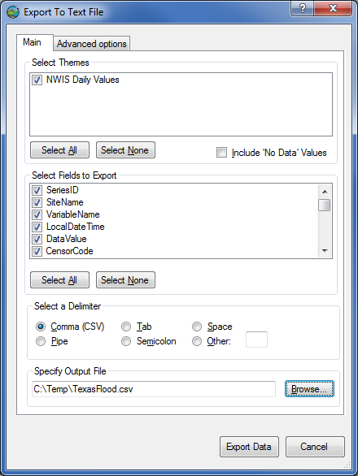

Figure 12 Export To Text File dialog

1. When the tool has finished, navigate to the file on disk and open it to view the result.

# Summary

In this walkthrough, you learned how to install and run HydroDesktop to search for time series data of a particular variable in a particular region of interest. You’ve seen how to visualize the result and export the data for use in other programs.

Now that you have a basic understanding of how HydroDesktop works, we encourage you to explore the other tools that HydroDesktop has to offer, and to take advantage of all the wonderful hydrologic data now available to describe our water environment!