HydroDesktop Workshop

1st MapWindow User Conference

Orlando, 2nd April 2010





Table of Contents

Introduction 3

Scope of the Workshop 3

Part 1 - Getting started with HydroDesktop 5

1. Download and Install HydroDesktop 5

Step 1.1 Install HydroDesktop – Select the language 5

Step 1.2 Install HydroDesktop – Setup 5

Step 1.3 Install HydroDesktop – Installation Location Folder 6

Step 1.4 Install HydroDesktop – Start Menu Folder 6

Step 1.5 Install HydroDesktop – Create Desktop Icon 7

Step 1.6 Review Installation Settings 7

Step 1.7 Installation Progress 8

Step 1.7 Installation Complete 8

1. Search and download Air Temperature Data 11

2. Search and download Streamflow Data 12

3. Create Graph and Statistical Summary 12

4. Export Data from Table 12

5. Export Data Theme to Shapefile 12

Part 2 – Create a HydroDesktop Plugin 12

1. Setup a Visual Studio Project 12

2. Add References 12

3. Implement the IMapPlugin Interface 12

4. Add a Menu Item 12

5. Add a Toolbar button 12

6. Launch a new Form 12

7. Read Data from HydroDesktop Database 12

8. Select all DataSeries by Variable 12

9. Create Summary Table 12

10. Create a Feature Set with data values 12

11. Modify the Symbology 12

12. Add Labels 12

13. Interpolate a Continuous Raster Map 12

14. Change the Raster Symbology 12

# Introduction

HydroDesktop is a free computer program for accessing streamflow, atmosphere, water quantity and water quality data from the CUAHSI hydrological data services. The CUAHSI (Consortium of universities for advanced hydrological science) is a group of organizations with a common goal: To advance the understanding of the global water cycle at all levels. In order to improve the availability of hydrological information, members of the CUAHSI group have created a special format called *WaterML*. WaterML is a standardized XML document format for sharing hydrological information on the Internet. The WaterML standard specification allows for a very detailed description of various types of hydrological datasets from simple water stage measurements to complex water chemistry analytical laboratory samples. WaterML can be easily understood by hydrologists as well as computer programs.

Currently there are more than 100 Internet servers (*HydroServers*) which provide free hydrological data in the WaterML format. Most of the HydroServers are located within the USA . In addition, the NCDC / NOAA server provides hourly meteorological data from professional stations from nearly all countries of the world. Other servers include the U.S national agencies (USGS, EPA), international organizations (NOAA), universities and environmental research groups.

HydroDesktop includes built-in tools for creating graphs, customized hydrological maps and data export. It also includes advanced tools for time series forecasting and geospatial data analysis. An important feature of HydroDesktop is extensibility. Hydrologists and any other users can add new customized functionality by creating a plug-in in VB.NET or C#. The entire source code is freely available on the HydroDesktop website. Internally HydroDesktop uses the MapWindow 6 map components – the newest version of the MapWindow GIS open source library. This makes all advanced geospatial data processing algorithms of the MapWindow 6 library accessible for HydroDesktop plugin programmers.

**TODO: add a HydroDesktop Overview Schema**

# Scope of the Workshop

This workshop has two main parts. In the first part we will explain how to use HydroDesktop to search, download and analyze hydrological data from your area of interest. In the second part we will demonstrate how to create your own HydroDesktop plugin. After this workshop, you will be able to:

* Search for available hydrological data in your area
* Download the data using HydroDesktop
* Create a customized hydrological map
* Create graphs and table summaries of the data
* Extend HydroDesktop functionality by creating a plug-in
* Programatically access data from the HydroDesktop database
* Create a dynamic interactive hydrological map using a HydroDesktop plug-in
* Use the MapWindow Geoprocessing tools for data interpolation

For more information about HydroDesktop, visit the official website [www.hydrodesktop.org](http://www.hydrodesktop.org) where you can find the latest official release, documentation, user discussion forum and feature requests. Other useful links are listed in the table below.

**Useful Resources and Links**

|  |  |  |
| --- | --- | --- |
| Link Name | Website | Description |
| HydroDesktop | www.hydrodesktop.org | The official HydroDesktop Website |
| CUAHSI Hydrological Information System | http://his.cuahsi.org | The CUAHSI Hydrological Information System. Includes detailed information about the WaterML document format. |
| HIS Central Metadata Catalog | http://hiscentral.cuahsi.org | The central registry of publicly accessible HydroServers |
| HydroSeek | www.hydroseek.net | Interactive Web map server for searching and downloading hydrological data |
| MapWindow 6 Open Source GIS | http://mapwindow.codeplex.com | The MapWindow 6 Open Source GIS mapping components |

# Part 1 - Getting started with HydroDesktop

## Download and Install HydroDesktop

HydroDesktop is included on the Workshop Flash Disk and CDs. To install HydroDesktop, go to folder HydroDesktop/Setup and double-click the file **HydroDesktopSetup.exe**

### Step 1.1 Install HydroDesktop – Select the language

The first screen of the setup allows to select the installation language. Please select your preferred language.

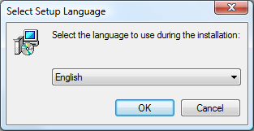

Figure Installation - Select Language

### Step 1.2 Install HydroDesktop – Setup

The second screen of the setup is displayed. It is recommended to close other programs such as Internet Explorer before continuing the setup.

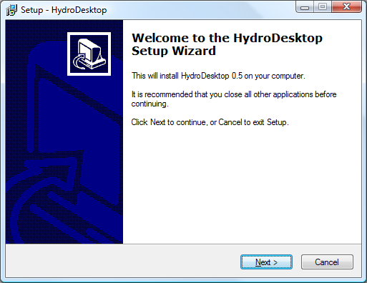

Figure HydroDesktop Setup Initial Window - Choose "Next"

### Step 1.3 Install HydroDesktop – Installation Location Folder

In the next step you can specify the installation location folder. By default, HydroDesktop will be installed in the folder: Program Files\CUAHSI HIS\HydroDesktop. Click next to confirm the location.

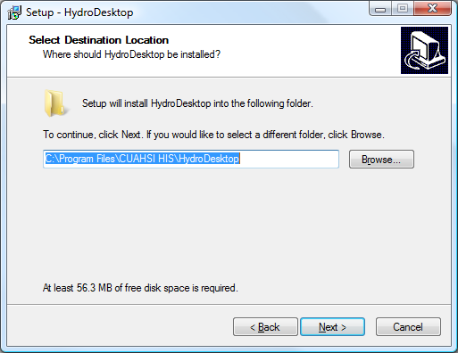

Figure Default Installation Location - Confirm the location and choose "Next"

### Step 1.4 Install HydroDesktop – Start Menu Folder

The fourth step allows to specify the start menu folder. By default, HydroDesktop will be accessible in the “CUAHSI HIS” folder in the Start / All Programs computer menu.

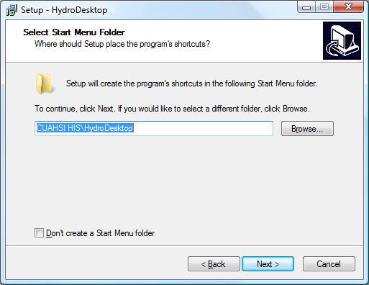

Figure Start Menu Folder - Confirm the name and choose "Next"

### Step 1.5 Install HydroDesktop – Create Desktop Icon

If the “Create Desktop Icon” is selected, the “HydroDesktop” program launching icon will be displayed on the desktop. Click “Next”.

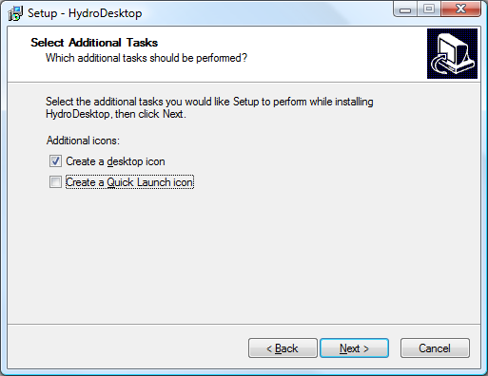

Figure Create Desktop Icon - Choose "Next"

### Step 1.6 Review Installation Settings

The Ready to Install window is shown. Review the installation settings and click Install to begin the installation of HydroDesktop.

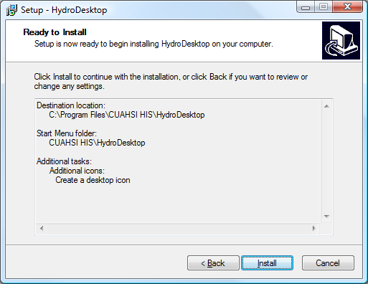

Figure Confirm the Installation and click "Install"

### Step 1.7 Installation Progress

The Installation progress window is shown.

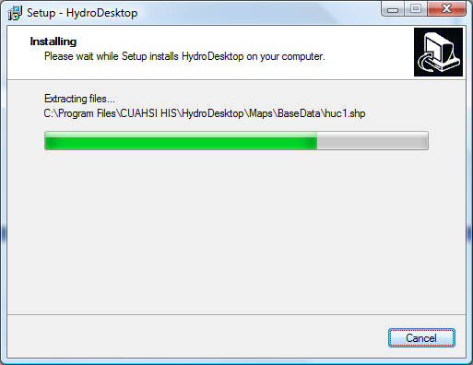

Figure The Installation Progress

### Step 1.7 Installation Complete

Once installation is finished, the Installation Complete screen is shown. Click Finish to automatically launch HydroDesktop. The HydroDesktop program can also be started by:

1. Double – click the HydroDesktop icon on the computer desktop
2. Select Start – All Programs – CUAHSI HIS - HydroDesktop

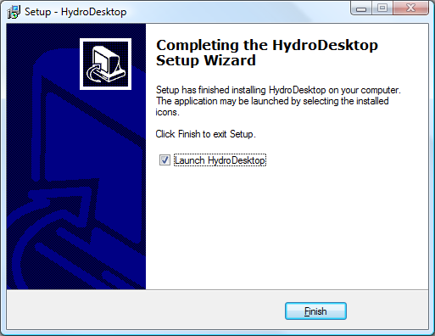

Figure Installation Finished - Click "Finish" to launch HydroDesktop

## HydroDesktop Interface

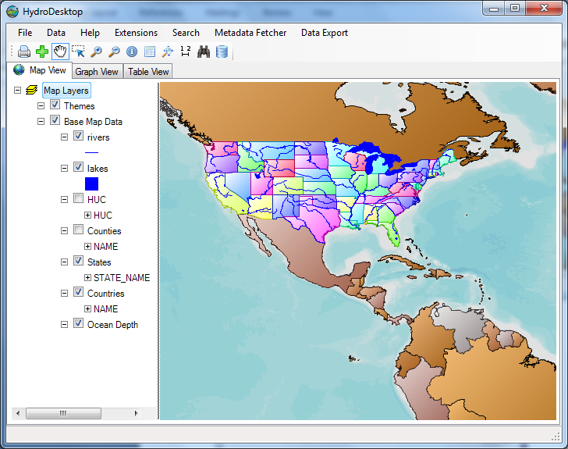

## Search and Download Data

The key function of HydroDesktop is search and download of hydrological data from various servers. The search has and download has following steps:

1. Select the Search Method (HIS Central or Metadata Cache)
2. Select the Region (draw rectangle, select polygon, select state, select county, select watershed)
3. Select the keywords
4. Select the date and time range
5. Select the Web services
6. Run Search
7. Select the series for download
8. Download Data

The steps 3, 4 and 5 are optional – you can skip these steps during the search.

In the following example, search and download the air temperature data for year 2010 for the state of Florida.

*Note: Instead of Florida, you can choose a different region, for example your own country.*

To launch the Search, go to the main menu and Select Search – Search and Download Data.

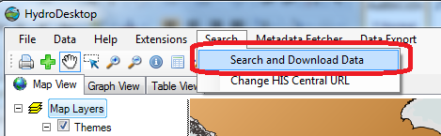

Figure Start the Search and Download

### Step 3.1 Select the Search Options

In the first step, the Search options are selected. Select the search option and click Next to continue the search. HydroDesktop supports two options:

* **Search in HIS Central**

When using this option, HydroDesktop will connect to a special HIS Central server. HIS Central stores detailed information about sites and variables from multiple organizations and HydroServers . This option is recommended to use for searching data from large organizations (NCDC, USGS, EPA). Because of the large number of registered sites, the search may take more time for very large regions. Therefore it is recommended to limit the region size to one country or one U.S state.

* **Search in Local Metadata Cache**

When using this option, HydroDesktop searches for available sites and variables in the local Metadata Cache. Before using this option, you need to register the organization’s hydroServer URL using the HydroDesktop Metadata Fetcher plug-in. This option is recommended to use for smaller organizations such as universities and experimental watersheds. This option is faster than using “Search in HIS Central”.

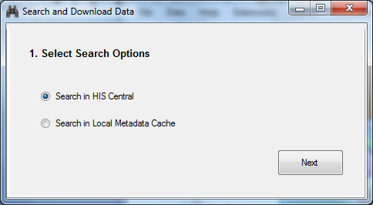

Figure Select the Search Options – Click Next to continue the Search

### Step 3.2 Select the Region

In the second step of the search the region is selected. You can select the region using 5 different methods:

* Draw Rectangle
* Select Polygon
* Select State
* Select County
* Select HUC

**Selecting a US State**

Click the Select State button. A new window is shown. In the new window type in the state name “Florida” and click OK. The map view will display the “Florida” state and the information about latitude / longitude bounding box will be updated.

***Alternative Option: Selecting a Country***

To select a country instead of a U.S state, press the “select polygons” button. In the legend, click on the **Countries** layer. After the Countries layer is highlighted in the legend, click with the mouse on the country in the map. The country is selected and highlighted in the map.

**Confirm the Selection**

After selecting the State or Country, click the button **More Options** to proceed to the next search step.

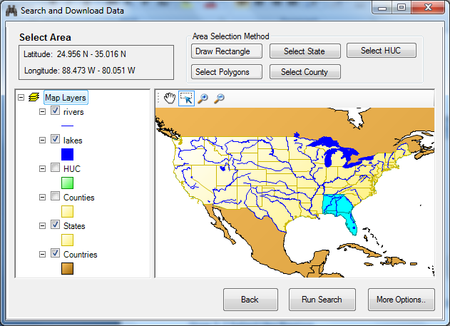

Figure Search - Select the Area

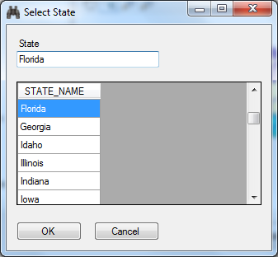

Figure Search - Select the State

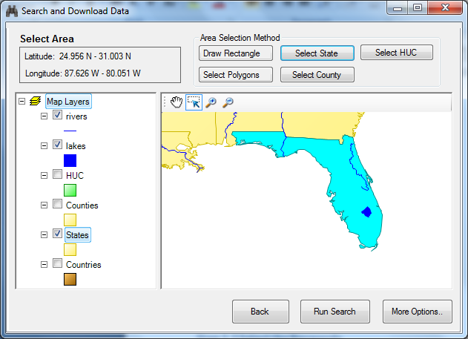

Figure The Selected State

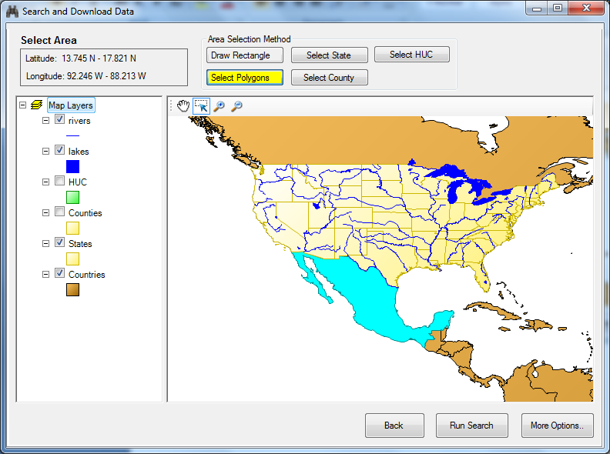

Figure Alternative Search Option - Select Country using the "Select Polygons" option

### Step 3.3 Select the Keywords

In the third step the search keywords are selected. In the keyword text box, type in the keyword “Air Temperature”. This highlights the keyword in the keyword list on the left. Then click the “Add” arrow button to include Air temperature in the list of selected keywords. Click **More Options** to confirm the selection.

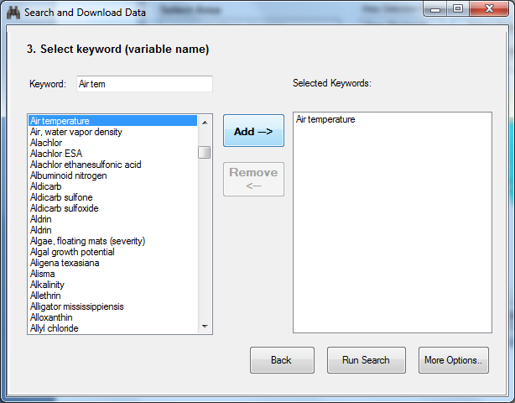

### Step 3.4 Select the Time Range

In the fourth step of the search, select the date range. By default the date range is set to the previous year. In this search example, change the Start Date to January 01, 2010. The date can be changed by typing in the day and year or by selecting in the calendar. Click More Options to confirm the selection and continue the search.

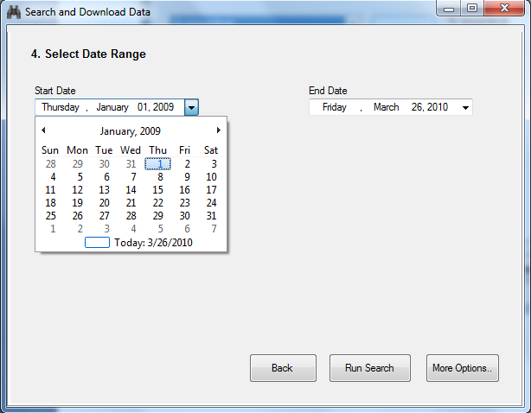

Figure Select Date Range

### Step 3.5 Select Web Services

In the fifth step of the search the web services are selected . The web service is the server of the organization that provides hydrological data. You can choose one or more web services. In this example, click on the row with title **NCDC hourly Data**. Then click Run Search to continue the search.

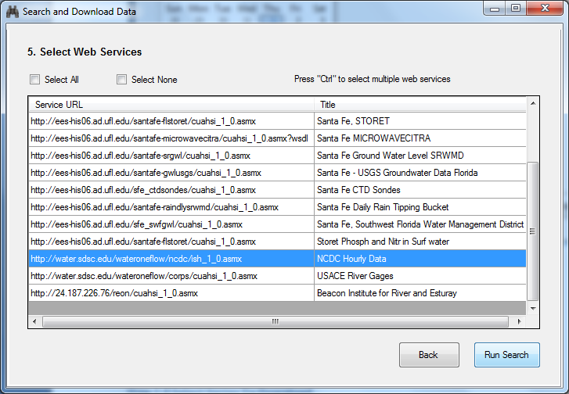

Figure Select the Web Services

### Step 3.6 Run Search

The search summary with selected options is shown. Click Run Search again to start the search.

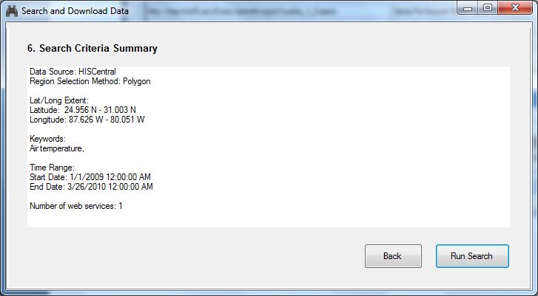

Figure Search Criteria Summary

The search progress is shown. During the search, HydroDesktop sends multiple queries to the HIS Central server to find out about available sites with Air Temperature in the region. This might take a minute or two. After the search is complete, The message “Search Complete” is shown. Click OK to view search results.

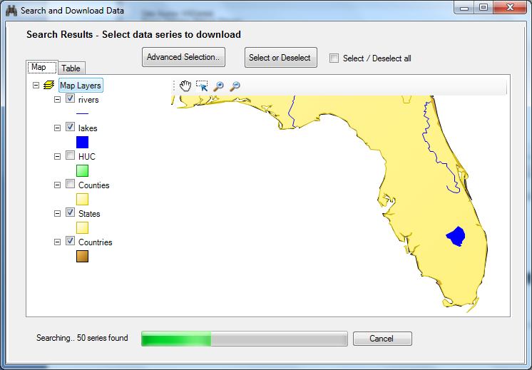

Figure Search Progress

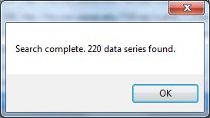

Figure Search is Complete

### Step 3.7 Select Data Series to Download

The search results are shown in a new map. Each site has the organization logo. In this case, all sites belong to the National Climatic Data Center (NCDC) organization. To speed up the data download, you can select a subset of the sites on the map or in the table.

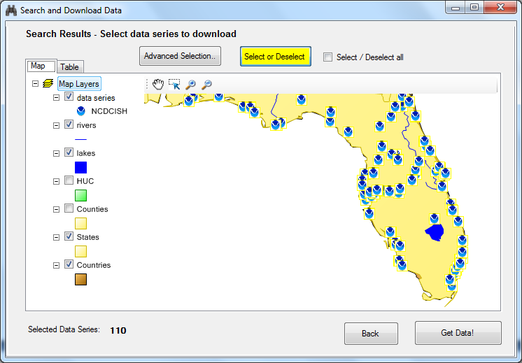

Figure Select Sites to Download in the Map

To view detailed information about found sites, click the “Table” tab. In the table you can select multiple rows by holding the “Ctrl” button and clicking the rows. You can change the order of columns by clicking on the column header. Make sure that only rows with VariableName equal to AIR-TEMPERATURE Observation Air Temperature are selected. The number of selected series will be 110. The selected sites will also be highlighted in the map. When selection is complete, click the “Get Data” button.

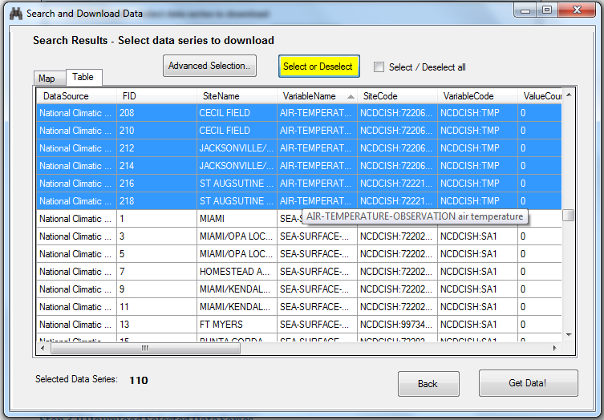

Figure Select Sites using the Table

### Step 3.8 Set the Data Theme

The next screen is shown. Here you can specify the “Theme name”. The theme name is the text that will appear in the map legend after the data is downloaded.

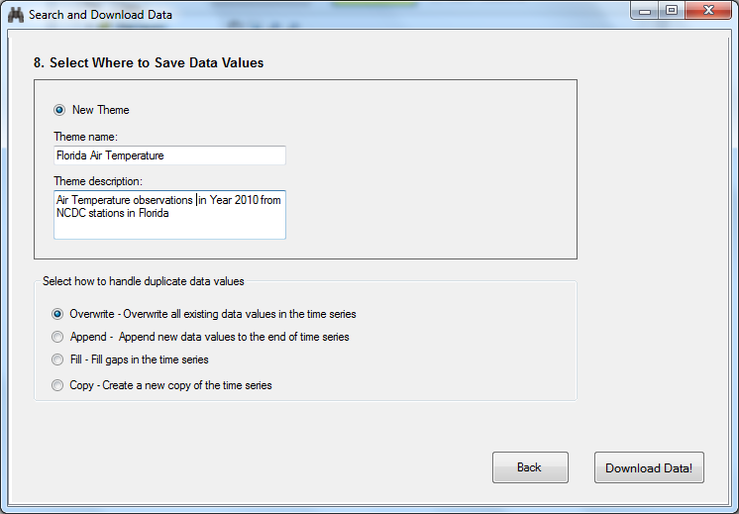

Figure Choose the Theme Name

### Step 3.9 Download Selected Data Series

The download progress is shown in the progress bar. This may take several minutes. After the download is complete, Click OK to view downloaded sites in the map and click Close to close the progress window.

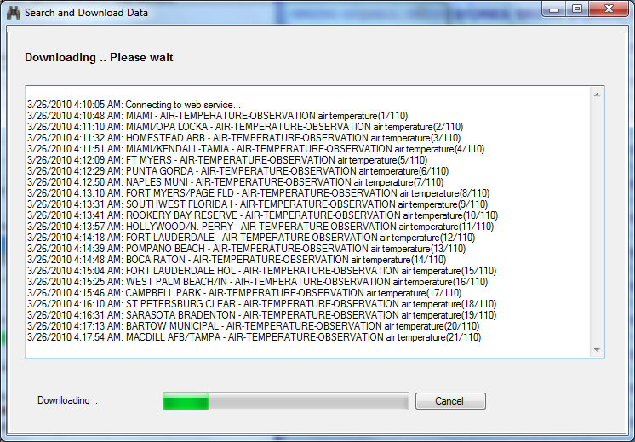

Figure Download Progress

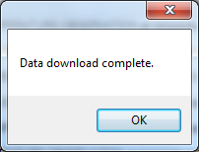

Figure Download is Complete

### Step 3.10 View Downloaded Sites and Variables in the Map

The Downloaded data series are now shown in the map in the Themes group. You can see a new theme “Florida Air Temperature”. To get more information about each site, right – click on the theme name and choose “View Attributes”

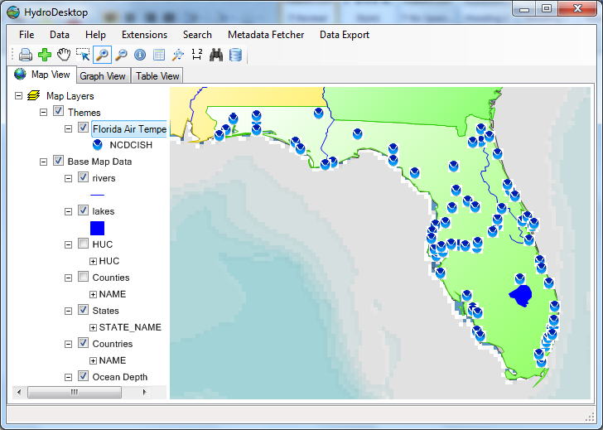

Figure View Downloaded Data Series in the Map

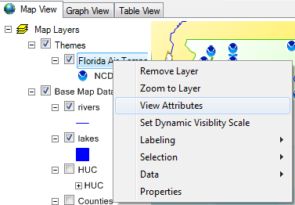

Figure View The Attribute Table menu

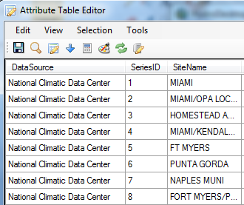

Figure Table of Downloaded Data Series

## Create Graph and Statistical Summary using the Graph View

### Step 4.1 Display Multiple Graphs

### Step 4.2 Change the Date Range of the Graph

### Step 4.3 View Detailed Series Properties

## View Data Values in the Table View

## Export Data To Text File

### Step 6.1 Use the DataExport Plugin to Export Theme to Text File

## Export Data Theme to Shapefile

### Step 7.1 Right-click in the legend and choose Export Data

# Part 2 – Create a HydroDesktop Plugin

## Setup a Visual Studio Project

## Add References

## Implement the IMapPlugin Interface

## Add a Menu Item

## Add a Toolbar button

## Launch a new Form

## Read Data from HydroDesktop Database

## Select all DataSeries by Variable

## Create Summary Table

## Create a Feature Set with data values

## Modify the Symbology

## Add Labels

## Interpolate a Continuous Raster Map

## Change the Raster Symbology

# Appendix 1– Download HydroDesktop from [www.hydrodesktop.org](http://www.hydrodesktop.org)

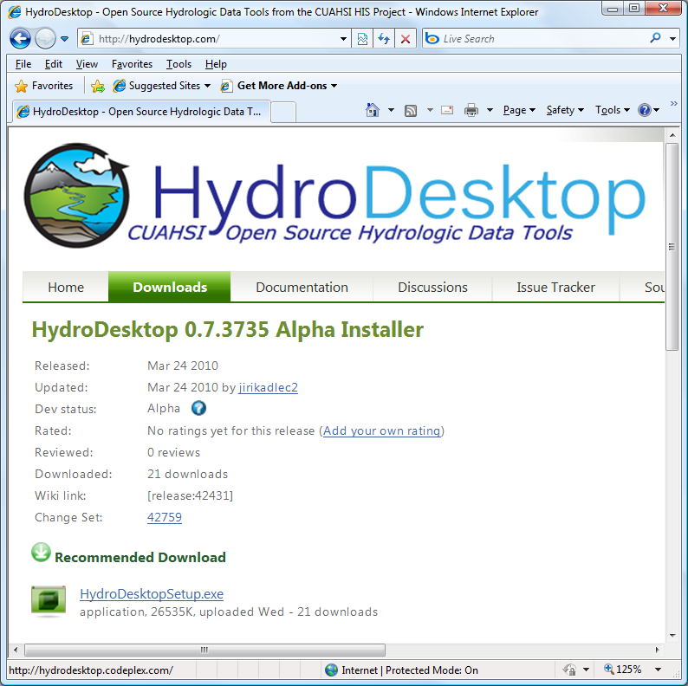

Figure The HydroDesktop Download Website

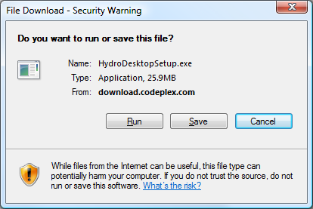

Figure File Download Warning - Select "Save"

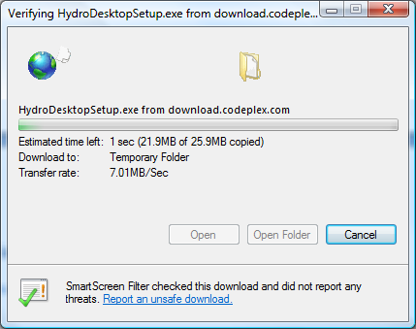

Figure File Download Progress - Select "Open Folder" and double-click HydroDesktopSetup.exe

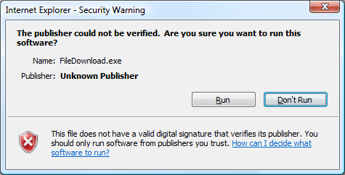

Figure Run the Installation Setup File - Click "Run"

# Appendix 2 - Setup the HydroDesktop Database

