HydroDesktop Workshop

1st MapWindow User Conference

Orlando, 2nd April 2010





Table of Contents

HydroDesktop Workshop 1

Introduction 3

Scope of the Workshop 4

Part 1 - Getting started with HydroDesktop 5

1. Download and Install HydroDesktop 5

Step 1.1 Install HydroDesktop – Select the language 5

Step 1.2 Install HydroDesktop – Setup 6

Step 1.3 Install HydroDesktop – Installation Location Folder 6

Step 1.4 Install HydroDesktop – Start Menu Folder 7

Step 1.5 Install HydroDesktop – Create Desktop Icon 7

Step 1.6 Review Installation Settings 8

Step 1.7 Installation Progress 8

Step 1.7 Installation Complete 9

1. HydroDesktop Interface 10

2. Search and Download Data 10

Step 3.1 Select the Search Options 11

Step 3.2 Select the Region 12

Step 3.3 Select the Keywords 15

Step 3.4 Select the Date Range 15

Step 3.5 Select Web Services 16

Step 3.6 Run Search 16

Step 3.7 Select Data Series to Download 18

Step 3.8 Set the Data Theme 19

Step 3.9 Download Selected Data Series 20

Step 3.10 View Downloaded Sites and Variables in the Map 21

3. Create Graph and Statistical Summary using the Graph View 23

Step 4.1 Display Multiple Graphs 23

Step 4.1 Display Multiple Graphs 24

Step 4.2 Change the Date Range of the Graph 25

Step 4.3 View Detailed Series Properties 25

4. View Data Values in the Table View 27

5. Export Data To Text File 28

Step 6.1 Use the DataExport Plugin to Export Theme to Text File 28

6. Export Data Theme to Shapefile 32

Step 7.1 Right-click in the legend and choose Export Data 32

Step 4.2 Change the Date Range of the Graph 34

Step 4.3 View Detailed Series Properties 34

7. View Data Values in the Table View 34

8. Export Data To Text File 34

Step 6.1 Use the DataExport Plugin to Export Theme to Text File 34

9. Export Data Theme to Shapefile 34

Step 7.1 Right-click in the legend and choose Export Data 34

Part 2 – Create a HydroDesktop Plugin 35

1. Set up a Visual Studio Project 35

2. Add References 36

3. Change the Build Output Path 37

4. Add MapWindow Controls to Visual Studio Toolbox 37

5. Define the Assembly Attribute 38

6. Implement the IMapPlugin Interface 39

7. Test the plugin 41

8. Add a Menu Item 42

9. Launch a new Form 43

10. Get the list of available Variables 44

11. Read DataValues From the Database 45

12. Create a Feature Set with data values 45

13. Add Labels 46

Appendix 1– Download HydroDesktop from www.hydrodesktop.org 48

Appendix 2 - Setup the HydroDesktop Database 50

# 

# Introduction

HydroDesktop is a free computer program for accessing streamflow, atmosphere, water quantity and water quality data from the CUAHSI hydrological data services. The CUAHSI (Consortium of universities for advanced hydrological science) is a group of organizations with a common goal: To advance the understanding of the global water cycle at all levels. In order to improve the availability of hydrological information, members of the CUAHSI group have created a special format called *WaterML*. WaterML is a standardized XML document format for sharing hydrological information on the Internet. The WaterML specification allows for a very detailed description of various types of hydrological datasets from simple water stage measurements to complex water chemistry analytical laboratory samples. WaterML can be easily understood by both hydrologists and computer programs.

Currently there are more than 100 Internet servers (*HydroServers*) which provide free hydrological data in the WaterML format. Most of the HydroServers are located within the USA . In addition, the National Climatic Data Center (NCDC) server provides hourly meteorological data from professional stations from nearly all countries of the world. Other servers include the U.S national agencies (USGS, EPA), international organizations (NOAA), universities, experimental watersheds and environmental research groups.

HydroDesktop includes built-in tools for creating graphs, customized hydrological maps and data export. It also includes advanced tools for time series forecasting and geospatial data analysis. An important feature of HydroDesktop is extensibility. Hydrologists and any other users can add new customized functionality by creating a plug-in in VB.NET or C#. The entire source code is freely available on the HydroDesktop website. Internally HydroDesktop uses the MapWindow 6 map components – the newest version of the MapWindow GIS open source library. This makes all advanced geospatial data processing algorithms of the MapWindow 6 library accessible for HydroDesktop plugin programmers.

# Scope of the Workshop

This workshop has two main parts. In the first part we will explain how to use HydroDesktop to search, download and analyze hydrological data from your area of interest. In the second part we will demonstrate how to create your own HydroDesktop plugin. After this workshop, you will be able to:

* Search for available meteorological and hydrological data in your area
* Download the data using HydroDesktop
* Create a customized hydrological map of your area
* Extend HydroDesktop functionality by creating a plug-in

For more information about HydroDesktop, visit the official website [www.hydrodesktop.org](http://www.hydrodesktop.org) where you can find the latest official release, documentation, user discussion forum and feature requests. Other useful links are listed in the table below.

**Useful Resources and Links**

|  |  |  |
| --- | --- | --- |
| Link Name | Website | Description |
| HydroDesktop | www.hydrodesktop.org | The official HydroDesktop Website |
| CUAHSI Hydrological Information System | http://his.cuahsi.org | The CUAHSI Hydrological Information System. Includes detailed information about the WaterML document format. |
| HIS Central Metadata Catalog | http://hiscentral.cuahsi.org | The central registry of publicly accessible HydroServers |
| HydroSeek | www.hydroseek.net | Internet map server for searching and downloading hydrological data |
| MapWindow 6 Open Source GIS | http://mapwindow.codeplex.com | The MapWindow 6 Open Source GIS mapping components |

# Part 1 - Getting started with HydroDesktop

## Download and Install HydroDesktop

HydroDesktop is included on the Workshop Flash Disk and CDs. To install HydroDesktop, go to folder HydroDesktop/Setup and double-click the file **HydroDesktopSetup.exe.** A series of installation screens (Select Setup Language, Select start menu folder, Create Desktop Icon) will be shown. You can use the default options and click Next on each screen.

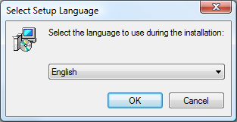

Figure Initial Installation Screen

Once installation is finished, the Installation Complete screen is shown. Click Finish to automatically launch HydroDesktop. The HydroDesktop program can also be started by:

1. Double – click the HydroDesktop icon on the computer desktop
2. Select Start – All Programs – CUAHSI HIS - HydroDesktop

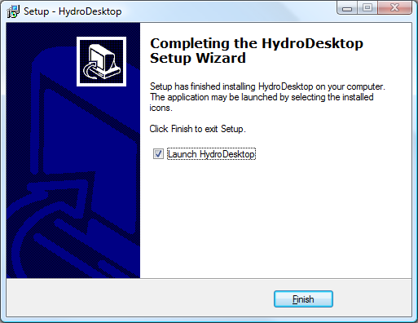

Figure Installation Finished - Click "Finish" to launch HydroDesktop

## Starting HydroDesktop

The main part of the HydroDesktop interface is the map. By default, the map contains simple base data (countries of the world, U.S states, major rivers and lakes, watersheds). The other parts are the Graph View and Table view menu. By default the map view does not contain any site with hydrological time series data. These sites can be added to the map in two possible ways:

* Search and Download Data
* Open an existing HydroDesktop database with downloaded data. This option is explained in Appendix 2.

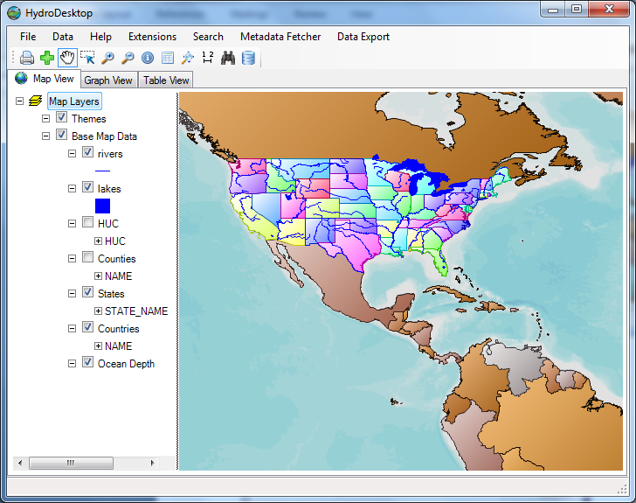

## Search and Download Data

The key function of HydroDesktop is search and download of hydrological data from various servers. The search has and download has following steps:

1. Select the Search Method (HIS Central or Metadata Cache)
2. Select the Region (draw rectangle, select polygon, select state, select county, select watershed)
3. Select the keywords
4. Select the date and time range
5. Select the Web services
6. Run Search
7. Select the series for download
8. Download Data

The steps 3, 4 and 5 are optional – you can skip these steps during the search.

In the following example, search and download the air temperature data for year 2010 for the state of Florida.

*Note: Instead of Florida, you can choose a different region, for example your own country.*

To launch the Search, go to the main menu and Select Search – Search and Download Data.

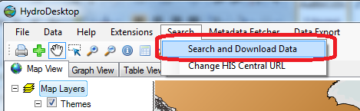

Figure Start the Search and Download

### Step 3.1 Select the Search Options

In the first step, the Search options are selected. Select the search option and click Next to continue the search. HydroDesktop supports two options:

* **Search in HIS Central**

When using this option, HydroDesktop will connect to a special HIS Central server. HIS Central stores detailed information about sites and variables from multiple organizations and HydroServers . This option is recommended to use for searching data from large organizations (NCDC, USGS, EPA). Because of the large number of registered sites, the search may take more time for very large regions. Therefore it is recommended to limit the region size to one country or one U.S state.

* **Search in Local Metadata Cache**

When using this option, HydroDesktop searches for available sites and variables in the local Metadata Cache. Before using this option, you need to register the organization’s hydroServer URL using the HydroDesktop Metadata Fetcher plug-in. This option is recommended to use for smaller organizations such as universities and experimental watersheds. This option is faster than using “Search in HIS Central”.

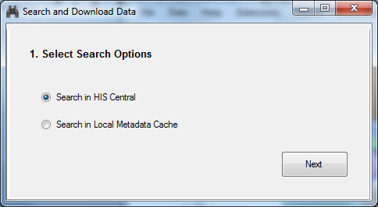

Figure 4 Select the Search Options – Click Next to continue the Search

### Step 3.2 Select the Region

In the second step of the search the region is selected. You can select the region using 5 different methods:

* Draw Rectangle
* Select Polygon
* Select State
* Select County
* Select HUC

**Selecting a US State**

Click the Select State button. A new window is shown. In the new window type in the state name “Florida” and click OK. The map view will display the “Florida” state and the information about latitude / longitude bounding box will be updated.

***Alternative Option: Selecting a Country***

To select a country instead of a U.S state, press the **Select Country** button. A new window is shown. In the new window type name of the country and click OK. The country is selected and highlighted in the map.

**Confirm the Selection**

After selecting the State or Country, click the button **More Options** to proceed to the next search step.

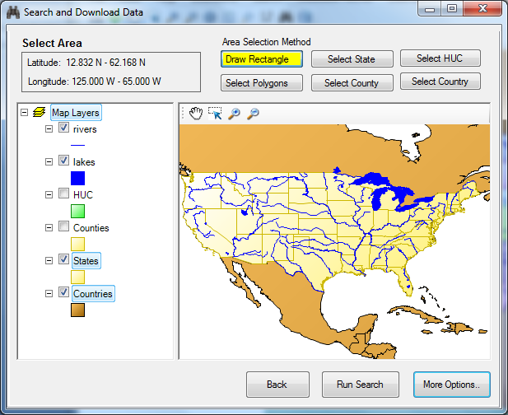

Figure 5 Search - Select the Area

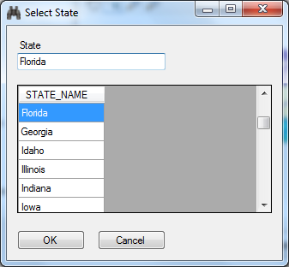

Figure 6 Search - Select the State

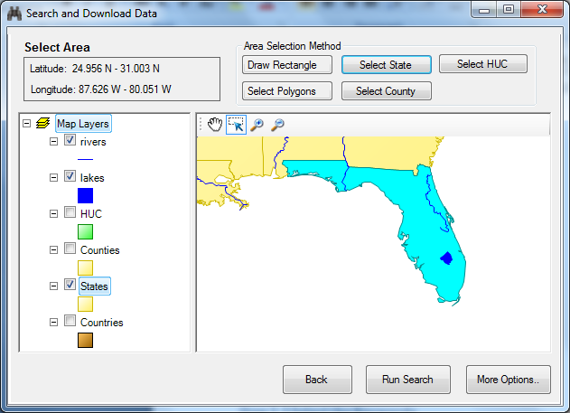

Figure The Selected State

### Step 3.3 Select the Keywords

In the third step the search keywords are selected. In the keyword text box, type in the keyword “Air Temperature”. This highlights the keyword in the keyword list on the left. Then click the “Add” arrow button to include Air temperature in the list of selected keywords. Click **More Options** to confirm the selection.

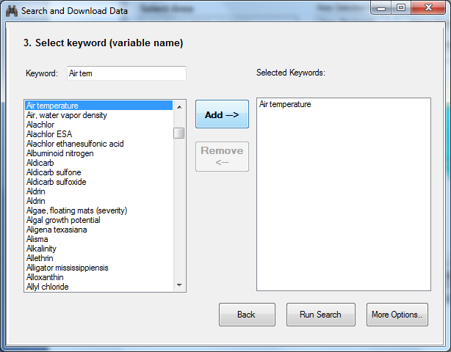

### Step 3.4 Select the Date Range

In the fourth step of the search, select the date range. By default the date range is set to the previous year. In this search example, change the Start Date to January 01, 2010. The date can be changed by typing in the day and year or by selecting in the calendar. Click More Options to confirm the selection and continue the search.

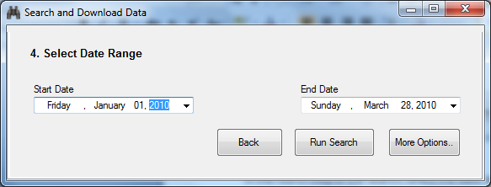

Figure Select Date Range

### Step 3.5 Select Web Services

In the fifth step of the search the web services are selected . The web service is the server of the organization that provides hydrological data. You can choose one or more web services. In this example, click on the row with title **NCDC hourly Data**. Then click Run Search to continue the search.

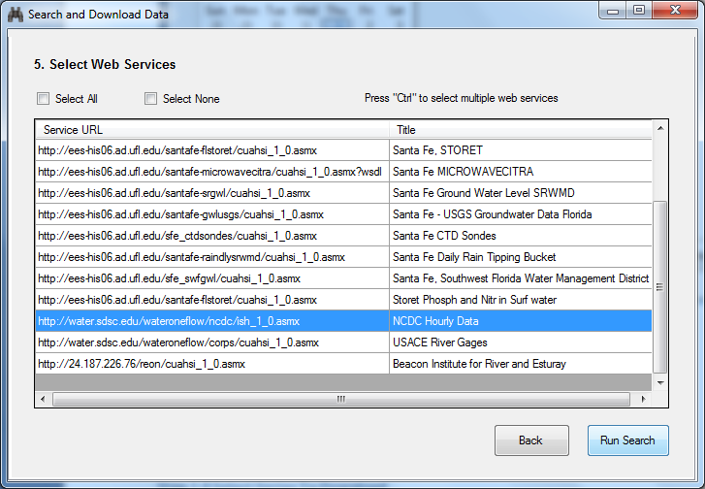

Figure Select the Web Services

### Step 3.6 Run Search

The search summary with selected options is shown. Click Run Search again to start the search.

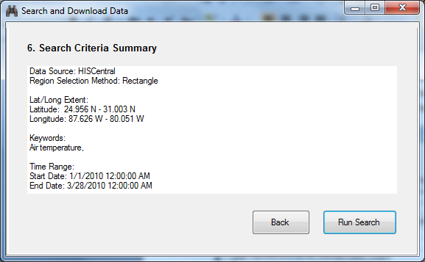

Figure Search Criteria Summary

The search progress is shown. During the search, HydroDesktop sends multiple queries to the HIS Central server to find out about available sites with Air Temperature in the region. This might take a minute or two. After the search is complete, The message “Search Complete” is shown. Click OK to view search results.

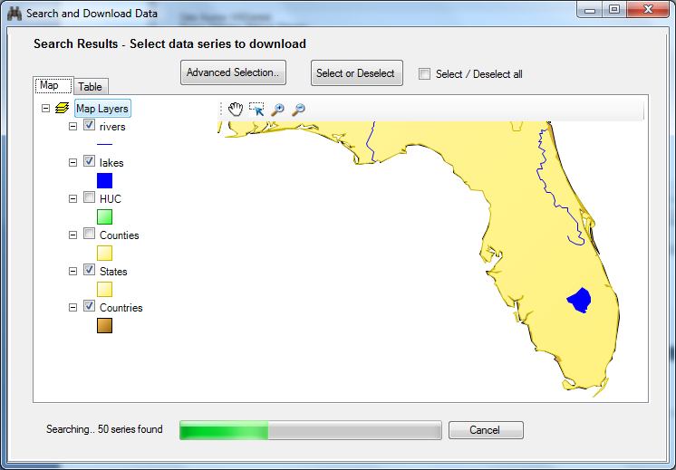

Figure Search Progress

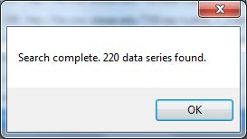

Figure Search is Complete

### Step 3.7 Select Data Series to Download

The search results are shown in a new map. Each site has the organization logo. In this case, all sites belong to the National Climatic Data Center (NCDC) organization. In this step, the time series for download need to be selected. There are four options for selecting the series for download:

1. Check the Select All checkbox
2. Click or drag a rectangle to select sites in the map
3. Select rows in the table. Go to the Table tab and select the rows
4. Advanced selection. Click Advanced Selection to enter a detailed selection query.

For the Florida air temperature, check the Select / Deselect all checkbox. All sites are highlighted in the map. When selection is complete, click the **Get Data** button.

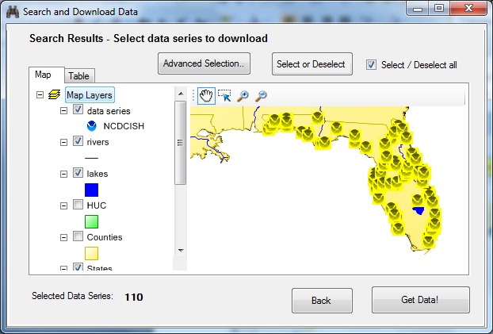

Figure Select Sites to Download in the Map

To view detailed information about found sites, click the “Table” tab. In the table you can select multiple rows by holding the “Ctrl” button and clicking the rows. You can change the order of columns by clicking on the column header. Make sure that only rows with VariableName equal to AIR-TEMPERATURE Observation Air Temperature are selected. The number of selected series will be 110. The selected sites will also be highlighted in the map. When selection is complete, click the “Get Data” button.

### Step 3.8 Set the Data Theme

The next screen is shown. Here you can specify the “Theme name”. The theme name is the text that will appear in the map legend after the data is downloaded.

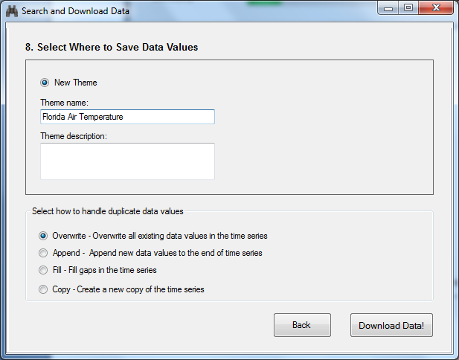

Figure Choose the Theme Name

### Step 3.9 Download Selected Data Series

The download progress is shown in the progress bar. This may take several minutes. After the download is complete, Click OK to view downloaded sites in the map and click Close to close the progress window.

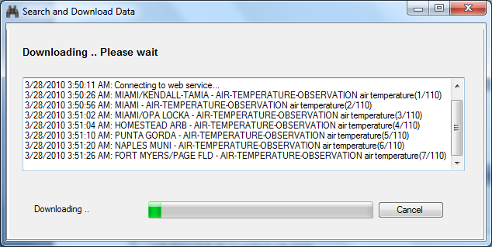

Figure Download Progress

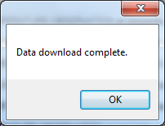

Figure Download is Complete

### Step 3.10 View Downloaded Sites and Variables in the Map

The Downloaded data series are now shown in the map in the Themes group. You can see a new theme “Florida Air Temperature”. To get more information about each site, right – click on the theme name and choose “View Attributes”

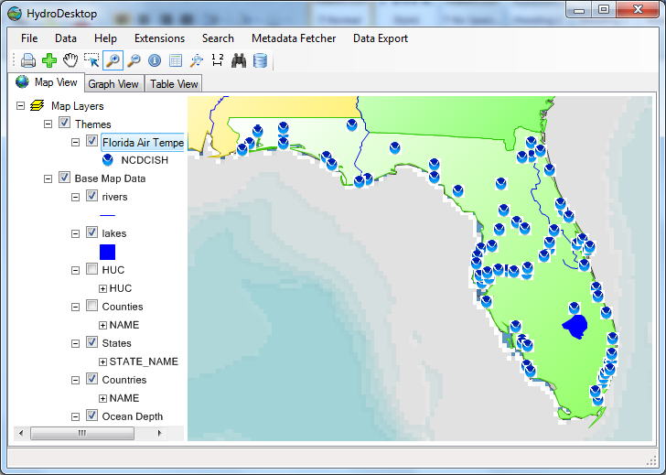

Figure View Downloaded Data Series in the Map

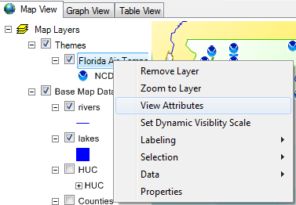

Figure View The Attribute Table menu

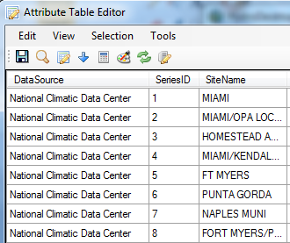

Figure 19 Table of Downloaded Data Series

For each time series, the data source, site name, variable name and other attributes are listed. Sites selected in the map are automatically highlighted in the attribute table.

**Note:**

The attribute table does not contain the actual air temperature values. Each data series consists of multiple data values. To view the actual data values, use the **Table View** and **Graph View**.

## Table View

The Table view displays the downloaded data values in a table by checking the time series variable name and site name in the list of time series in the left panel. The table view has two main options:

* Show All Fields in Sequence
* Show Just Values in Parallel

When the second option is selected, the values of each time series are shown as a separate column.

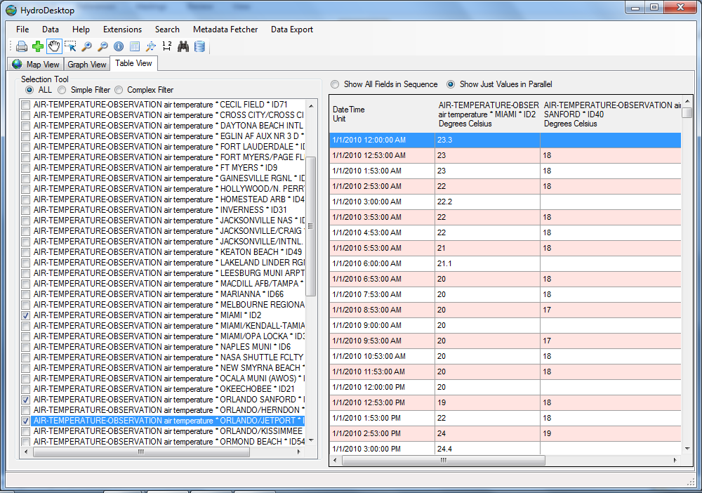

Figure Table View

## Graph View

The graph view can be used to compare multiple time series. To display a time series in the graph view, check the check box in the left hand panel. The color of the time series plot can be changed by right-clicking on the graph and selecting the Change plot color context menu. The date range of the plot can be changed by going to Plot Options, changing the begin date and end date and clicking **Apply Options**.

***Note:*** *To change the date range, the Change to original date range check box needs to be unchecked*.

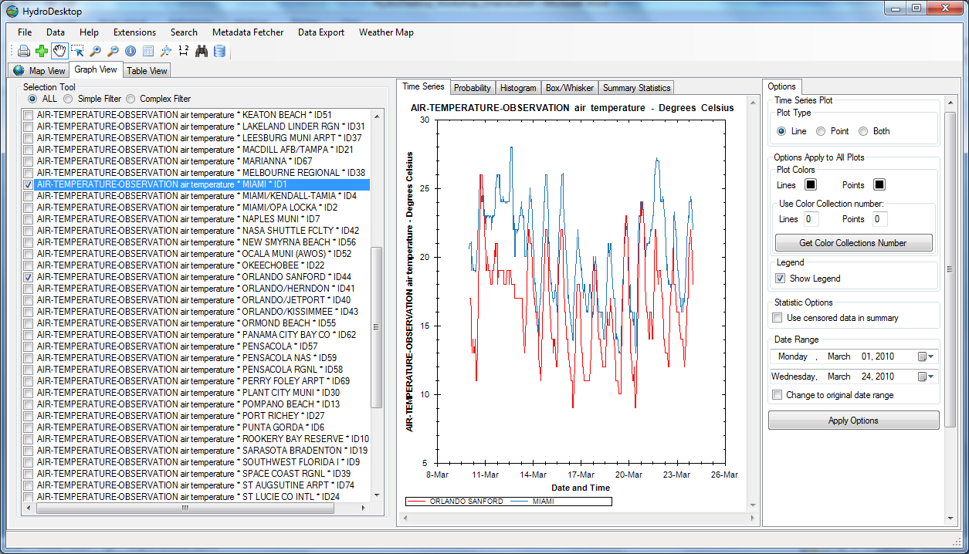

Figure Show multiple time series in the graph view

## Export Data To Text File

The downloaded data can be exported using the Data Export option in the main menu. To export your data, go to Data Export and select the option Export Theme time series to text file. The attributes to export can be selected. Check the fields SiteName, LocalDateTime and DataValue, set the delimiter to comma and choose the output file. Click Export Data to start export. The progress of export is shown. After the export is complete, you can display the exported table in Excel or in a text editor.

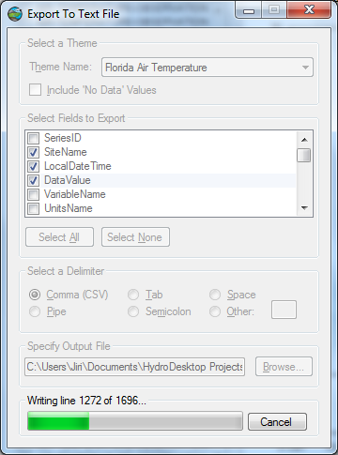

Figure Export Data To Text File

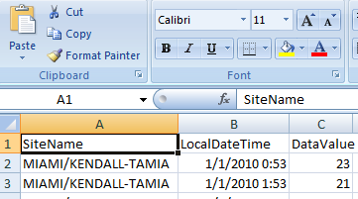

Figure View Exported Data in Excel

# Part 2 – Create a HydroDesktop Plugin

In the previous part of the workshop we demonstrated how to use HydroDesktop to download air temperature data, show graphs and display tables. In the second part of the workshop we will show how to create a customized temperature map by writing a HydroDesktop plugin

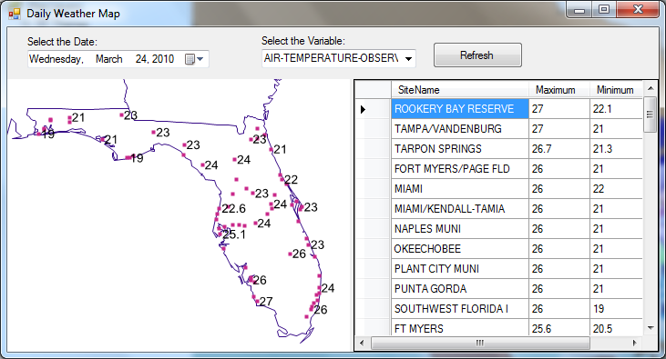

Figure The sample plug-in form

## Set up a Visual Studio Project

Open Visual Studio and start a new ‘Class Library’ project. Go To File – New – Project.. and select Class Library. Set the project’s name to SamplePluginVB and specify the folder where you want the project to be saved.

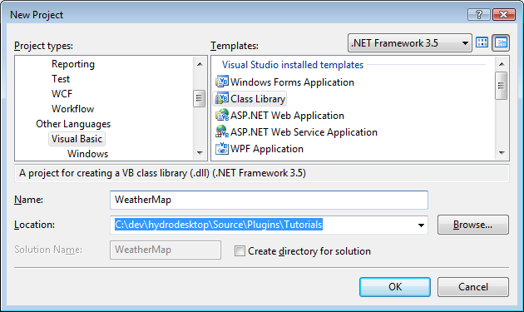

Figure Create a new Visual Basic.NET Class Library Project

## Add References

You will need to add the following reference to your project:

* **MapWindow.dll** This is the main software library that allows you to interact with the map and GIS data.
* **System.Windows.Forms.dll** Required if you want the plug-in to add a custom menu item, toolbar button or display a custom form.
* **HydroDesktop.Data.dll** This is the software library for accessing data in the HydroDesktop database and communicating with hydrological web servers.

To add the reference, go to Solution Explorer, right-click on the project name (WeatherMap) and select *Add Reference* in the context menu. Go to the Browse tab and navigate to the files MapWindow.dll and HydroDesktop.Data.dll. The assemblies are located in the same folder where HydroDesktop is installed (Program Files\CUAHSI HIS\HydroDesktop).

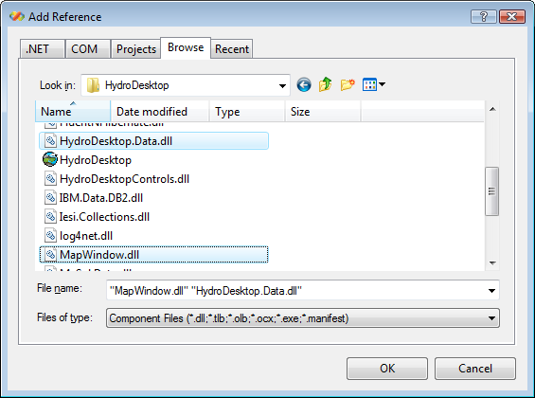

Figure Add a reference to MapWindow.dll in VB.NET

**Important:** After adding the reference, make sure that the **Copy Local** property is set to **False**.

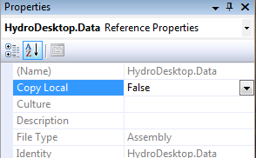

Figure Set Copy Local to false after adding the reference

## Change the Build Output Path

In Project Properties window, go to the Compile tab. Change the Build output path to

**Program Files\CUAHSI HIS\HydroDesktop\Plugins**

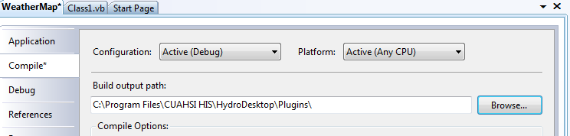

Figure Setting the Build output path for the plug-in

## Add MapWindow Controls to Visual Studio Toolbox

In our plugin we will use a new MapWindow map control. In order to add the control, go to Visual Studio Toolbox. First, select “Add Tab” and type “MapWindow”. Second, select **Choose Items**, select **Browse** .. and go to Program Files\Cuahsi HIS\HydroDesktop\MapWindow.dll. The new MapWindow controls including the map controls will appear in the Visual Studio toolbox.

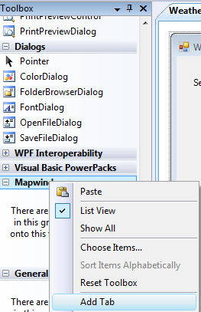

Figure 29 MapWindow Toolbox - Choose Items

## Define the Assembly Attribute

In order to be recognized as a MapWindow plug-in, the assembly needs to have a special MapWindowPluginAssembly attribute in the AssemblyInfo.vb file. To Add the attribute, go to Solution Explorer. Make sure the **Show All Files** option is checked. Go to the My Project subfolder and double click on the **AssemblyInfo.vb** file.

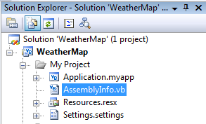

Figure Location of the file AssemblyInfo.vb

At the start of the file add the statements as shown in the code listing below:

Imports MapWindow.Plugins

<Assembly:MapWindowPluginAssembly()>

Imports System

Imports System.Reflection

Imports System.Runtime.InteropServices

Imports MapWindow.Plugins

' General Information about an assembly is controlled through the following

' set of attributes. Change these attribute values to modify the information

' associated with an assembly.

' Review the values of the assembly attributes

<Assembly: MapWindowPluginAssembly()>

<Assembly: AssemblyTitle("WeatherMap")>

<Assembly: AssemblyDescription("")>

## Implement the IMapPlugin Interface

Each HydroDesktop plugin must contain one class which implements the **MapWindow.Plugins.IMapPlugin** interface. In your project, go to Solution Explorer and select Add Class… Rename the class as Main.vb and open its code file.

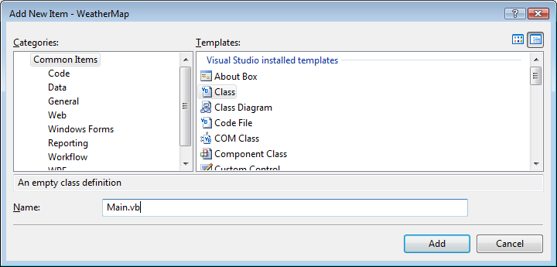

The listing below shows the code of a basic HydroDesktop plugin. The plugin can be detected by HydroDestkop and it appears in the Extensions – Plugins menu of HydroDesktop. Because it is a MapWindow plugin, it can also be used in the MapWindow GIS application.

Imports System.Windows.Forms

Imports MapWindow.Components

Imports MapWindow.Map

Imports MapWindow.Plugins

<MapWindowPlugin("Weather Map", Author:="MyName", UniqueName:="WeatherMap_1_0", Version:="1.0")> _

Public Class Main

Inherits Extension

Implements IMapPlugin

'declare a class variable with a reference to the main Map

Private _mapWin As IMapPluginArgs

'Initialize the plugin and get the map handle

Public Sub Initialize(ByVal args As IMapPluginArgs) Implements IMapPlugin.Initialize

_mapWin = args

MsgBox("The plugin WeatherMap is initialized!")

End Sub

'Dectivate method - occurs when the plugin is unchecked

Public Overloads Sub Deactivate() Implements IMapPlugin.Deactivate

MyBase.Deactivate()

End Sub

'Activate method - just use the base class implementation

Public Overloads Sub Activate() Implements IMapPlugin.Activate

MyBase.Activate()

End Sub

'IsEnabled property - just use the base class implementation

Public Property IsEnabled() As Boolean Implements IMapPlugin.IsEnabled

Get

Return MyBase.IsEnabled

End Get

Set(ByVal value As Boolean)

MyBase.IsEnabled = value

End Set

End Property

End Class

The Main.vb class code has four important parts:

1. **The <MapWindowPlugin> attribute**.

This attribute contains the plugin name, the author name, the plugin unique name, and the plugin version.

1. The **Inherits Extension** and **Implements IMapPlugin** statement.

Each plugin must implement the IMapPlugin interface. By inheriting from the Extension class, we can use the default implementation of some of the IMapPlugin methods.

1. The **Initialize** method.

Sub Initialize(ByVal args As IMapPluginArgs)

The initialize method is executed when the user first selects the plug-in. This is the place where new toolbars, buttons and menu items should be created. The Initialize method has the **args** parameter. This parameter can be used to access the main map and other components of the main application from within the plugin.

1. The **Deactivate** method.

Public Overloads Sub Deactivate()

The Deactivate method is executed when the unselects the plugin in the plugins menu. Any custom toolbars or menu items added by the plugin should be removed in the Deactivate method.

## Test the plugin

To test the plugin, choose Build Solution in Visual Studion (F6). Then launch the program HydroDesktop.exe from Program Files\CUAHSI HIS\HydroDesktop. In HydroDesktop, go to the Extensions – Plugins menu. The menu should contain the new “Weather Map” plugin. In case your plugin is not detected, double-check the build output path of the plugin. Try selecting the plugin “Weather Map” in the HydroDesktop menu. The message box will be shown.

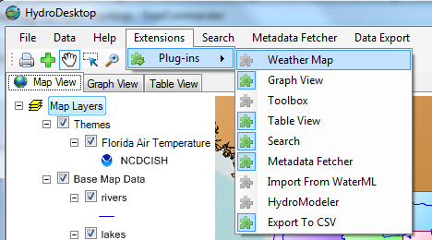

Figure Select the Plugin

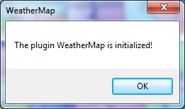

Figure The plugin message box

## Add a Menu Item

The plugin will add a new menu item to the HydroDesktop main menu. The menu item is added in the Initialize method using the following code:

Public Sub Initialize(ByVal args As IMapPluginArgs) Implements IMapPlugin.Initialize

'Assign the map handle

_mapWin = args

'To add the first menu item

Dim menu1 As New ToolStripMenuItem("Weather Map")

menu1.Name = "mnuWeatherMap"

'To add the second menu item

Dim menu2 As New ToolStripMenuItem("Create Map")

menu1.DropDownItems.Add(menu2)

'Add the click event handler

AddHandler menu1.Click, AddressOf Menu1_click

_mapWin.MainMenu.Items.Add(menu1)

End Sub

'This code runs when the menu item is clicked

Private Sub Menu1_click()

MsgBox("You clicked the Weather Map menu item")

End Sub

'Dectivate method - occurs when the plugin is unchecked

Public Overloads Sub Deactivate() Implements IMapPlugin.Deactivate

MyBase.Deactivate()

'To remove the menu item

_mapWin.MainMenu.Items.RemoveByKey("mnuWeatherMap")

End Sub

In the Initialize method, one menu item (“Weather Map”) with a sub-menu item (“Create Map”) is added. The Menu1_click event will be run every time the user clicks the menu item. To attach the code to the event, the code:

AddHandler menu1.Click, AddressOf Menu1_click

is required. In the Deactivate method, the menu items are removed when the user unchecks the plugin. Close HydroDesktop, rebuild the plugin and restart HydroDesktop. Activate the plugin using Extensions – Plugins – Weather Map. The new menu item will be shown. Every time the Create Map item is clicked, a message box is shown.

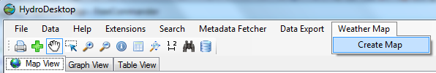

Figure The new menu item added by the plugin

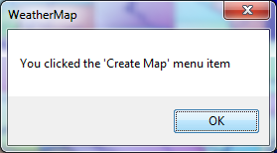

Figure The message box

## Launch a new Form

The next step is to launch a new form. The form will contain the weather map and statistical summary for the specified time period. In Visual Studio, add a new form with a DateTimePicker control, MapWindow map control and DataGridView control.

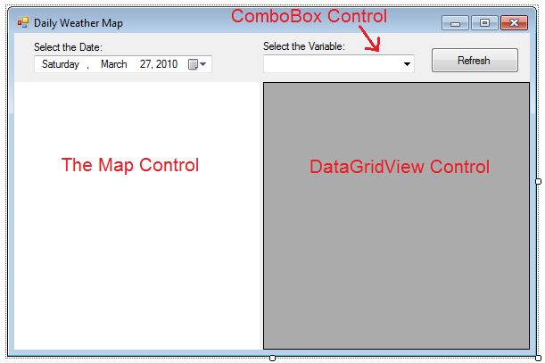

Figure 35 New Form - Design View

## Get the list of available Variables

In the Form_Load Event, the combo box will be populated with available variables. Use the code listing below:

Private Sub WeatherMapForm_Load(ByVal sender As Object, ByVal e As System.EventArgs) Handles Me.Load

'Set the db manager

db = Config.DefaultDataRepositoryOperations

'Get the table of variables

Dim sqlQuery As String = "SELECT VariableID, VariableName FROM Variables"

Dim tblVariables As DataTable = db.LoadTable("tblVariables", sqlQuery)

ComboBox1.DataSource = tblVariables

ComboBox1.DisplayMember = "VariableName"

ComboBox1.ValueMember = "VariableID"

'Add the 'STATES' Layer

Dim statesFileName As String = AppDomain.CurrentDomain.BaseDirectory & "\Maps\BaseData\states.shp"

Dim statesLayer As MapPolygonLayer = Map1.Layers.Add(statesFileName)

statesLayer.Symbolizer.SetFillColor(Color.Transparent)

End Sub

## Read DataValues From the Database

When the Refresh button is clicked, we can select the maximum and minimum temperature value for each site for the user-specified time period and variable. This is shown in the code listing below:

Private Sub btnCreateMap_Click(ByVal sender As System.Object, ByVal e As System.EventArgs) Handles btnCreateMap.Click

'Get the selected variable id

Dim selectedVariableID As Integer = Me.ComboBox1.SelectedValue

'Get the start time and end time

Dim startTime As DateTime = DateTimePicker1.Value

Dim endTime As DateTime = DateTimePicker1.Value.AddDays(1)

'Create the SQL query with VariableID, StartTime and EndTime parameters

Dim sqlQuery As String = _

"select SiteName, Latitude, Longitude, " & _

"MAX(datavalue) AS 'max', MIN(datavalue) AS 'min' from sites " & _

"INNER JOIN DataSeries ON Sites.SiteID = DataSeries.SiteID " & _

"INNER JOIN Variables ON DataSeries.VariableID = Variables.VariableID " & _

"INNER JOIN DataValues ON DataSeries.SeriesID = DataValues.SeriesID " & _

"WHERE Variables.VariableID = ? AND LocalDateTime > ? AND LocalDateTime < ? " & _

"GROUP BY SiteName, Latitude, Longitude"

'Setup the database select command

Dim cmd As DbCommand = db.CreateCommand(sqlQuery)

cmd.Parameters.Add(db.CreateParameter(DbType.Int32, selectedVariableID))

cmd.Parameters.Add(db.CreateParameter(DbType.DateTime, startTime))

cmd.Parameters.Add(db.CreateParameter(DbType.DateTime, endTime))

'Display the table

Dim table As DataTable = db.LoadTable("table1", cmd)

DataGridView1.DataSource = table

'Refresh the Map

CreateMap(table)

End Sub

## Create a Feature Set with data values

In the CreateMap function, we create a new feature set with the Max and Min attribute values. Max is the maximum temperature for the selected day. Min is the minimum temperature for the selected day.

'remove any existing layers

Map1.Layers.Clear()

'Add the 'STATES' Layer

Dim statesFileName As String = AppDomain.CurrentDomain.BaseDirectory & _"\Maps\BaseData\states.shp"

Dim statesLayer As MapPolygonLayer = Map1.Layers.Add(statesFileName)

statesLayer.Symbolizer.SetFillColor(Color.Transparent)

Dim fs As New FeatureSet(MapWindow.Geometries.FeatureTypes.Point)

'add columns to the data table

fs.DataTable.Columns.Add(New DataColumn("SiteName", GetType(String)))

fs.DataTable.Columns.Add(New DataColumn("Max", GetType(Double)))

fs.DataTable.Columns.Add(New DataColumn("Min", GetType(Double)))

For Each row As DataRow In sourceTable.Rows

Dim latitude As Double = CDbl(row.Item("Latitude"))

Dim longitude As Double = CDbl(row.Item("Longitude"))

Dim coordinate As New Coordinate(longitude, latitude)

Dim newFeature As Feature = New Feature(coordinate)

fs.Features.Add(newFeature)

'Assign the attributes

newFeature.DataRow.Item("SiteName") = row.Item("SiteName")

newFeature.DataRow.Item("Max") = row.Item("Max")

newFeature.DataRow.Item("Min") = row.Item("Min")

Next

'Add the feature set to the map as a new layer

Dim myLayer As New MapPointLayer(fs)

Map1.Extents = myLayer.Envelope

Map1.Layers.Add(myLayer)

Map1.Invalidate()

## Add Labels

Finally, we will add labels to the map. The label will show the maximum temperature value at the site during the selected day.

'Add labels

Dim expression As String = "[Max]"

Dim ls As New LabelSymbolizer()

ls.Orientation = ContentAlignment.MiddleRight

Map1.AddLabels(myLayer, expression, "", ls)

Map1.Invalidate()

Map1.MapFrame.ResetBuffer()

To test the final plugin, select “Build WeatherMap” and launch HydroDesktop. The following map will appear:



# Appendix 1– Download HydroDesktop from [www.hydrodesktop.org](http://www.hydrodesktop.org)

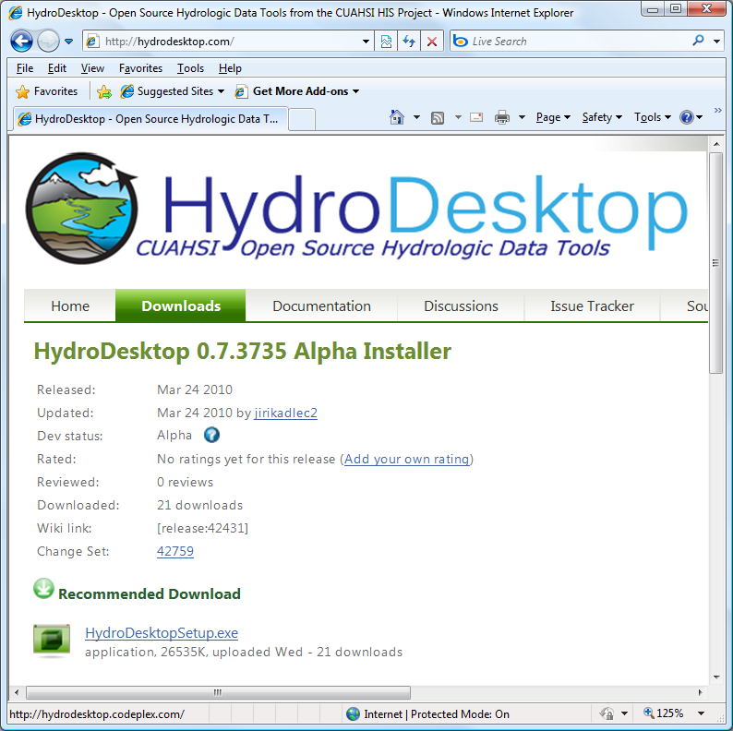

Figure The HydroDesktop Download Website

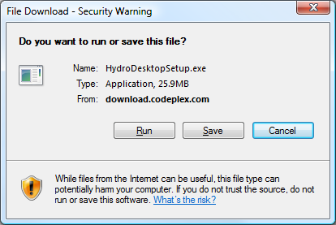

Figure File Download Warning - Select "Save"

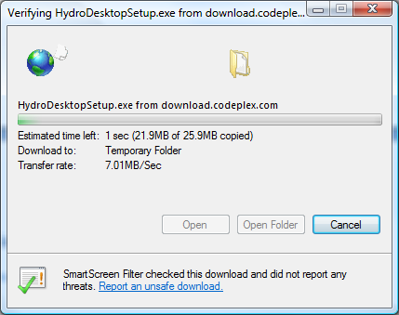

Figure File Download Progress - Select "Open Folder" and double-click HydroDesktopSetup.exe

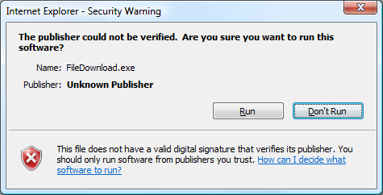

Figure Run the Installation Setup File - Click "Run"

# Appendix 2 - Setup the HydroDesktop Database

