HydroDesktop Workshop

1st MapWindow User Conference
Orlando, 2nd April 2010





Table of Contents
HydroDesktop Workshop 1
Introduction 3
Scope of the Workshop 3
Part 1 - Getting started with HydroDesktop 4
1. Download and Install HydroDesktop 4
1. Starting HydroDesktop 6
2. Search and Download Data 7
Step 3.1 Select the Search Options 7
Step 3.2 Select the Region 8
Step 3.3 Select the Keywords 11
Step 3.4 Select the Date Range 11
Step 3.5 Select Web Services 12
Step 3.6 Run Search 12
Step 3.7 Select Data Series to Download 14
Step 3.8 Set the Data Theme 15
Step 3.9 Download Selected Data Series 15
Step 3.10 View Downloaded Sites and Variables in the Map 16
3. Table View 18
4. Graph View 19
5. Export Data To Text File 20
Part 2 – Create a HydroDesktop Plugin 21
1. Set up a Visual Studio Project 21
2. Add References 22
3. Change the Build Output Path 23
4. Add MapWindow Controls to Visual Studio Toolbox 23
5. Define the Assembly Attribute 24
6. Implement the IMapPlugin Interface 25
7. Test the plugin 27
8. Add a Menu Item 28
9. Launch a new Form 29
10. Get the list of available Variables 30
11. Read DataValues From the Database 31
12. Create a Feature Set with data values 31
13. Add Labels 32
14. Getting More Information 33

Introduction
HydroDesktop is a free computer program for accessing streamflow, atmosphere, water quantity and water quality data from the CUAHSI hydrological data services. The CUAHSI (Consortium of universities for advanced hydrological science) is a group of organizations with a common goal: To advance the understanding of the global water cycle at all levels. In order to improve the availability of hydrological information, members of the CUAHSI group have created a special format called WaterML. WaterML is a standardized XML document format for sharing hydrological information on the Internet. The WaterML specification allows for a very detailed description of various types of hydrological datasets from simple water stage measurements to complex water chemistry analytical laboratory samples. WaterML can be easily understood by both hydrologists and computer programs.
Currently there are more than 100 Internet servers (HydroServers) which provide free hydrological data in the WaterML format. Most of the HydroServers are located within the USA . In addition, the National Climatic Data Center (NCDC) server provides hourly meteorological data from professional stations from nearly all countries of the world. Other servers include the U.S national agencies (USGS, EPA), international organizations (NOAA), universities, experimental watersheds and environmental research groups.
HydroDesktop includes built-in tools for creating graphs, customized hydrological maps and data export. It also includes advanced tools for time series forecasting and geospatial data analysis. An important feature of HydroDesktop is extensibility. Hydrologists and any other users can add new customized functionality by creating a plug-in in VB.NET or C#. The entire source code is freely available on the HydroDesktop website. Internally HydroDesktop uses the MapWindow 6 map components – the newest version of the MapWindow GIS open source library. This makes all advanced geospatial data processing algorithms of the MapWindow 6 library accessible for HydroDesktop plugin programmers.

Scope of the Workshop
This workshop has two main parts. In the first part we will explain how to use HydroDesktop to search, download and analyze hydrological data from your area of interest. In the second part we will demonstrate how to create your own HydroDesktop plugin. After this workshop, you will be able to:
- Search for available meteorological and hydrological data in your area
- Download the data using HydroDesktop
- Create a customized hydrological map of your area
- Extend HydroDesktop functionality by creating a plug-in
For more information about HydroDesktop, visit the official website www.hydrodesktop.org where you can find the latest official release, documentation, user discussion forum and feature requests. Other useful links are listed in the table below.
Useful Resources and Links
Link Name | Website | Description
HydroDesktop | www.hydrodesktop.org | The official HydroDesktop Website
CUAHSI Hydrological Information System | http://his.cuahsi.org | The CUAHSI Hydrological Information System. Includes detailed information about the WaterML document format.
HIS Central Metadata Catalog | http://hiscentral.cuahsi.org | The central registry of publicly accessible HydroServers
HydroSeek | www.hydroseek.net | Internet map server for searching and downloading hydrological data
MapWindow 6 Open Source GIS | http://mapwindow.codeplex.com | The MapWindow 6 Open Source GIS mapping components

Part 1 - Getting started with HydroDesktop

Download and Install HydroDesktop
HydroDesktop is included on the Workshop Flash Disk and CDs. To install HydroDesktop, go to folder HydroDesktop/Setup and double-click the file HydroDesktopSetup.exe. A series of installation screens (Select Setup Language, Select start menu folder, Create Desktop Icon) will be shown. You can use the default options and click Next on each screen.
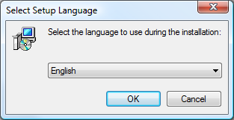
Figure 1 Initial Installation Screen
Once installation is finished, the Installation Complete screen is shown. Click Finish to automatically launch HydroDesktop. The HydroDesktop program can also be started by:
- Double – click the HydroDesktop icon on the computer desktop
- Select Start – All Programs – CUAHSI HIS - HydroDesktop
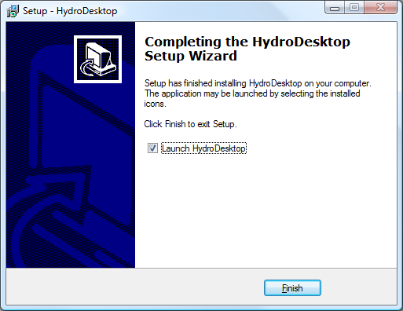
Figure 2 Installation Finished - Click "Finish" to launch HydroDesktop

Starting HydroDesktop
The main part of the HydroDesktop interface is the map. By default, the map contains simple base data (countries of the world, U.S states, major rivers and lakes, watersheds). The other parts are the Graph View and Table view menu. By default the map view does not contain any site with hydrological time series data. These sites can be added to the map in two possible ways:
- Search and Download Data
- Open an existing HydroDesktop database with downloaded data. This option is explained in Appendix 2.
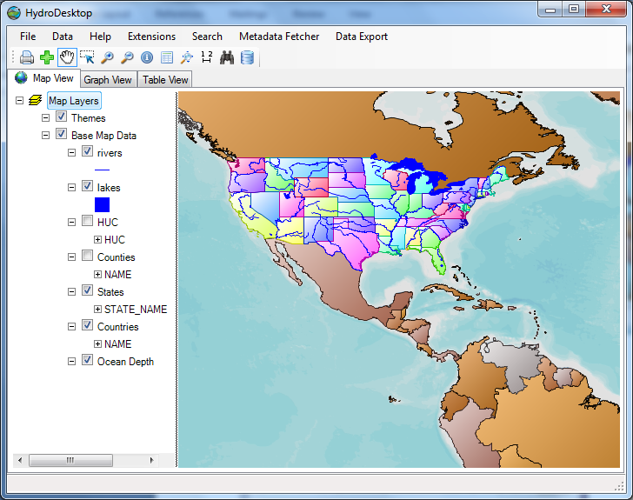

Search and Download Data
The key function of HydroDesktop is search and download of hydrological data from various servers. The search has and download has following steps:
- Select the Search Method (HIS Central or Metadata Cache)
- Select the Region (draw rectangle, select polygon, select state, select county, select watershed)
- Select the keywords
- Select the date and time range
- Select the Web services
- Run Search
- Select the series for download
- Download Data
The steps 3, 4 and 5 are optional – you can skip these steps during the search.
In the following example, search and download the air temperature data for year 2010 for the state of Florida.
Note: Instead of Florida, you can choose a different region, for example your own country.
To launch the Search, go to the main menu and Select Search – Search and Download Data.
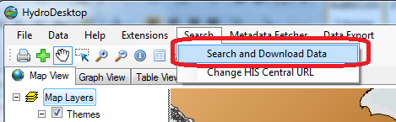
Figure 3 Start the Search and Download

Step 3.1 Select the Search Options
In the first step, the Search options are selected. Select the search option and click Next to continue the search. HydroDesktop supports two options:
- Search in HIS Central
When using this option, HydroDesktop will connect to a special HIS Central server. HIS Central stores detailed information about sites and variables from multiple organizations and HydroServers . This option is recommended to use for searching data from large organizations (NCDC, USGS, EPA). Because of the large number of registered sites, the search may take more time for very large regions. Therefore it is recommended to limit the region size to one country or one U.S state.

- Search in Local Metadata Cache
When using this option, HydroDesktop searches for available sites and variables in the local Metadata Cache. Before using this option, you need to register the organization’s hydroServer URL using the HydroDesktop Metadata Fetcher plug-in. This option is recommended to use for smaller organizations such as universities and experimental watersheds. This option is faster than using “Search in HIS Central”.
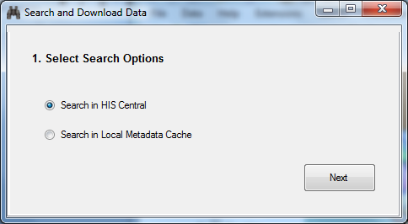
Figure 4 Select the Search Options – Click Next to continue the Search

Step 3.2 Select the Region
In the second step of the search the region is selected. You can select the region using 5 different methods:
- Draw Rectangle
- Select Polygon
- Select State
- Select County
- Select HUC
Selecting a US State
Click the Select State button. A new window is shown. In the new window type in the state name “Florida” and click OK. The map view will display the “Florida” state and the information about latitude / longitude bounding box will be updated.
Alternative Option: Selecting a Country
To select a country instead of a U.S state, press the Select Country button. A new window is shown. In the new window type name of the country and click OK. The country is selected and highlighted in the map.
Confirm the Selection
After selecting the State or Country, click the button More Options to proceed to the next search step.
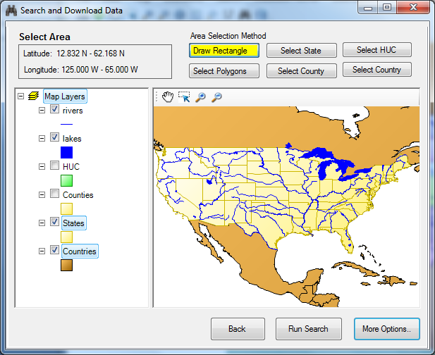
Figure 5 Search - Select the Area
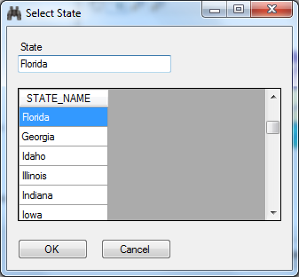
Figure 6 Search - Select the State
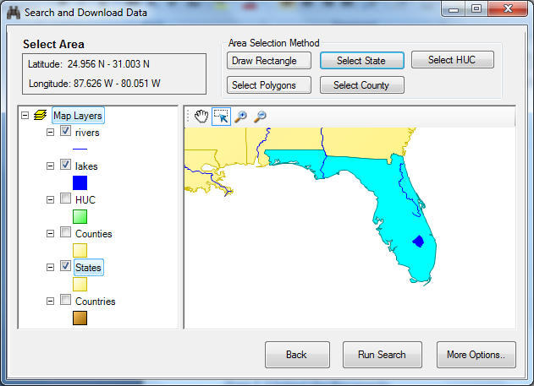
Figure 7 The Selected State

Step 3.3 Select the Keywords
In the third step the search keywords are selected. In the keyword text box, type in the keyword “Air Temperature”. This highlights the keyword in the keyword list on the left. Then click the “Add” arrow button to include Air temperature in the list of selected keywords. Click More Options to confirm the selection.
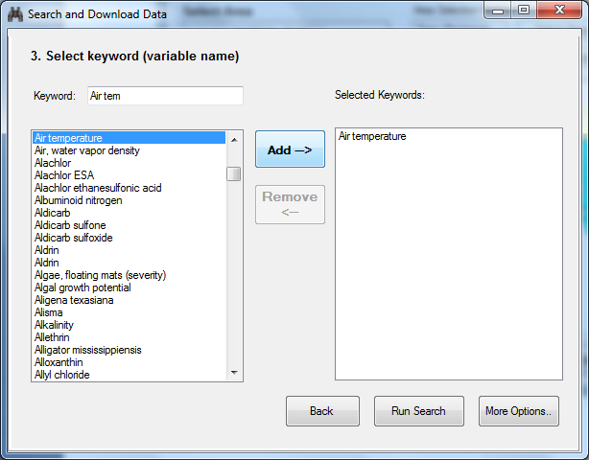

Step 3.4 Select the Date Range
In the fourth step of the search, select the date range. By default the date range is set to the previous year. In this search example, change the Start Date to January 01, 2010. The date can be changed by typing in the day and year or by selecting in the calendar. Click More Options to confirm the selection and continue the search.
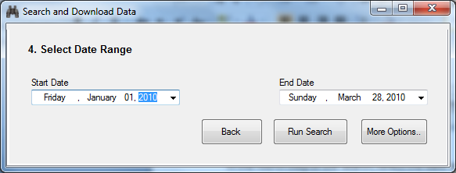
Figure 8 Select Date Range

Step 3.5 Select Web Services
In the fifth step of the search the web services are selected . The web service is the server of the organization that provides hydrological data. You can choose one or more web services. In this example, click on the row with title NCDC hourly Data. Then click Run Search to continue the search.
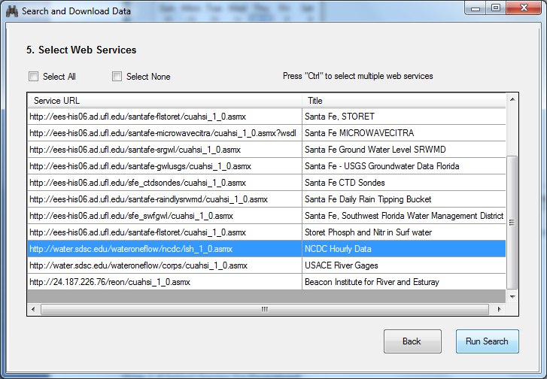
Figure 9 Select the Web Services

Step 3.6 Run Search
The search summary with selected options is shown. Click Run Search again to start the search.
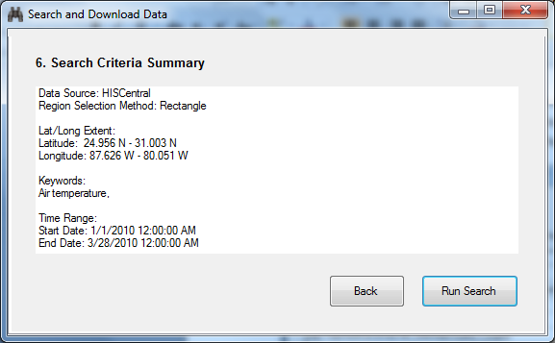
Figure 10 Search Criteria Summary
The search progress is shown. During the search, HydroDesktop sends multiple queries to the HIS Central server to find out about available sites with Air Temperature in the region. This might take a minute or two. After the search is complete, The message “Search Complete” is shown. Click OK to view search results.
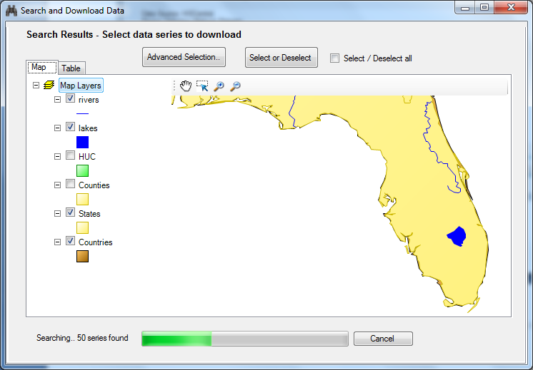
Figure 11 Search Progress
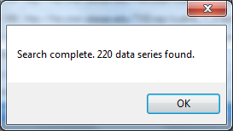
Figure 12 Search is Complete

Step 3.7 Select Data Series to Download
The search results are shown in a new map. Each site has the organization logo. In this case, all sites belong to the National Climatic Data Center (NCDC) organization. In this step, the time series for download need to be selected. There are four options for selecting the series for download:
- Check the Select All checkbox
- Click or drag a rectangle to select sites in the map
- Select rows in the table. Go to the Table tab and select the rows
- Advanced selection. Click Advanced Selection to enter a detailed selection query.
For the Florida air temperature, check the Select / Deselect all checkbox. All sites are highlighted in the map. When selection is complete, click the Get Data button.
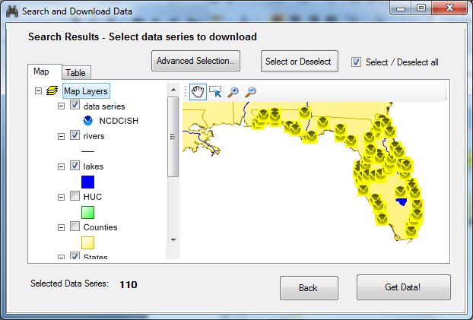
Figure 13 Select Sites to Download in the Map
To view detailed information about found sites, click the “Table” tab. In the table you can select multiple rows by holding the “Ctrl” button and clicking the rows. You can change the order of columns by clicking on the column header. Make sure that only rows with VariableName equal to AIR-TEMPERATURE Observation Air Temperature are selected. The number of selected series will be 110. The selected sites will also be highlighted in the map. When selection is complete, click the “Get Data” button.

Step 3.8 Set the Data Theme
The next screen is shown. Here you can specify the “Theme name”. The theme name is the text that will appear in the map legend after the data is downloaded.
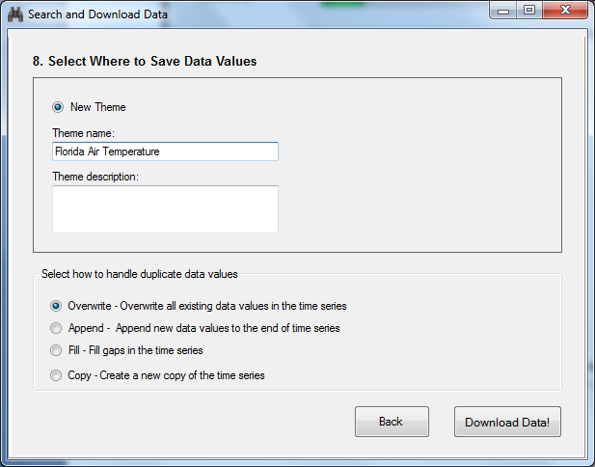
Figure 14 Choose the Theme Name

Step 3.9 Download Selected Data Series
The download progress is shown in the progress bar. This may take several minutes. After the download is complete, Click OK to view downloaded sites in the map and click Close to close the progress window.
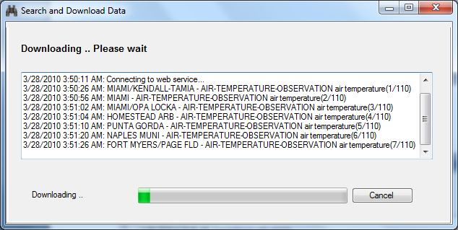
Figure 15 Download Progress
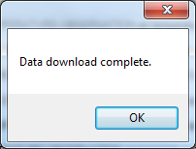
Figure 16 Download is Complete

Step 3.10 View Downloaded Sites and Variables in the Map
The Downloaded data series are now shown in the map in the Themes group. You can see a new theme “Florida Air Temperature”. To get more information about each site, right – click on the theme name and choose “View Attributes”
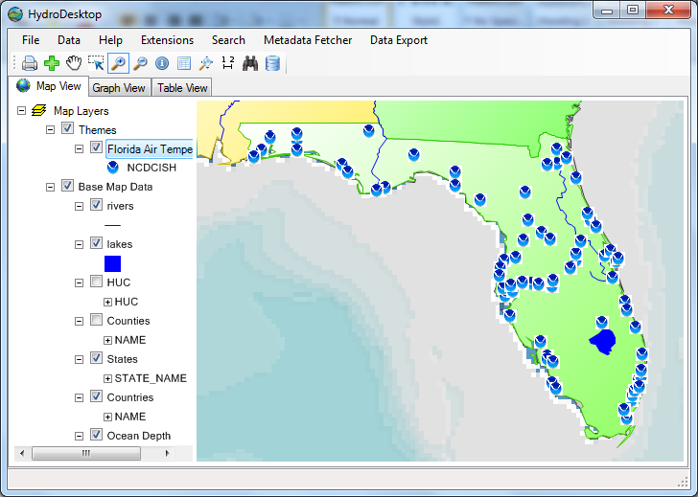
Figure 17 View Downloaded Data Series in the Map
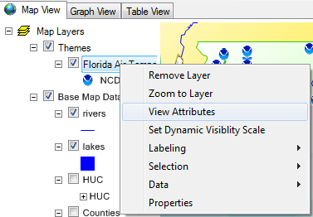
Figure 18 View The Attribute Table menu
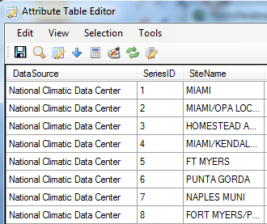
Figure 19 Table of Downloaded Data Series
For each time series, the data source, site name, variable name and other attributes are listed. Sites selected in the map are automatically highlighted in the attribute table.
Note:
The attribute table does not contain the actual air temperature values. Each data series consists of multiple data values. To view the actual data values, use the Table View and Graph View.

Table View
The Table view displays the downloaded data values in a table by checking the time series variable name and site name in the list of time series in the left panel. The table view has two main options:
- Show All Fields in Sequence
- Show Just Values in Parallel
When the second option is selected, the values of each time series are shown as a separate column.
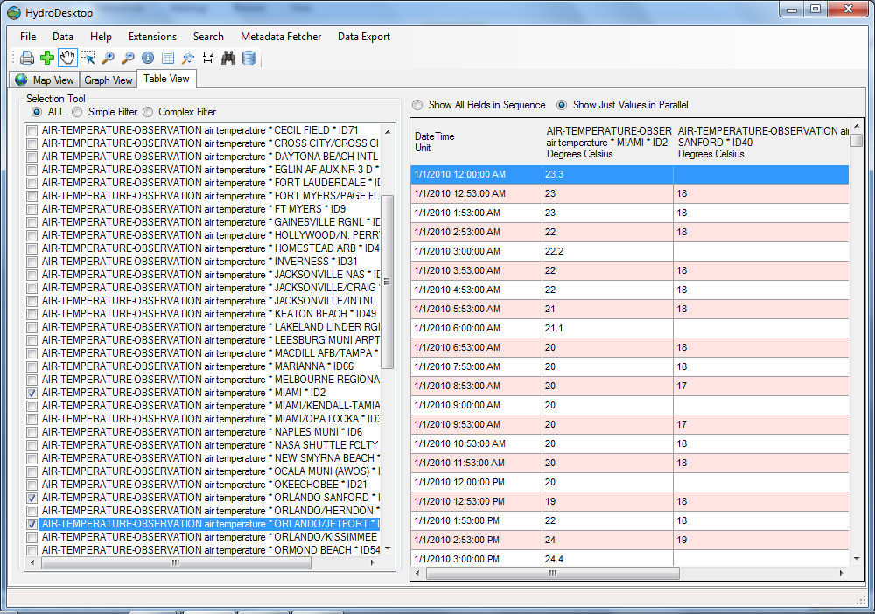
Figure 20 Table View

Graph View
The graph view can be used to compare multiple time series. To display a time series in the graph view, check the check box in the left hand panel. The color of the time series plot can be changed by right-clicking on the graph and selecting the Change plot color context menu. The date range of the plot can be changed by going to Plot Options, changing the begin date and end date and clicking Apply Options.
Note: To change the date range, the Change to original date range check box needs to be unchecked.

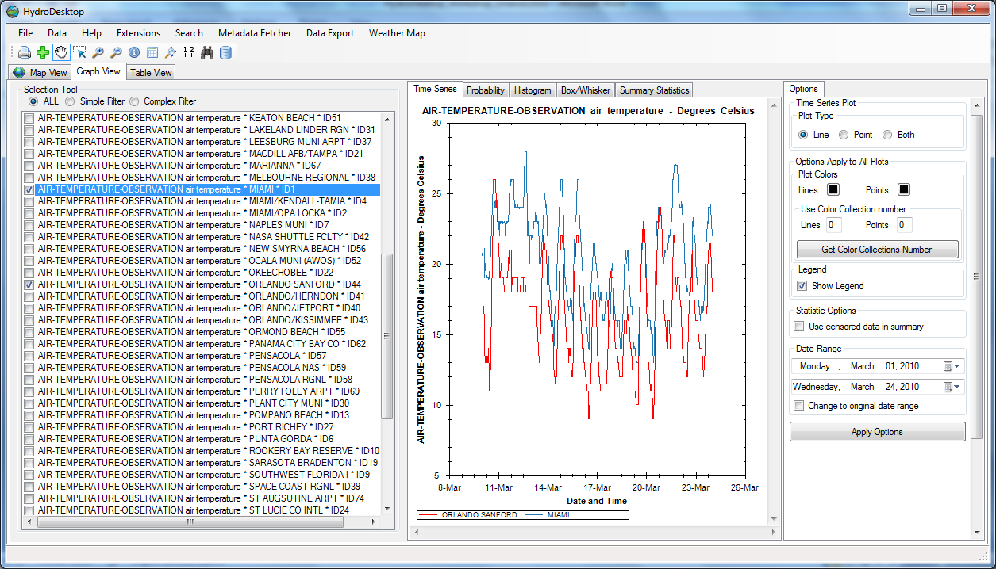
Figure 21 Show multiple time series in the graph view

Export Data To Text File
The downloaded data can be exported using the Data Export option in the main menu. To export your data, go to Data Export and select the option Export Theme time series to text file. The attributes to export can be selected. Check the fields SiteName, LocalDateTime and DataValue, set the delimiter to comma and choose the output file. Click Export Data to start export. The progress of export is shown. After the export is complete, you can display the exported table in Excel or in a text editor.
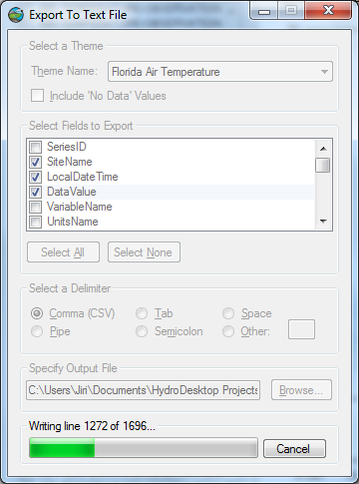
Figure 22 Export Data To Text File

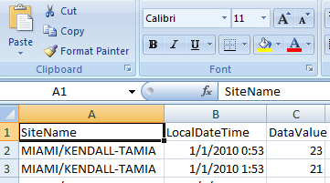
Figure 23 View Exported Data in Excel

Part 2 – Create a HydroDesktop Plugin
In the previous part of the workshop we demonstrated how to use HydroDesktop to download air temperature data, show graphs and display tables. In the second part of the workshop we will show how to create a customized temperature map by writing a HydroDesktop plugin
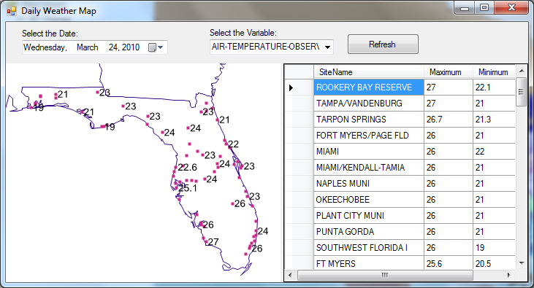
Figure 24 The sample plug-in form

Set up a Visual Studio Project
Open Visual Studio and start a new ‘Class Library’ project. Go To File – New – Project.. and select Class Library. Set the project’s name to SamplePluginVB and specify the folder where you want the project to be saved.
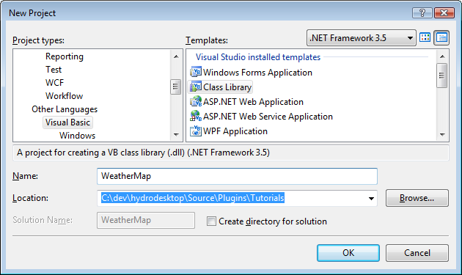
Figure 25 Create a new Visual Basic.NET Class Library Project

Add References
You will need to add the following reference to your project:
- MapWindow.dll This is the main software library that allows you to interact with the map and GIS data.

- System.Windows.Forms.dll Required if you want the plug-in to add a custom menu item, toolbar button or display a custom form.

- HydroDesktop.Data.dll This is the software library for accessing data in the HydroDesktop database and communicating with hydrological web servers.

To add the reference, go to Solution Explorer, right-click on the project name (WeatherMap) and select Add Reference in the context menu. Go to the Browse tab and navigate to the files MapWindow.dll and HydroDesktop.Data.dll. The assemblies are located in the same folder where HydroDesktop is installed (Program Files\CUAHSI HIS\HydroDesktop).
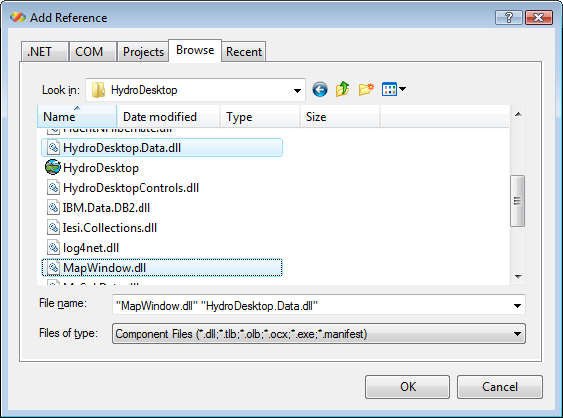
Figure 26 Add a reference to MapWindow.dll in VB.NET
Important: After adding the reference, make sure that the Copy Local property is set to False.
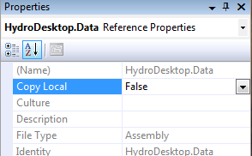
Figure 27 Set Copy Local to false after adding the reference

Change the Build Output Path
In Project Properties window, go to the Compile tab. Change the Build output path to
Program Files\CUAHSI HIS\HydroDesktop\Plugins
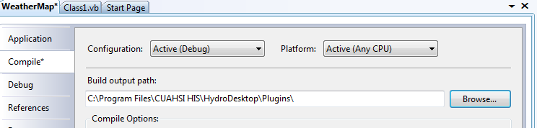
Figure 28 Setting the Build output path for the plug-in

Add MapWindow Controls to Visual Studio Toolbox
In our plugin we will use a new MapWindow map control. In order to add the control, go to Visual Studio Toolbox. First, select “Add Tab” and type “MapWindow”. Second, select Choose Items, select Browse .. and go to Program Files\Cuahsi HIS\HydroDesktop\MapWindow.dll. The new MapWindow controls including the map controls will appear in the Visual Studio toolbox.
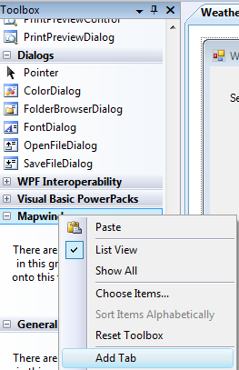
Figure 29 MapWindow Toolbox - Choose Items

Define the Assembly Attribute
In order to be recognized as a MapWindow plug-in, the assembly needs to have a special MapWindowPluginAssembly attribute in the AssemblyInfo.vb file. To Add the attribute, go to Solution Explorer. Make sure the Show All Files option is checked. Go to the My Project subfolder and double click on the AssemblyInfo.vb file.
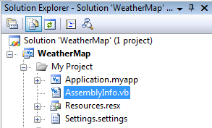
Figure 30 Location of the file AssemblyInfo.vb
At the start of the file add the statements as shown in the code listing below:
Imports MapWindow.Plugins
<Assembly:MapWindowPluginAssembly()>
Imports System
Imports System.Reflection
Imports System.Runtime.InteropServices
Imports MapWindow.Plugins

' General Information about an assembly is controlled through the following
' set of attributes. Change these attribute values to modify the information
' associated with an assembly.

' Review the values of the assembly attributes

<Assembly: MapWindowPluginAssembly()>

<Assembly: AssemblyTitle("WeatherMap")>
<Assembly: AssemblyDescription("")>

Implement the IMapPlugin Interface
Each HydroDesktop plugin must contain one class which implements the MapWindow.Plugins.IMapPlugin interface. In your project, go to Solution Explorer and select Add Class… Rename the class as Main.vb and open its code file.
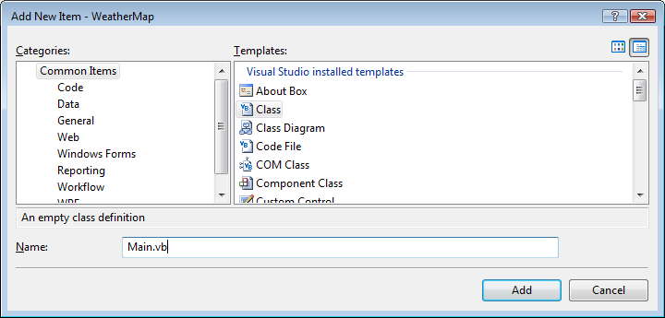

The listing below shows the code of a basic HydroDesktop plugin. The plugin can be detected by HydroDestkop and it appears in the Extensions – Plugins menu of HydroDesktop. Because it is a MapWindow plugin, it can also be used in the MapWindow GIS application.

Imports System.Windows.Forms
Imports MapWindow.Components
Imports MapWindow.Map
Imports MapWindow.Plugins

<MapWindowPlugin("Weather Map", Author:="MyName", UniqueName:="WeatherMap_1_0", Version:="1.0")> _
Public Class Main
Inherits Extension
Implements IMapPlugin

'declare a class variable with a reference to the main Map
Private _mapWin As IMapPluginArgs

'Initialize the plugin and get the map handle
Public Sub Initialize(ByVal args As IMapPluginArgs) Implements IMapPlugin.Initialize

_mapWin = args
MsgBox("The plugin WeatherMap is initialized!")

End Sub

'Dectivate method - occurs when the plugin is unchecked
Public Overloads Sub Deactivate() Implements IMapPlugin.Deactivate
MyBase.Deactivate()
End Sub

'Activate method - just use the base class implementation
Public Overloads Sub Activate() Implements IMapPlugin.Activate
MyBase.Activate()
End Sub

'IsEnabled property - just use the base class implementation
Public Property IsEnabled() As Boolean Implements IMapPlugin.IsEnabled
Get
Return MyBase.IsEnabled
End Get

Set(ByVal value As Boolean)
MyBase.IsEnabled = value
End Set
End Property

End Class

The Main.vb class code has four important parts:

- The <MapWindowPlugin> attribute.
This attribute contains the plugin name, the author name, the plugin unique name, and the plugin version.

- The Inherits Extension and Implements IMapPlugin statement.
Each plugin must implement the IMapPlugin interface. By inheriting from the Extension class, we can use the default implementation of some of the IMapPlugin methods.

- The Initialize method.
Sub Initialize(ByVal args As IMapPluginArgs)
The initialize method is executed when the user first selects the plug-in. This is the place where new toolbars, buttons and menu items should be created. The Initialize method has the args parameter. This parameter can be used to access the main map and other components of the main application from within the plugin.

- The Deactivate method.
Public Overloads Sub Deactivate()
The Deactivate method is executed when the unselects the plugin in the plugins menu. Any custom toolbars or menu items added by the plugin should be removed in the Deactivate method.

Test the plugin
To test the plugin, choose Build Solution in Visual Studion (F6). Then launch the program HydroDesktop.exe from Program Files\CUAHSI HIS\HydroDesktop. In HydroDesktop, go to the Extensions – Plugins menu. The menu should contain the new “Weather Map” plugin. In case your plugin is not detected, double-check the build output path of the plugin. Try selecting the plugin “Weather Map” in the HydroDesktop menu. The message box will be shown.
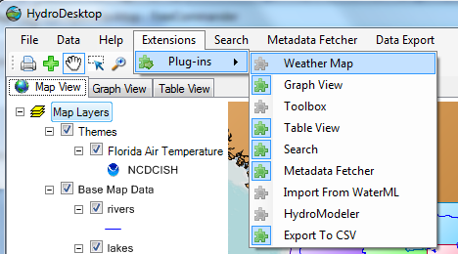
Figure 31 Select the Plugin
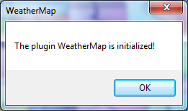
Figure 32 The plugin message box

Add a Menu Item
The plugin will add a new menu item to the HydroDesktop main menu. The menu item is added in the Initialize method using the following code:
Public Sub Initialize(ByVal args As IMapPluginArgs) Implements IMapPlugin.Initialize

'Assign the map handle
_mapWin = args

'To add the first menu item
Dim menu1 As New ToolStripMenuItem("Weather Map")
menu1.Name = "mnuWeatherMap"

'To add the second menu item
Dim menu2 As New ToolStripMenuItem("Create Map")
menu1.DropDownItems.Add(menu2)

'Add the click event handler
AddHandler menu1.Click, AddressOf Menu1_click
_mapWin.MainMenu.Items.Add(menu1)

End Sub

'This code runs when the menu item is clicked
Private Sub Menu1_click()
MsgBox("You clicked the Weather Map menu item")
End Sub
'Dectivate method - occurs when the plugin is unchecked
Public Overloads Sub Deactivate() Implements IMapPlugin.Deactivate
MyBase.Deactivate()
'To remove the menu item
_mapWin.MainMenu.Items.RemoveByKey("mnuWeatherMap")
End Sub
In the Initialize method, one menu item (“Weather Map”) with a sub-menu item (“Create Map”) is added. The Menu1_click event will be run every time the user clicks the menu item. To attach the code to the event, the code:
AddHandler menu1.Click, AddressOf Menu1_click
is required. In the Deactivate method, the menu items are removed when the user unchecks the plugin. Close HydroDesktop, rebuild the plugin and restart HydroDesktop. Activate the plugin using Extensions – Plugins – Weather Map. The new menu item will be shown. Every time the Create Map item is clicked, a message box is shown.
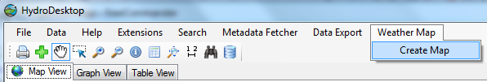
Figure 33 The new menu item added by the plugin
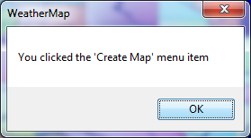
Figure 34 The message box

Launch a new Form
The next step is to launch a new form. The form will contain the weather map and statistical summary for the specified time period. In Visual Studio, add a new form with a DateTimePicker control, MapWindow map control and DataGridView control.
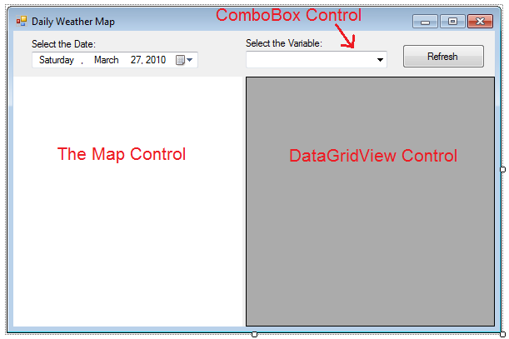
Figure 35 New Form - Design View

Get the list of available Variables
In the Form_Load Event, the combo box will be populated with available variables. Use the code listing below:
Private Sub WeatherMapForm_Load(ByVal sender As Object, ByVal e As System.EventArgs) Handles Me.Load

'Set the db manager
db = Config.DefaultDataRepositoryOperations

'Get the table of variables
Dim sqlQuery As String = "SELECT VariableID, VariableName FROM Variables"
Dim tblVariables As DataTable = db.LoadTable("tblVariables", sqlQuery)
ComboBox1.DataSource = tblVariables
ComboBox1.DisplayMember = "VariableName"
ComboBox1.ValueMember = "VariableID"

'Add the 'STATES' Layer
Dim statesFileName As String = AppDomain.CurrentDomain.BaseDirectory & "\Maps\BaseData\states.shp"

Dim statesLayer As MapPolygonLayer = Map1.Layers.Add(statesFileName)
statesLayer.Symbolizer.SetFillColor(Color.Transparent)

End Sub

Read DataValues From the Database
When the Refresh button is clicked, we can select the maximum and minimum temperature value for each site for the user-specified time period and variable. This is shown in the code listing below:
Private Sub btnCreateMap_Click(ByVal sender As System.Object, ByVal e As System.EventArgs) Handles btnCreateMap.Click

'Get the selected variable id
Dim selectedVariableID As Integer = Me.ComboBox1.SelectedValue

'Get the start time and end time
Dim startTime As DateTime = DateTimePicker1.Value
Dim endTime As DateTime = DateTimePicker1.Value.AddDays(1)

'Create the SQL query with VariableID, StartTime and EndTime parameters
Dim sqlQuery As String = _
"select SiteName, Latitude, Longitude, " & _
"MAX(datavalue) AS 'max', MIN(datavalue) AS 'min' from sites " & _
"INNER JOIN DataSeries ON Sites.SiteID = DataSeries.SiteID " & _
"INNER JOIN Variables ON DataSeries.VariableID = Variables.VariableID " & _
"INNER JOIN DataValues ON DataSeries.SeriesID = DataValues.SeriesID " & _
"WHERE Variables.VariableID = ? AND LocalDateTime > ? AND LocalDateTime < ? " & _
"GROUP BY SiteName, Latitude, Longitude"

'Setup the database select command
Dim cmd As DbCommand = db.CreateCommand(sqlQuery)
cmd.Parameters.Add(db.CreateParameter(DbType.Int32, selectedVariableID))
cmd.Parameters.Add(db.CreateParameter(DbType.DateTime, startTime))
cmd.Parameters.Add(db.CreateParameter(DbType.DateTime, endTime))

'Display the table
Dim table As DataTable = db.LoadTable("table1", cmd)
DataGridView1.DataSource = table

'Refresh the Map
CreateMap(table)

End Sub

Create a Feature Set with data values
In the CreateMap function, we create a new feature set with the Max and Min attribute values. Max is the maximum temperature for the selected day. Min is the minimum temperature for the selected day.
'remove any existing layers
Map1.Layers.Clear()

'Add the 'STATES' Layer
Dim statesFileName As String = AppDomain.CurrentDomain.BaseDirectory & _"\Maps\BaseData\states.shp"

Dim statesLayer As MapPolygonLayer = Map1.Layers.Add(statesFileName)
statesLayer.Symbolizer.SetFillColor(Color.Transparent)

Dim fs As New FeatureSet(MapWindow.Geometries.FeatureTypes.Point)

'add columns to the data table
fs.DataTable.Columns.Add(New DataColumn("SiteName", GetType(String)))
fs.DataTable.Columns.Add(New DataColumn("Max", GetType(Double)))
fs.DataTable.Columns.Add(New DataColumn("Min", GetType(Double)))

For Each row As DataRow In sourceTable.Rows
Dim latitude As Double = CDbl(row.Item("Latitude"))
Dim longitude As Double = CDbl(row.Item("Longitude"))
Dim coordinate As New Coordinate(longitude, latitude)
Dim newFeature As Feature = New Feature(coordinate)
fs.Features.Add(newFeature)

'Assign the attributes
newFeature.DataRow.Item("SiteName") = row.Item("SiteName")
newFeature.DataRow.Item("Max") = row.Item("Max")
newFeature.DataRow.Item("Min") = row.Item("Min")
Next

'Add the feature set to the map as a new layer
Dim myLayer As New MapPointLayer(fs)

Map1.Extents = myLayer.Envelope
Map1.Layers.Add(myLayer)
Map1.Invalidate()

Add Labels
Finally, we will add labels to the map. The label will show the maximum temperature value at the site during the selected day.
'Add labels
Dim expression As String = "[Max]"
Dim ls As New LabelSymbolizer()
ls.Orientation = ContentAlignment.MiddleRight
Map1.AddLabels(myLayer, expression, "", ls)

Map1.Invalidate()
Map1.MapFrame.ResetBuffer()
To test the final plugin, select “Build WeatherMap” and launch HydroDesktop. The following map will appear:

Getting More Information
To get more information about HydroDesktop and writing your own plugins, visit the website:
www.hydrodesktop.org
with documentation, discussion forum, and the complete source code of all HydroDesktop plugins.

