Creating a Sample Project Package

Jiří Kadlec **This tutorial works with HydroDesktop 1.5 experimental release.**

1. Using Windows explorer , create a new folder (for example Desktop\Jacob’s Well Spring)
2. In HydroDesktop, go to File – Save As
3. Navigate to the new folder and type-in the new project file name (for example Jacob’s Well Spring.dspx)

(The dspx file is a text file that has information about the data layers and symbology)

1. Install **nuget package explorer** from nuget.codeplex.com.
2. Select **Create a new package**.
3. Select Edit – Edit package metadata and enter the package id, package description, version, author and tags. Click OK.

(NOTE: in the tags text box you must enter the value **SampleProject.)**

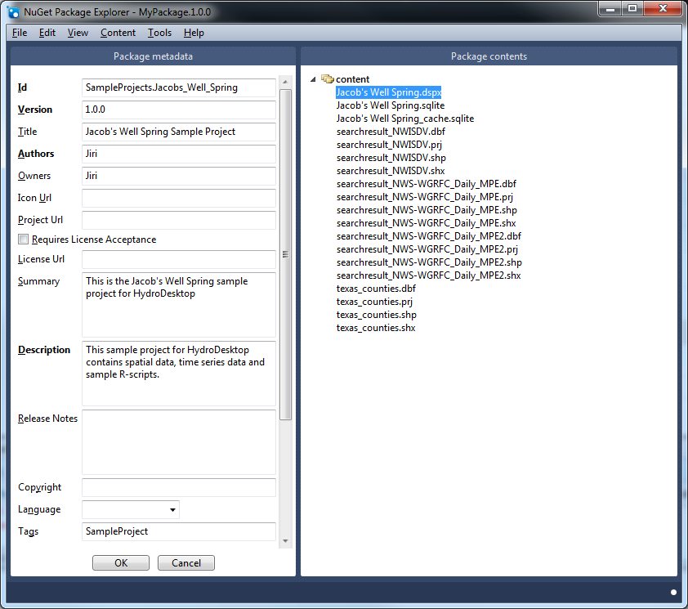

1. In the main menu select Content – Add – content Folder. This will create a new content folder symbol in the Package contents panel.
2. Right-click on the content icon in the Package contents panel and select add existing file..
3. In the file dialog select all files from the Desktop\Jacob’s Well spring folder. These files should include a .dspx project file, two .sqlite database files and some shapefiles (.shp, .shx, .dbf).
4. Select File-Save As... This will save the package as a .**nupkg** file

(NOTE) A .nupkg file is similar to a ZIP file.

1. In your web browser go to [**www.myget.org**](http://www.myget.org)**.** Select My Feeds and sign-in. You should see the DotSpatial package feed. Select Add a Package and browse to your .**nupkg** package file.

(NOTE) You may need the package uploading privileges. Ask **mudnug** who is the DotSpatial coordinator to give you the privileges.

1. After a minute, The package is accessible to all MapWindow 6 and HydroDesktop users. You can install it using the Online tab in the File - Open Sample Project... dialog and then open it using the Installed Sample Projects tab in the Open Sample Project dialog.

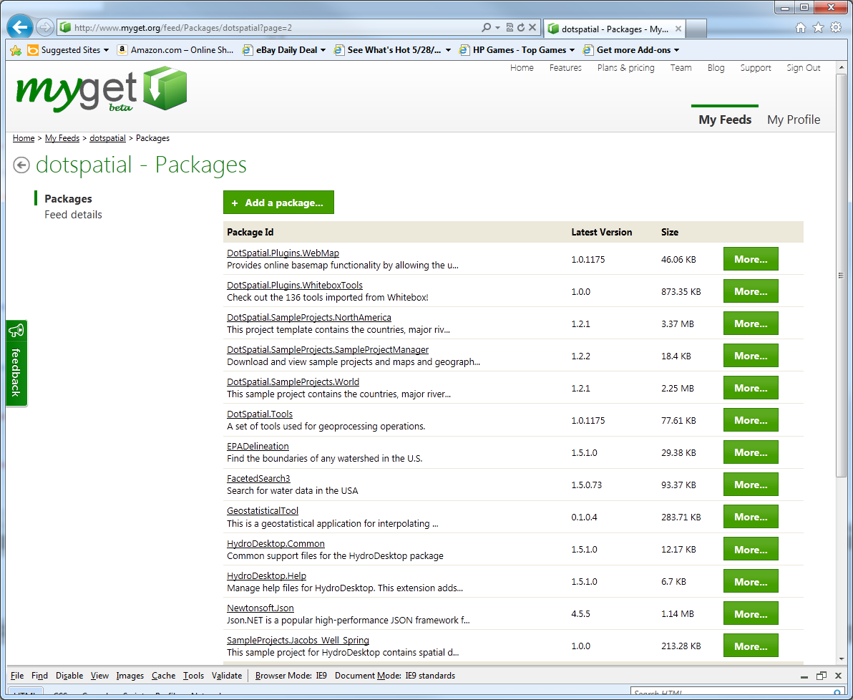

Installing the sample project in HydroDesktop:

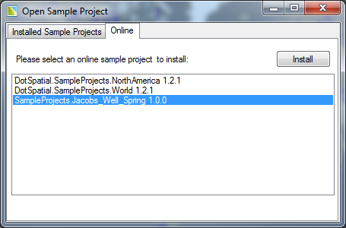

Opening the sample projects in HydroDesktop:

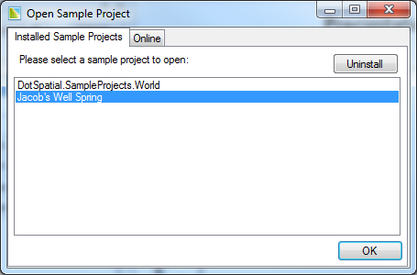

# Suggested Improvement Task:

Create an extension for DotSpatial / HydroDesktop that wil do the described steps 1 – 10 automatically by clicking one button!