Hydrology Exercise – Precipitation

# Calculating Total Precipitation in a Watershed

The goal of this exercise is to test the kriging interpolation method to create a precipitation map and calculate the total precipitation in the Elbe watershed. The Elbe (“Labe” in Czech) is a major European river. In this example the map will show precipitation during the 2002 European Flood event in the Elbe.

**Notice:**

This exercise uses an experimental version of HydroDesktop, a GIS software for hydrologic analyses. HydroDesktop is still in a testing stage and may have some bugs. If you follow this exercise carefully, then you shouldn’t encounter these bugs One important goal of this exercise is to generate feedback to the development team to help them improve the HydroDesktop user interface.

**Steps:**

1. Download the **1.4.11 Recommended Release** of HydroDesktop from: [www.hydrodesktop.org](http://www.hydrodesktop.org). Open HydroDesktop. In the initial screen, select *open existing project* and select the **“elbe”** sample project (a project contains pre-defined maps of the area of interest).
2. Search for Precipitation data in the upper Elbe watershed:
   1. Using the Map tab, navigate to Elbe watershed using the zoom and pan tools.
   2. In the “Area” box on the Search tab, select the Draw Rectangle option. Using the mouse define the search area:

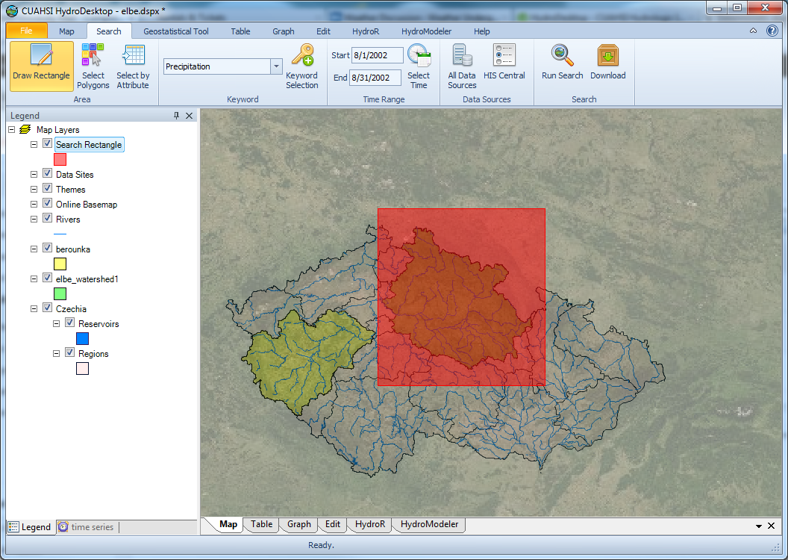

* 1. In the “Keyword” box on the Search tab, type in the keyword **precipitation.**
  2. In the “Time Range” box on the Search tab, set the dates to 8/1/2002 – 8/31/2002
  3. In the “Search” box on the Search tab, click the “Run Search” button. This will initiate a search for all online precipitation data within the search area and time range specified. The results of this search will be added to a new data layer in your map called “Central European Climate Data.”
  4. After the search is completed close the “Search finished” window

1. Download the precipitation data:
   1. Right-click on the **Central European Climate Data** layer in the map legend (also called the “table of contents”) and choose *Selection* - *Select All*. This will highlight in the map all data sites resulting from your search.
   2. In the “Search” box in the Search tab click the *Download* button. This will initiate a download of all of the precipitation data at the sites you selected in the previous step.
   3. The download manager shows the data download progress. After download completes, close the download manager window.

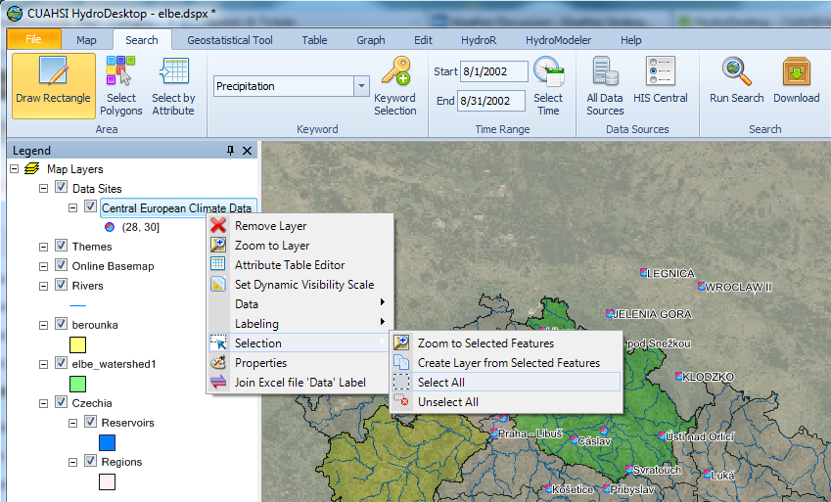

1. View precipitation time series in a graph – the precipitation time series graphs for August 2002 are shown.
   1. Select the “Graph” tab in the user interface.
   2. Explore your data by adding individual time series to the graph by clicking the check box next to each time series name.
   3. Create a graph of all downloaded data and export this to your project report by right clicking in the graph and choosing “copy”. You can the “paste” the graph in Microsoft Word.
2. Calculate the precipitation sum at each site:
   1. Return to the map view by selecting the “Map” tab in the user interface.
   2. Right-click on the Central European Climate Data layer
   3. In the context menu select ***Data – Show Data Values In Map***

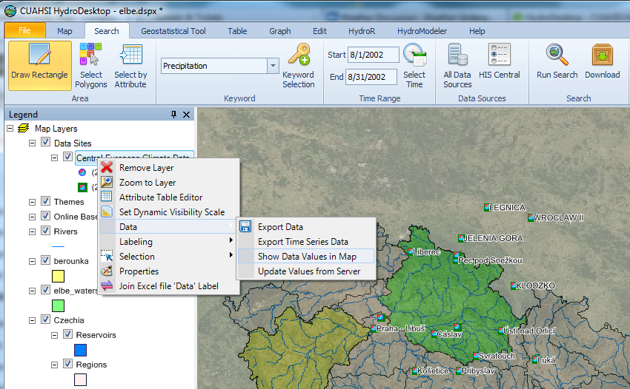

* 1. Select the default time period (8/1/2002-8/31/2002) and select **SUM** aggregate value. Then click the “OK” button. This will add a new point layer to the map with the sum of precipitation at each site for the specified time period.
  2. After the sum is calculated uncheck the “Central European Climate Data” layer in the map legend to view the newly created layer with labels showing the precipitation sum.
  3. After the sum is calculated you can view the August 2002 precipitation sum in the attribute table. To view the attribute table right-click on the **Sum-20020802-20020829** layer to open the context-menu and select **Attribute Table Editor.** Verify that this column was created and contains precipitation summation data.

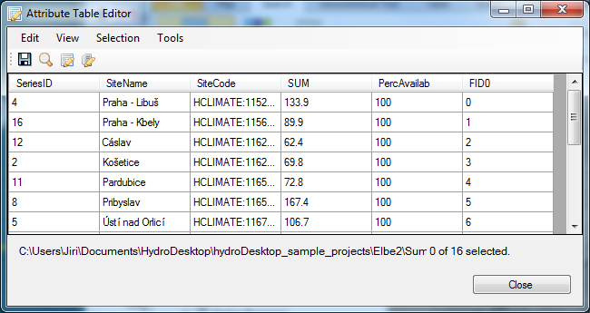

1. Spatial interpolation using kriging

Return to the main map view by closing the **Attribute Table Editor.** You should have a “**Geostatistical Tool**” in your user interface. If this tab is not present then you need to activate the “GeostatisticalTool” Extension using the Extension Manager under the File menu. In the Geostatistical Tool tab, select Geostatistical Methods and Ordinary Kriging. In the “Dataset” box, select Sum-20020802-20020829 for the “Layer” and select SUM for the “Field”.

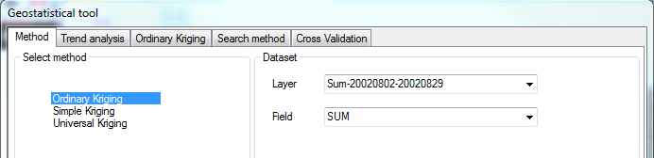

1. Perform kriging interpolation
   1. Keep the other default settings (Ordinary Kriging method, Prediction Map Output, and no Pre-processing). Select the “Next” button to view the semivariogram.
   2. Keep the default settings and click the “Next” button to view the search method.
   3. Keep the default settings for search method and click the “Next” button to view the Cross Validation analysis. Notice the calculated error in the cross validation. Are these prediction errors reasonable?
   4. It’s generally preferable to create raster data with a “rounded” cell size. Set the pixel size of the result raster to 1000 meters.
   5. The outpur raster should cover the whole watershed area. To set the area, click “Extension Area” and select Layer “elbe_watershed1” and click “Accept”
   6. . Click “Create” to perform the kriging interpolation. Upon completion, close the Geostatistical tool window.

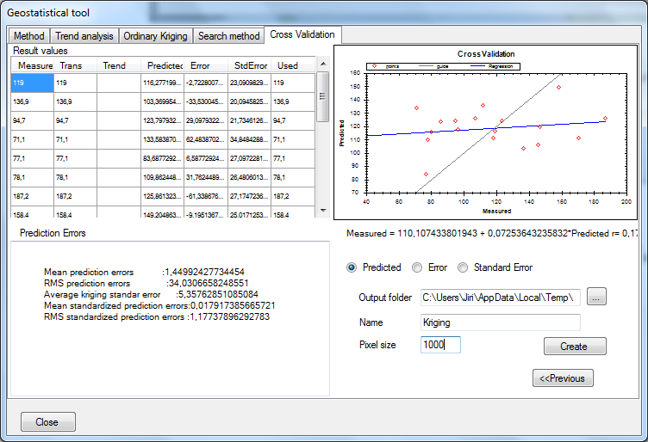

1. Change the color scheme of the precipitation raster:
   1. Right click on the “kriging” layer in the map legend table of contents and select Properties.
   2. Change the color ramp to RGB, set Start Color to light blue, End Color to dark blue and set number of breaks to 5 (Num Breaks in the “Statistics” tab).
   3. Click the “OK” button. This will re-color your raster data map to represent five different levels of precipitation.

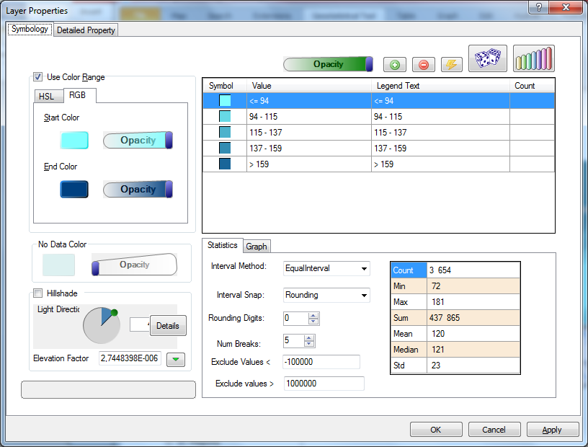

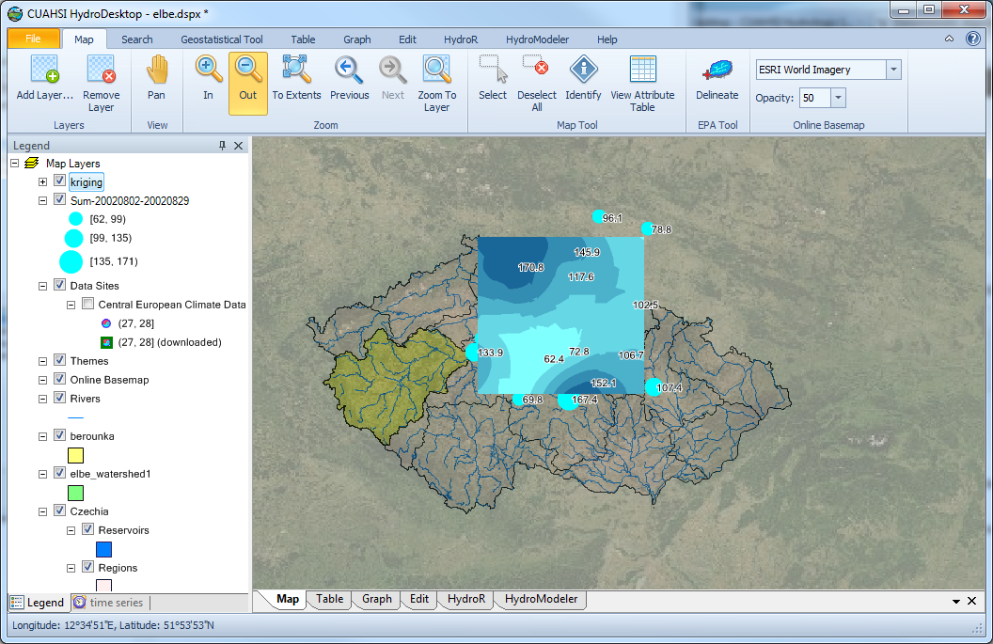

1. Calculate Total Precipitation within the upper Elbe watershed

For this step you need to install the DotSpatial.Tools extension. To install this extension go to **File –** **Extension Manager** and select the “Online” tab. In the list of online extensions select **DotSpatial.Tools** and click Install. After installation completes, a new tab called “Tools” will appear in the bottom left of the program user interface next to the “Legend” tab and “time series” tab.

* 1. In the *tools* panel open the *Analysis* toolgroup and double click the *Clip Raster Layer* tool.
  2. For the input “Raster,” select kriging and for the input “Polygon for Clipping,” select Elbe_watershed1.
  3. For the output file name, click the “plus” button next to the output file name text box and browse to an appropriate folder location to save the output data. Enter a new file name for the output raster, for example elbe_precip.bgd (bgd is a standard raster file format used by HydroDesktop.)
  4. Click “OK” to begin the clipping of your precipitation raster.

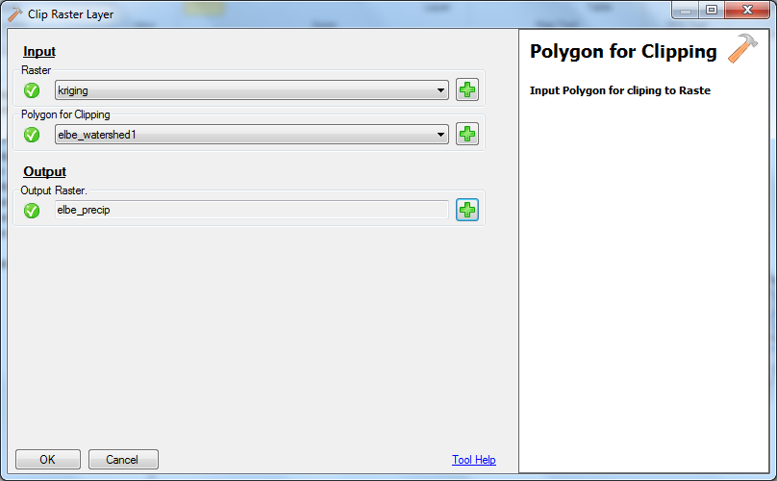

* 1. After the clipping finishes, return to the Map tab in the user interface and select Add Layer to add the elbe_precip.bgd raster file to the map. Uncheck the original “kriging” raster layer and change the color scheme of the calculated raster similar to the original raster color scheme.

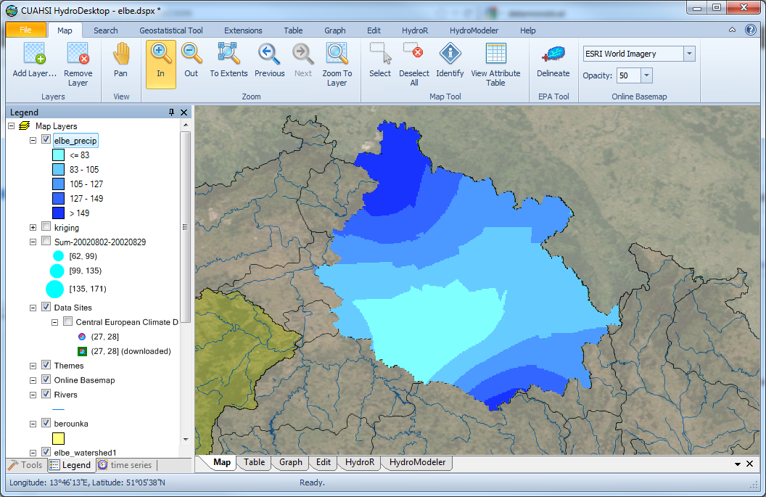

1. Total precipitation on the watershed – you can find this value as the average in the raster properties window. This this the average precipitation in each grid cell. To get the total precipitation volume, convert the precipitation from mm to m3 and multiply by number of grid cells in the watershed.

SURVEY

Please complete the following ANONYMOUS survey: (mark appropriate answer with “**X**” )

1. Which of the following software have you previously used extensively (e.g. for more than 1 hour)?

|  |  |
| --- | --- |
| Microsoft Excel (or equivalent) |  |
| Relational database management software (e.g. Access, MS SQL, MySQL) |  |
| ESRI ArcGIS (or ArcView) |  |
| CUAHSI HydroDesktop |  |
| Other GIS software |  |
| Software development tools (e.g. HTML, Visual Basic, C++, PHP, Java, etc.) |  |
| Online mapping web sites |  |

1. How long did it take you to query and download your data?

|  |  |
| --- | --- |
| Less than 5 minutes |  |
| 5-10 |  |
| 10-15 |  |
| 15-30 |  |
| Longer than 30 minutes |  |

1. How long did it take you to do the precipitation interpolation?

|  |  |
| --- | --- |
| Less than 5 minutes |  |
| 5-10 |  |
| 10-15 |  |
| 15-30 |  |
| Longer than 30 minutes |  |

1. What was the best feature of the software?

|  |
| --- |
| Please answer here: |

1. What would you recommend be changed in the software?

|  |
| --- |
| Please answer here: |

How easy or difficult did you find the following tasks in the exercise: (please place an “X” where applies)

|  |  |  |  |  |  |
| --- | --- | --- | --- | --- | --- |
|  | Very easy | easy | medium | difficult | Very difficult |
| Installing HydroDesktop |  |  |  |  |  |
| Searching for data |  |  |  |  |  |
| Downloading data |  |  |  |  |  |
| Calculating aggregate data values |  |  |  |  |  |
| Kriging Interpolation |  |  |  |  |  |
| Symbolizing the raster |  |  |  |  |  |
| Clipping the raster by the watershed |  |  |  |  |  |

7. What is your current or most recently achieved academic level?

Please answer here:

|  |  |
| --- | --- |
| Freshman |  |
| Sophomore |  |
| Junior |  |
| Senior |  |
| M.S. |  |
| Ph.D. |  |
| Post Doctoral researcher |  |