HydroDesktop Exercise – Precipitation

# Calculating Total Precipitation in a Watershed using HydroDesktop 1.5

The goal of this exercise is to test the interpolation methods to create a precipitation map and calculate the total precipitation in a river basin. The Elbe (“Labe” in Czech) is a major European river. In this example the map will show precipitation during the 2002 European Flood event in the Elbe. This exercise can be used in any area that has rainfall data available through HydroDesktop.

**Notice:**

This exercise uses HydroDesktop, a GIS software for hydrologic analyses. HydroDesktop is still in a testing stage and may have some bugs. If you follow this exercise carefully, then you shouldn’t encounter these bugs. One important goal of this exercise is to generate feedback to the development team to help them improve the HydroDesktop user interface. If you’re willing to complete the survey at the end of this document, it might be helpful to read the survey questions now so that you can keep them in mind as you complete this exercise.

**Steps:**

1. Download the **1.5.12 Recommended Release** of HydroDesktop from: [www.hydrodesktop.org](http://www.hydrodesktop.org). Open HydroDesktop. In the initial screen, select *Create New Project From Template* and select the **“elbe”** sample project (a project contains pre-defined maps of the area). Click OK to open the project.
2. Install the **DataAggregation** and **GeostatisticalTool** extensions:
   1. In the menu bar at the top, click *File* – *Extension Manager…*
   2. In the extension manager select the Online tab. Find the extension by typing the name in the “Search” box and install it by clicking the *Install* button.

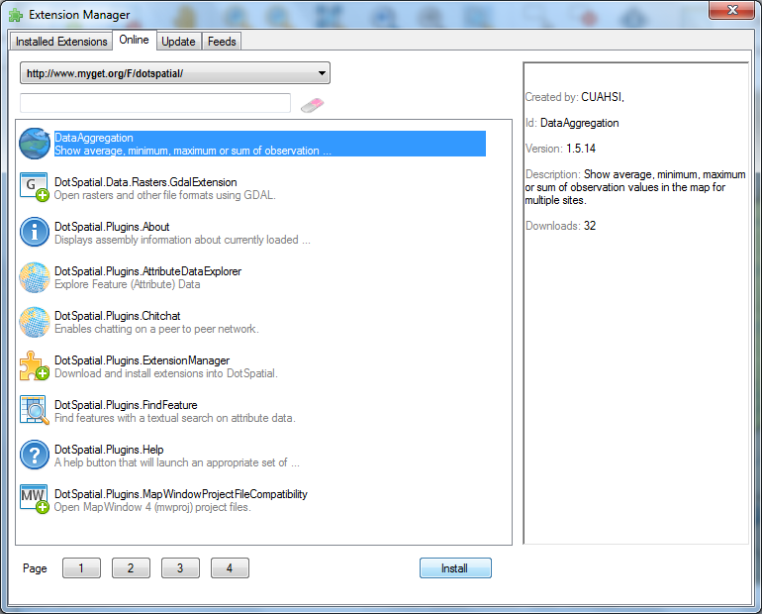

* 1. Install the extension: DataAggregation
  2. Install the extension: GeostatisticalTool
  3. Close the extension manager. In HydroDesktop, notice the new “Interpolation Tool” tab in the ribbon.

1. Search for Precipitation data in the upper Elbe watershed:
   1. In the Legend, right-click elbe_watershed1 and click *Zoom to Layer*.
   2. In the “Area” group on the “Search” tab of the ribbon, select the *Draw Rectangle* tool. Using the mouse define the search area encompassing the entire watershed, as shown in the figure below:

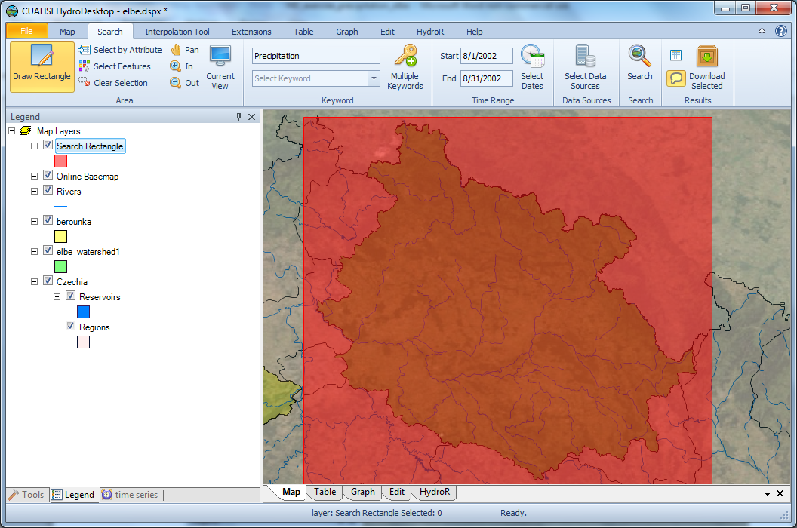

* 1. In the text box at the top of the Keyword group, type in the keyword **precipitation.**
  2. In the “Time Range” group, set the dates to 8/1/2002 – 8/31/2002.
  3. In the “Search” group, click the *Search* button. This will initiate a search for all online precipitation data within the search area and time range specified. The results of this search will be added to a new data layer in your map called “Central European Climate Data.”
  4. After the search is completed close the “Search Progress” window. The results show the locations of time series data that match your search. You will choose the time series you actually want to download in the next step.

1. Download the precipitation data:
   1. Right-click on the **Central European Climate Data** layer in the Legend and click *Selection* - *Select All*. This will highlight in the map all data sites resulting from your search.
   2. In the “Results” group in the ribbon, click the *Download Selected* button. This will initiate a download of all of the precipitation data at the sites you selected in the previous step.
   3. The download manager shows the data download progress. After download completes, *close* the download manager window.

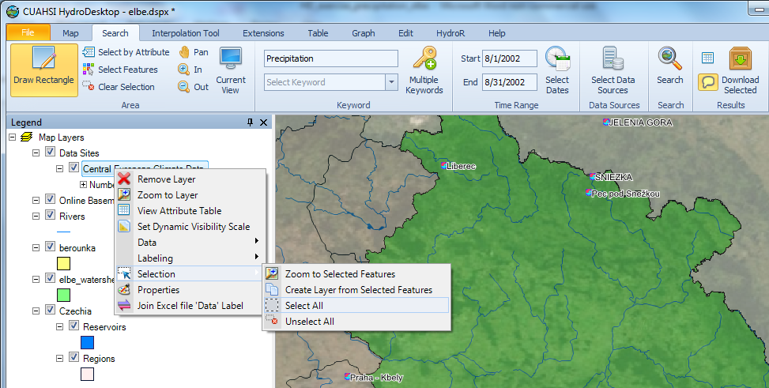

1. View precipitation time series in a graph – the precipitation time series graphs for August 2002 are shown.
   1. Select the “Graph” tab in the ribbon.
   2. Explore your data by adding individual time series to the graph by clicking the check box next to each time series in the panel on the left.
   3. Export the graph to your project report by right clicking in the graph and clicking “Copy”. You can the paste the graph in another program such as Microsoft Word.
2. Calculate the precipitation sum at each site:
   1. Return to the map view by selecting the “Map” tab in the ribbon.
   2. Right-click the **Central European Climate Data** layer.
   3. In the context menu click *Data – Show Data Values In Map.* This command was added with the DataAggregation extension.

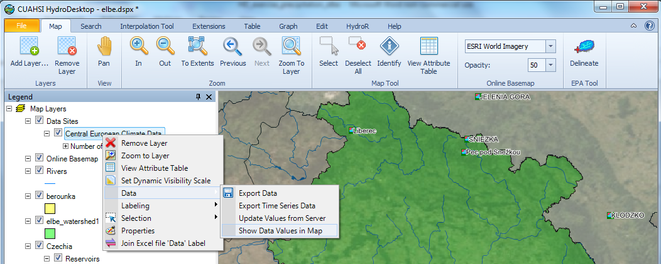

* 1. Choose **SUM** as the Type of Aggregation. You’ll use the default time period (8/2/2002-8/29/2002). Click the *OK* button. This will add a new point layer to the map with the sum of precipitation at each site for the specified time period.
  2. After the sum is calculated uncheck the **Central European Climate Data** layer in the map legend to view the newly created layer with labels showing the precipitation sum in millimeters.
  3. After the sum is calculated you can view the August 2002 precipitation sum in the attribute table. To view the attribute table right-click **Sum-20020801-200208** and click *View Attribute Table***.** Verify that the table has a SUM column that was created and contains precipitation summation data.
  4. Close the **ADE-Sum-20020802-20020829** panel.

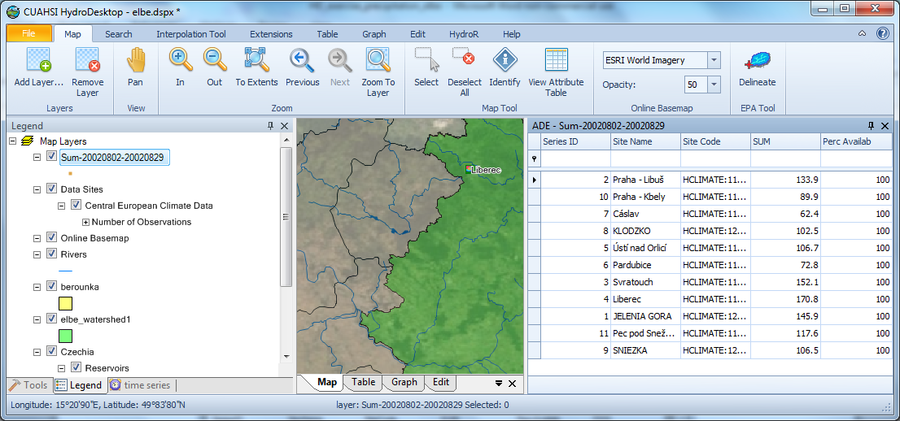

1. Prepare for spatial interpolation using inverse distance weighted (IDW) method:

In the “Interpolation Tool” tab, click Deterministic Methods. Select **Sum-20020802-20020829** for the “Layer” and select **SUM** for the “Field”. Click the *Next* button to select the parameters.

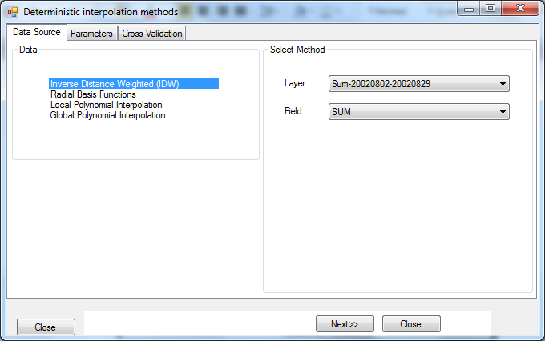

1. Perform IDW interpolation:
   1. Keep the default parameters (power, maximum neighbors, minimum neighbors). Click the *Next* button to view the cross-validation. Notice the calculated error in the cross validation. Are these prediction errors reasonable?
   2. It’s generally preferable to create raster data with a “rounded” cell size. Set the Pixel size of the result raster to 1000 meters. The raster cell size units are the units of the current map projection. Information about current map units can be found if you right-click on the *Map Layers* item in the map legend and select *Projection*.

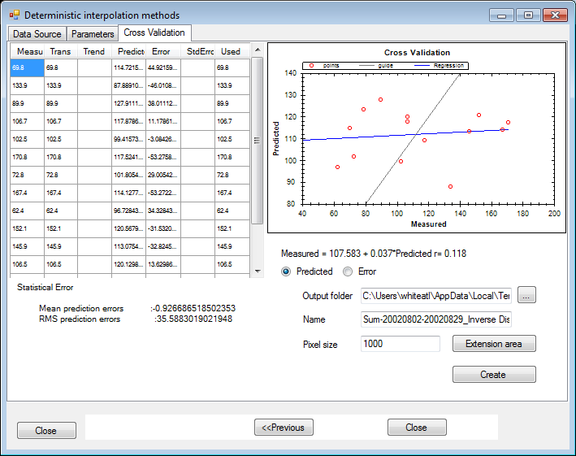

* 1. The output raster should cover the whole watershed area. To set the area, click *Extension Area* and select Layer “elbe_watershed1”. Also check the “Mask” check box and select the “elbe_watershed1” as the mask layer. Click *Accept* to confirm the area settings.

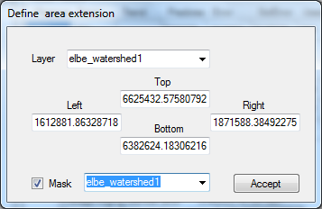

* 1. Click *Create* to perform the IDW interpolation. The interpolated precipitation raster will be added to the map. Upon completion, close the Deterministic interpolation methods window.

1. Change the color scheme of the precipitation raster:
   1. Right click on the **sum-20020802-20020829_inverse distance weighted (IDW)** layer in the map legend and click *Properties*.
   2. Change the color ramp to RGB, set Start Color to light blue, End Color to dark blue and set number of breaks to 5 (Num Breaks in the “Statistics” tab).
   3. Click the *OK* button. This will re-color your raster data map to represent five different levels of precipitation.

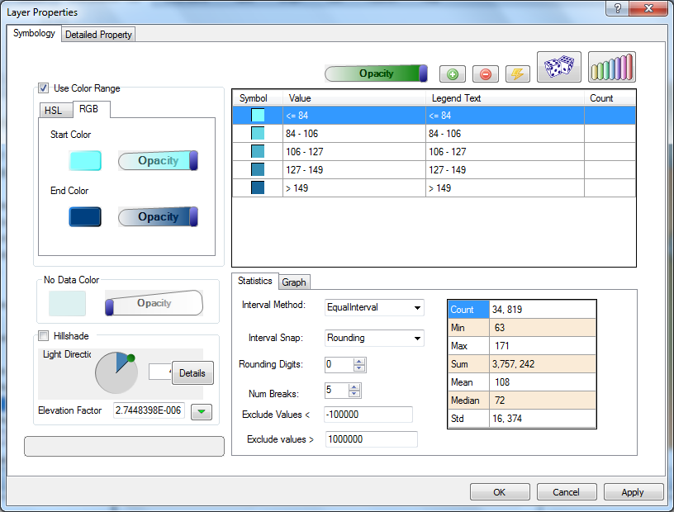

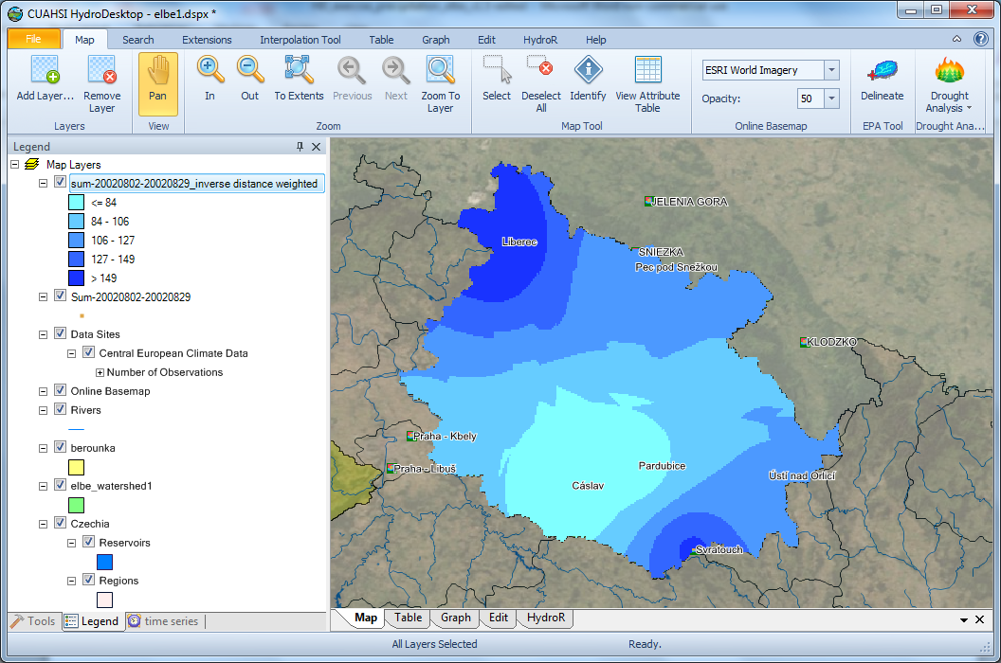

1. Calculate Total Precipitation within the upper Elbe watershed:

Total precipitation on the watershed – you can find this value as the **mean** in the raster properties window. This is the average precipitation in each grid cell. To get the total precipitation volume, convert the precipitation from mm to m3 and multiply by number of grid cells in the watershed:

In our example the raster cell size is 1000 x 1000 meters which is 106 m2.

The mean precipitation is 108 mm which is 1.08 x 10-1 m. (Note that your values may differ slightly if your search area was not the exact same as that used by the author.)

The average precipitation volume in a raster cell in is 1.08 x 105 m3.

The number of raster cells is 34,819 which is 3.4819 x 104.

The total precipitation volume is 3.4819 x 104 x 1.08 x 105.

This is approximately 3.758 x 109 m3 or (in cubic kilometers) 3.758 km3.

1. Extra exercise – Compare interpolation methods:

Perform the interpolation again, but change the exponent parameter of the inverse distance weighted interpolation method. How does this change the total precipitation volume?

# SURVEY

Please complete the following ANONYMOUS survey: (mark appropriate answer with “**X**” )

1. Which of the following software have you previously used extensively (e.g. for more than 1 hour)?

|  |  |
| --- | --- |
| Microsoft Excel (or equivalent) |  |
| Relational database management software (e.g. Access, MS SQL, MySQL) |  |
| ESRI ArcGIS (or ArcView) |  |
| CUAHSI HydroDesktop |  |
| Other GIS software |  |
| Software development tools (e.g. HTML, Visual Basic, C++, PHP, Java, etc.) |  |
| Online mapping web sites |  |

1. How long did it take you to query and download your data?

|  |  |
| --- | --- |
| Less than 5 minutes |  |
| 5-10 |  |
| 10-15 |  |
| 15-30 |  |
| Longer than 30 minutes |  |

1. How long did it take you to do the precipitation interpolation?

|  |  |
| --- | --- |
| Less than 5 minutes |  |
| 5-10 |  |
| 10-15 |  |
| 15-30 |  |
| Longer than 30 minutes |  |

1. What was the best feature of the software?

|  |
| --- |
| Please answer here: |

1. What would you recommend be changed in the software?

|  |
| --- |
| Please answer here: |

How easy or difficult did you find the following tasks in the exercise: (please place an “X” where applies)

|  |  |  |  |  |  |
| --- | --- | --- | --- | --- | --- |
|  | Very easy | Easy | Medium | Difficult | Very difficult |
| Installing HydroDesktop |  |  |  |  |  |
| Searching for data |  |  |  |  |  |
| Downloading data |  |  |  |  |  |
| Calculating aggregate data values |  |  |  |  |  |
| Interpolation |  |  |  |  |  |
| Symbolizing the raster |  |  |  |  |  |
| Calculating runoff volume |  |  |  |  |  |

7. What is your current or most recently achieved academic level?

Please answer here:

|  |  |
| --- | --- |
| Freshman |  |
| Sophomore |  |
| Junior |  |
| Senior |  |
| M.S. |  |
| Ph.D. |  |
| Post Doctoral researcher |  |