Adding a new Hydroserver Data Source in HydroDesktop *HydroDesktop version: 1.5*

**Step 1** Download HydroDesktop from <http://hydrodesktop.codeplex.com> website

**Step 2** Start HydroDesktop and select “DotSpatial.SampleProject.World” project template

**Step 3** Select the **Search** tab.

**Step 4** In the Search tab click **Select Data Sources**.

**Step 5** In the Data Sources dialog select **Local Data Source** and click **Add Data Source**…

**Step 6** In the **WaterOneFlow Service Info** dialog enter the Title: “test server” and URL: the URL of the Hydroserver web service ending with the cuahsi_1_1.asmx, for example: <http://hydroserver.hostei.com/services/cuahsi_1_1.asmx>

(notice: **If** your server uses the **WOFpy** software than you must add the URL that ends with: /soap/wateroneflow )

**Step 7** In the WaterOneFlow Service Info dialog click **Update Database**

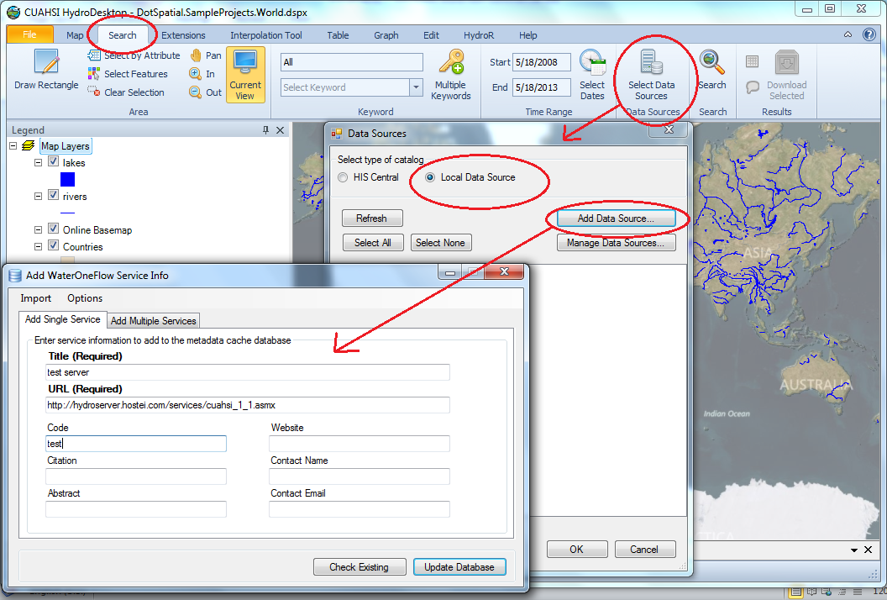

**Step 8** Click **OK** in the 1 new service added … message box.

**Step 9** In the **Metadata Fetcher** dialog select the “test server” data service.

**Step 10** In the Metadata Fetcher dialog click **Download Metadata**.

**Step 11** Click **OK** in the Download complete … message box. (Note. If the server is not working properly then an error message is shown instead)

**Step 12** **Close** the **Metadata Fetcher** dialog.

**Step 13** Click **Refresh** in the **Data Sources** dialog. The “test server” will now be shown in the data sources list.

**Step 14** In the **Data Sources** dialog click **OK**. (this closes the dialog)

**Step 15** In the Search ribbon tab click **Search**. If the “current view is too large” message appears click Yes (continue search).

**Step 16** Close the **Search Progress** window.

**Step 17** In the **map** **move the mouse** over one of the sites and click **Download Data**.

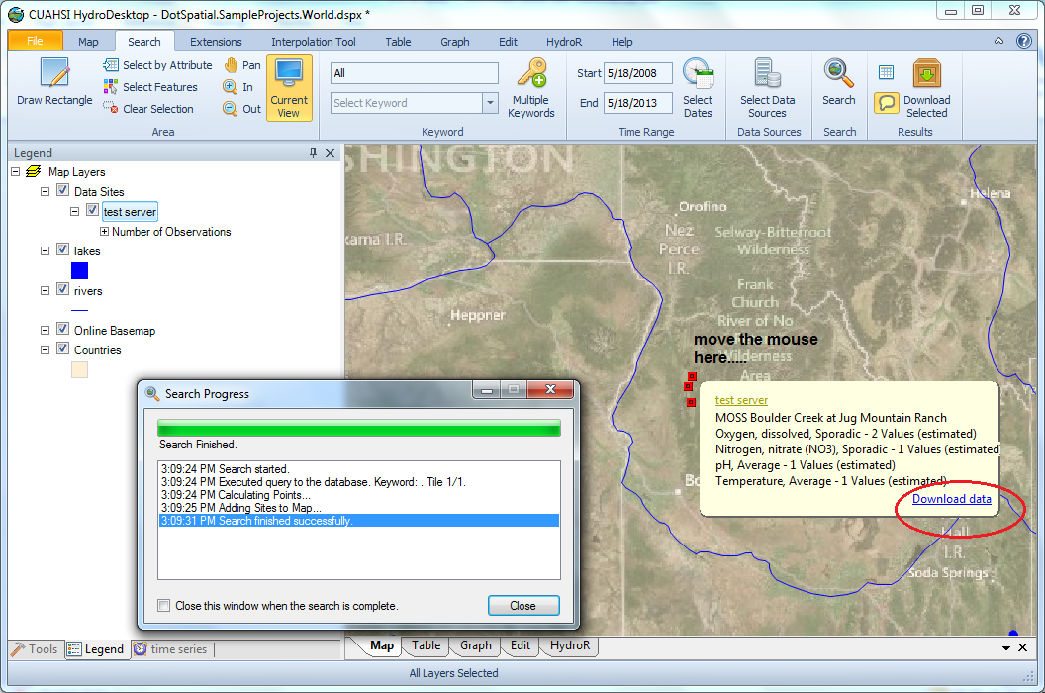

**Step 18** Wait until the download completes and **close** the **Download manager** window. (Note: if there is an error on the server then an error message will be shown in the download manager window)

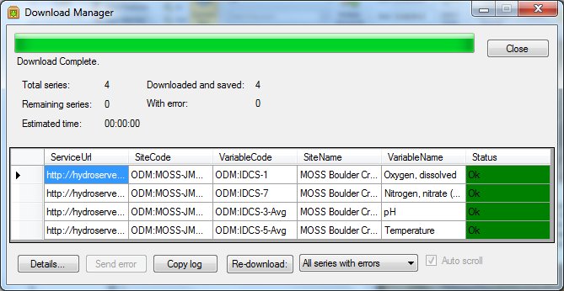

**Step 19** In HydroDesktop select the Graph ribbon tab.

**Step 20** Select one or more data series to plot. If the server is working successfully then the data points are show in the plot.

