**Instructions for Converting an ODM 1.1 Database to an ODM 1.1.1 Database**

Jeffery S. Horsburgh[1]

2-21-2012

For ODM 1.1.1, we have added a field called SiteType to the Sites table along with an associated SiteType controlled vocabulary table that defines the terms that you can use in the SiteType field. To make it easy for you to add this functionality to your existing ODM 1.1 database, we have developed a SQL Script that you can execute on your existing database.

Use the following steps to update your ODM 1.1 database to ODM 1.1.1:

1. Make sure you back up your ODM 1.1 database before you begin to make sure you can go back if anything goes wrong.
2. Open SQL Server Management Studio by clicking Start 🡪 All Programs 🡪Microsoft SQL Server 200X 🡪 SQL Server Management Studio.
3. Log in to your database server using an account that has read and write access to the ODM database that you wish to modify.
4. Open the Convert_ODM_1.1_to_ODM_1.1.1 SQL script by choosing Open 🡪 File option from the File pull down menu at the top of SQL Server Management Studio. You can also drag the script file onto the Script Window area of SQL Server Management Studio. Your window should look something like the following:

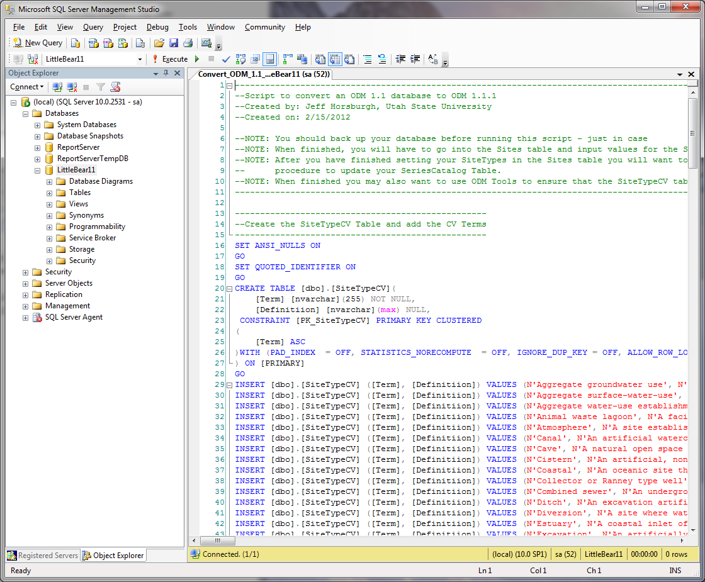

1. Ensure that the ODM database that you would like to modify is the target for this script. You can set this by choosing the name of your ODM database from the drop down menu next to the script execute button.



1. Once you have set the target ODM database, click the Execute button to execute the script on your database.



1. When the script is finished, you will see the following in the results pane at the bottom of your script. If you scroll through the messages in the results pane, you should not see any errors.

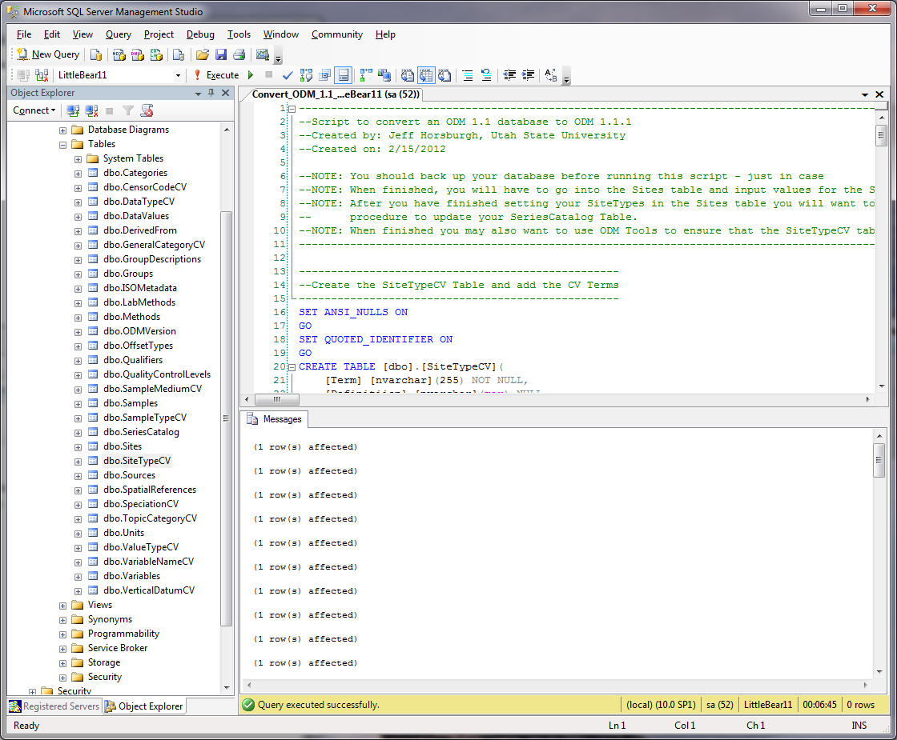

1. The script you just executed added the SiteType field to the Sites table, it added the SiteTypeCV table and its relationship to the Sites table, and it added the SiteType field to the SeriesCatalog table. However, the script does not set the values of the SiteType for each site in your Sites table. You must do this next.
2. Open the SiteTypeCV table in SQL Server Management Studio by right clicking on the table name in the Object Explorer and selecting either “OpenTable” or “Select top 1000 rows.” Scroll through the CV terms and select appropriate SiteTypes for the Sites listed in your Sites table. Remember that you should only set the value of SiteType to one of the existing CV terms.
3. Open your Sites table by right clicking on the table name in the Object Explorer and selecting “Open Table” or “Edit top 200 rows.” You should now be able to type appropriate terms from the SiteTypeCV table directly into the SiteType field in the Sites table.

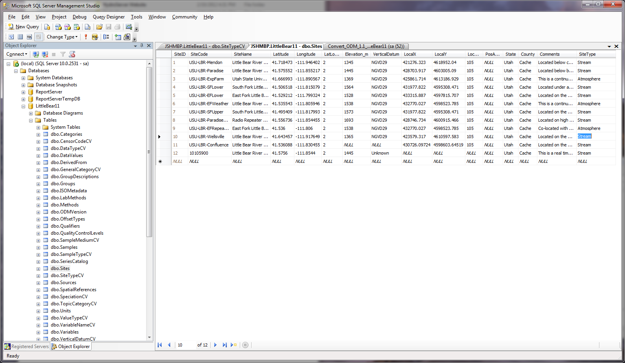

**NOTE**: If you have many sites in your ODM database, it might be easier to write a SQL script to update them all at once rather than typing the SiteType for each one in the Sites table.

1. As a final step, you will want to make sure that the SiteTypes you have set in the Sites table get propagated to the SeriesCatalog table. You can easily do this by executing the spUpdateSeriesCatalog stored procedure. In the Object Explorer, expand the “Programmability” folder under your ODM database. Then expand the “Stored Procedures” folder. You should see the following:

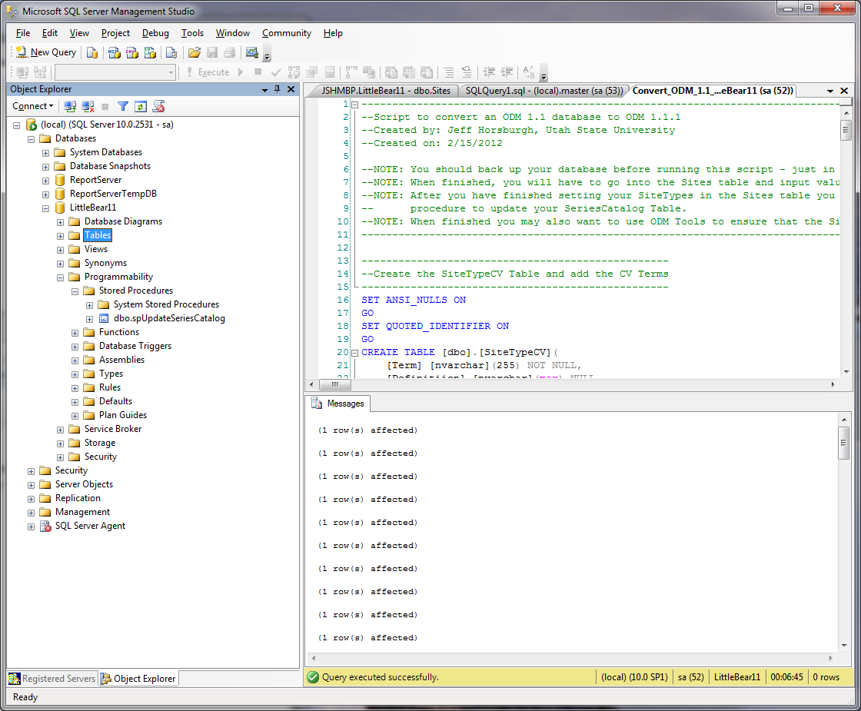

1. Right click on “spUpdateSeriesCatalog” and select “Execute stored procedure” from the context menu. Click the “OK” button at the bottom of the window that pops up. When the stored procedure has completed running, you will see a single record in the Results panel:

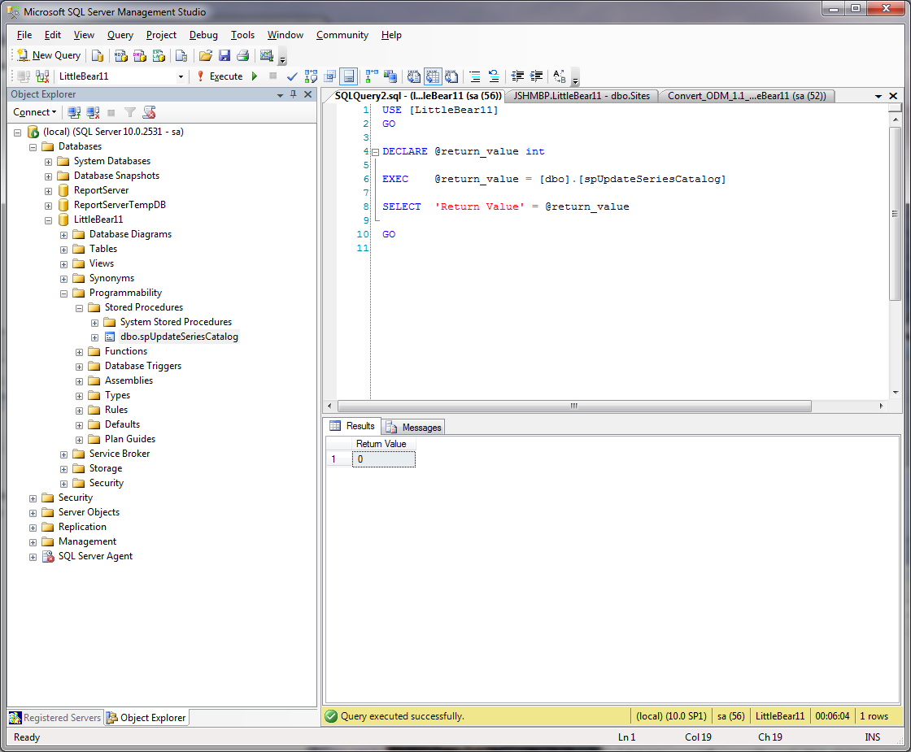

1. As a last step in the process you may want to connect to your ODM database using ODM Tools to ensure that your SiteTypeCV table is up to date. Consult the ODM Tools software manual for instructions on how to do this.
2. Congratulations! Your ODM 1.1 database has now been converted to ODM 1.1.1.

1. Utah Water Research Laboratory, Utah State University, Logan, UT 84322-8200, jeff.horsburgh@usu.edu