# Getting Started with ODM 1.1 for MySQL

# Instructions for Creating a Blank ODM 1.1 Database Within an Instance of MySQL

Jeffery S. Horsburgh[1]

8-25-2011

**Introduction**

This document describes how to create a blank ODM 1.1 database within your instance of MySQL so you can get started using ODM. In order to do so, you must be running a version of MySQL. These instructions are written using a product called MySQL Workbench installed on a Windows 7 machine. MySQL Workbench is a cross-platform, visual database design tool developed by MySQL. MySQL Workbench is available as a native GUI tool on Windows, Linux, and OS X in different editions and is available for free download at <http://wb.mysql.com/>.

You will also need to download the MySQL dump file, which is a SQL script that creates the ODM schema within a blank MySQL database. You can download the required script file at

<http://his.cuahsi.org/odmdatabases.html>.

**Creating a Blank Database**

The general process for creating an ODM database within MySQL involves creating a new empty database schema and then using the ODM MySQL dump file, which is a SQL script, to create the tables, relationships, constraints, etc. of ODM within the empty MySQL database.

The following are the steps required to create a new blank database within which you can create your ODM schema:

1. Open MySQL Workbench by clicking Start --> All Programs --> MySQL --> MySQL Workbench. The following window will open:

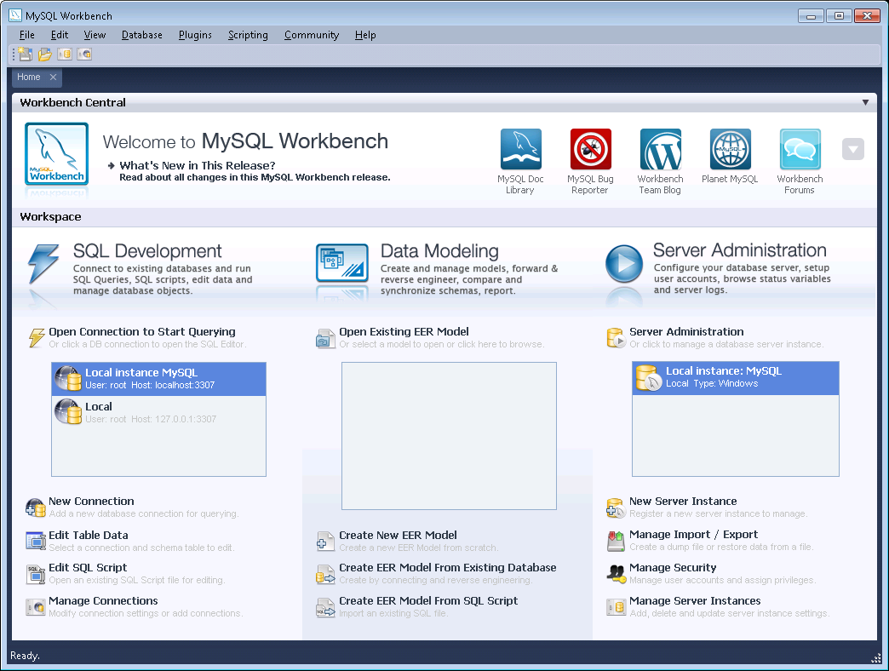

1. Under the SQL Development area, make sure the correct instance of MySQL is selected - i.e., the instance within which you want to create the database. For this example we will use "Local instance MySQL."



1. Right click on the "Local instance MySQL" instance in the list and select "Query Database" from the context menu. The following window will open:

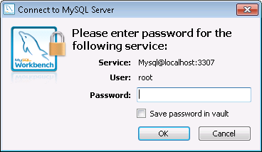

1. Enter your password and click the "OK" button to continue. Your MySQL Workbench window will now look something like the following:

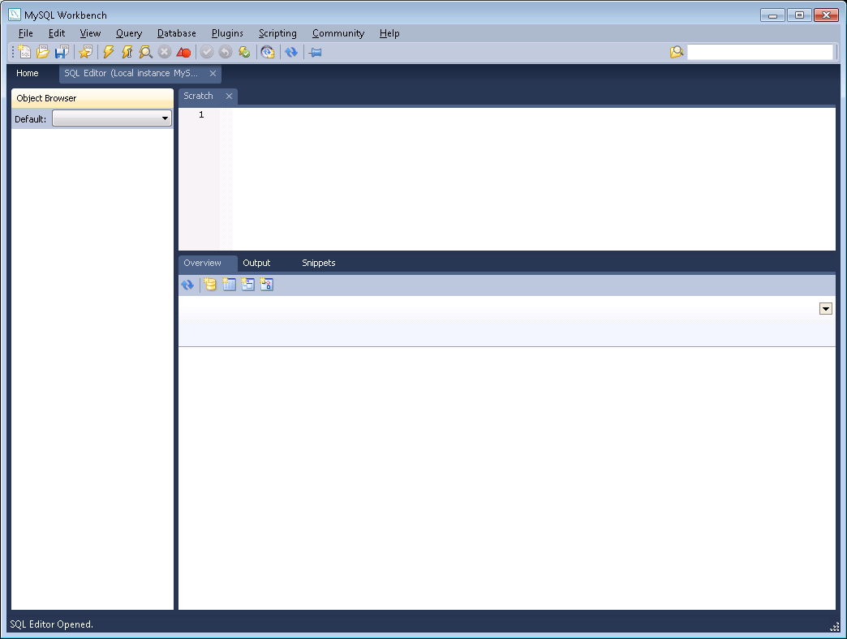

1. Right click within the Object Browser at the left of the window and select "Create Schema" from the context menu.
2. On the window that pops up, specify a name for your new database schema in the "Name" text box (for this example I have called my new schema "ODMDatabase") and then click the "Apply" button at the bottom of the form.

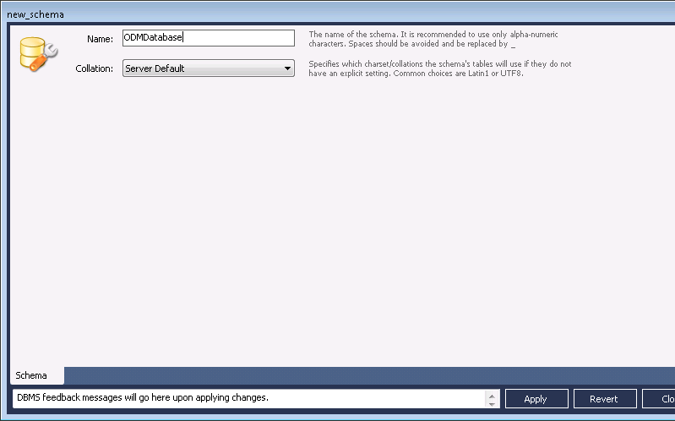

1. Another window will pop up summarizing the SQL Script that will create the database. Click the Apply button, and then click the "Finish" button

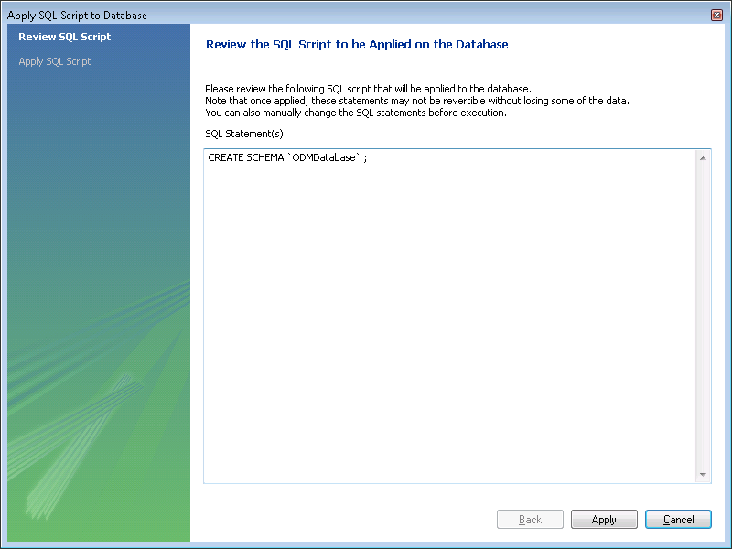

1. You will now notice that a new database has appeared in the Object Browser within the MySQL Workbench.

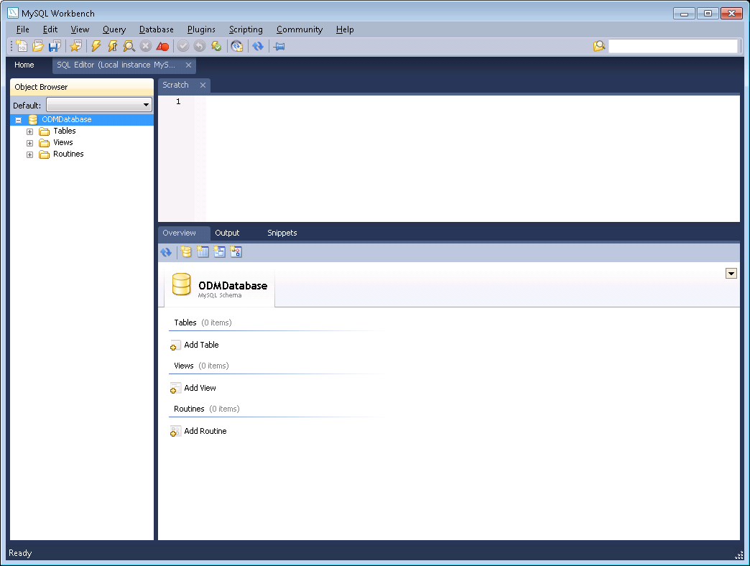

1. The next step is to execute the SQL script that will create all of the ODM tables, relationships, constraints, etc. In MySQL Workbench, click the "File" pull down menu and select "Open SQL Script." A file browser will open. Navigate to the ODM SQL script, select it in the file browser, and then click the "Open" button.

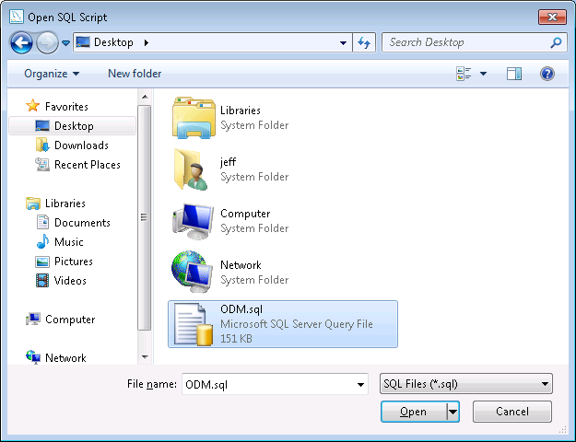

1. You will notice that the script has now been opened in the SQL Editor in MySQL Workbench.

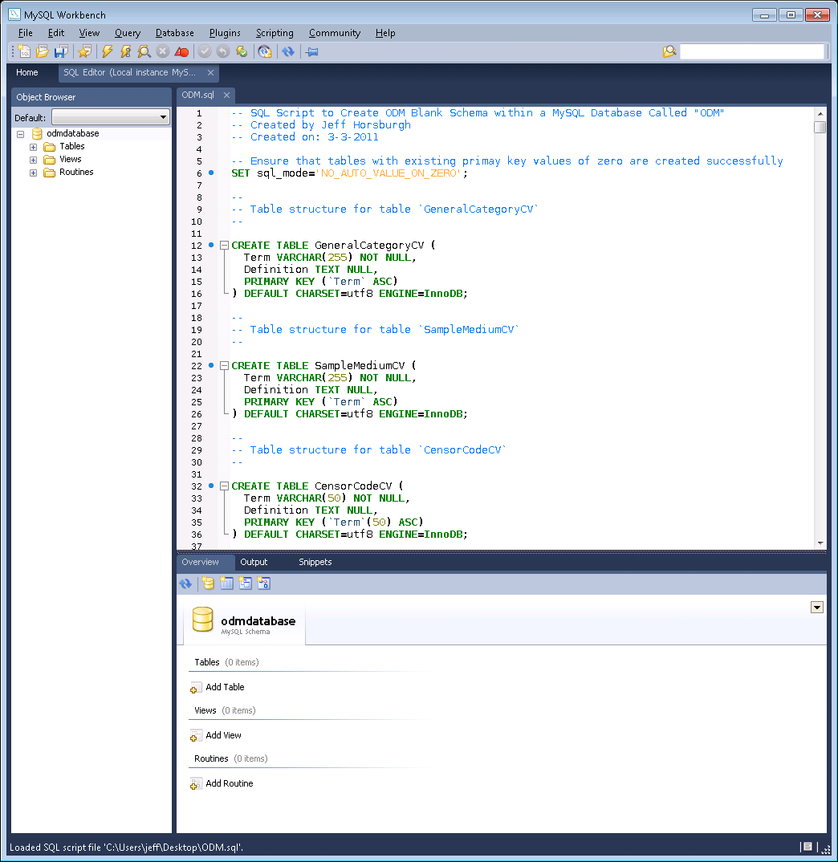

1. Next, you need to select your new blank database so that the commands in the script will target your new database. At the top of the "Object Browser", click the pull down box next to the "Default" label and select your blank database (in this example, the "odmdatabase" that we just created).

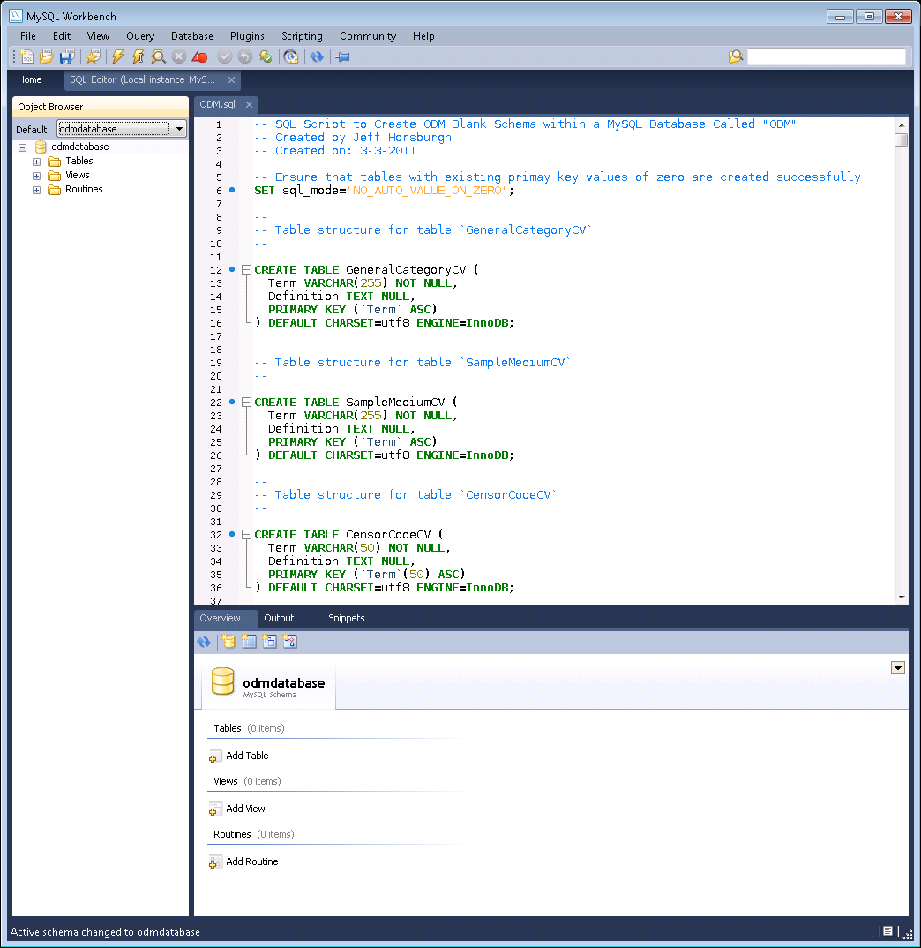

1. Click the execute button on the toolbar (the lightening bolt icon) to execute the script. You will notice at the bottom of the MySQL Workbench window that the progress of the script commands is shown.
2. When the script has finished, you can right click on the database name in the Object Browser and select "Refresh All". You will then be able to expand the "Tables" folder under the database to see the ODM tables that have been added to your database.

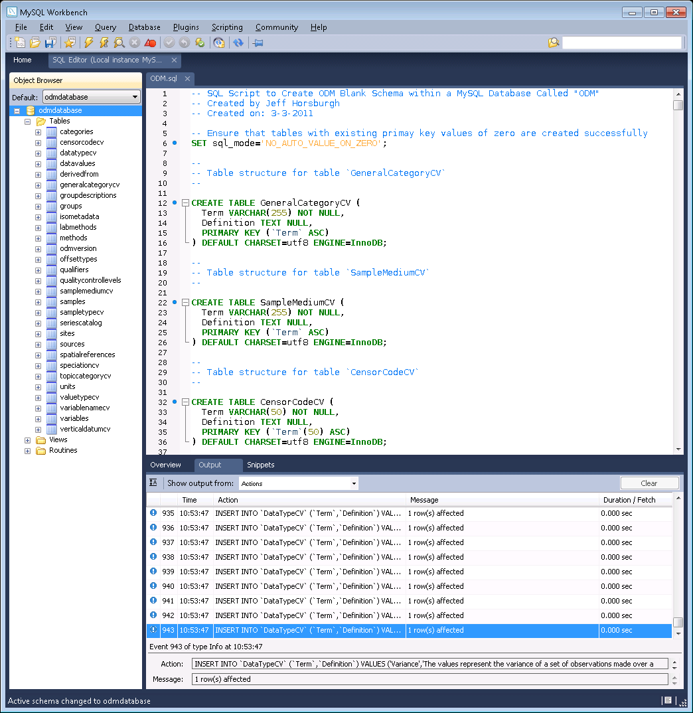

1. Although there is no data in your blank ODM database, you can view the contents of the controlled vocabulary tables in your database by right clicking on them in the Object Browser and choosing “Select Rows - Limit 1000” from the context menu. The contents of the table will be shown in the "Output" area at the bottom of the MySQL Workbench window.
2. Congratulations! You now have a blank ODM database in your instance of MySQL and you can start loading data.

1. Utah Water Research Laboratory, Utah State University, Logan, UT 84322-8200, jeff.horsburgh@usu.edu