

HydroServer Map

A Web application for presenting spatial and temporal data on a HydroServer

August 2011

Prepared by:

Jeffery S. Horsburgh

Utah Water Research Laboratory

Utah State University

Distribution

The HydroServer Map and all associated source code and documentation are available at the following URL: [http://his.cuahsi.org/](http://his.cuahsi.org/odmdataloader.html).

The HydroServer Map software, source code, and documentation are provide free of charge under the Berkeley Software Distribution (BSD) license. Please see the following license information:

Copyright (c) 2009, Utah State University

All rights reserved.

Redistribution and use in source and binary forms, with or without modification, are permitted provided that the following conditions are met:

* Redistributions of source code must retain the above copyright notice, this list of conditions and the following disclaimer.
* Redistributions in binary form must reproduce the above copyright notice, this list of conditions and the following disclaimer in the documentation and/or other materials provided with the distribution.
* Neither the name of Utah State University nor the names of its contributors may be used to endorse or promote products derived from this software without specific prior written permission.

THIS SOFTWARE IS PROVIDED BY THE COPYRIGHT HOLDERS AND CONTRIBUTORS "AS IS" AND ANY EXPRESS OR IMPLIED WARRANTIES, INCLUDING, BUT NOT LIMITED TO, THE IMPLIED WARRANTIES OF MERCHANTABILITY AND FITNESS FOR A PARTICULAR PURPOSE ARE DISCLAIMED. IN NO EVENT SHALL THE COPYRIGHT OWNER OR CONTRIBUTORS BE LIABLE FOR ANY DIRECT, INDIRECT, INCIDENTAL, SPECIAL, EXEMPLARY, OR CONSEQUENTIAL DAMAGES (INCLUDING, BUT NOT LIMITED TO, PROCUREMENT OF SUBSTITUTE GOODS OR SERVICES; LOSS OF USE, DATA, OR PROFITS; OR BUSINESS INTERRUPTION) HOWEVER CAUSED AND ON ANY THEORY OF LIABILITY, WHETHER IN CONTRACT, STRICT LIABILITY, OR TORT (INCLUDING NEGLIGENCE OR OTHERWISE) ARISING IN ANY WAY OUT OF THE USE OF THIS SOFTWARE, EVEN IF ADVISED OF THE POSSIBILITY OF SUCH DAMAGE.

Disclaimers

Although much effort has been expended in the development and testing of the software described in this document, errors and inadequacies may still occur. Users must make the final evaluation as to the usefulness of this software for their application.

The HydroServer Map and this software manual are based upon work supported by the National Science Foundation (NSF) under Grants No. 03-26064, and 06-10075 and by the Inland Northwest Research Alliance (INRA). Any opinions, findings, and conclusions or recommendations expressed in this material are those of the author and do not necessarily reflect the views of NSF or INRA.

Acknowledgements

The team of engineers and software developers that developed the software described in this document includes:

**Jeffery S. Horsburgh**, Research Assistant Professor, Civil and Environmental Engineering, Utah Water Research Laboratory, Utah State University, Logan, UT.

**Justin Berger**, Programmer, Utah Water Research Laboratory, Utah State University, Logan, UT

**Ben Morris**, Programmer, Utah Water Research Laboratory, Utah State University, Logan, UT

**David G. Tarboton**, Professor, Civil and Environmental Engineering, Utah Water Research Laboratory, Utah State University, Logan, UT.

**Kim Schreuders**, System Administrator, Utah Water Research Laboratory, Utah State University, Logan, UT

**Stephanie Reeder**, Programmer, Utah Water Research Laboratory, Utah State University, Logan, UT

Technical Support

There is no formal ongoing support for this freely distributed open source software. However, we are interested in feedback. If you find errors, have suggestions, or are interested in any later versions, please contact:

Jeffery S. Horsburgh

Utah State University

8200 Old Main Hill

Logan, UT 84322-8200

jeff.horsburgh@usu.edu

Table of Contents

1.0 Introduction and Software Description 1

1.1 General Functionality 1

1.2 Platform and Minimum System Requirements 1

2.0 Installation Information 2

2.1 Installation Prerequisites 2

2.1.1 Setting Up a Domain for Your HydroServer 2

2.4 Installing and Configuring the HydroServer Map 3

3.0 The HydroServer Map Calling Interface 9

# 1.0 Introduction and Software Description

The CUAHSI Hydrologic Information System (HIS) Project is developing information technology infrastructure to support hydrologic science. One of the major components of the HIS is a software stack called HydroServer that can be used for storing and publishing hydrologic data. HydroServer includes a point Observations Data Model (ODM), which is a relational database schema that was designed for storing time series data, a suite of data loaders and tools for working with ODM, the WaterOneFlow Web services that publish data stored in an ODM database on the Internet in WaterML format, and the capability to publish geographic information systems (GIS) datasets as spatial data services. Using the HydroServer software stack, server administrators can create any number of observational data services published using the WaterOneFlow web services as well as any number of spatial data services published as Open Geospatial Consortium (OGC) services. The HydroServer Map application was created as user interface to the observational and GIS data services published on a HydroServer.

## 1.1 General Functionality

The HydroServer Map is a Web application that was created for visualizing within a Web browser the GIS and observational data services that have been published for a particular region on a HydroServer. A “region” can be an experimental watershed, research site, or other geographic area within which data are being collected, and each region can have its own map. A region’s map can contain multiple observational data services (i.e., a combination of an ODM database and WaterOneFlow web service) and multiple GIS data services (a GIS dataset or map published as a service in ArcGIS Server). The definition of the set of observational services and GIS data services that are linked to a region and displayed within its map is stored in the HydroServer Capabilities database.

The HydroServer Map connects to the HydroServer Capabilities database and dynamically builds its content from tables within the database. Because it is capable of creating a map within the user’s Web browser for any of the regions for which data are hosted on the HydroServer, HydroServer administrators can add new regions and/or services to their HydroServer by adding their descriptions to the HydroServer Capabilities database, after which the Map application can automatically present the new region or service in the Web browser. All of this is done without modifying the source code of the Map application.

## 1.2 Platform and Minimum System Requirements

The HydroServer Map was designed to be used on HydroServers running Windows Server 2003 or Windows Server 2008. It requires Microsoft IIS as the Web server and ArcGIS Server as the GIS Server. HydroServers must have the Microsoft .Net Framework Version 3.5 installed prior to installing the HydroServer Map. Instructions for obtaining the .Net Framework Version 3.5 from Microsoft are included in the Installation Instructions section below. The HydroServer Map also requires an instance of the HydroServer Capabilities database implemented within Microsoft SQL Server 2005 or 2008.

# 2.0 Installation Information

## 2.1 Installation Prerequisites

Prior to installing the HydroServer Map, you must first install the Microsoft .Net Framework Version 3.5 and Microsoft IIS. If you have Microsoft SQL Server 2008 installed, Version 3.5 of the .Net framework will be installed already. The .Net Framework Version 3.5 is free, and is required to run software applications developed in Microsoft’s Visual Studio .Net 2008. If you are running Windows Server 2008 R2, the .Net Framework Version 3.5 is included as part of your operating system, and you can add it as a Windows Feature using the Windows Server 2008 Server Manager. If you are running Windows Server 2003, instructions for downloading and installing the .Net Framework Version 3.5 can be obtained from the Microsoft website via the following URL:

<http://www.microsoft.com/downloads/details.aspx?FamilyId=AB99342F-5D1A-413D-8319-81DA479AB0D7&displaylang=en>

Additionally, you must have ArcGIS Server 9.3.1 installed on the server on which you will be installing the HydroServer Map prior to installing the HydroServer Map. The HydroServer Map was built using the ArcGIS Server Application Developer’s Framework (ADF) and will not work on a machine that does not have ArcGIS Server 9.3.1 installed.

Implementing the HydroServer Map also requires that you have an instance of the HydroServer Capabilities database attached to SQL Server. It is helpful to install the HydroServer Time Series Analyst before you install the HydroServer Map so that you know what the URL for your Time Series Analyst will be.

NOTE: The HydroServer Capabilities database does not have to be on the same physical machine as the HydroServer Map; however, the HydroServer Map does require a direct SQL connection to the HydroServer Capabilities database using a SQL Server authentication login. If you do not already have a HydroServer Capabilities database, please consult the HydroServer Capabilities software manual for instructions on how to create one.

### 2.1.1 Setting Up a Domain for Your HydroServer

Prior to installing the HydroServer Web applications – e.g., the HydroServer Website, the HydroServer Map, the Time Series Analyst, the WaterOneFlow Web Services, and the HydroServer Capabilities Web Services – you will want to create a domain for your HydroServer. You will need to work with the Information Technology professionals within your organization to help you create a domain. Once a domain has been created for your HydroServer, you can proceed in the setup of the HydroServer software.

In implementing the HydroServer Web applications, it is helpful to understand the structure of the overall deployment so that each of the pieces can be implemented correctly. The HydroServer Website was designed to be a parent, or root level, application within a domain that you set up for your HydroServer. For example, if you were to create a domain name for your HydroServer called “icewater.usu.edu,” the URL for your HydroServer Website would be at the root level of that domain (i.e., <http://icewater.usu.edu/> would be the URL for your HydroSerever Website). Each of the other HydroServer Web applications was designed to be a child application of the HydroServer domain. The following shows how the other HydroServer Web applications would be implemented under the HydroServer Website within the same domain:

<http://icewater.usu.edu/tsa/> - The Time Series Analyst

<http://icewater.usu.edu/map/> - The HydroServer Map application

<http://icewater.usu.edu/HydroServerCapabilities/> - the HydroServer Capabilities Web service

<http://icewater.usu.edu/LittleBearRiver/> - a WaterOneFlow web service for the Little Bear River experimental watershed

<http://icewater.usu.edu/MudLake/> - a WaterOneFlow web service for data collected within Mud Lake at the Bear Lake National Wildlife Refuge

The above example assumes that your HydroServer is serving as the Web server running Microsoft Internet Information Services (IIS), as the database server running Microsoft SQL Server, and as the GIS server running ArcGIS Server. This doesn’t have to be the case, though, and there is quite a lot of flexibility for the components of your HydroServer to be spread across multiple machines and implemented within multiple domains. In general, the HydroServer documentation assumes that you are assembling your HydroServer within a single domain.

## 2.4 Installing and Configuring the HydroServer Map

Use the following steps to install and configure the HydroServer Map. The following steps were written for a web server running Windows Server 2008, IIS Version 7.0, and ArcGIS Server 9.3.1.

1. The HydroServer Map application is distributed as a zip file that contains the application directory. Extract the “HydroServerMap” folder from the zip file (“HydroServerMap.zip”) to a web application directory on your HydroServer. For this example, I have set up a folder called “icewater” under my “c:\inetpub\wwwroot\” path. Within the “icewater” folder, I have copied the “HydroServerMap” folder (see the following figure), which contains the application folders and files.

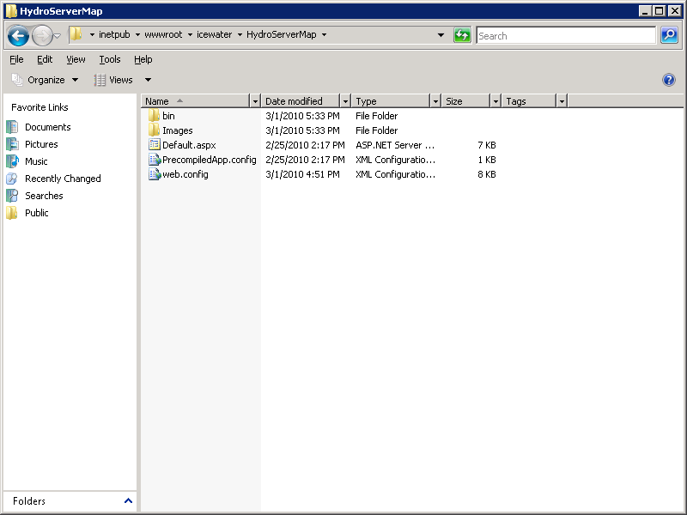

NOTE: In this example, I have put the HydroServer Map files within a folder called “icewater” within my “c:\inetpub\wwwroot\” folder. I might do this if I were building a HydroServer within a domain called “icewater,” e.g., if the URL for my HydroServer Website was something like <http://icewater.usu.edu>. This folder can also contain the other Web applications that are part of HydroServer, including the HydroServer Capabilities Web service, the HydroServer Website, and the WaterOneFlow web services.

1. Open the Internet Information Services (IIS) Manager by clicking Start 🡪 Administrative Tools 🡪 Internet Information Services (IIS) Manager. The following window will appear.

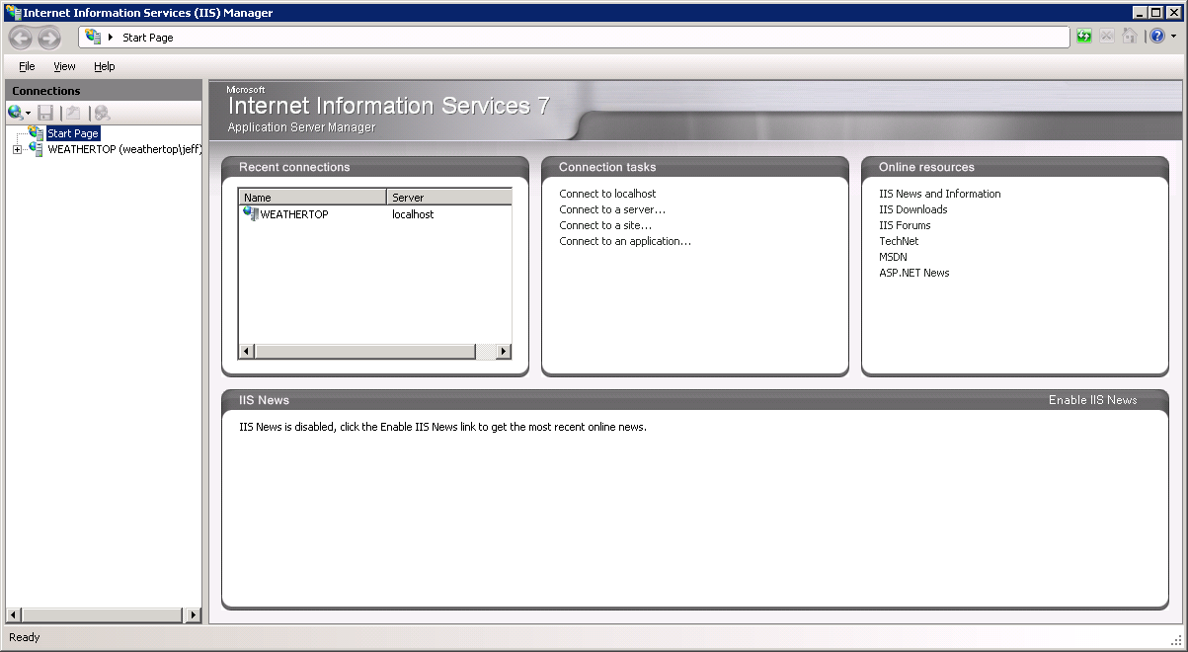

1. Expand your server in the tree view at the left of the form by clicking on the plus sign next to its name. Then, expand the “Sites” element by clicking on the plus sign.
2. Since the HydroServer Map was created in Microsoft Visual Studio 2008, we will first create an Application Pool for running it. In the tree view on the left, right click on “Application Pools” and select “Add Application Pool”. The following window will appear.

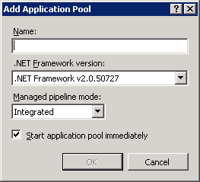

1. Create a name for the Application Pool in the “Name:” text box. For this example, we will call our Application Pool “HydroServer.” Make sure that “.NET Framework v2.0.50727” is selected in the “.Net Framework version:” text box. From the “Managed pipeline mode:” drop down box, make sure that “Integrated” is selected. Ensure that the check box next to “Start application pool immediately” is checked. Your form should look like the following:

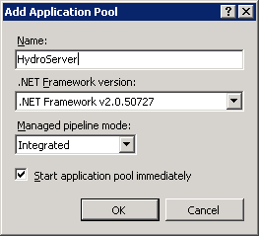

NOTE: In this example we are creating an Application Pool called “HydroServer.” We have chosen the “Integrated” Managed pipeline mode because the HydroServer Map was created using Visual Studio 2008. If you implement other HydroServer web applications that were developed in Visual Studio 2008 (e.g., the HydroServer Website, the HydroServer Capabilities Web Service, or the Time Series Analyst), you can reuse the same Application Pool for those applications.

1. For this example, we will implement the HydroServer Map as an application under the default website on your server. See the note below about setting the HydroServer Map up as an application under a website other than the default website. In the IIS Manager, right click on the name of the website (in this example “Default Web Site”) in the tree view at the left side of the form and then select “Add Application” from the context menu. The following window will open:

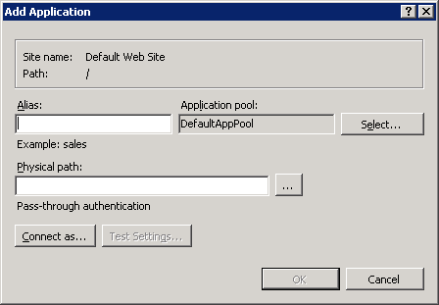

1. In the “Alias:” text box, give your map a name. For this example, we will simply call it “map.”
2. Click the “Select” button next to the “Application pool:” box. In the “Select Application Pool” form that pops up, select the application pool that you just created (for this example, “HydroServer”) from the “Application pool” drop down list and then click “OK”.

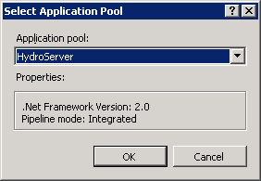

1. Click the “…” navigate button next to the “Physical path:” box. The following window will open. Navigate to and select the folder where you extracted the HydroServer Map application files (e.g., c:\inetpub\wwwroot\icewater\HydroServerMap”). Then click the “OK” button.

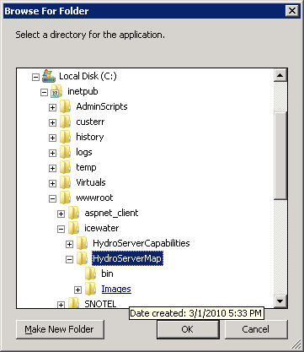

1. Your “Add Application” form should now look something like the following.

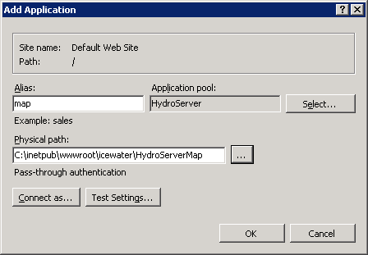

1. Click the “OK” button to complete this step. You will now notice that there is a new application under your website called “map.”

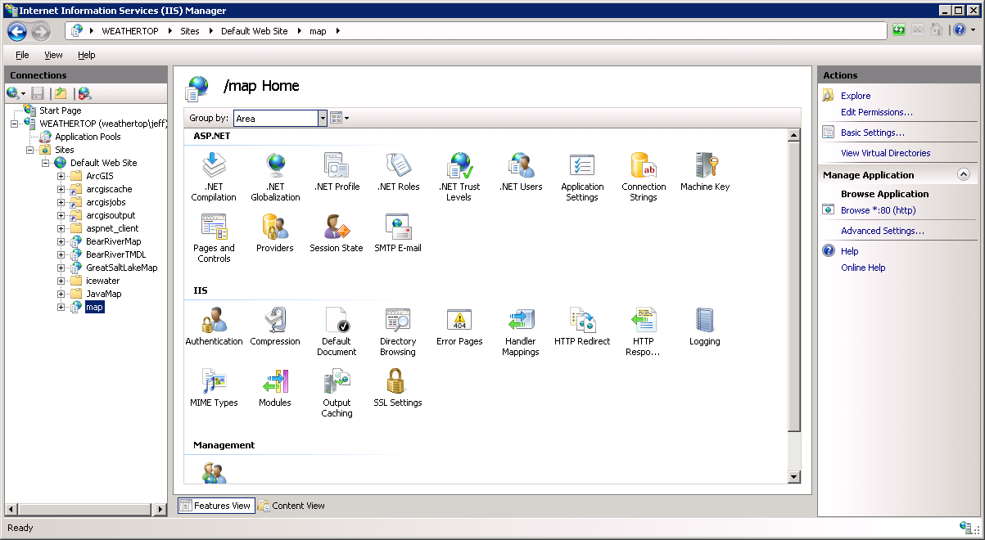

NOTE: The process for setting up the HydroServer Map under a website other than the default web site is similar to setting it up under the default website in IIS. However, you must first have created the alternative website in IIS before you can do this. In the example above, since I implemented the HydroServer Map under the default website on a machine called “weathertop.uwrl.usu.edu”, my HydroServer Map will have a URL path of <http://weathertop.uwrl.usu.edu/map/>. If I wanted my HydroServer Website to have a different URL, I would first have to set up an appropriate domain name and then set up a website in IIS to handle that domain name. For example, I could register a domain name called “icewater.usu.edu” and have it pointed at this same machine. I would then create a website in IIS called “HydroServer” that would handle the “icewater.usu.edu” domain. Then, I would follow the steps above to set up the HydroServer Map under the “HydroServer” website in IIS. The path for my HydroServer Website would then be <http://icewater.usu.edu/> and the path for the HydroServer Map would be <http://icewater.usu.edu/map/>. If you wish to register alternate domain names for your HydroServer, you will need to work with the individuals in charge of your IT infrastructure.

1. Next, we need to tell the HydroServer Map how to connect to the HydroServer Capabilities SQL Server database. Make sure that the HydroServer Map application is selected in the tree view at the left of the IIS Manager window. Under the “ASP.NET” icon group in the middle section of the IIS Manager form, double click on the “Connection Strings” icon. This will open the connection strings editor within the IIS Manager.

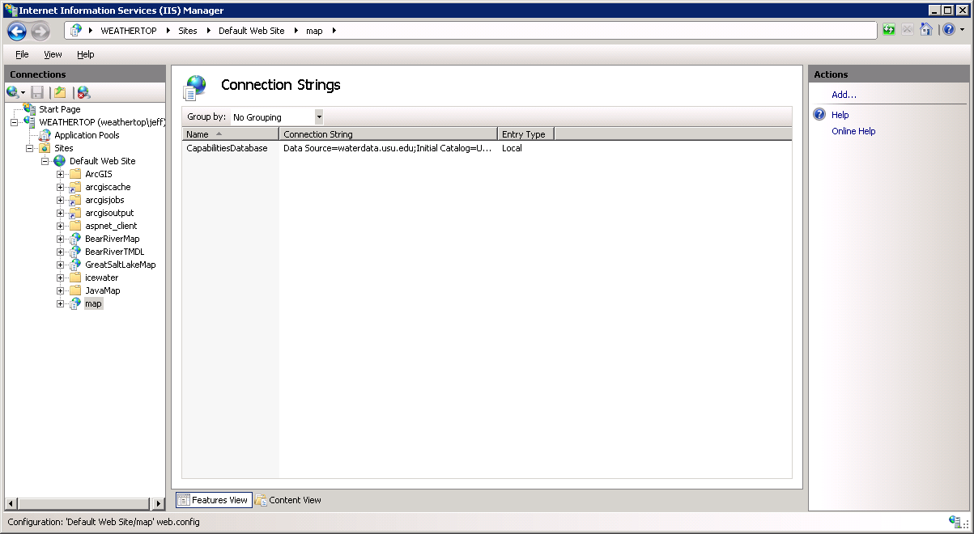

1. Double click on the “CapabilitiesDatabase” line. The following form will open:

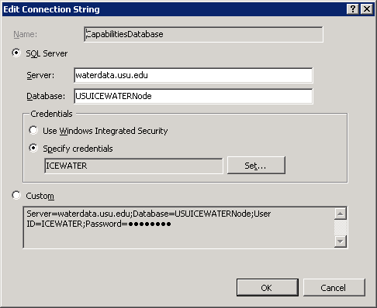

1. On this form, you need to edit the items to match the location and user credentials for your HydroServer Capabilities database. Using the figure above, fill in the appropriate values for your database and server. In this example, I am connecting the HydroServer Map to a HydroServer Capabilities database called “USUICEWATERNode” on a SQL Server machine called “waterdata.usu.edu.” I have created a SQL Server user with read only access to that database called “ICEWATER.” To specify your SQL Server username and password, click the “Set” button next to the “Specify credentials” radio button and text box. You will notice that the connection string for your database is automatically created for you in the text box at the bottom of the form. Click the “OK” button when you are finished.

NOTE: Since the HydroServer Map is a public web application, you want to make sure that you create a SQL Server user within your HydroServer Capabilities database that has read only access for use in specifying the connection from the HydroServer Map. You can do this within SQL Server Management Studio.

1. Next, we need to edit a couple of application settings for our HydroServer Map. These application settings include a default region and the URL of your HydroServer Time Series Analyst. Click on the name of the HydroServer Map application in the tree view of the IIS Manager to exit the Connection Strings editor. Then, double click on the “Application Settings” icon in the middle section of the IIS Manager form under the ASP.Net group. This will open the application settings editor in IIS:

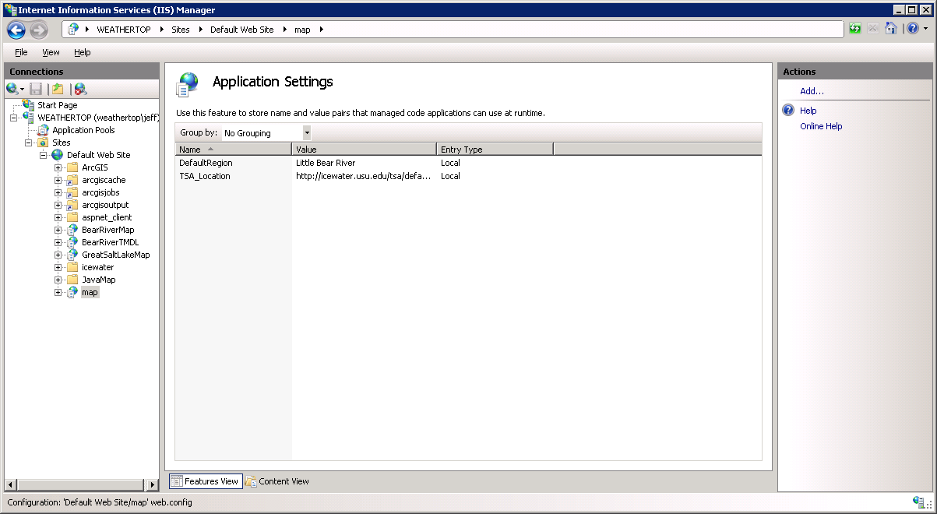

1. You will notice that there are two items in the list of application settings that need to be edited by you to ensure that your HydroServer Map functions correctly. Double click in the item called “DefaultRegion.” The following window will open:

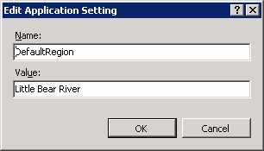

1. You need to set the text in the “Value” text box to the name of one of the regions for which you have published data on your HydroServer. This setting specifies a default for the map application so it can load data for a region if someone navigates to its base URL. The value of this setting can be set to the name of any of the regions in your HydroServer Capabilities Database. **Do not edit the text in the “Name” text box!** When you have edited the text in the “Value” box, click the OK button to continue.
2. Double click on the setting called “TSA_Location.” The following window will open:

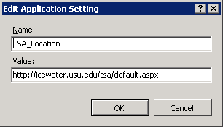

1. Set the text in the “Value” text box to the base URL of your HydroServer Time Series Analyst. See the above figure for an example. You must include the “default.aspx” part of the URL in this setting. Click on the OK button when you are finished.

NOTE: If you have not installed your HydroServer Time Series Analyst yet, you will have to supply the URL to where it will be installed on your HydroServer. The HydroServer Map launches the Time Series Analyst when users click on a monitoring site on the map, and so it needs the base URL for where your TSA is located.

1. Congratulations! Your HydroServer Map setup is now complete. You should be able to navigate to your HydroServer Map in a web browser. For this example, the URL would be <http://weathertop.uwrl.usu.edu/map/> as we set it up under the Default Website on a machine called “weathertop.uwrl.usu.edu.”

# 3.0 The HydroServer Map Calling Interface

The HydroServer Map can be launched in a specified state by passing a region name as a parameter to the application in the URL string. When you specify a region in the URL string for the HydroServer Map, it is launched and loads data for the specified region. If you do not specify a region in the URL when you launch the HydroServer Map, it will load data for the default region that you set in the application settings for the Map. The following are examples of what a fully qualified URL for the HydroServer Map might look like:

[http://icewater.usu.edu/map/default.aspx?Region=Little Bear River](http://icewater.usu.edu/map/default.aspx?Region=Little%20Bear%20River)

[http://icewater.usu.edu/map/default.aspx?Region=Mud Lake](http://icewater.usu.edu/map/default.aspx?Region=Mud%20Lake)