

HydroServer Website

A Web application for presenting the capabilities of a HydroServer

May 2010

Prepared by:

Jeffery S. Horsburgh

Utah Water Research Laboratory

Utah State University

Distribution

The HydroServer Website and all associated source code and documentation are available at the following URL: [http://his.cuahsi.org/](http://his.cuahsi.org/odmdataloader.html).

The HydroServer Website software, source code, and documentation are provide free of charge under the Berkeley Software Distribution (BSD) license. Please see the following license information:

Copyright (c) 2009, Utah State University

All rights reserved.

Redistribution and use in source and binary forms, with or without modification, are permitted provided that the following conditions are met:

* Redistributions of source code must retain the above copyright notice, this list of conditions and the following disclaimer.
* Redistributions in binary form must reproduce the above copyright notice, this list of conditions and the following disclaimer in the documentation and/or other materials provided with the distribution.
* Neither the name of Utah State University nor the names of its contributors may be used to endorse or promote products derived from this software without specific prior written permission.

THIS SOFTWARE IS PROVIDED BY THE COPYRIGHT HOLDERS AND CONTRIBUTORS "AS IS" AND ANY EXPRESS OR IMPLIED WARRANTIES, INCLUDING, BUT NOT LIMITED TO, THE IMPLIED WARRANTIES OF MERCHANTABILITY AND FITNESS FOR A PARTICULAR PURPOSE ARE DISCLAIMED. IN NO EVENT SHALL THE COPYRIGHT OWNER OR CONTRIBUTORS BE LIABLE FOR ANY DIRECT, INDIRECT, INCIDENTAL, SPECIAL, EXEMPLARY, OR CONSEQUENTIAL DAMAGES (INCLUDING, BUT NOT LIMITED TO, PROCUREMENT OF SUBSTITUTE GOODS OR SERVICES; LOSS OF USE, DATA, OR PROFITS; OR BUSINESS INTERRUPTION) HOWEVER CAUSED AND ON ANY THEORY OF LIABILITY, WHETHER IN CONTRACT, STRICT LIABILITY, OR TORT (INCLUDING NEGLIGENCE OR OTHERWISE) ARISING IN ANY WAY OUT OF THE USE OF THIS SOFTWARE, EVEN IF ADVISED OF THE POSSIBILITY OF SUCH DAMAGE.

Disclaimers

Although much effort has been expended in the development and testing of the software described in this document, errors and inadequacies may still occur. Users must make the final evaluation as to the usefulness of this software for their application.

The HydroServer Website and this software manual are based upon work supported by the National Science Foundation (NSF) under Grants No. 03-26064, and 06-10075 and by the Inland Northwest Research Alliance (INRA). Any opinions, findings, and conclusions or recommendations expressed in this material are those of the author and do not necessarily reflect the views of NSF or INRA.

Acknowledgements

The team of engineers and software developers that developed the software described in this document includes:

**Jeffery S. Horsburgh**, Research Assistant Professor, Civil and Environmental Engineering, Utah Water Research Laboratory, Utah State University, Logan, UT.

**Ben Morris**, Programmer, Utah Water Research Laboratory, Utah State University, Logan, UT

**David G. Tarboton**, Professor, Civil and Environmental Engineering, Utah Water Research Laboratory, Utah State University, Logan, UT.

**Kim Schreuders**, System Administrator, Utah Water Research Laboratory, Utah State University, Logan, UT

Technical Support

There is no formal ongoing support for this freely distributed open source software. However, we are interested in feedback. If you find errors, have suggestions, or are interested in any later versions, please contact:

Jeffery S. Horsburgh

Utah State University

8200 Old Main Hill

Logan, UT 84322-8200

jeff.horsburgh@usu.edu

Table of Contents

1.0 Introduction and Software Description 5

1.1 General Functionality 5

1.2 Platform and Minimum System Requirements 5

2.0 Installation Information 6

2.1 Installation Prerequisites 6

2.1.1 Setting Up a Domain for Your HydroServer 6

2.4 Installing and Configuring the HydroServer Website 7

2.0 Customizing the HydroServer Website 13

2.1 Customizing the Look and Feel of the HydroServer Website 13

2.2 Advanced Configuration and Editing 14

Appendix A: Additional Required Setup Steps for Windows Server 2003 15

# 1.0 Introduction and Software Description

The CUAHSI Hydrologic Information System (HIS) Project is developing information technology infrastructure to support hydrologic science. One of the major components of the HIS is a software stack called HydroServer that can be used for storing and publishing hydrologic data. HydroServer includes a point Observations Data Model (ODM), which is a relational database schema that was designed for storing time series data, a suite of data loaders and tools for working with ODM, the WaterOneFlow Web services that publish data stored in an ODM database on the Internet in WaterML format, and the capability to publish geographic information systems (GIS) datasets as spatial data services. Using the HydroServer software stack, server administrators can create any number of observational data services published using the WaterOneFlow web services as well as any number of spatial data services published as Open Geospatial Consortium (OGC) services. The HydroServer Website was created as user interface for presenting the capabilities of a HydroServer (e.g., the list of data services published in the server and information about how to access them).

## 1.1 General Functionality

The HydroServer Website is a Web application that was created to present the capabilities of a HydroServer. It is intended to present the list of regions for which data have been published, the list of observational data services hosted by the server, the list of spatial data services hosted by the server, and the relationships between services and the regions that they represent. A region can be an experimental watershed, research site, or other geographic area within which data are being collected.

The HydroServer Website is a tool that enables data consumers to browse and preview the contents of a HydroServer in a Web browser. Additionally, it provides a visual identity for the server that can be customized by the server administrator. The HydroServer Website connects to the HydroServer Capabilities database and automatically generates much of the content on its pages from content within the database. Because of this, HydroServer administrators can add new regions and services to their HydroServer Website simply by adding their descriptions to the HydroServer Capabilities database.

## 1.2 Platform and Minimum System Requirements

The HydroServer Website was designed to be used on HydroServers running Windows Server 2003 or Windows Server 2008. It requires Microsoft IIS as the Web server. In addition, HydroServers must have the Microsoft .Net Framework Version 3.5 installed prior to installing the HydroServer Website. Instructions for obtaining the .Net Framework Version 3.5 from Microsoft are included in the Installation Instructions section below. The HydroServer Website also requires an instance of the HydroServer Capabilities database implemented within Microsoft SQL Server 2005 or 2008. The HydroServer Capabilities database does not have to be on the same physical machine as the HydroServer Website; however, the HydroServer Website does require a direct SQL connection to the HydroServer Capabilities database using a SQL Server authentication login.

# 2.0 Installation Information

## 2.1 Installation Prerequisites

Prior to installing the HydroServer Website, you must first install the Microsoft .Net Framework Version 3.5 and Microsoft IIS. If you have Microsoft SQL Server 2008 installed, Version 3.5 of the .Net framework will be installed already. The .Net Framework Version 3.5 is free, and is required to run software applications developed in Microsoft’s Visual Studio .Net 2008. If you are running Windows Server 2008 R2, the .Net Framework Version 3.5 is included as part of your operating system, and you can add it as a Windows Feature using the Windows Server 2008 Server Manager. If you are running Windows Server 2003, instructions for downloading and installing the .Net Framework Version 3.5 can be obtained from the Microsoft website via the following URL:

<http://www.microsoft.com/downloads/details.aspx?FamilyId=AB99342F-5D1A-413D-8319-81DA479AB0D7&displaylang=en>

Implementing the HydroServer Website also requires that you have an instance of the HydroServer Capabilities database attached to SQL Server. If you do not already have a HydroServer Capabilities database, please consult the HydroServer Capabilities software manual for instructions on how to create one. Prior to installing the HydroServer website, you should also complete the setup for your HydroServer Capabilities Web Services, the Time Series Analyst, and the HydroServer Map application. The HydroServer website presents links to each of these applications throughout its contents, so they should exist before you proceed with installing the HydroServer Website. Consult the software manuals for these applications for instructions on installing and configuring them.

### 2.1.1 Setting Up a Domain for Your HydroServer

Prior to installing the HydroServer Web applications – e.g., the HydroServer Website, the HydroServer Map Application, the Time Series Analyst, the WaterOneFlow Web Services, and the HydroServer Capabilities Web Services – you will want to create a domain for your HydroServer. You will need to work with the Information Technology professionals within your organization to help you create a domain for your HydroServer. Once a domain has been created for your HydroServer, you can proceed in the setup of the HydroServer software.

In implementing the HydroServer Web applications, it is helpful to understand the structure of the overall deployment so that each of the pieces can be implemented correctly. The HydroServer Website was designed to be a parent, or root level, application within a domain that you set up for your HydroServer. For example, if you were to create a domain name for your HydroServer called “icewater.usu.edu,” the URL for your HydroServer Website would be at the root level of that domain (i.e., <http://icewater.usu.edu/> would be the URL for your HydroServer Website). Each of the other HydroServer Web applications was designed to be a child application of the HydroServer domain. The following shows how the other HydroServer Web applications would be implemented under the HydroServer Website within the same domain:

<http://icewater.usu.edu/tsa/> - The Time Series Analyst

<http://icewater.usu.edu/map/> - The HydroServer Map application

<http://icewater.usu.edu/HydroServerCapabilities/> - the HydroServer Capabilities Web service

<http://icewater.usu.edu/LittleBearRiver/> - a WaterOneFlow web service for the Little Bear River experimental watershed

<http://icewater.usu.edu/MudLake/> - a WaterOneFlow web service for data collected within Mud Lake at the Bear Lake National Wildlife Refuge

The above example assumes that your HydroServer is serving as the Web server running Microsoft Internet Information Services (IIS), as the database server running Microsoft SQL Server, and as the GIS server running ArcGIS Server. This doesn’t have to be the case, though, and there is quite a lot of flexibility for the components of your HydroServer to be spread across multiple machines and implemented within multiple domains. In general, the HydroServer documentation assumes that you are assembling your HydroServer within a single domain.

## 2.4 Installing and Configuring the HydroServer Website

Use the following steps to install and configure the HydroServer Website. The following steps were written for a web server running Windows Server 2008 and IIS Version 7.0.

1. Copy the “HydroServerWebsite” folder from the zip file containing the HydroServer Website program files (“HydroServerWebsite.zip”) to a web application directory on your HydroServer. For this example, I have set up a folder called “icewater” under my “c:\inetpub\wwwroot\” path. I copied the “HydroServerWebsite” folder from the zip file to the “icewater” folder (see the following figure).

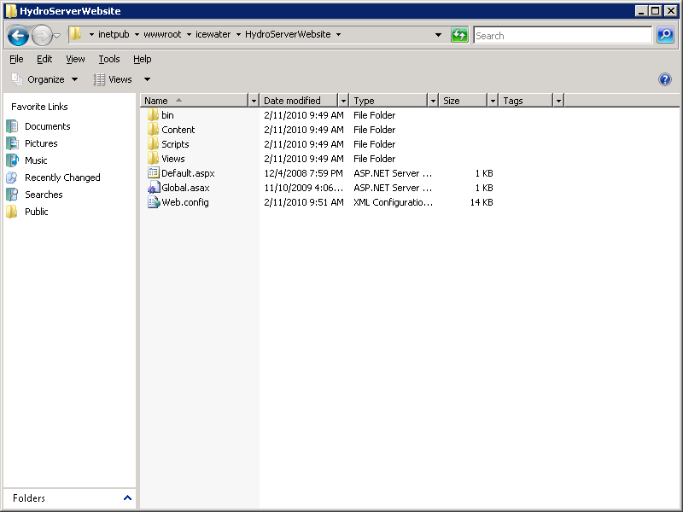

NOTE: In this example, I have put the HydroServer Website files within a folder called “icewater” within my “c:\inetpub\wwwroot\” folder. I might do this if I were building a HydroServer within a domain called “icewater,” e.g., if the URL for my HydroServer Website was something like <http://icewater.usu.edu>. This folder can also contain the other Web applications that are part of HydroServer, including the HydroServer Capabilities Web service, the HydroServer Website, and the WaterOneFlow web services.

1. Open the Internet Information Services (IIS) Manager by clicking Start 🡪 Administrative Tools 🡪 Internet Information Services (IIS) Manager. The following window will appear.

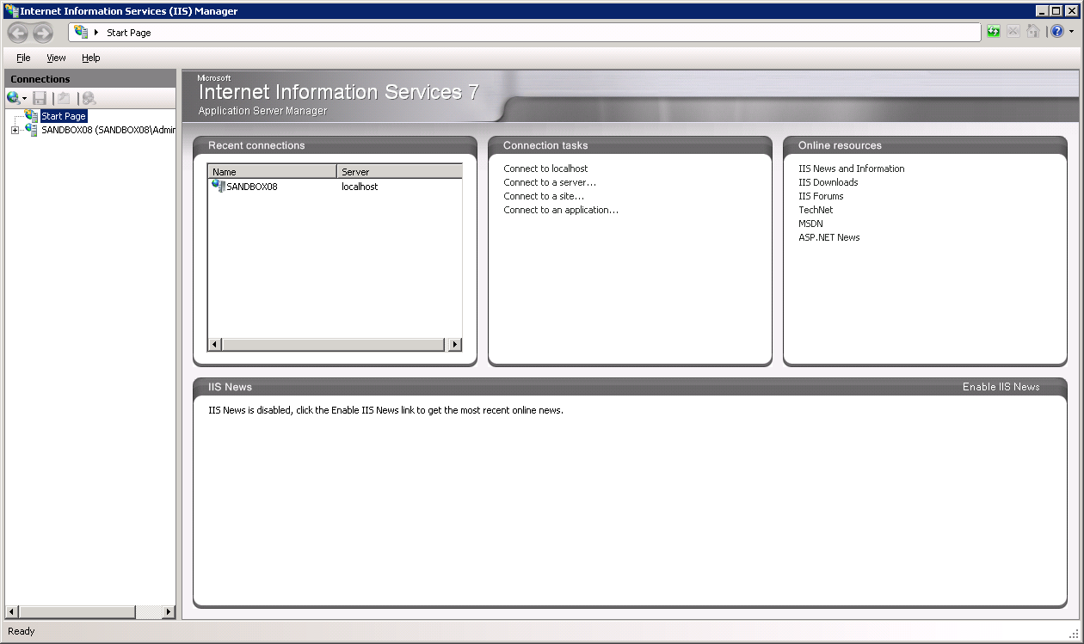

1. Expand your server in the tree view at the left of the form by clicking on the plus sign next to its name. Then, expand the “Sites” element by clicking on the plus sign.
2. Since the HydroServer Website was created in Microsoft Visual Studio 2008, we will first create an Application Pool for running it. In the tree view on the left, right click on “Application Pools” and select “Add Application Pool”. The following window will appear.

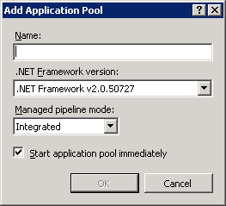

1. Create a name for the Application Pool in the “Name:” text box. For this example, we will call our Application Pool “HydroServer.” Make sure that “.NET Framework v2.0.50727” is selected in the “.Net Framework version:” text box. From the “Managed pipeline mode:” drop down box, make sure that “Integrated” is selected. Ensure that the check box next to “Start application pool immediately” is checked. Your form should look like the following:

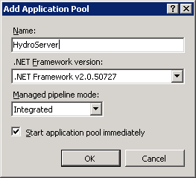

NOTE: In this example we are creating an Application Pool called “HydroServer.” We have chosen the “Integrated” Managed pipeline mode because the HydroServer website was created using Visual Studio 2008. If we implement other HydroServer web applications (e.g., the HydroServer Capabilities Web Service and the HydroServer Time Series Analyst) that were developed in Visual Studio 2008, we can reuse this Application Pool for those applications.

1. For this example, we will implement the HydroServer website as the default website on your server. If you would like to use a different website as the default website on your server, see the note below this section on setting the HydroServer Website up as a website other than the default website. In the IIS Manager, click on the name of the website (in this example “Default Web Site”) in the tree view at the left side of the form to select it. In the right hand column of the IIS manager under Actions 🡪 Edit Site you will see a link called “Basic Settings.” Click on that link to open the following window:

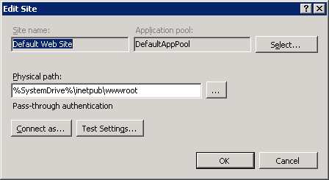

1. Click the “Select” button next to the “Application pool:” box. In the “Select Application Pool” form that pops up, select the application pool that we just created (in this example, “HydroServer”) from the “Application pool” drop down list and then click “OK”.

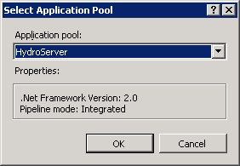

1. Click the “…” navigate button next to the “Physical path:” box. The following window will open. Navigate to and select the folder where you extracted the HydroServer Website application files (e.g., c:\inetpub\wwwroot\icewater\HydroServerWebsite”). Then click the “OK” button.

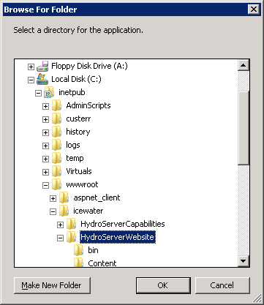

1. Your “Edit Site” form should now look something like the following. Click the “OK” button to complete this step.

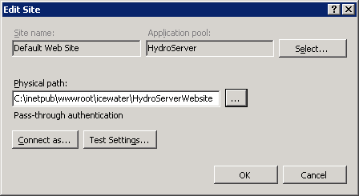

NOTE: The process for setting up the HydroServer Website as a website other than the default web site is similar to setting it up as the default website in IIS. However, you must first have created the website in IIS before you can do this. In the example above, since I implemented HydroServer Website as the default website on a machine called “sandbox08.uwrl.usu.edu”, my HydroServer Website will have a URL path of <http://sandbox08.uwrl.usu.edu/>. If I wanted my HydroServer Website to have a different URL, I would first have to set up an appropriate domain name and then set up a website in IIS to handle that domain name. For example, I could register a domain name called “icewater.usu.edu” and have it pointed at this same machine. I would then create a website in IIS called “HydroServer” that would handle the “icewater.usu.edu” domain. Then, I would follow the steps above to set up the HydroServer Website as the “HydroServer” website in IIS. The path for my HydroServer website would then be <http://icewater.usu.edu/>. If you wish to register alternate domain names for your HydroServer, you will need to work with the individuals in charge of your IT infrastructure.

1. Next, we need to tell the HydroServer Website how to connect to the HydroServer Capabilities SQL Server database. Make sure that the Default Website is selected in the tree view at the left of the IIS Manager window. Under the “ASP.NET” icon group in the middle section of the IIS Manager form, double click on the “Connection Strings” icon. This will open the connection strings editor within the IIS Manager.

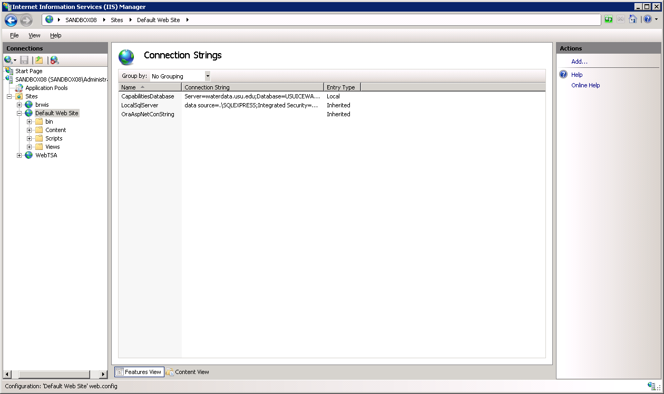

1. Double click on the “CapabilitiesDatabase” line. The following form will open:

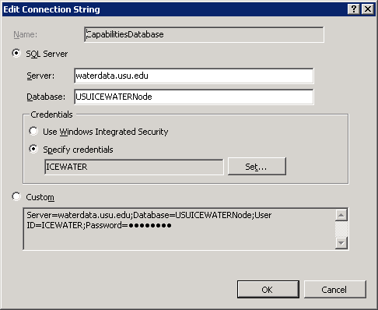

1. On this form, you need to edit the items to match the location and user credentials for your HydroServer Capabilities database. Using the figure above, fill in the appropriate values for your database and server. In this example, I am connecting the HydroServer Website to a HydroServer Capabilities database called “USUICEWATERNode” on a SQL Server machine called “waterdata.usu.edu.” I have created a SQL Server user with read only access to that database called “ICEWATER.” To specify your SQL Server username and password, click the “Set” button next to the “Specify credentials” radio button and text box. You will notice that the connection string for your database is automatically created for you in the text box at the bottom of the form. Click the “OK” button when you are finished.

NOTE: Since the HydroServer Website is a public web application, you want to make sure that you create a SQL Server user within your HydroServer Capabilities database that has read only access for use in specifying the connection from the HydroServer Website. You can do this within SQL Server Management Studio.

1. Next, we need to edit a number of application settings for our HydroServer Website. These application settings will control some of the items that are displayed on your website. Click on the Default Website in the IIS tree view (it will still be selected at this point, but you have to click on it again to get out of the connections strings dialog). Double click on the “Application Settings” icon in the middle section of the IIS Manager form under the ASP.Net group. This will open the application settings editor in IIS:

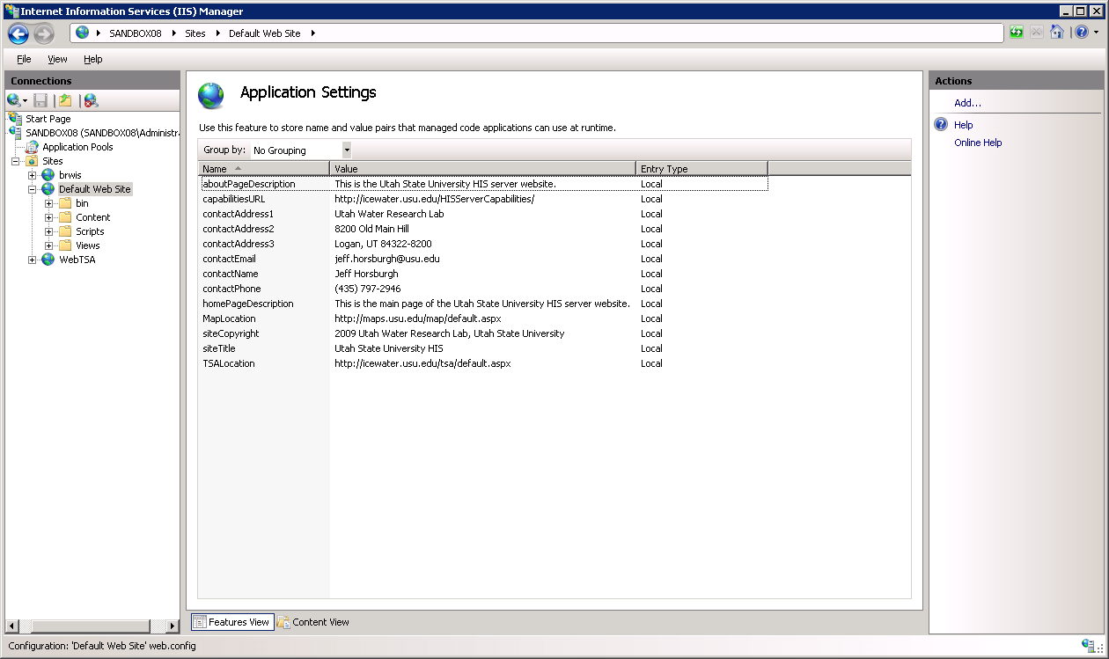

1. You will notice that there are several items in the list of application settings that need to be edited by you to ensure that your HydroServer Website displays correct information. To edit these items, double click on them. When you do, a window similar to the following will open:

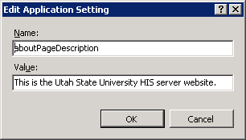

1. You need to set the text in the “Value” text box to what you want to have displayed on your HydroServer Website. **Do not edit the text in the “Name” text box!** When you have edited the text in the “Value” box, click the OK button to continue. You need to set the values for each of the application settings in the list using this procedure. The following is a list of the application settings and a description of what their value should be set to. You can customize the text of these application settings to meet your needs.

* **aboutPageDescription** – this text is displayed as a paragraph below the title on the “About” page of the website. Example: “This is the Utah State University HydroServer Website.”
* **capabilitiesURL** – this is the URL to your HydroServer Capabilities web service. It will be displayed on the “About” page of the website. Example: <http://icewater.usu.edu/HydroServerCapabilities/>.
* **contactAddress1** – this is the first line of the address for the HydroServer contact person. The contact information is displayed on the “About” page of the website. Example: “Utah Water Research Laboratory”
* **contactAddress2** – this is the second line of the address for the HydroServer contact person. The contact information is displayed on the “About” page of the website. Example: “8200 Old Main Hill”
* **contactAddress3** – this is the third line of the address for the HydroServer contact person. The contact information is displayed on the “About” page of the website. Example: “Logan, UT 84322-8200”
* **contactEmail** – this is the email address for the HydroServer contact person. Example: “jeff.horsburgh@usu.edu”
* **contactName** – this is the full name of the HydroServer contact person. Example: “Jeff Horsburgh”
* **contactPhone** – this is the phone number for the HydroServer contact person. Example “(435) 797-2946”
* **homePageDescription** – this text is displayed as a paragraph just below the title on the “Home” page of the website. Example: “Welcome to the Utah State University ICEWATER HydroServer Website!”
* **MapLocation** – this is the base URL to your HydroServer Map Application. The HydroServer Website uses this to create dynamic links within the Website to the map. Example: <http://maps.usu.edu/map/default.aspx>.
* **siteCopyright** – this text is displayed in the copyright at the bottom of each page in your HydroServer Website. Example: “2009 Utah Water Research Laboratory, Utah State University”
* **siteTitle** – this text is displayed in the title bar of your HydroServer website. Example: “Utah State University ICEWATER HydroServer”
* **TSALocation** – this is the base URL to your HydroServer Time Series Analyst. The HydroServer website uses this to create dynamic links to the Time Series Analyst on pages in your website. Example: <http://icewater.usu.edu/tsa/default.aspx>

1. Congratulations! Your HydroServer Website setup is now complete. You should be able to navigate to your HydroServer Website in a web browser. For this example, the URL would be <http://sandbox08.uwrl.usu.edu/> as we set it up as the Default Website on a machine called “sandbox08.uwrl.usu.edu.”

# 2.0 Customizing the HydroServer Website

Most of the content of the HydroServer Website is created dynamically by querying the HydroServer Capabilities database. However, you can customize the look and feel of the website, and you can add HTML content if you wish. The HydroServer Website was written using Microsoft ASP.NET in Microsoft Visual Studio 2008 and uses Microsoft Model View Controller (MVC) 2.0. Each of the pages within the website are ASP “view” files that display the content of the website. They have the following file extensions: *\*.aspx* and *\*.ascx*. The pages are a combination of HTML and ASP Scripting Tags (<% %>) that are embedded within the HTML to display information queried from the HydroServer Capabilities database.

## 2.1 Customizing the Look and Feel of the HydroServer Website

To customize the color scheme and the look and feel of the website, you can edit the Site.css file found in the Contents folder of your HydroServer Website directory. This is a Cascading Style Sheets (CSS) file that determines the style of the entire website. You can edit existing styles or you can replace them with your own styles.

The "Master Page" which provides common structural elements to every page in the HydroServer Website is found in the following location Views/Shared/Site.Master and is also editable in the same way. Editing this Master page, along with Contents/Site.css, will allow you to give each page your own custom structure, colors, background, etc.

Copies of the default view files are also contained in an assembly file called HISServer.Framework.dll found in the bin folder, which is required for the website to function properly. If you need to revert to the default version of a view file, simply delete the view file from the Views folder; the default version will then be used from the assembly. If you make a new view file in the proper part of the Views folder, it will replace the default version from the assembly.

## 2.2 Advanced Configuration and Editing

The page files, or “views,” are contained in the HydroServer Website directory under the “Views” folder. It is possible to edit the HTML of the views to change the way existing elements on the pages are displayed, to remove existing HTML content, or to add additional custom HTML content. You can simply open the view file associated with the page that you want to edit in an HTML editor, insert new content or make any changes to existing content and then save the view file. As an example, to change the content of the “Home” page, you would need to edit the HTML content in the view file at the following location: “*HydroServerWebsiteDirectory/Views/Home/Index.aspx*.” It is recommended that you keep a copy of the original view files in case you make mistakes and want to revert to the original views.

The HydroServer Website was designed such that a standard set of descriptive elements/metadata would be displayed for the regions and services supported by the HydroServer. Although it is possible to edit the HTML content of any of the pages using any text or HTML editor (e.g., Visual Studio, Dreamweaver, or even NotePad), you should avoid removing or changing any of the ASP scripting tags or the HTML code that displays their contents. These tags define data elements from the Capabilities database that will be displayed on the page and generally have the following format: “<% ASP Scripting Tags %>.”

# Appendix A: Additional Required Setup Steps for Windows Server 2003

Because Windows Server 2003 uses IIS Version 6.0, there are a couple of extra steps that are required in the setup if you are using Windows Server 2003. They are as follows:

To configure IIS 6.0 to run the HydroServer website, you'll need to set up a wildcard map.

1. Open IIS Manager, right click on the HydroServer website application, and select "properties."

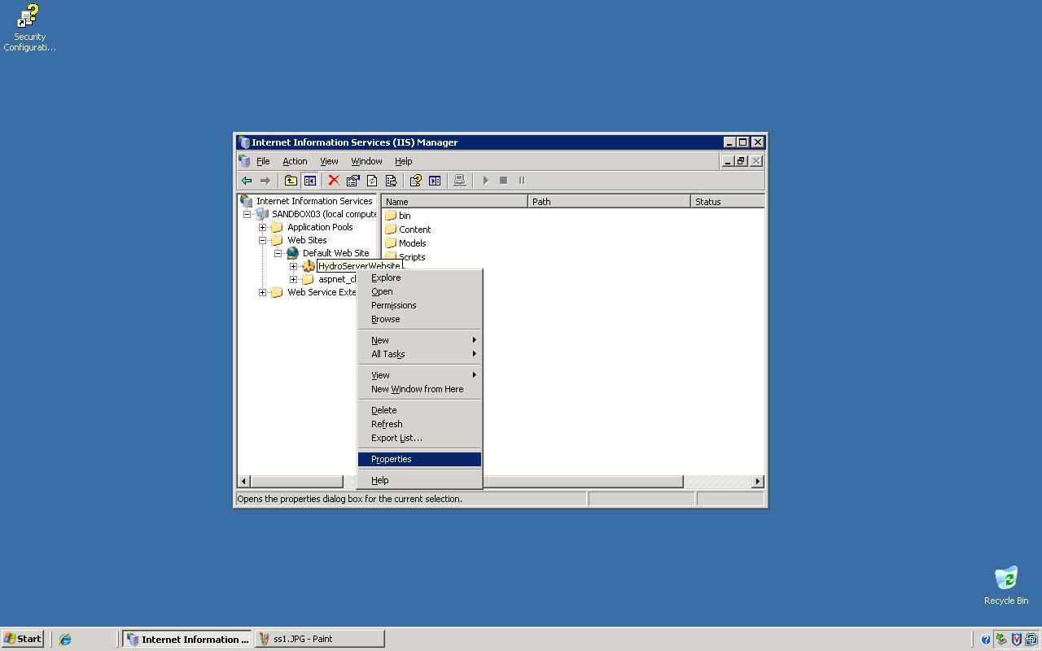

2. Under the "Virtual Directory" tab, press the "Configuration..." button.

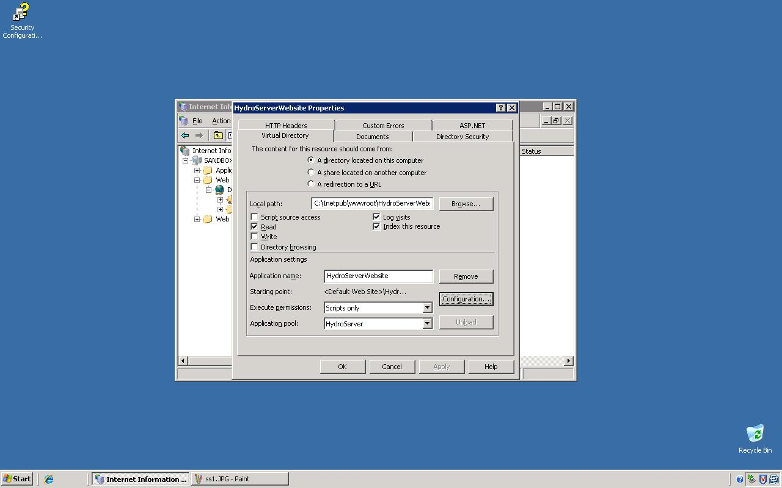

3. Click the "Insert..." button.

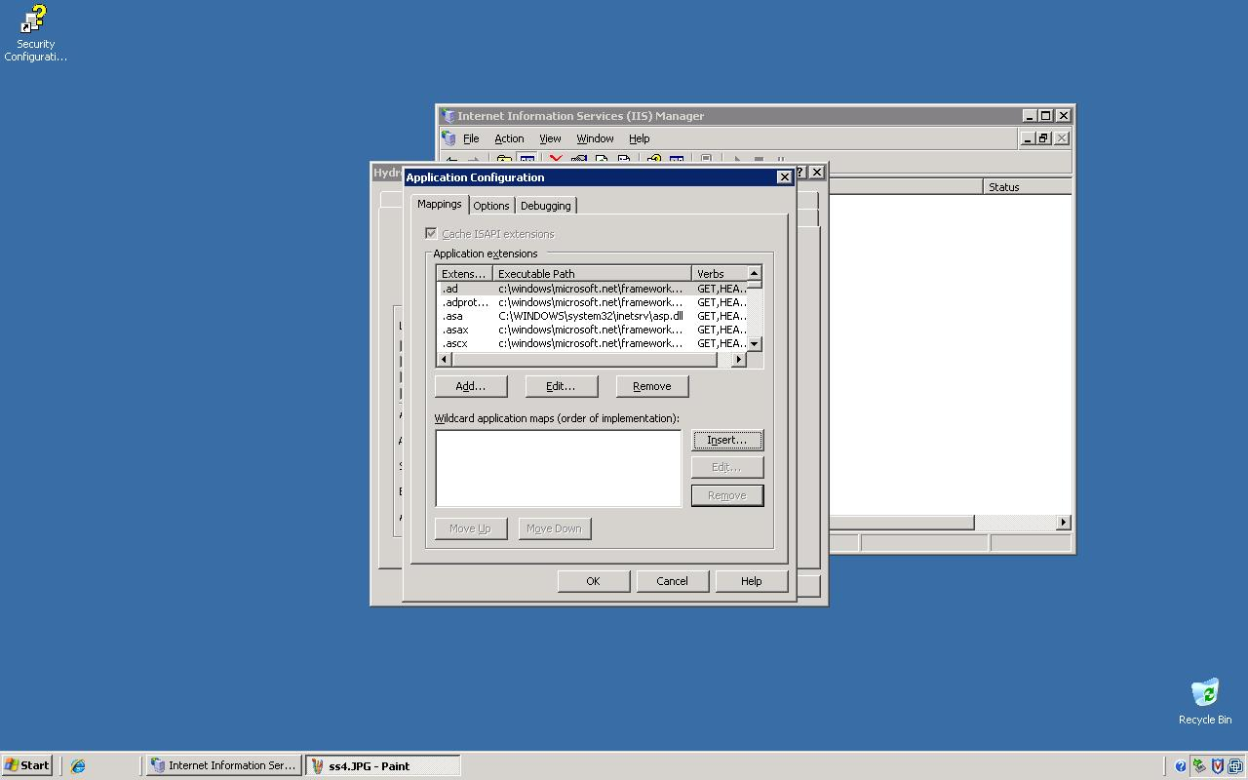

4. Enter the path: "C:\Windows\Microsoft.NET\Framework\v2.0.50727\aspnet_isapi.dll" and *uncheck* the box that says "Verify that file exists." Press OK.

