**Reintegra 2.0**

Rachel Strobel

**Description of your project**

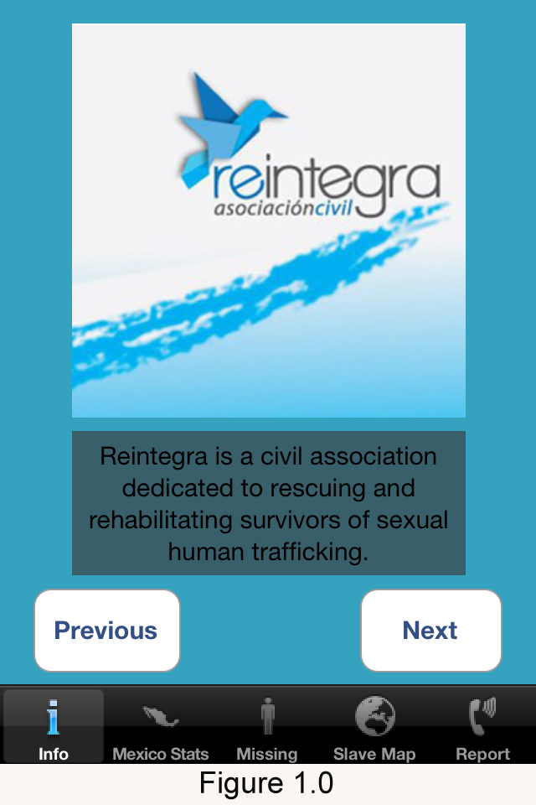Reintegra 2.0 is an extension of version 1.0. Extended central features will include five view controllers, a bottom tab bar, and an app icon. Each view controller will have different features that will represent an important part of what Reintegra wants to accomplish. Such features are providing information on statistics and progress happening in Mexico, finding missing persons, gaining more information about the issue of human trafficking, and reporting any suspicious behavior to respected authorities. I have already started on project 2. The information below will represent my overall vision for the project, a summary of what I have done so far, and future plans for implementation and testing.

I wanted to organize all of these view controllers and have them displayed in an easy and understandable way for users so I created a tab bar in the rootcontroller xib file and connected my .m and .h delegate files to every view controller via the UITabBarController superclass. I customized Reintegra 1.0 and decided to place it in the first view controller called, *MADInfoViewController*. As seen in Figure 1.0, this is a way that the user can gain insight into who Reintegra is and what the organization wants to accomplish. The content and data in the *MADInfoViewController* can be thought of as the mission statement of Reintegra.

The second view controller, *MADMexicoViewController,* will display a picker view where the user can click on any state in Mexico through the picker and an assortment of data will appear in a text view below. Data information of each state will be stored in an array in the mexico.plist. Statistical information for each state that will be seen in the text view when the user clicks on the state, will be stored within the code in the *MADMexicoViewController.m* file. This view controller is important because it provides a way for the user to know and understand the facts and statistics of human trafficking within each Mexican state.

The third view controller, *MADMissingViewController*, will display information in a sorted list with a picture and name of missing persons. *MADMissingViewController* will be based off of the *countries1* class lab and how we showed an arrangement of countries in a list with a picture of the globe next to each country. This is an important view controller for the user because it provides a way for users view people that are missing, along with their name, and what they look like. I am going to attempt to create this view controller in the UITableView but I know that I might run into some technical errors. If this is the case, I will format this view controller in the UIViewController class.

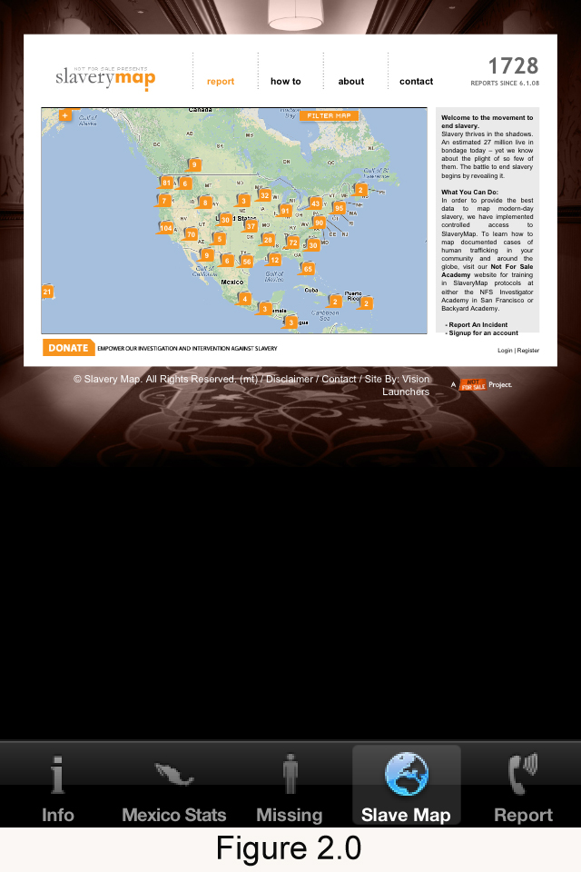The fourth view controller, *MADMapViewController,* will have a web view and will open to url: [www.slaverymap.org](http://www.slaverymap.org). This is a powerful website where the user can view any region in the world and see where cases of human trafficking have happened and one can report where other cases have occurred. This view controller is a little tricky because the web site was designed to be viewed in landscape mode so that when I click on ‘Scales Page To Fit’ in the attributes inspector in the .xib file, the website appears very small as in Figure 2.0. To accommodate this, I am going to attempt to force this specific view controller to only be viewed in landscape mode so the website will be more visually stimulating for the user. All other view controllers in Reintegra 2.0 will be able to be seen in portrait and landscape mode.

The last view controller, *MADReportViewController,* will have an assorted list of different ways that someone can report cases of human trafficking. This will include a list of phone numbers and resources that the user can contact to report a missing person or suspicious signs of human trafficking.

**Testing**

I will test the Reintegra 2.0 iPhone app in my iPhone simulator. I will look for working features, ease of use for user navigation, clarity and ease of use in portrait and landscape mode, and icons and images that transcend Western and Latino culture. I will also unsure that all UI elements fit within Apple standards.