Analysis of the cars data set in R

by Osita Onyejekwe
Part 1
data(cars)
str(cars)
## 'data.frame': 50 obs. of 2 variables:
## $ speed: num 4 4 7 7 8 9 10 10 10 11 ...
## $ dist : num 2 10 4 22 16 10 18 26 34 17 ...
summary(cars)
## speed dist
## Min. : 4.0 Min. : 2.00
## 1st Qu.:12.0 1st Qu.: 26.00
## Median :15.0 Median : 36.00
## Mean :15.4 Mean : 42.98
## 3rd Qu.:19.0 3rd Qu.: 56.00
## Max. :25.0 Max. :120.00
plot(cars)
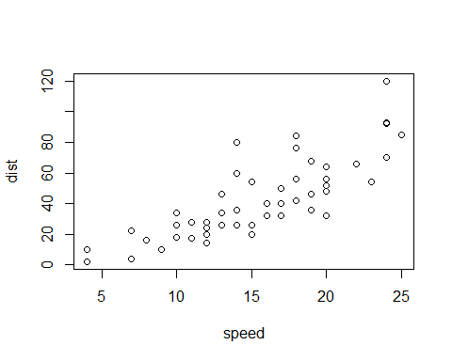 Part 2
hist(cars$speed)
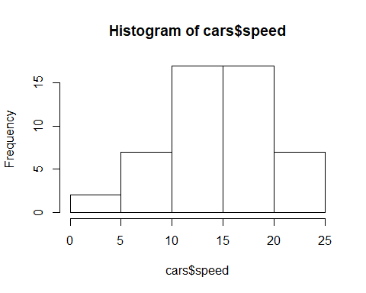
boxplot(cars$speed)
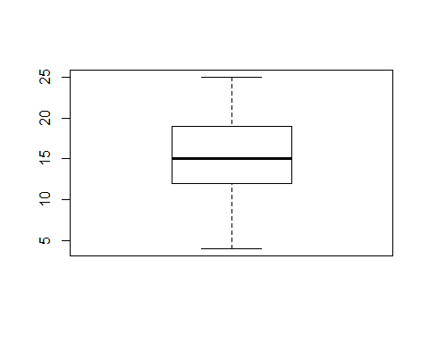 The mean speed of the car is 15.4
hello i can't wait for the patriots to win the next superbowl
Part 3: Data Import
survey<- read.csv('/Users/osita/OneDrive/Desktop/STAT 2600 SPRING 2021/Coding/survey_data2020.csv')
class(survey)
## [1] "data.frame"
head(survey, 3)
## Program PriorExp Rexperience OperatingSystem TVhours
## 1 PPM Some experience Never used Windows 10.5
## 2 Other Extensive experience Basic competence Mac OS X 3.0
## 3 MISM Never programmed before Basic competence Windows 0.0
## Editor
## 1 Other
## 2 Microsoft Word
## 3 Microsoft Word
survey<- read.csv('/Users/osita/OneDrive/Desktop/STAT 2600 SPRING 2021/Coding/survey_data2020.csv')
class(survey)
## [1] "data.frame"
head(survey,3)
## Program PriorExp Rexperience OperatingSystem TVhours
## 1 PPM Some experience Never used Windows 10.5
## 2 Other Extensive experience Basic competence Mac OS X 3.0
## 3 MISM Never programmed before Basic competence Windows 0.0
## Editor
## 1 Other
## 2 Microsoft Word
## 3 Microsoft Word

Lecture 2 Day 2

STAT 2600
Part 1: Simple Summary
Use the str() function to get a simple summary of your data frame object
str(survey)
## 'data.frame': 57 obs. of 6 variables:
## $ Program : Factor w/ 3 levels "MISM","Other",..: 3 2 1 3 3 3 3 3 3 2 ...
## $ PriorExp : Factor w/ 3 levels "Extensive experience",..: 3 1 2 2 2 3 2 3 3 3 ...
## $ Rexperience : Factor w/ 4 levels "Basic competence",..: 4 1 1 4 4 1 4 3 1 1 ...
## $ OperatingSystem: Factor w/ 3 levels "Linux/Unix","Mac OS X",..: 3 2 3 3 3 2 2 2 3 3 ...
## $ TVhours : num 10.5 3 0 10 4 0 2 20 4 0 ...
## $ Editor : Factor w/ 5 levels "Excel","LaTeX",..: 4 3 3 1 3 3 3 4 3 3 ...
Factor refers to categorical data wherease TVhours is a numerica variable
summary(survey)
## Program PriorExp Rexperience
## MISM : 9 Extensive experience : 8 Basic competence :24
## Other:10 Never programmed before: 8 Experienced : 6
## PPM :38 Some experience :41 Installed on machine: 7
## Never used :20
##
##
## OperatingSystem TVhours Editor
## Linux/Unix: 2 Min. : 0.000 Excel : 1
## Mac OS X :19 1st Qu.: 3.000 LaTeX : 5
## Windows :36 Median : 5.000 Microsoft Word:40
## Mean : 6.763 Other : 8
## 3rd Qu.:10.000 R Markdown : 3
## Max. :21.000
Data Frame Basics
Lists, and data frames (and their “tidy” variants)—> next week but for now some basics Goal here is to observe what an R object is made up off, using **attributes()
attributes(survey)
## $names
## [1] "Program" "PriorExp" "Rexperience" "OperatingSystem"
## [5] "TVhours" "Editor"
##
## $class
## [1] "data.frame"
##
## $row.names
## [1] 1 2 3 4 5 6 7 8 9 10 11 12 13 14 15 16 17 18 19 20 21 22 23 24 25
## [26] 26 27 28 29 30 31 32 33 34 35 36 37 38 39 40 41 42 43 44 45 46 47 48 49 50
## [51] 51 52 53 54 55 56 57
An R data frame is a list whose columns can refer to by name or index When you see $ symbol it tells you that it’s a list of some kind
**Data Frame Dimensions
We use nrow() and ncol to determine the number of survey responses and the number of survey questions
nrow(survey) # number of rows (responses)
## [1] 57
ncol(survey) # number of columns (questions)
## [1] 6
57
We collected data on 6 survey questions from 57 respondents. Respondents represnted 3 CU programs. 38 of the respondents were from PPM
We collected data on 6 survey questions from 57 repondents. Respondents represented 3 CU programs. 38 of the respondents were from PPM

Lecture 2 Day 3

STAT 2600
Indexing rows and columns
- Data frames have two dimensions to index across
- You can use square bracket notation df[rows,cols] to extract specifed rows and cols from a data frame df
- There are alos other approaches, as illustrated below
Indexing data frames
- There are many diferrent ways of indexing the same peice of a data frame
- Each vector below contains 57 enteries.
More Indexing
- Note that single brackets and double brackets have different effects
Bar Plot (categorical) Here we’ll use qplot() from the ggplot2 library (part of tidyverse)
library(ggplot2)
Histogram (continuous data)
Here we’ll use qplot() from the ggplot2 library (part of tidyverse)
library(ggplot2)
** tidy column selection: select()**
It is preferable to use the select() function to select subsets of columns
library(dplyr)
## Warning: package 'dplyr' was built under R version 3.5.3
##
## Attaching package: 'dplyr'
## The following objects are masked from 'package:stats':
##
## filter, lag
## The following objects are masked from 'package:base':
##
## intersect, setdiff, setequal, union
select(survey, Program, Editor)
## Program Editor
## 1 PPM Other
## 2 Other Microsoft Word
## 3 MISM Microsoft Word
## 4 PPM Excel
## 5 PPM Microsoft Word
## 6 PPM Microsoft Word
## 7 PPM Microsoft Word
## 8 PPM Other
## 9 PPM Microsoft Word
## 10 Other Microsoft Word
## 11 PPM Microsoft Word
## 12 PPM LaTeX
## 13 PPM Microsoft Word
## 14 PPM Microsoft Word
## 15 PPM Other
## 16 PPM Other
## 17 PPM Microsoft Word
## 18 MISM LaTeX
## 19 MISM Microsoft Word
## 20 PPM Microsoft Word
## 21 PPM Microsoft Word
## 22 Other Microsoft Word
## 23 PPM Microsoft Word
## 24 PPM Other
## 25 Other LaTeX
## 26 Other Microsoft Word
## 27 Other Microsoft Word
## 28 MISM Microsoft Word
## 29 PPM R Markdown
## 30 PPM R Markdown
## 31 PPM Microsoft Word
## 32 MISM Microsoft Word
## 33 PPM Microsoft Word
## 34 PPM Microsoft Word
## 35 PPM Microsoft Word
## 36 PPM Microsoft Word
## 37 MISM Microsoft Word
## 38 MISM R Markdown
## 39 Other Microsoft Word
## 40 PPM Microsoft Word
## 41 PPM Microsoft Word
## 42 Other Microsoft Word
## 43 PPM Microsoft Word
## 44 PPM Microsoft Word
## 45 PPM Other
## 46 PPM Microsoft Word
## 47 PPM Other
## 48 PPM Microsoft Word
## 49 MISM LaTeX
## 50 PPM Microsoft Word
## 51 Other Microsoft Word
## 52 PPM Microsoft Word
## 53 PPM Microsoft Word
## 54 PPM Microsoft Word
## 55 PPM LaTeX
## 56 Other Microsoft Word
## 57 MISM Other
More indexing rows and columns
- If you leave, e.g, the rows value blank in df[rows, cols], it will pull all the rows for the specified cols
- leaving cols blank pulls all the columns for the specified rows
More indexing
In lab 1 you were introduced to the colon operator : We can use this operator for inrxing
Subsets of data We are often interested in learning something specific about a subset of the data
More subset examples
“tidy” subsetting with filter()
- In general, it is preferable to use the filter() function
- Here is an example of selecting all responses from students who are either in PPM or Other and who listed their R experience as “Basic competence”.
filter() allows you to split conditions across lines * On the previous code chunk, we had
- This is equivalent to the easier parse to call
**“tidy” selection of rows and columns * What if we wanted to select a subset of rows and columns with a combination of filter and select? * Here’s one strategy
Piping with %>%
- Here’s a better strategy, which uses “piping” to supply the output of one computation as an argument into the next
- Most of our data processing/summarization pipelines in R will invole lots of piping
- The symbol %>% is pronounced “pipe”"
**Piping: Preferred style * When piping, it’s best to pipe right from the start
# OK:
# BETTER:
Splitting a long expression
- As your function calls get longer and more complicated, you may find it useful to split them over muliple lines
- Supose you had something like this
- You can split this across multiple lines by putting a linke break after an operator
- Note that the line break occurs after the & operator
- Some simple calcuations
** (Preview of) “tidy” data summaries with group_by and summarize
- Here’s a much easier and cleaner way of getting the average TV Hours watched by students in each program. We use group_by and summarize
** Defining variables **

