# NORC Data Uploads (FAST)

#### Contacts: PIP

PI

* Bonnie Jortberg
* Perry Dickinson

Data Team:

* Dionisia de la Cerda
* Sabrina Lor (exports reports from REDCap)
* Kim Wiggins (process and upload to NORC site)
* Danika Buss

Upload Site [**https://uau.norc.org/**](https://uau.norc.org/)

#### Contacts: NORC

* Alex Figueroa, [Figueroa-Alexandria@norc.org](mailto:Figueroa-Alexandria@norc.org)

Folder: data_management_team/norc

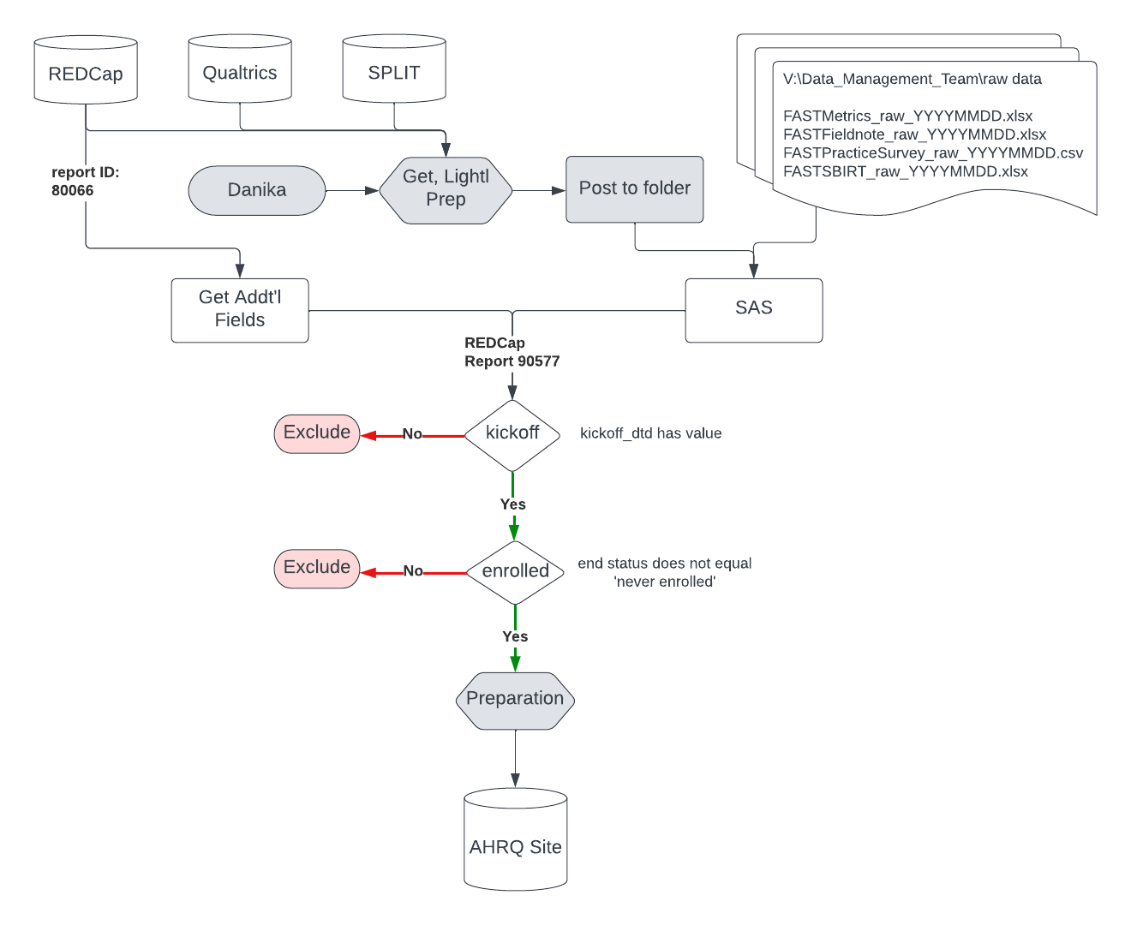

## Goal / Results Outcome

Uploads Required: total = 6

Template columns: counts=variables needed from raw files

| Template | Column / Field Count | Cumulative Fields |
| --- | --- | --- |
| Intervention Tracker - Post Intervention ONLY | 8 | 8 |
| Practice Survey - Baseline | 64 | 72 |
| Process Measures - Baseline | 13 | 85 |
| Process Measures - Post Intervention | 13 | 98 |
| SBI_RT and MAT Implementation Checklist - Baseline | 55 | 153 |
| SBI_RT and MAT Implementation Checklist - Post Intervention | 55 | 208 |

## Steps: Upload (Prep, Upload, Summarize)

1. Get additional Survey info needed
   1. DESCRIPTION: some fields were required for the upload that weren’t in the raw survey file [#DO list]
   2. LOCATION: REDCap, Project ID 16776 (FAST Application and Project Management)
   3. REPORT: ReportID 80066 (PracticeApplication_NORC_Upload): Has fields needed that aren’t included in the raw exports
2. Update 00_config file
   1. Rename macros to match date of raw (_YYYYMMDD)
   2. Check mapping / libnames
3. Create split_id inclusion list
   1. DESCR: Inclusion Rule: Include any practice with a kickoff date
   2. DATA SOURCE: Data_Management_team/raw data/FASTPracticeMeta_raw_YYYYMMDD.xlsx
      1. Colname:

### Data / Info Sources

#### Raw Data

* Path: \\data.ucdenver.pvt\dept\SOM\FM\FM\Data_Management_Team\raw data

#### Data Dictionaries / Codebooks

* Practice Innovation Cross Project data folders > [Practice Innovation Cross Project - Data Collection Tools Catalogue - All Documents (sharepoint.com)](https://olucdenver.sharepoint.com/sites/PracticeInnovationProjectManagement/Shared%20Documents/Forms/AllItems.aspx?csf=1&web=1&e=okWG8Q&OR=Teams%2DHL&CT=1661888658457&clickparams=eyJBcHBOYW1lIjoiVGVhbXMtRGVza3RvcCIsIkFwcFZlcnNpb24iOiIyNy8yMjA3MzEwMTAwNSIsIkhhc0ZlZGVyYXRlZFVzZXIiOmZhbHNlfQ%3D%3D&cid=1a5351b5%2D4391%2D4031%2D8cf2%2D9a284de447d4&RootFolder=%2Fsites%2FPracticeInnovationProjectManagement%2FShared%20Documents%2FData%20team%2FData%20Collection%20Tools%20Catalogue&FolderCTID=0x0120004398D79CDA39C8478A63EFE8029D294D)
* Fn: [Field Note_Qualtrics_DD_FAST_current.xlsx (sharepoint.com)](https://olucdenver.sharepoint.com/:x:/r/sites/PracticeInnovationProjectManagement/_layouts/15/Doc.aspx?sourcedoc=%7B415C703B-48EB-47ED-AC13-4AD691429AF8%7D&file=Field%20Note_Qualtrics_DD_FAST_current.xlsx&wdOrigin=TEAMS-ELECTRON.p2p.bim&action=default&mobileredirect=true)

#### NORC upload work folders, files

Root dir: \\data.ucdenver.pvt\dept\SOM\FM\FM\Data_Management_Team\norc

* `name/` = folder; `name.ext` = file; See each folder’s readme for provenance

|-- code/

|-- README.txt

contains file/code provenance

|-- code/logs/

logs for all uploads to use for comparison, notes, %put statements

|-- docs/

general documentation and background; interim / temporary documents

|-- 202208/

August final datasets and website upload results (accepted & not accepted files)

|-- data/

final .sas7bdat datasets and exported .xlsx files used for the aug upload >

|-- upload_counts_all_files_20220825.xlsx

has counts for all uploaded files

|-- upload_results/

|-- returned_with_issues/ attempted uploads that were returned with issues; see tabs

called *‘Bad Data’* (their term, not mine – I think it’s a super weird term )

|-- `InterventionTracker_attempt2_20220915.xlsx` etc..: each final upload .xlsx files

|-- 202302/

FEBRUARY

|-- data/

|-- upload_results

## FEB 2022

Results Email to Alex (sent

Survey Questions

Some split id’s were in raw survey >1, and one practice had no splitID: per Danika:

* **Guardian Angels Health Center** (no splitID) : not FAST, only ISP. Split ID is 2083
* **Center Pointe Family Medicine**— has two record IDs because they enrolled in ISP in 2020 and then enrolled in FAST in 2021. It’s the same practice and practice ID in SPLIT (3319), but if you’re looking at the payer data that doesn’t match up across the records, then I would only look at Record 178 (row 115 in the spreadsheet you sent me) since that is the info the practice provided when enrolling in FAST.
* **High Plains Adult Health Center**— not enrolled in FAST, only ISP; they have two records because they completed an application for ISP twice. It’s the same practice with the same practice ID in SPLIT (2087) but one of the names listed is their “official practice name” and one is their “preferred practice name.”

Can’t upload 2224 to any files; emailed NORC team on 02/16 with final counts

## August 2022

### Results

[1]

### Templates, Fields, Values

|  |  |  |
| --- | --- | --- |
| Folder | Contains | Filename |
| docs | Reference, variable alignment; downloaded from NORC website on 08/26; includes extracted comments containing field submission specifications | Norc_templates_comment_20220825.xlsx |
| code | Import NORC templates | 01_import_templates.sas |
| code | Project paths & aliases | 00_paths_aliases.sas |

1. Re-downloaded templates (08/25/2022) to make sure they hadn’t changed (copied into one file)
2. Extracted comments with VBA code below

(Developer > VBA > Insert > Module > save)  
 Function Extract_Comments(xCell As Range) As String

On Error Resume Next

Extract_Comments = xCell.Comment.Text

End Function

1. Save as .xlsx to keep macro function

### Practice Survey (Baseline only)

Files used:

|  |  |  |
| --- | --- | --- |
| Use | Contains | Filename |
| raw data | Practice Survey | FASTPracticeSurvey_raw_08222022.csv |
| raw data | Practice Application | FASTApplication_raw_08222022.csv |
| reference | Reference, variable alignment | Norc_templates_comment_20220825.xlsx (see tab2) |
| Dictionary | Full access from Sabrina | Data_dictionary_full_access.csv |
| sas code | %included file with %lets, all | 00_paths_aliases.sas |
| sas code | Import, Prep Practice Survey  Recode inpatientcare | 10a_getData_PracSurv_20220825.sas [49, 43] |
| sas code | Import, clean: Practice App | 10b_prep_survey [46, 20] |
| output | Exported file for upload | survey_baseline.xlsx |
| results |  | survey_baseline_results.xlsx |

Notes:

1. Variables come from both Practice Survey AND Practice Application

* Created report in REDCap::FAST ‘PracticeApplication_NORC_Upload’ (08/26/2022, report ID 80066)
* Saved to folder ‘data raw’

1. Duplicate IDs in PracticeSurvey file: norc.survey_multiple_ids created, exported ‘pracsurvey_mult_20220825.xlsx’
   1. Emailed to Sabrina (Next time email to support@ OR find JIRA ticket if you can)
      1. Practice_id 35 had 3 entries, all with separate names and 2 different zip codes
      2. Practice_id 141 had 2 entries with different responses in many columns

Email from Sabrina 08/26/2022

Changed to update in the codefiles and re-ran all documents and re-uploaded them.

|  |  |  |  |
| --- | --- | --- | --- |
| recordid | practice_id | name | Sabrina’s Notes |
| 14 | 35 | Highlands Health for Life | This is the correct practice for the split id 35. |
| 15 | 35 | Aspen Internal Medicine Consultants | Aspen Internal Medicine’s split id is 3106. Not sure why “35” was entered in for the split id on the survey, but in the verification form it shows 3106 as the correct split id. |
| 16 | 35 | Denver Family Medicine | Denver Family Medicine’s split id is 2070. Similar case to the Aspen Internal Medicine practice. 35 was entered in as the practice’s split id on the practice survey, but in the verification form it shows 2070 as the correct split id. |
| 24 | 141 | Family Medical Associates | This is the correct practice for the split id 141. |
| 25 | 141 | Internal Medical Associates of Lafayette | Internal Medicine Associates of Lafayette’s split id is 2601. 141 is the incorrect split id that was entered on the survey, but in the verification form it shows 2601 as the correct split id. |

Uploaded all; 49 records in survey

### Metrics

Metrics Files

|  |  |  |
| --- | --- | --- |
| Use | Contains | Filename |
| raw data | Raw file from Sabrina | FASTMetrics_raw_08222022.csv |
| template | Fields needed | Norc_templates_comment_20220825.xlsx |
| sas code | %included file with %lets, all | 00_paths_aliases.sas | |
| sas file | Import, clean, export .xlsx |  |
| output | Exported file for upload |  |

Notes:

1. Task_id:
   1. 194 [n=50]: Baseline > why exported 34 below…
   2. 215 [n=35]: Post-Intervention
   3. 196 [n=81]

Export norc.metrics_baseline_20220825.xlsx

* 34 obs, 16 cols

Export norc.metrics_post_20220825.xlsx

* 44 rows, 16 cols

### SBI_RT

BAD DATA practice_id 2224 had to be removed to upload; all the responses were missing anyways, but FYI – was only in baseline sbi_rt

|  |  |  |
| --- | --- | --- |
| Type | Upload | Filename |
| raw data | Data | FASTSBIRT_raw_08222022.xlsx |
| raw data | Reference, variable alignment | Norc_templates_comment_20220825.xlsx (see tab2) |
| sas file | Import, clean | 12_getData_sbirt_20220828.sas [46, 20] |
| sas code | %include let statements: all | 00_paths_aliases.sas |
| output | Exported file for upload | Sbirt_baseline_20220828.xlsx |
| Output | Exported file for upload | Sbirt_post_20220828.xlsx |

Creates dataset for template: norc.templates_sbirt

#### Results Aug 2022

Baseline upload count = 51

Post intervention count = 37

Total = 88

### FIELD NOTES / Intervention Tracker

BAD DATA practice_id 2224 had to be removed to upload; all the responses were missing anyways, but FYI – was only in baseline sbi_rt

Cols/Fields needed:

GRANTEE

PRACTICE_ID

DATE_OF_CONTACT

MODE

MODE_OTHER

DURATION

PRIMARY_PURPOSE

PRIMARY_PURPOSE_OTHER

ADDITIONAL_KICKOFF

ADDITIONAL_ADMIN

ADDITIONAL_WORKFLOW

ADDITIONAL_HIT

ADDITIONAL_QUALITY

ADDITIONAL_ENGAGEMENT

ADDITIONAL_TRAINING

ADDITIONAL_OTHER

NOTES

Session_num response alignment

0: none this session

1: Session 1,

2: Session 2,

3: Session 3,

4: Session 4,

5: Session 5,

6: Session 6,

7: Session 7,

Session 8: Optional, Telehealth

0, none this session| 1, Session 1| 2, Session 2| 3, Session 3|4,Session 4 | 5, Session 5 |6, Session 6 | 7, Session 7| 8, Optionial: Telehealth

Table : Fieldnote / Intervention Tracker - updated 09/14/22 kw

|  |  |  |
| --- | --- | --- |
| Type | Upload | Filename |
| raw data | Data | FASTFieldnote_raw_08222022.xlsx |
| raw data | Reference, variable alignment | Norc_templates_comment_20220825.xlsx (see tab2) |
| Dir Paths | %include let statements: all | 00_paths_aliases.sas |
| Formats | Sas format for time (in min) | 13a_fn_formats.sas |
| EDA, q’s | EDA, export to Sabrina (data) | 13c_fn_import_eda_exportqs.sas   * fn_dups_20221915.xlsx * fn_v_baseline_20220915.xlsx |
| File create | Clean & export final file  -bad data: 2224  (upload_20220800/data…) | 13d_fn_createFile.sas   * InterventionTracker_20220915.xlsx (ret.) * InterventionTracker_attempt2_20220915.xlsx |
| results | proc freq all raw import fields | Logs > fieldnote_allfields_freqs_raw_import |
| Logs, results | Batch ran 13c, 13d again and sent log, report to folder |  |

Ran proc freq for all fields for raw import > saved in **norc/logs folder**

RAW IMPORT field freq notes:

* Task_id
  + 191: surveys during intervention
  + 198: final fieldnote
* Kickoff_date: 54 total, missing 461
* End_dtd: What means? N=40, missing = 475;
* Elearn: 276 = 0, 239 = 1
* Formal_group: 479=0, 36=1
  + Well the data dictionary certainly helps! Sabrina showed me where it was in TEAMS
  + “formal_group” = Is this practice part of a formal FAST group for your facilitation activities? IGNORE
    - Doug’s response via email
  + So probably only keep where formal_group=1?
* Num_encounters_1 0,1,2 = 205, 304, 6
* Survey_id: all are 58 except 1 is missing
* Total_encounters: all are 0? Why?
* Missing a sim_id in one row – emailed Sabrina to ask about it;
* Emailed bonnie a few questions about the data re: ‘additional’ items – I think I’m going to leave them blank – she emailed Doug, they said wait for Dionisia, but DD was out that week and the next week w an emergency so uploaded with best guesses.

#### UPDATE 09/13, Fieldnote (Intervention Tracker) (see email/ notes for details)

* File ‘13c_getData_fn.sas’ added to re-do, left in 13b for notes / etc if there are questions on the data call today regarding other variables.
* There are 6 practice_id’s that are in field notes that aren’t in the baseline – I don’t think I’ll be able to submit them but I’ll try – emailed to Sabrina also

#### Email from NORC team, directions for email after upload processed:

“Your team’s last data upload occurred in February. Your next scheduled upload is in August. A couple of reminders when completing your submission:

* Please upload your most recent version of all instruments
* Old data for a practice will be overwritten by new data for that practice; any revisions to a practice’s data since your last upload will save in the system
* Please send NORC an email noting when you completed your upload and how many practices were included with each instrument (total practices, not just newly submitted)”

## January

1. Run Code file 10a_getData_PracSurv.sas (results: 51 obs jan vs 49 aug) >> **out.survey_20230123**
2. Get Application data from Redcap:
   1. Redcap / FAST Application & Project Management / PracticeApplication_NORC_Upload’ > download
3. Run Code file: 10a_getData_PracApp: [176, 23] > matched with applications for FAST > n=51 >> **out.app_20230123**
   1. One missing a split id in application: St. Vincent Family Health Center
4. Run code file to merge the above df’s `10c_merge_pracSurv…` > out.survey_baseline_20230123
   1. Exports to out.survey_baseline_20230123.xlsx
5. Run code 11a_getData_Metrics
   1. Task_id in 194, 215 > n obs = 86 jan (aug was 82)

## Appendix

### Feb 2023 Submission

### August 2022 Submission

Sept 15 email to NORC:

The most recent versions of the following instruments have been uploaded to the website (counts = total practices, per request):

Practice Survey Baseline: 49

Process Measures, Baseline: 44

Process Measures, Post: 34

SB/IRT and MAT Implementation Checklist, Baseline: 50

SB/IRT and MAT Implementation Checklist, Post: 37

Intervention Tracker: 51

#### Fieldnote (Intervention Tracker) notes re: inclusions

From: Delacerda, Dionisia <[DIONISIA.DELACERDA@CUANSCHUTZ.EDU](mailto:DIONISIA.DELACERDA@CUANSCHUTZ.EDU)>   
Sent: Wednesday, September 14, 2022 1:04 PM  
To: Wiggins, Kimberly <[KIMBERLY.WIGGINS@CUANSCHUTZ.EDU](mailto:KIMBERLY.WIGGINS@CUANSCHUTZ.EDU)>  
Subject: RE: Fieldnote

The dates are not as important as the content – we picked the kick off data because it was one of the options for what happened in the interaction.

There is a variable in the template that list the different types of interactions that want tracked.

The other session are not cut and dry enough to do that way, so I think just doing the kick off meeting is enough.

### Jan/Feb Submission

1: all files are in S:\FM\FM\Data_Management_Team\raw data\DD_KW, as well as the updated code files: ‘GetData_FAST_Jan2022KTW’ and ‘NORC’; the sas codes document variables and observations for each iteration as well as what the steps were, so maybe take a look and make sure the counts make sense??

2: I don’t know how to make missing values = ‘999’ – I looked all over but the means didn’t justify the end – all the methods seemed way harder than just doing it myself for now – long-term might want a new option, but for now I just opened the files and found the missing cells and replaced all blanks (it doesn’t like Go to Special > Blanks because they’re all character, so I did:

ctrl+A  to select all, then ctrl+F > left ‘Find What’ blank > Options > select “Match entire cell contents” > Final all

> ctrl+A to select empty cells > formula bar enter 999 and hit ctrl+enter to fill in all blanks).

* Only for 3 files: Survey_app and the SBIRT base and its post. I removed the measures that had M1_NUMBER =0 so those have no missing data.

3: re: SBIRT files (base and post), there are three columns that SAS doesn't like because they’re longer than 32 bytes. I shortened them in the sas code / file but after reading to excel I just went in manually and updated the column names: they are -

               1a: DOCUMENTATIONTOOL_EHRUN change to DOCUMENTATIONTOOL_EHRUNSTRUCTURED

               1b: DOCUMENTATIONTOOL_EHRST change to DOCUMENTATIONTOOL_EHRSTANDARDIZED

               1c: POSITIVE_INDIV change to POSITIVE_INDIVIDUAL_PROCESS_GENERAL

2: Feb 1 upload attempt notes:

1. Practice Survey and Application says all processed (**attached**; 47 rows processed, and strangely enough, practice 30 works here just fine… )
2. NORC_SBIRTPost: said practice 30 not recognized. I removed that row but all data are in "baddata" tab now. no notes.
3. NORC_SBIRTbaseline: said practices 30, 3490 not recognized; I removed those two rows from the file itself but now all data are saying "baddata"
4. Process Measures Baseline: getting weird script (KW emailed image to Alex, she's seeing if it's IT)
5. Process Measures Post: same as Baseline.

Update Feb 2022: practices won’t go in if they’re not in the baseline set, so that might be why…

1. The work.survey is just a temp one to get the practice_id – it was stored as a number and wouldn’t merge so I just grabbed this one – the final dataset is saved as norc.survey_baseline;