## 《一些RBER-UBER图》

《2023. ALCod: Adaptive LDPC Coding for 3D NAND Flash Memory Using Inter-Layer RBER Variation》

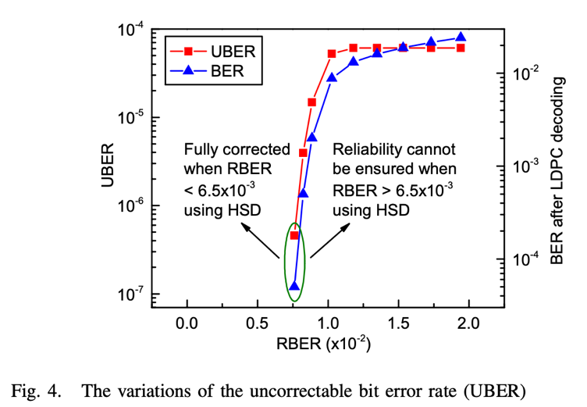

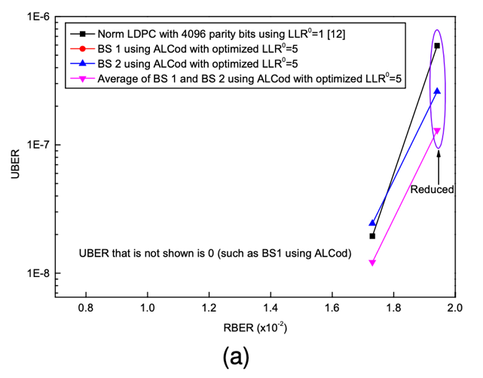

《2016.Embedded Three-Bit ECC for Emerging Memories》

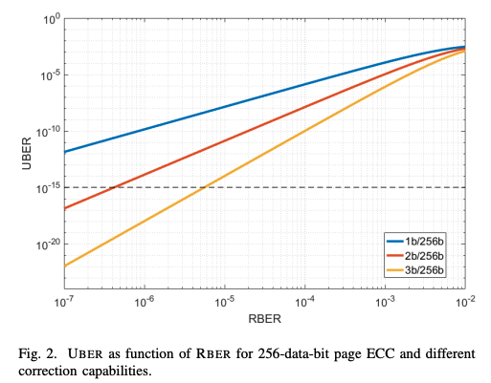

《A 38.64-Gb/s Large-CPM 2-KB LDPC Decoder Implementation for NAND Flash Memories》

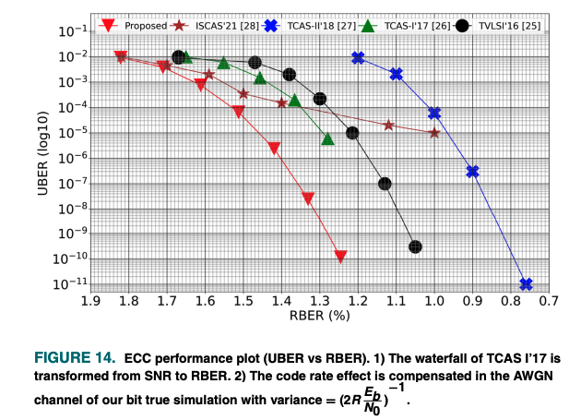

《<https://www.flashmemorysummit.com/English/Collaterals/Proceedings/2013/20130814_E22_YangJ.pdf>》

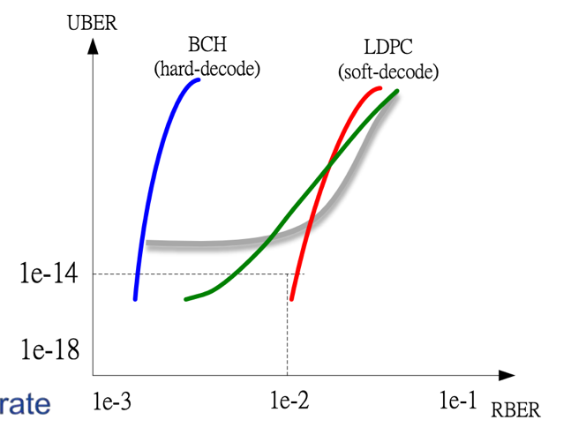

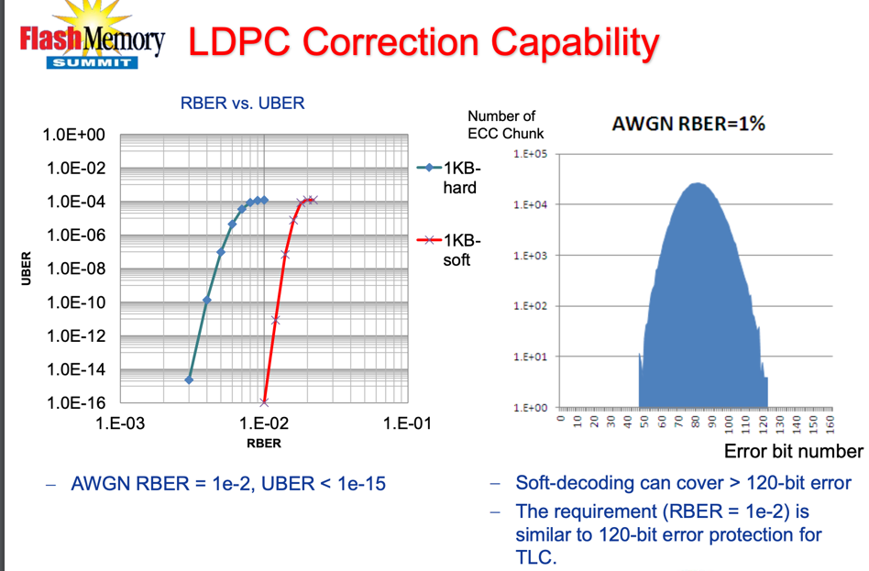

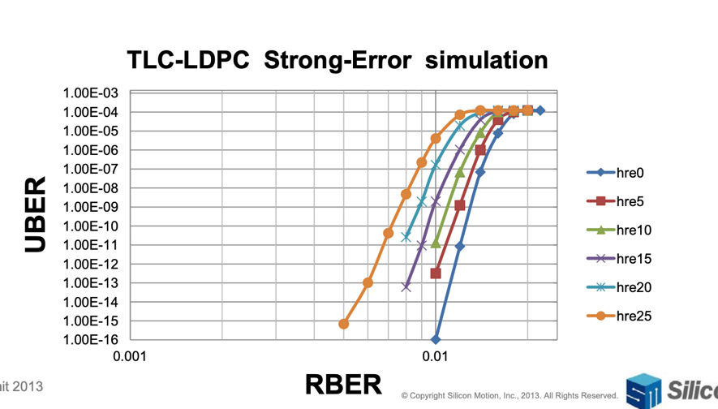

《A Energy-optimized (37840, 34320) Symmetric BC-BCH Decoder for Healthy Mobile Storages》

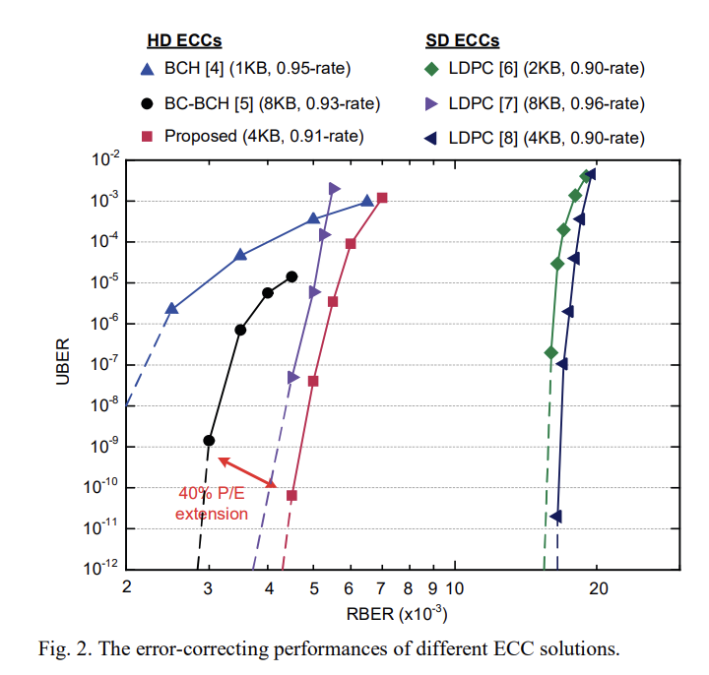

《Design of LDPC coding schemes for exploitation of bit error rate diversity across dies in NAND flash memory》

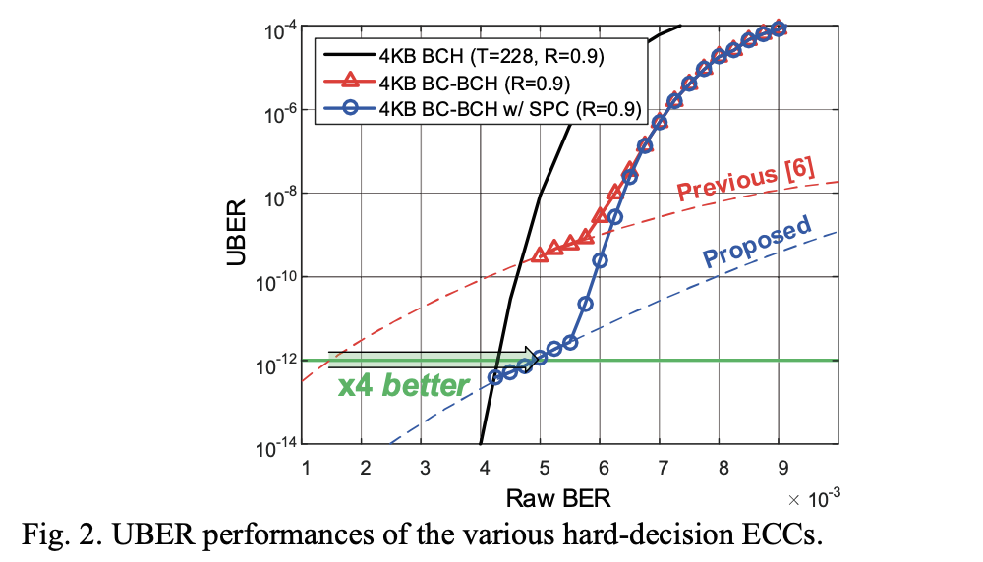

《Low-Latency Unfolded-KES Architecture for Emerging Storage Class Memories》

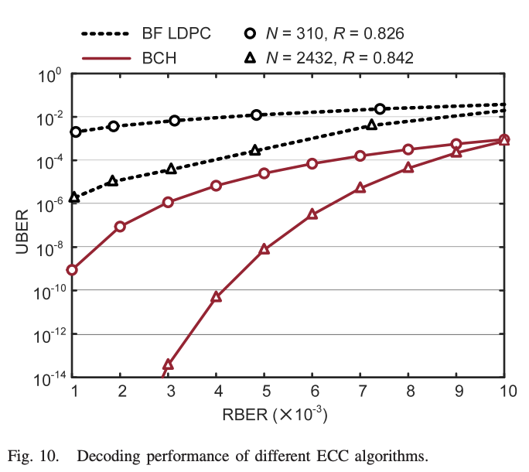

《High-Throughput ECC with Integrated Chipkill Protection for Nonvolatile Memory Arrays》

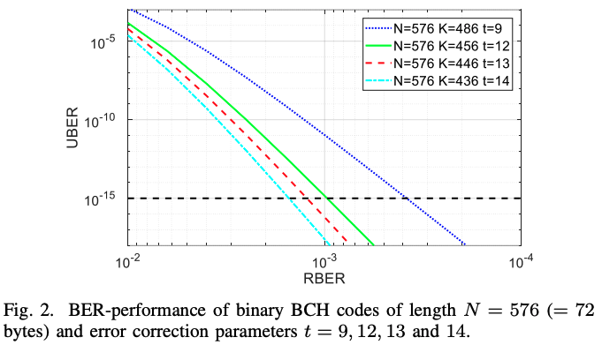

《A Low Power and Ultra High Reliability LDPC Error Correction Engine with Digital Signal Processing for Embedded NAND Flash Controller in 40nm COMS》

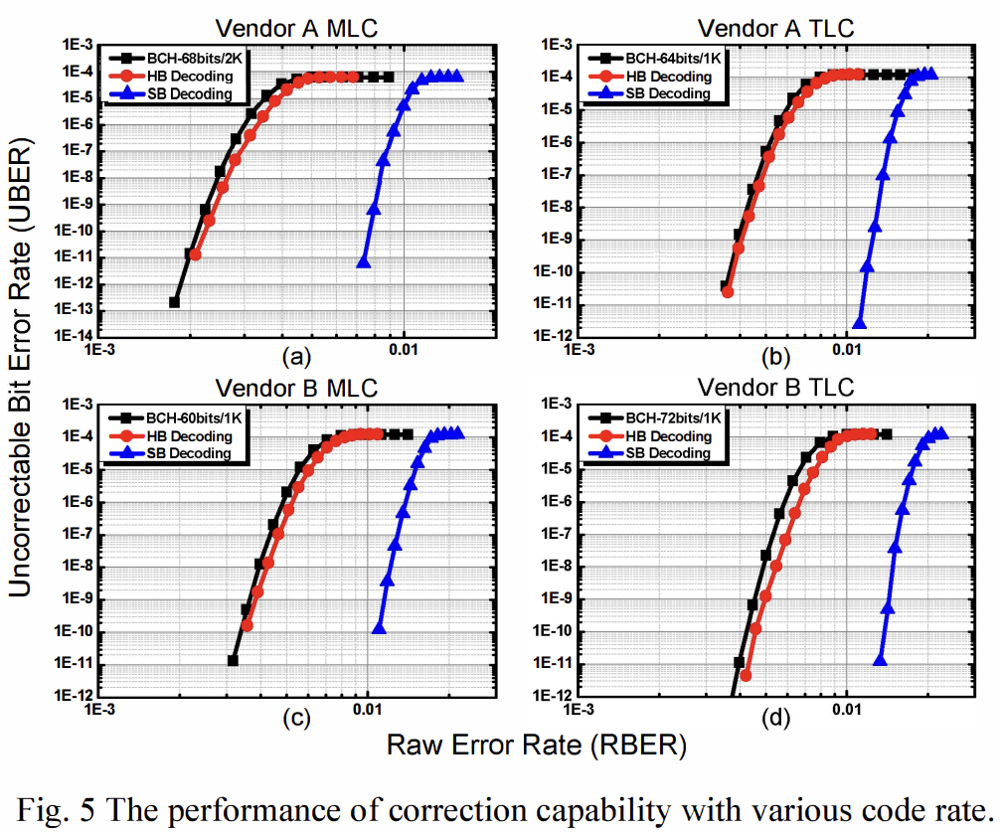

《18.Energy-Efficient Symmetric BC-BCH Decoder Architecture for Mobile Storages》

