Deeptime RoC Analysis
Windows User Manual
Multi-timescale Deep-time Rate-of-Change Analysis Software
Applicable version: v1.0.1
Platform: Windows
Document date: 2026-08-31

Contents
1. Software Introduction 1
2. Package Structure 1
3. Quick Start 2
4. Input Data Format Requirements 2
5. GUI Guide 3
5.1 Input Data Page 3
5.2 RoC Settings Page 4
5.3 Advanced Analysis Page 6
5.4 Run & Log Page 7
5.5 Results Preview Page 8
6. Configuration File 9
7. Output Results 9
8. Main Output Table Fields 10
9. Method Overview 11
10. How to Cite 12
11. Version Information 12
12. Developer Information and Contact Details 12

Software Introduction
Deeptime RoC Analysis is a multi-timescale rate-of-change (RoC) analysis software package designed for deep-time palaeoclimate time series. The Windows version is packaged as an executable, so users do not need to install Python or open a terminal. Double-click RoC_Workflow.exe to launch the graphical user interface. The Python source code and launchers for Windows and macOS are available in the public GitHub repository.

Package Structure
After extracting the Windows distribution package, keep the folder structure unchanged. Do not move RoC_Workflow.exe separately, and do not delete the _internal folder.
File | Description
RoC_Workflow.exe | Main software executable. Double-click this file to launch the graphical user interface.
_internal/ | Background calculation program and runtime dependencies. Do not delete or move them.
_internal/RoC_Workflow_Main.exe | Background calculation program called automatically by the GUI; users normally do not need to open it manually.
config_test.yaml | Fast installation and workflow-verification configuration; it is not the manuscript parameter record.
config_full.yaml | Complete configuration containing the exact analysis parameter settings used for the associated manuscript.
data/ | Example input-data folder. The default example dataset is data/O.xlsx.
outputs/ | Results output folder. It may be empty before the first run; the software writes results to it automatically.
logo.ico / logo.png | Software icon files.
README.md | Brief instructions in English.
LICENSE | Licence file.
CITATION.cff | Software citation information.

Quick Start
- Extract RoC_Workflow_Windows_v1.0.1.zip.
- Open the extracted RoC_Workflow folder.
- Double-click RoC_Workflow.exe.
- On the 1. Input Data page, select the input Excel file and confirm the Age column and Value column.
- On the 2. RoC Settings page, set the age range, Step, and time-bin widths.
- On the 3. Advanced Analysis page, confirm the post-analysis options.
- Go to 4. Run & Log. First click Check settings / Dry run to check the input, and then click Run workflow to start the full calculation.
- After the calculation is complete, view the results in the outputs folder or on the 5. Results Preview page.

Input Data Format Requirements
The input data must be an Excel file (.xlsx or .xls); the first worksheet is used by default. The table must contain at least an age column and a value column. Records with a blank, non-numeric, or invalid Age or Value are removed during preprocessing. If multiple records have exactly the same Age, the software automatically averages the corresponding values in the Value column. The Age values may be ordered from younger to older or vice versa; the software can sort the data automatically using the Sort data by Age option.

GUI Guide
The Deeptime RoC Analysis GUI contains five pages: 1. Input Data, 2. RoC Settings, 3. Advanced Analysis, 4. Run & Log, and 5. Results Preview. Use the tabs at the top to switch between pages, or use the Previous step / Next step buttons at the bottom to move through the workflow.

5.1 Input Data Page
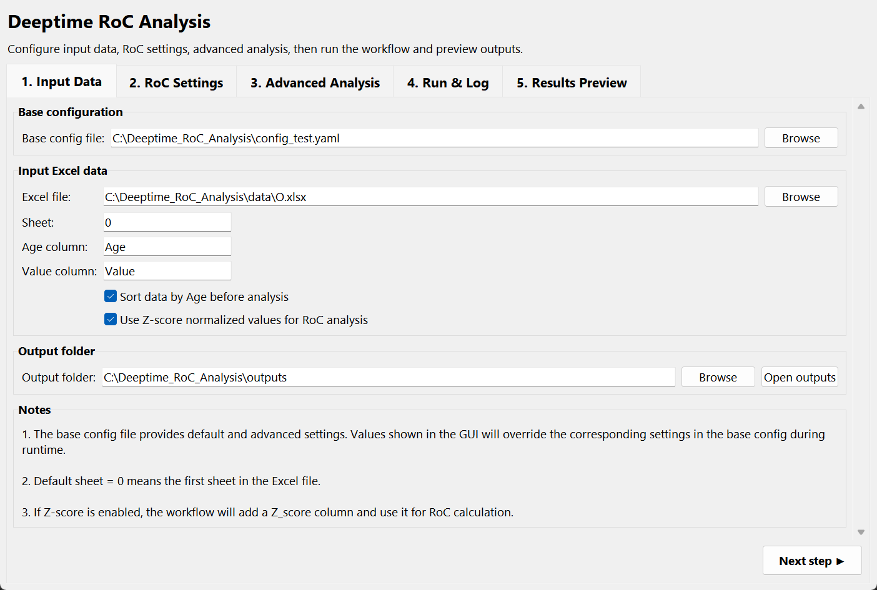
- Base config file: The base configuration file provides default and advanced parameters. Parameters displayed in the GUI override the corresponding settings in the base configuration file at runtime.
- Excel file input: Path to the input Excel file.
- Sheet: Worksheet number or name. 0 indicates the first worksheet.
- Age column: Name of the age column; the default is Age.
- Value column: Name of the value column; the default is Value.
- Sort data by Age before analysis: Specifies whether to sort the data by Age before calculation. This option is generally recommended.
- Use Z-score normalized values for RoC analysis: Specifies whether to convert the values in the Value column to Z-scores before calculating RoC. This is suitable for relative comparisons among different proxies.
- Output folder: Results output folder. The default is outputs.

5.2 RoC Settings Page
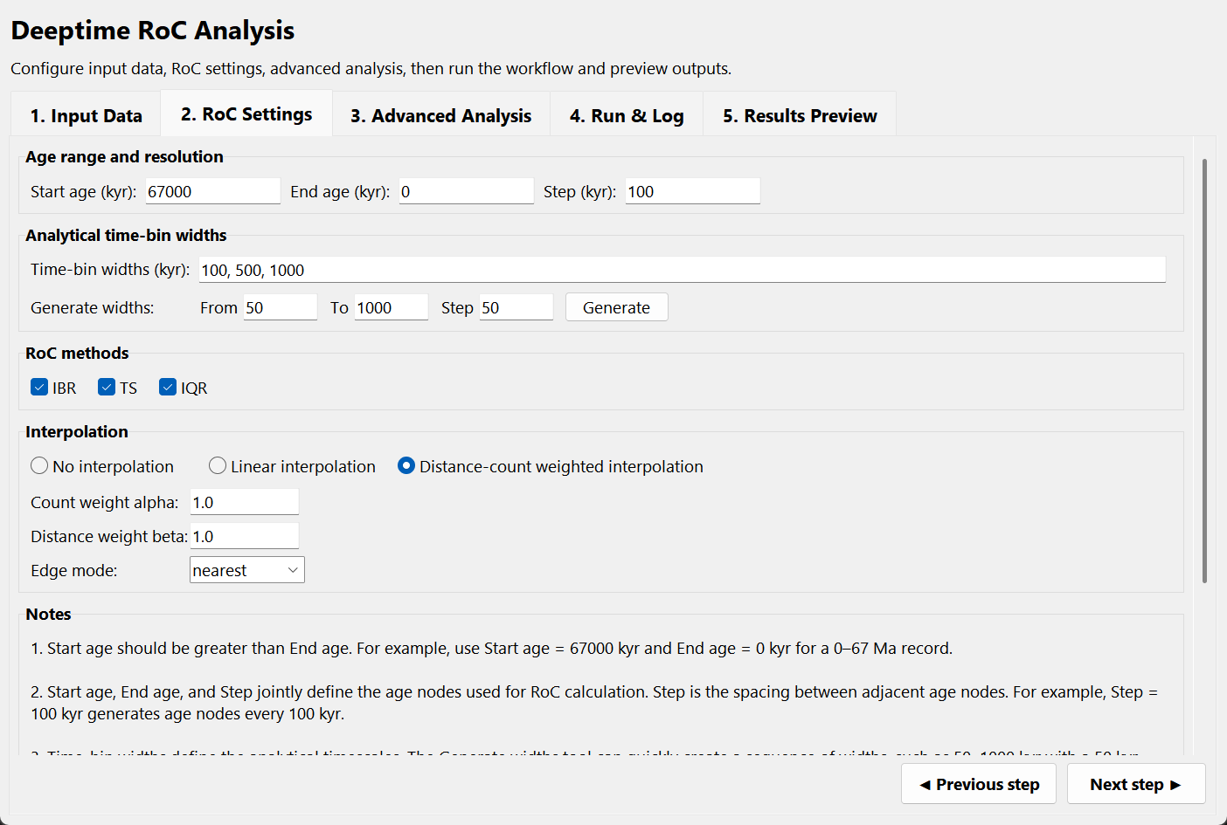
- Start age (kyr): The older end of the analysis interval, for example, 67000 kyr.
- End age (kyr): The younger end of the analysis interval, for example, 0 kyr.
- Step (kyr): Spacing between age nodes. For example, Step = 100 kyr generates age nodes at 0, 100, 200 ... kyr.
- Time-bin widths (kyr): List of analysis timescales, for example, 100, 500, 1000.
- Generate widths: Quickly generate a continuous series of timescales. For example, Setting From to 50, To to 1000, and Step to 50 generates timescales every 50 kyr from 50 to 1000 kyr.
- IBR (Inter-bin Rate): First calculate the time-bin mean, then interpolate, and finally calculate the rate of change between adjacent bins at the selected analysis timescale.
- TS (Theil-Sen slope): Calculate a robust slope within each time-bin.
- IQR(Interquartile Range): Calculate the interquartile range within each time-bin to represent within-bin variability.
- No interpolation: Do not interpolate missing values.
- Linear interpolation: Fill missing values using linear interpolation.
- Distance-count weighted interpolation: For an internal missing target, use only the nearest valid bin on each side. Each of the two bracketing bins is weighted by sample count and temporal distance; more distant valid bins do not contribute. This is the recommended default option.
- Count weight alpha: Sample-count weighting parameter used only for weighted interpolation.
- Distance weight beta: Distance-weighting parameter used only for weighted interpolation.
- Edge mode: Controls how missing values at the beginning and end of the interpolated series are handled: nearest, NaN, or zero.

5.3 Advanced Analysis Page
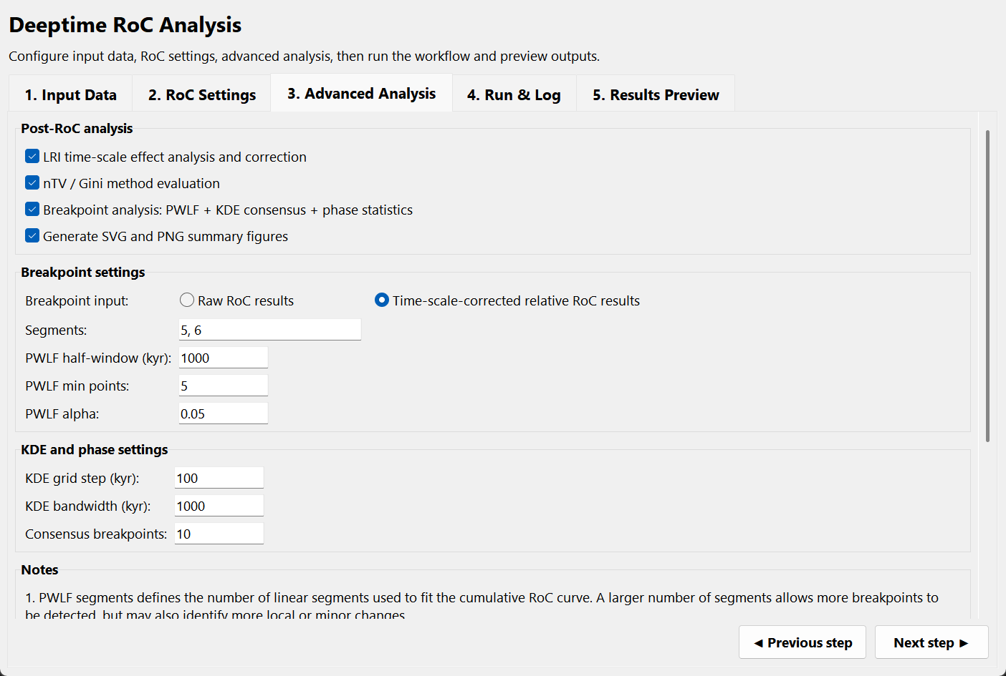
- LRI time-scale effect analysis and correction: Analyse how RoC varies with timescale and generate timescale-corrected relative RoC.
- nTV / Gini method evaluation: Calculate nTV and Gini to evaluate the variability intensity and unevenness of RoC series across methods and timescales.
- Breakpoint analysis: Includes PWLF breakpoint detection, KDE consensus breakpoint detection, and phase statistics.
- Generate SVG and PNG summary figures: Generate summary figures in SVG and PNG formats by default.
- Breakpoint input: Select whether phase analysis is based on raw RoC or timescale-corrected relative RoC.
- Segments: Number of line segments in the PWLF piecewise-linear fit. Multiple values may be entered, for example, 5, 6.
- PWLF half-window: Window size for local statistical comparison on both sides of a breakpoint.
- PWLF min points: Minimum number of data points required on each side of a breakpoint for statistical testing.
- KDE grid step: Age-grid spacing used for KDE density estimation.
- KDE bandwidth: KDE smoothing window. Larger values merge nearby breakpoints, whereas smaller values retain more local peaks.
- Consensus breakpoints: Number of consensus breakpoints retained in the final result.

5.4 Run & Log Page
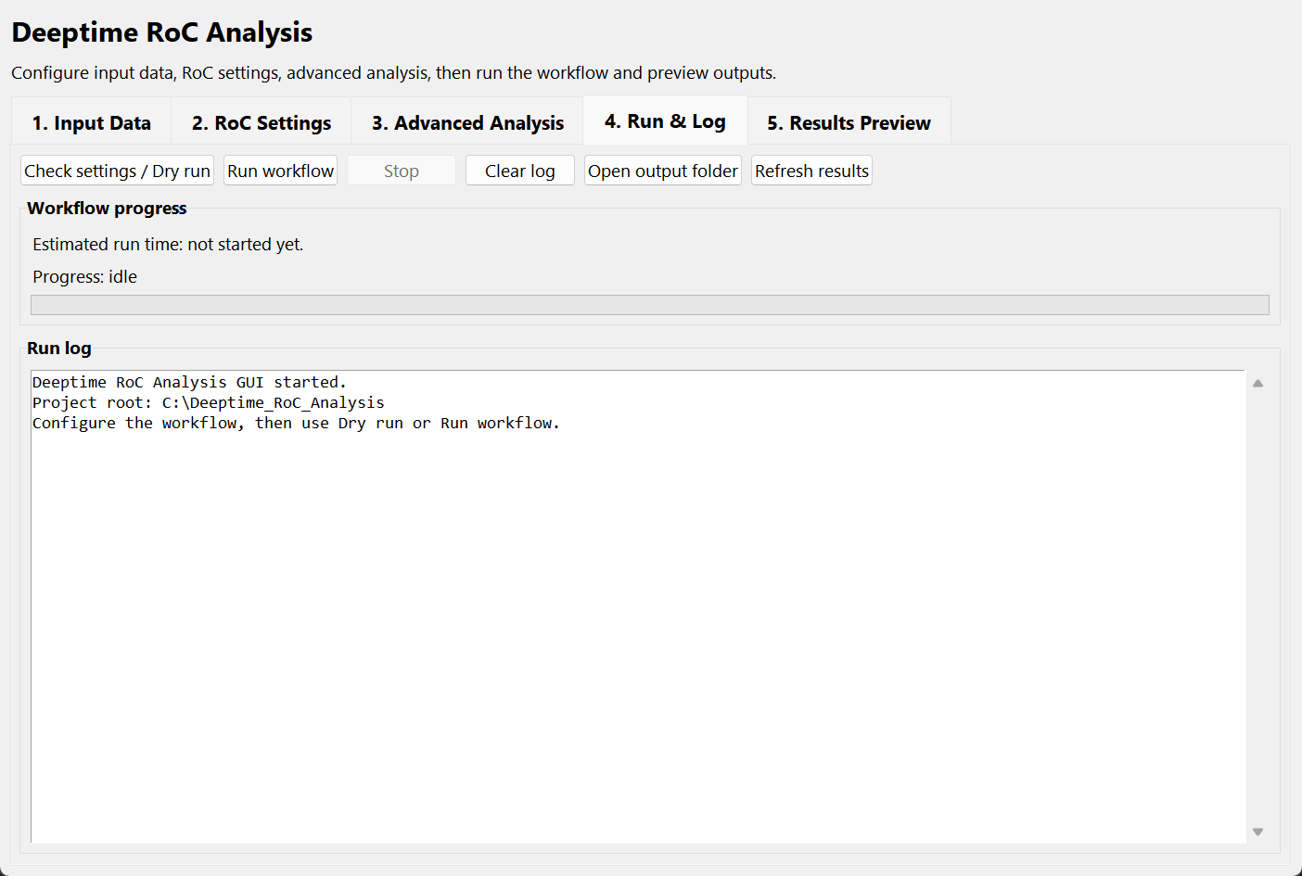
- Check settings / Dry run: Check the configuration and input data without running the full calculation. Use this before each full run.
- Run workflow: Start the full calculation.
- Stop: Terminate the current run.
- Clear log: Clear the log window.
- Open output folder: Open the outputs folder.
- Estimated run time: Displays an estimated runtime. The actual duration depends on the amount of data, number of timescales, PWLF/KDE settings, and computer performance.
- Progress: Stage-based progress bar showing the current workflow progress.

5.5 Results Preview Page
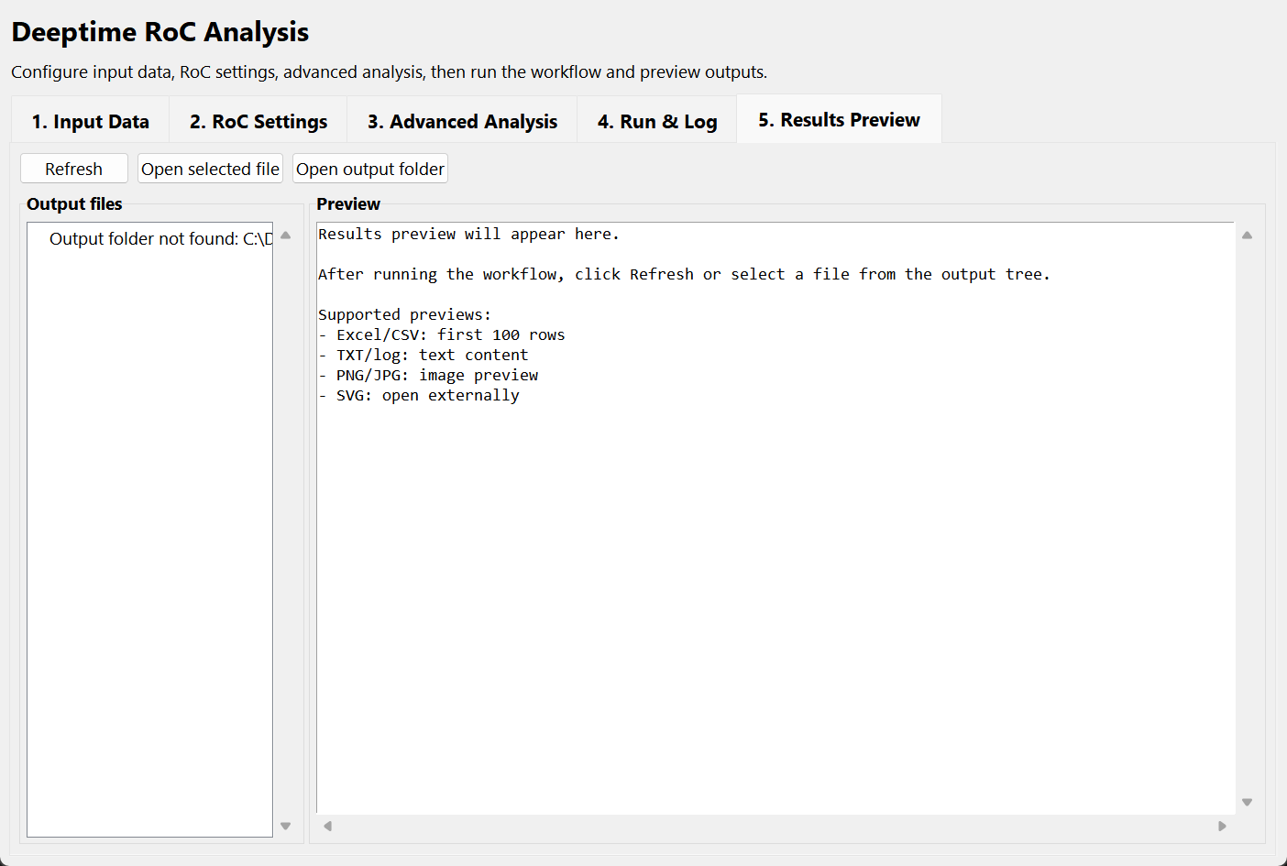
- Output files: The file tree on the left displays the contents of the outputs folder.
- Preview: The pane on the right displays previews of Excel, CSV, TXT, PNG, and other supported files.
- Refresh: Refresh the output file tree. Click this button if new results do not appear immediately.
- Open selected file: Open the selected file with the system default application.
- SVG files: SVG previews are not embedded in the GUI. Open them in a web browser, Adobe Illustrator, or similar vector-graphics software.

Configuration File
Deeptime RoC Analysis uses YAML configuration files to store default and advanced parameters. Parameters visible in the GUI override the corresponding settings in the base config file; advanced parameters not displayed in the GUI remain controlled by the base config file.

Output Results
Folder | Description
00_preprocessed | Preprocessed input data, including removal of invalid values, averaging of duplicate Age records, and optional Z-score standardisation.
01_timebin | Original time-bin calculation results. IBR corresponds to Mean_origin; TS/IQR corresponds to Rate_origin.
02_interpolated | Results after interpolation. Because the calculation procedures differ, for IBR, the mean is calculated for each bin, missing bins are interpolated, and RoC is then calculated; for TS/IQR, RoC is calculated directly within each bin, and missing bins are then interpolated. Therefore, in this folder, IBR corresponds to Mean_origin, and TS/IQR corresponds to Rate_origin.
03_rate | Final RoC series used as the basis for subsequent merging, LRI, metrics, PWLF, KDE, and phase analyses.
04_merged | Merged multi-timescale tables, with one all_timescales table for each method.
05_lri | LRI regression results, regression-point tables, and quantile-point tables.
06_normalized | Timescale-corrected relative RoC tables.
07_metrics | nTV and Gini method-evaluation results.
08_pwlf | PWLF breakpoint-detection results.
09_kde | KDE consensus breakpoint-detection results.
10_phase | Phase divisions and phase-mean statistics.
figures | Automatically generated SVG and PNG summary figures. The current version plots all calculated Timescale_* scales.
run_summary.txt | Summary of the parameters and output files for the current run.
logs | Runtime logs and diagnostic information for the current run.

Main Output Table Fields
Field | Description
Time_bin | Time-bin index.
Age_node | Central age node of the time-bin.
Timebin_width_kyr | Analysis timescale or time-bin width.
Counts | Number of data points in the time-bin.
Age_unique | Number of unique age points in the time-bin.
Metric | Current calculation metric: mean, ts, or iqr.
Mean_origin | Original time-bin mean, used mainly in the IBR workflow.
Mean_interp | Interpolated time-bin mean.
Rate_origin | Original bin-level result for TS or IQR.
Rate_interp | Interpolated TS or IQR result.
Age_kyr | Age of the final RoC series.
Rate | Final RoC or RoC-related value used in subsequent analyses.
IQR_quartile_method | Quartile method used for IQR: inc or exc.
IQR_min_count | Minimum number of finite values required to calculate IQR.

Method Overview
Method | Description
IBR | Inter-bin Rate. Calculate the mean within each time-bin, interpolate the mean series, and then calculate the absolute rate of change between the means of two non-overlapping bins separated by one time-bin width.
TS | Theil-Sen slope. Calculate a robust slope within each time-bin and use its absolute value as a RoC-related metric. This reduces the influence of outliers on trend estimation.
IQR | Interquartile range. Calculate Q3-Q1 within each time-bin to represent within-bin variability. IQR is a RoC-related variability metric rather than a direct rate of change in the strict sense.
LRI | Log-log regression index, used to describe the relationship between RoC and analysis timescale and to correct for timescale effects.
nTV | Normalized total variation, used to measure the overall variability intensity of a RoC series.
Gini | Measures the unevenness of the RoC distribution. Higher values indicate that changes are concentrated in fewer time intervals.
PWLF | Piecewise linear fitting. Identify phase transitions from the cumulative RoC curve.
KDE | Kernel density estimation. Integrate breakpoints across different methods, timescales, and PWLF segment settings to identify consensus breakpoints.
Phase statistics | Divide the record into phases using consensus breakpoints and calculate mean RoC and other metrics for different phases, methods, and timescales.

How to Cite
When using Deeptime RoC Analysis in a paper, report, or project, cite the software name, version, authors, year, and, where available, the GitHub repository URL or DOI. For the formal citation, refer to the CITATION.cff file included in the distribution package.

Version Information
Item | Description
Software name | Deeptime RoC Analysis
Current version | v1.0.1
Release date | 2026-08-31
Platform | Windows
Primary purpose | Multi-timescale RoC analysis of deep-time palaeoclimate records.

Developer Information and Contact Details

Hongyi Zhao
China University of Geosciences (Beijing)
zhaohy@email.cugb.edu.cn

Laiming Zhang
China University of Geosciences (Beijing)
lzhang@cugb.edu.cn

