Choosing a path test
Introduction
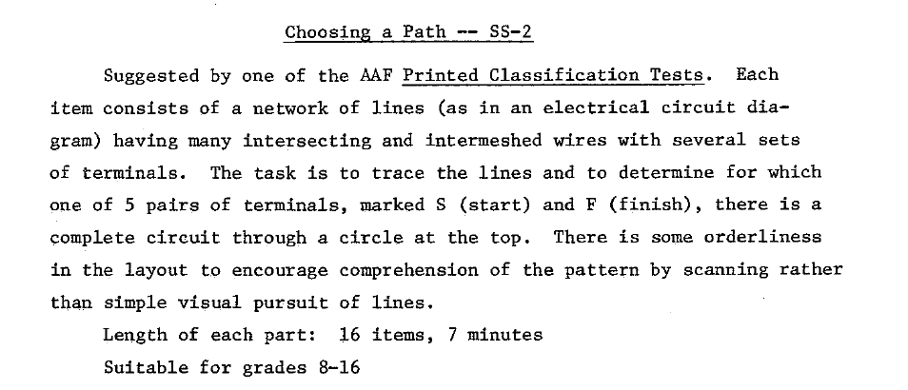
Score
None, but by induction, number of correct answers (previous/next test scored in this way)

Scoring keys
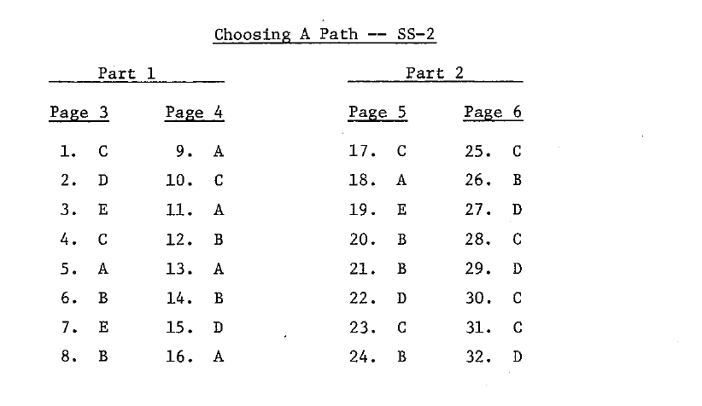
Norm
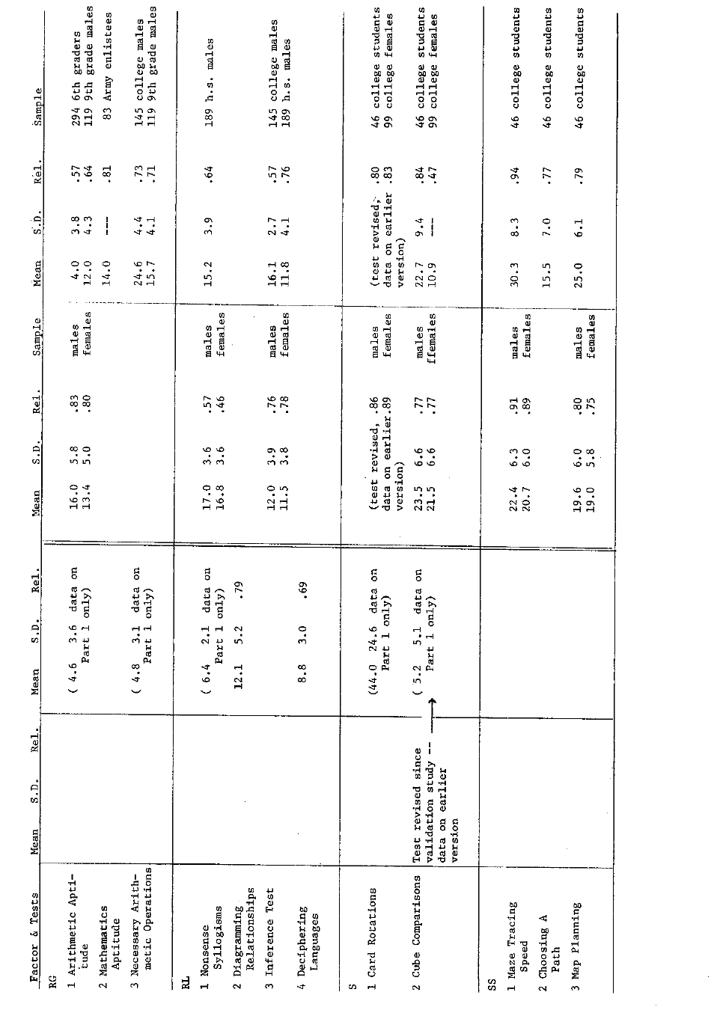

Reference
Ekstrom R. B., French J. W., Harman H. H. (1976). Manual for Kit of Factor-Referenced Cognitive Tests. Princeton: Educational Testing Service.

