The paper folding Test

Introduction
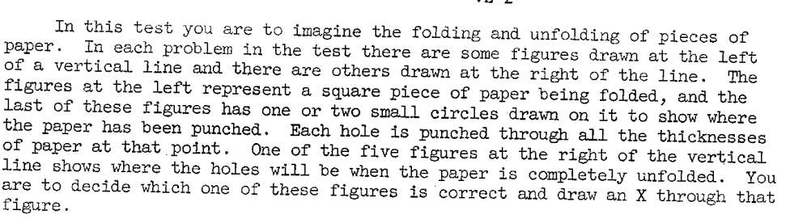

Score
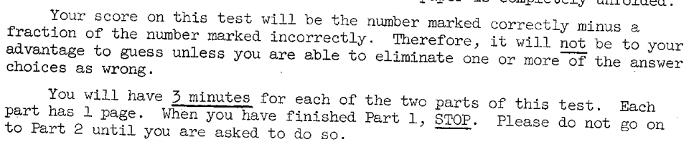

Scoring keys
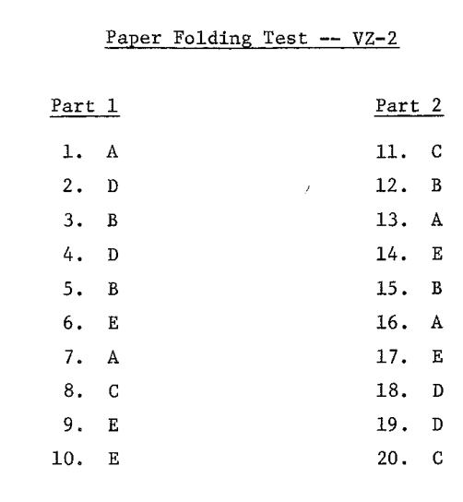

Norm
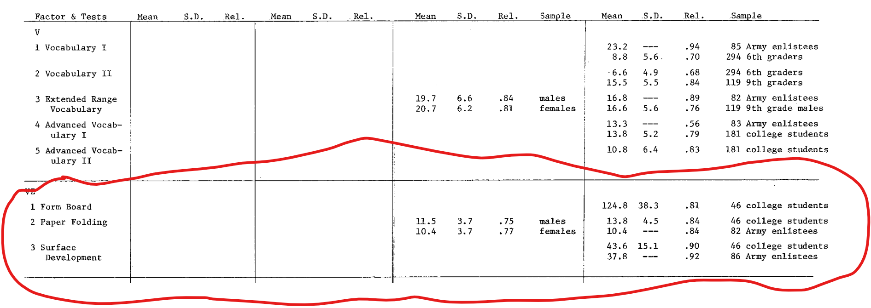

Reference
Ekstrom R. B., French J. W., Harman H. H. (1976). Manual for Kit of Factor-Referenced Cognitive Tests. Princeton: Educational Testing Service.

