The Surface Development Test

Introduction
The surface development test (Ekstrom, French, & Harman, 1976) was a representative task of small-scale spatial ability, and was used to measure participants’ spatial ability. In this test, participants were required to imagine how the surface of a 3D object could be unfolded onto a plane. Each item contained two drawings: one of an irregular polyhedron, and one of a pattern resembling its flattened cardboard cutout. Five edges in the polyhedron were numbered, and participants were instructed to indicate which specific lines in the flat shapes corresponded to each target edge.

Score

Scoring keys
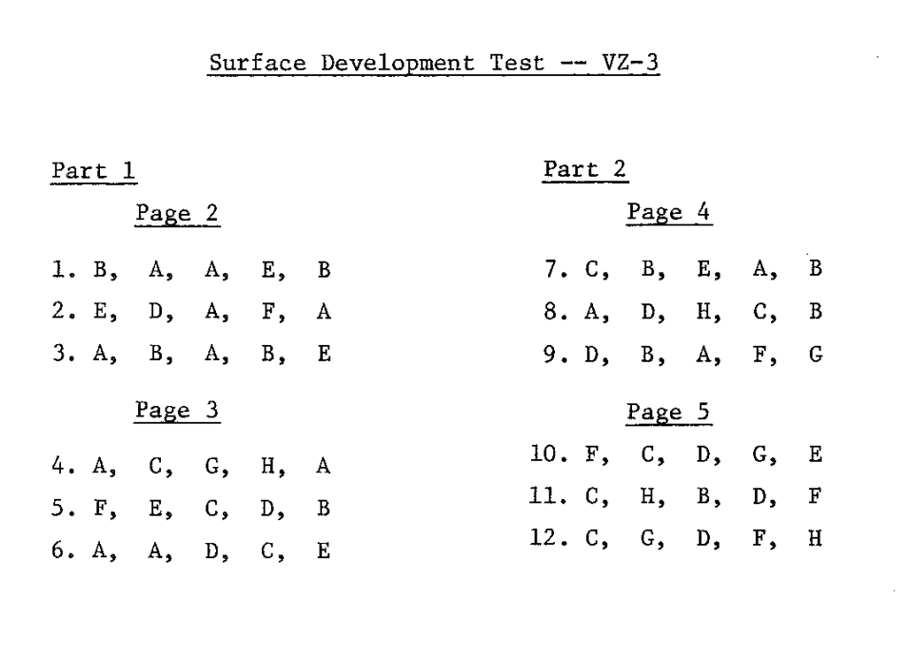

Norm
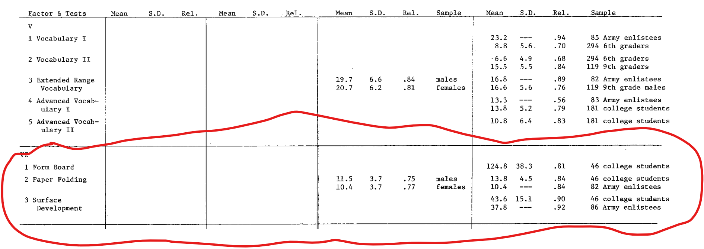

Reference
Ekstrom R. B., French J. W., Harman H. H. (1976). Manual for Kit of Factor-Referenced Cognitive Tests. Princeton: Educational Testing Service.

