GridBrawl Game
Siyao Yu(sy3342), Sitao Zhang(sz3419), Anyongyong Zhao(az2932)
Spring 2026
- Introduction
Our team plans to design a two-player, tile-based, competitive game implemented on the DE1 SoC FPGA platform. The game takes place on a closed map filled with hard walls and soft walls. Two players compete on the map by running across tiles to capture territory. Players can place bombs to destroy soft walls, create paths, and attack the opponent. If a player is hit by a bomb explosion, the player dies, and all tiles previously captured by that player become empty. The first player who captures 80 tiles wins the game.

- System Block Diagram
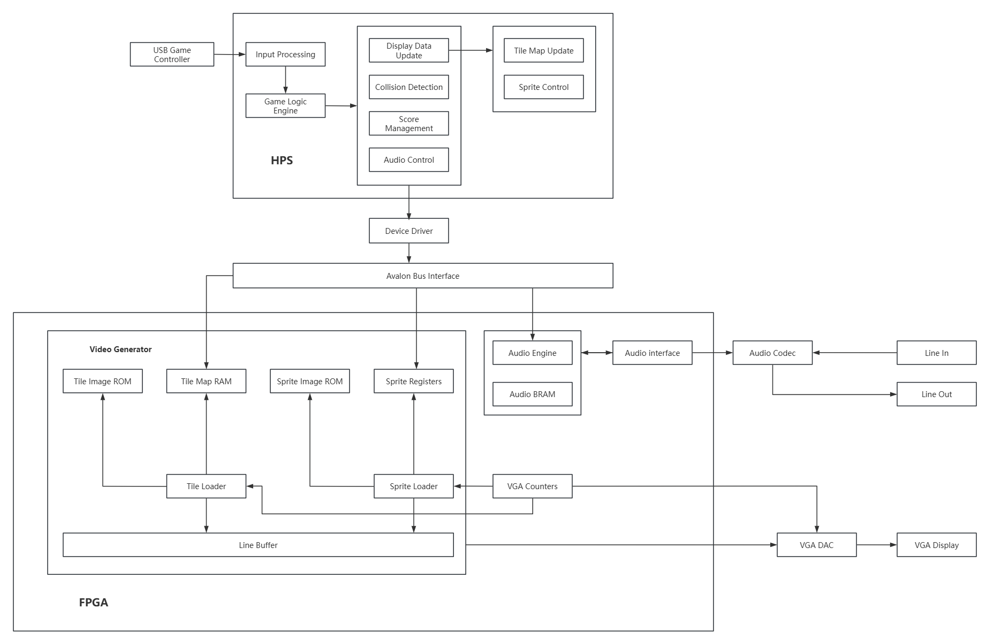
Figure 1. Hardware/Software System Block Diagram for GridBrawl on the DE1-SoC
- Algorithm
  - Hardware
- Graphics Display
Tile-based rendering: The display is implemented using a tile-based architecture on a 640 × 480 VGA screen, organized into a 20 × 15 grid with 32 × 32-pixel tiles.
Tile and map storage: The game map is stored in Tile Map RAM, where each entry corresponds to the tile type. The corresponding pixel data for each tile is stored in Tile Image ROM and accessed during rendering.
Sprite handling: Dynamic objects such as players, bombs, and explosions are implemented as sprites. Their states and positions are stored in Sprite Registers, and their pixel patterns are stored in Sprite Image ROM.
Line-by-line rendering: The system uses a line buffer to generate one scanline at a time. For each line, background tile pixels are first written into the line buffer, followed by sprite pixels to achieve proper layering.
VGA output: VGA Counters generate pixel coordinates and synchronization signals. The video generator uses these coordinates to fetch tile and sprite data and produces RGB values, which are sent through the VGA DAC to drive the display.

- Audio Output
Audio control: The FPGA audio module receives control signals from the HPS and selects appropriate sound effects based on game events such as explosions, bomb placement, and game over.
Audio playback: Audio samples are read from memory and managed by the audio controller, which sends the digital audio stream to the WM8731 audio CODEC for digital-to-analog conversion and output.
Parallel operation: The audio and video subsystems operate concurrently, allowing real-
time, graphics rendering, and synchronized sound playback.

  - Software
- Tile Coloring System
When a player moves onto an empty tile, the tile changes to that player’s color, and the player’s score increases by 1. If a player moves onto the opponent’s tile, the tile changes to the current player’s color. The current player’s score increases by 1, while the opponent’s score decreases by 1.

- Map Element
The map consists of 6 types of tiles:
Blue Tiles: Can be captured by players and change to the player’s color.
Yellow Tiles: Tiles currently controlled by Player 1.
Pink Tiles: Tiles currently controlled by Player 2.
Soft Walls: Can be destroyed by bomb explosions. Once destroyed, they become empty tiles that can be captured.
Hard Walls: Cannot be destroyed or captured, and act as permanent obstacles and map boundaries.

- Bomb System
Players can place bombs on the map. Each bomb produces a cross-shaped explosion covering five tiles, including the center tile and the four adjacent tiles in the up, down, left, and right directions. Bomb explosions can destroy soft walls and eliminate opponents within the blast radius. When an opponent is eliminated, all tiles previously captured by that opponent are cleared.

- Win Condition
The game ends when one player captures 80 tiles. The player who first reaches 80 captured tiles wins.

- Resource Budget
  - Video Resource Budget
Category | Graphics | Size (bits) | # of Images | Total Size (bits)
Player 1 |  | 32×32 | 4 | 32×32×4×24=98304
Player 2 |  | 32×32 | 4 | 32×32×4×24=98304
Bomb / Explosion |  | 32×32 | 12 | 32×32×12×24=294912
Tiles |  | 32×32 | 4 | 32×32×4×24=98304
Walls |  | 32×32 | 2 | 32×32×2×24=49152
UI Assets |  | 64×64 | 10 | 64×64×10×24=983040
Total | 1622016 bits

  - Audio Resource Budget
Category | Time (s) | Frequency (kHz) | # of Bits
Background Music | 16 | 8 | 16×8000×16=2,048,000
Explosion | 2 | 8 | 2×8000×16=256,000
Player Dies | 1 | 8 | 1×8000×16=128,000
Victory | 2 | 8 | 2×8000×16=256,000
Wall Breaks | 1 | 8 | 1×8000×16=128,000
Total | 2,816,000 bits

- Software/Hardware Interface
The HPS communicates with the FPGA hardware through the Avalon memory-mapped (Avalon-MM) bus. The HPS acts as an Avalon-MM master, while the FPGA exposes memory-mapped slave regions for the Tile Map RAM, Sprite Registers, and Audio Controller.

  - Controller interface
The game is controlled through USB gamepads connected to the HPS, which acts as the USB host. The controllers are standard USB Human Interface Devices (HID). When a controller is connected, the Linux USB subsystem automatically detects the device, performs enumeration, assigns a USB address, and identifies its interface and input endpoint.

The user-level software uses the libusb library to access the controllers. The program scans connected USB devices, selects the target controllers based on their device information, obtains a device handle, and claims the corresponding interface. Controller inputs are then read using interrupt transfers from the input endpoint. In this model, the HPS periodically polls the controller and receives small data packets that encode the current button.
These input packets are interpreted by software, which maps bit-level values to game commands, including movement and bomb placement. This interpretation layer converts low-level USB data into high-level control signals for the game.

The controller connects to the HPS via the USB interface. The HPS performs input processing and game logic, including player movement, collision detection, scoring, and game state updates. The FPGA does not process raw controller input or make game decisions. Instead, the HPS communicates the updated display and audio states to the FPGA via the Avalon-MM bus by writing to the tile map memory, sprite registers, and audio control registers. The FPGA continuously reads these memory-mapped values to generate VGA video output and audio playback in real time.

  - Address Mapping
Base Address | Offset | Meaning
0xFF200000 | 0x000 - 0x12B | Tile Map (300 total, 1 byte each)
0xFF201000 | 0x000 - 0x077 | Sprite 0 – Sprite 29 (4 bytes each)
0xFF202000 | 0x000 - 0x003 | Audio Controller

  - Detailed Register Definitions
All display-related states are stored in FPGA memory (Tile Map RAM and sprite registers) and updated by the HPS through the Avalon bus. The full game logic state is maintained in the HPS.

(1) Tile Map Memory
- Total tiles: 20 × 15 = 300
- Each tile: 3 bits
Total size (theoretical):
300 × 3 = 900 bits ≈ 113 bytes
Although only 3 bits are required, each tile is stored in 1 byte to simplify memory access and alignment.
Total size (actual):
300 × 1 byte = 300 bytes
Tile Map RAM (0x000 - 0x12B)
Each byte in the Tile Map RAM corresponds to a 32x32-pixel grid cell on the 20x15 game map.
- Bits [2:0]: Tile ID (0: Empty, 1: Blue Tile, 2: Pink Tile, 3: Yellow Tile, 4: Hard Wall, 5: Soft Wall)
- Bits [7:3]: Reserved.

(2) Sprite Registers
- Number of sprites: 30
- Each sprite: 32 bits
Total:
30 × 32 = 960 bits = 120 bytes
Sprite Register Interface (0x000 - 0x077)
Dynamic display objects are controlled through memory-mapped sprite registers. Each sprite occupies one 32-bit register in the FPGA peripheral address space. The HPS updates these registers to control which sprites are visible and where they appear on the screen.
Each sprite register contains:
Field | Bits | Description
X position | [9:0] | 0-639
Y position | [18:10] | 0-479
Sprite ID | [23:19] | 30 sprites
Enable | [24] | visible or not
Reserved | [31:25] | Unused

The total size is 25 bits, and each sprite entry is aligned to 32 bits.
The X and Y fields specify the upper-left pixel position of the sprite on the VGA display. The Sprite ID selects the sprite image stored in the sprite image ROM. The Enable bit determines whether the sprite is rendered. When Enable is 0, the sprite is ignored by the rendering hardware.

(3) Audio Controller (0x000 – 0x003)
- Bits [3:0]: Sound_ID
- Bits [31:4]: Reserved
The audio system continuously plays background music by default. The Sound_ID field specifies sound events.
When a sound effect is requested, the audio engine temporarily interrupts the background music, plays the selected sound once, and then automatically resumes the background music.
Write behavior:
Writing a value to the Sound Select Register triggers the corresponding sound event.

