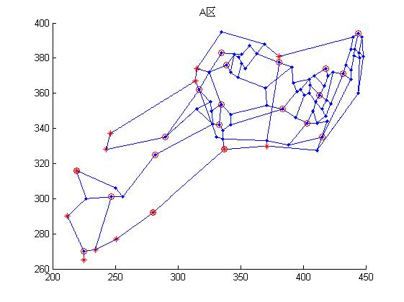
Figure 1. The diagram of the transportation network and the TPPSP locations of District A

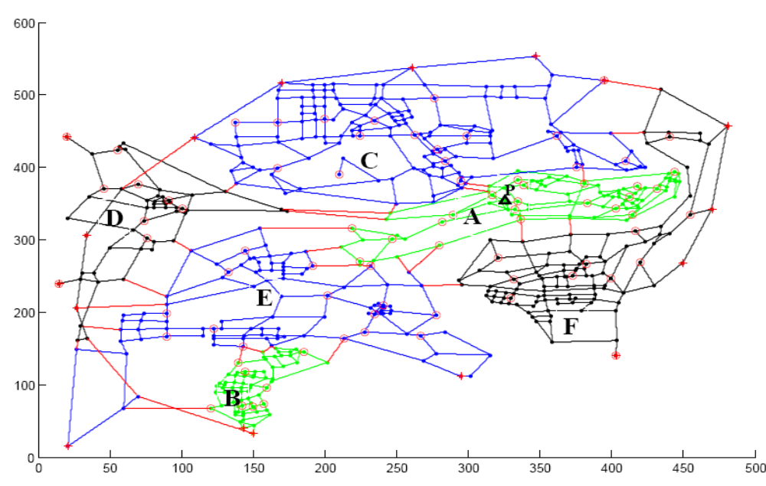

Figure 2. The diagram of the transportation network and the TPPSP locations of the city's six districts

Remarks:
(1) A solid line represents a road and a red line represents a road connecting two districts.
(2) A solid dot "·" represents an intersection, a cross line without a solid dot represents a 3D intersection, that is, a road is actually above another road without any connections.
(3) An asterisk "*" represents an intersection which is an access of the city．
(4) A circle "○" represents the location of a existed TPPSP．
(5) A circle asterisk "○* " represents that there is a TPPSP located at the intersection used to access the city．
(6) The different colors represent different districts in Figure 2.

