/*根据test1的用户ID和user表，查询对order中的sys_button的权限*/

SELECT * FROM sys_button

WHERE sys_button.BtnID IN

(SELECT cf_privilege.PrivilegeAccessKey FROM cf_privilege

WHERE cf_privilege.PrivilegeMaster='CF_User'

AND cf_privilege.PrivilegeMasterKey=

(SELECT cf_user.UserID FROM cf_user

WHERE cf_user.LoginName='test1')

AND cf_privilege.PrivilegeAccess='Sys_Button'

AND cf_privilege.PrivilegeOperation='Permit'

) 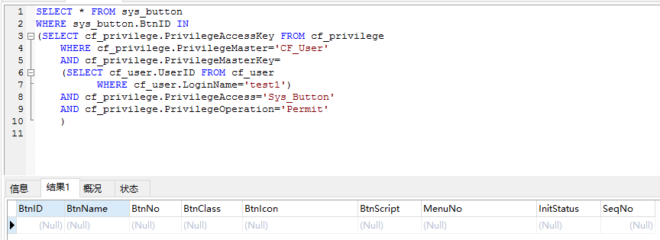

/*根据test1的用户ID和user表，查询对Sys_menu的权限*/

SELECT * FROM sys_menu

WHERE sys_menu.MenuID IN

(SELECT cf_privilege.PrivilegeAccessKey FROM cf_privilege

WHERE cf_privilege.PrivilegeMaster='CF_User'

AND cf_privilege.PrivilegeMasterKey=

(SELECT cf_user.UserID FROM cf_user

WHERE cf_user.LoginName='test1')

AND cf_privilege.PrivilegeAccess='Sys_Menu'

AND cf_privilege.PrivilegeOperation='Permit'

)

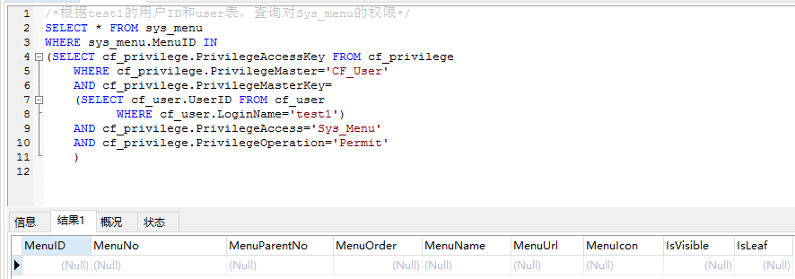

/*根据test1的角色ID和角色表，查询对Sys_menu的权限*/

SELECT * FROM sys_menu

WHERE sys_menu.MenuID IN

(SELECT cf_privilege.PrivilegeAccessKey FROM cf_privilege

WHERE cf_privilege.PrivilegeMaster='CF_Role'

AND cf_privilege.PrivilegeMasterKey=

(SELECT cf_userrole.RoleID FROM cf_userrole

WHERE cf_userrole.UserID =

(SELECT cf_user.UserID FROM cf_user

WHERE cf_user.LoginName='test1')

)

AND cf_privilege.PrivilegeAccess='Sys_Menu'

AND cf_privilege.PrivilegeOperation='Permit'

)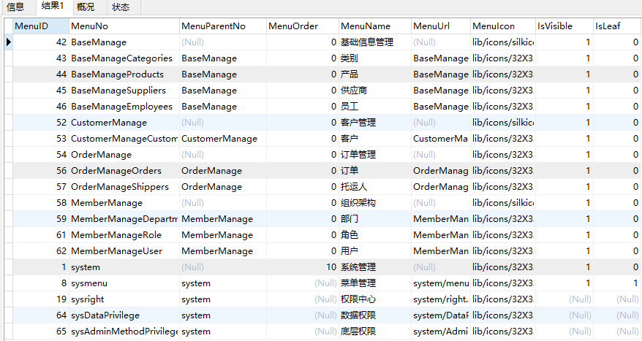

/*根据test1的角色ID和角色表，查询对order中的sys_button的权限*/

SELECT * FROM sys_button

WHERE sys_button.BtnID IN

(SELECT cf_privilege.PrivilegeAccessKey FROM cf_privilege

WHERE cf_privilege.PrivilegeMaster='CF_Role'

AND cf_privilege.PrivilegeMasterKey=

(SELECT cf_userrole.RoleID FROM cf_userrole

WHERE cf_userrole.UserID =

(SELECT cf_user.UserID FROM cf_user

WHERE cf_user.LoginName='test1')

)

AND cf_privilege.PrivilegeAccess='Sys_Button'

AND cf_privilege.PrivilegeOperation='Permit'

)