|  |
| --- |
| mboRijnland |
| Functional Design |
| Hotel La Casserai |

|  |
| --- |
| Jayant Schuil  23-6-2019 |

Inhoud

1. Summary 5

1.1. Summary for the customer 5

1.2. Versioncontrol 5

1.3. Mailing list 5

Henry Robben. (Product Owner) 5

2. Plan of action 6

2.1. Documents to be delivered 6

2.2. Planning 6

3. Programmme requirements 7

3.1. Goal 7

3.2. Current Situation 7

3.4. New situation 7

3.5. Functional requirements 7

3.5. System requirements for new situtation 8

4. Interface 9

4.1. Interface 9

4.2 Schematics 12

5. Use Case en Data Model 13

5.1.1. De Use Case 13

5.1.2. Het Sequence Diagram 14

14

5.2.1. Het ERD Model 15

15

5.2.2. Securing Database 15

6. Conclusion 16

6.1. Accountability 16

6.2. Bronvermelding 16

## 1. Summary

### Summary for the customer

This document contains the record of the functional design of the project “Hotel LaCasserai”. All components as well as conclusions and recommendations are processed in this overview, with any references to seperate comprehensive documents which have been written during this phase of development.

### 1.2. Versioncontrol

|  |  |  |  |  |
| --- | --- | --- | --- | --- |
| **version** | **Status** | **Date** | **Author** | **Changes** |
| 0.1 | Not definite | 23/06/19 | Jayant Schuil | Start and finish of this document. |

### 1.3. Mailing list

This document is made available to:

## Henry Robben. (Product Owner)

Jayant Schuil (Developer)

## 2. Plan of action

### 2.1. Documents to be delivered

* Information requirement;
* Functional design;
* Technical design;
* Development;
* Test report.

### 2.2. Planning

|  |  |  |  |
| --- | --- | --- | --- |
| Task | Status | Autor | Date |
| Information  requirement | Not definite | Jayant Schuil | 23-06-2019 |
| Functional Design | Not definite | Jayant Schuil | 23-06-2019 |
| Technical Design | Not definite | Jayant Schuil | 23-06-2019 |
| Development | Not definite | Jayant Schuil | 23-06-2019 |
| Test report | Not definite | Jayant Schuil | 23-06-2019 |

## 3. Programmme requirements

### 3.1. Goal

The goal of this project is to give clients of Hotel La Casserai the option to book a hotel room through a website.

### 3.2. Current Situation

At this moment every booking is handled through paper, which according to the hotel is old fashioned. The hotel wants a website that increases the effectiveness of the administrative functions and increases the customer experience.

***3.3. Reasoning behind change***

The hotel does not want to use as much paper for their administrative functions anymore.

### 3.4. New situation

The clients can book a room at the hotel through the website. The Administrators at the hotel can see, review, and keep up with what hotel rooms are booked.

### 3.5. Functional requirements

|  |  |  |  |
| --- | --- | --- | --- |
| **requirement** | **Is functional(yes/no)** | **Verdere acties** | **MoSCoW prioriteit** |
| 1. Kamer selecteren | yes |  | Must have |
| 2. CheckIn en CheckOut invullen | yes |  | Must Have |
| 3. Kamer reserveren | yes |  | Must Have |
| 4. Inlogsysteem | yes |  | Must Have |
| 5.Goed design | no |  | Could Have |

### 3.5. System requirements for new situtation

In order to use the website one must have a functioning desktop pc, laptop, or mobile phone with an internet connection.

The website has not yet been revealed to the public and therefor the user now must download the website through the github link.

In order to test the website one must have:

A desktop pc or laptop,

Sufficient hardware to run symfony,

Symfony

A copy of the website.

## 4. Interface

### 4.1. Interface

Home page

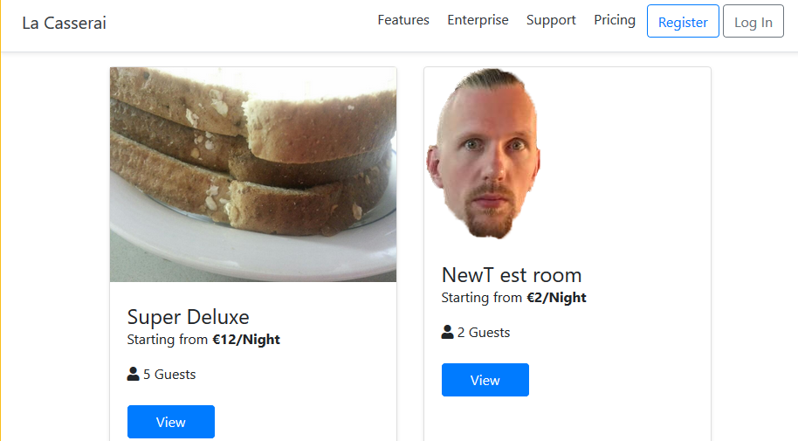

The home page features the logo in the top-left corner, a banner with navigation options, a register and login button. On the body of the web-page there are some of the rooms the hotel has on offer.

Room details

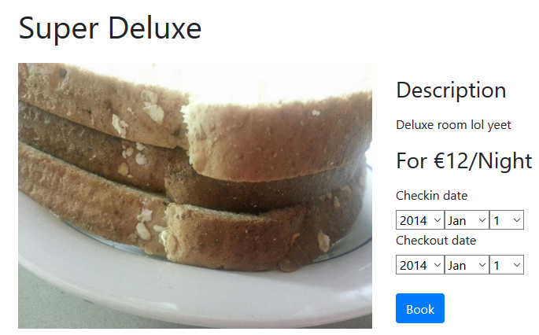

(I will leave out the banner at the top, since it remains unchanged through the rest of the screenshots)

Each room has a specific page dedicated to it. It contains a picture of the room to the left, with the room name/number at the top, a small description on the right, and the option to book said room.

Login page

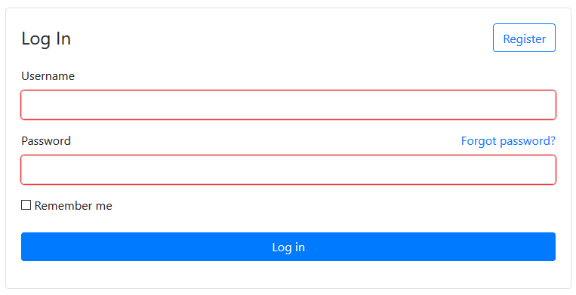

The login page features three inputs, a text field for the user name, a password field, and a remember me checkbox. The Register page is virtually the same, just with some extra fields.

Admin panel

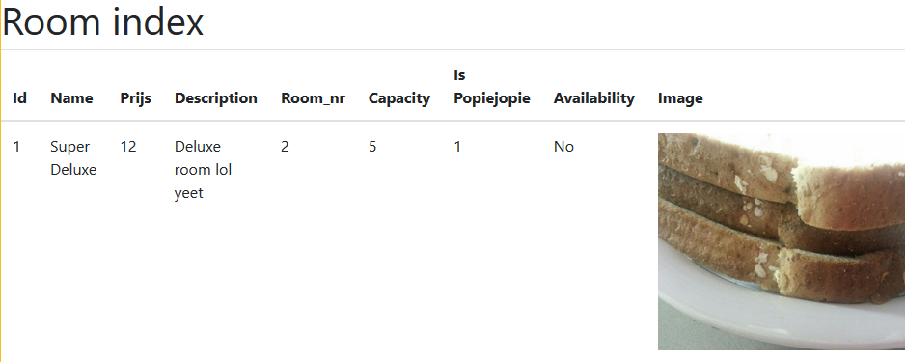

As an admin you can see each room listed as such. All of the rooms attributes are listed and a picture of the room is included. Admins can also edit and delete any given room.

### 4.2 Schematics

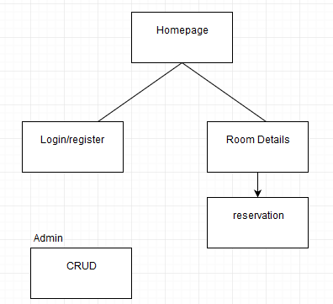

5. Use Case en Data Model

### 5.1.1. De Use Case

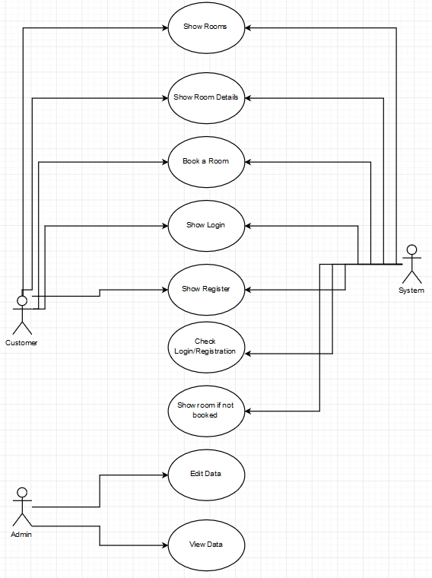

### 5.1.2. Het Sequence Diagram

## https://i.gyazo.com/ee4627ab84c0014f65bb333f7dd6bc51.png

### 5.2.1. Het ERD Model

## https://i.gyazo.com/a82b23a9eece15b9014901ed976b53fd.png

### 5.2.2. Securing Database

By Keeping Symfony up-to-date most of the work is done. The only other database security that has to be done is using roles to prohebit certain users to acces certains pages.

## 6. Conclusion

### 6.1. Accountability

* Problems have yet to be found

### 6.2. Bronvermelding

Draw.io – for creating UML