|  |
| --- |
| mboRijnland |
| Technical Design |
| La Casserai |

|  |
| --- |
| Jayant Schuil  23-6-2019 |

Inhoud

1 Samenvatting 2

1.1 Samenvatting voor de klant 2

1.2 Versiebeheer 2

1.3 Verzendlijst 2

2 Plan van aanpak 3

2.1 Op te leveren producten 3

2.2 Planning 3

3 Ontwikkelomgeving 4

3.1 De technische infrastructuur 4

3.2 Programmeertaal / ontwikkeltool 4

4 Specificaties van de interface 5

4.1 Interface 5

6 Beveiliging en onderhoud 8

6.1 Beveiliging 8

6.2 Beheer 8

7 Slotconclusie 8

7.1 Verantwoording 8

7.2 Brondocumentatie 8

## 1. Summary

### Summary for the customer

This document contains the record of the functional design of the project “Hotel LaCasserai”. All components as well as conclusions and recommendations are processed in this overview, with any references to seperate comprehensive documents which have been written during this phase of development.

### 1.2. Versioncontrol

|  |  |  |  |  |
| --- | --- | --- | --- | --- |
| **version** | **Status** | **Date** | **Author** | **Changes** |
| 0.1 | Not definite | 23/06/19 | Jayant Schuil | Start and finish of this document. |

### 1.3. Mailing list

This document is made available to:

## Henry Robben. (Product Owner)

Jayant Schuil (Developer)

## 2. Plan of action

### 2.1. Documents to be delivered

* Information requirement;
* Functional design;
* Technical design;
* Development;
* Test report.

### 2.2. Planning

|  |  |  |  |
| --- | --- | --- | --- |
| Task | Status | Autor | Date |
| Information  requirement | Not definite | Jayant Schuil | 23-06-2019 |
| Functional Design | Not definite | Jayant Schuil | 23-06-2019 |
| Technical Design | Not definite | Jayant Schuil | 23-06-2019 |
| Development | Not definite | Jayant Schuil | 23-06-2019 |
| Test report | Not definite | Jayant Schuil | 23-06-2019 |

## 3 Development Enviroment

### 3.1 Technical infrastructure

In order to use the website one must have a functioning desktop pc, laptop, or mobile phone with an internet connection.

The website has not yet been revealed to the public and therefor the user now must download the website through the github link.

In order to test the website one must have:

A desktop pc or laptop,

Sufficient hardware to run symfony,

Symfony

A copy of the website.

### 3.2 programming language and development tools

This website uses symfony

In order to develop the website you will need an IDE (prefferably with symfony support).

## 4. Interface

### 4.1. Interface

Home page

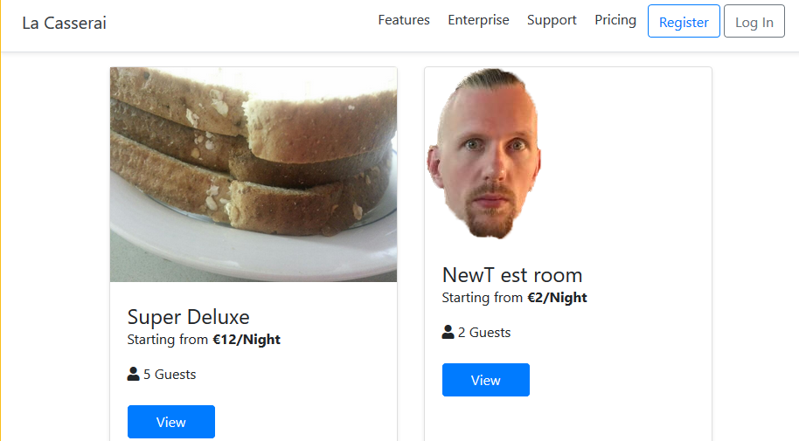

The home page features the logo in the top-left corner, a banner with navigation options, a register and login button. On the body of the web-page there are some of the rooms the hotel has on offer.

Room details

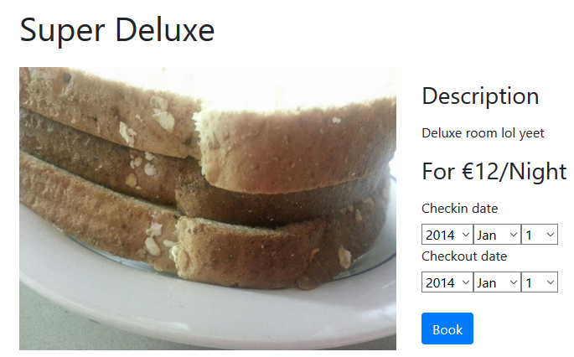

(I will leave out the banner at the top, since it remains unchanged through the rest of the screenshots)

Each room has a specific page dedicated to it. It contains a picture of the room to the left, with the room name/number at the top, a small description on the right, and the option to book said room.

Login page

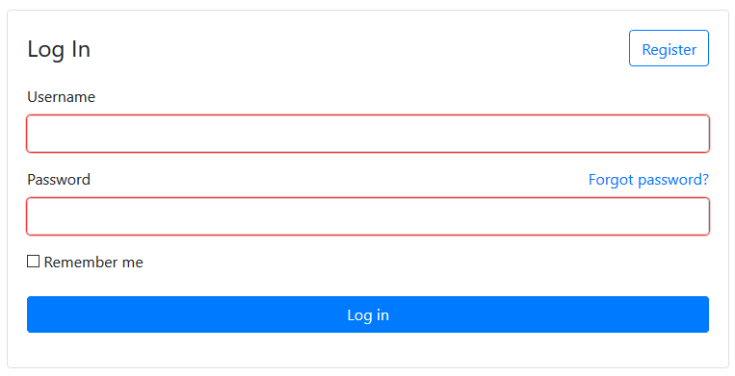

The login page features three inputs, a text field for the user name, a password field, and a remember me checkbox. The Register page is virtually the same, just with some extra fields.

Admin panel

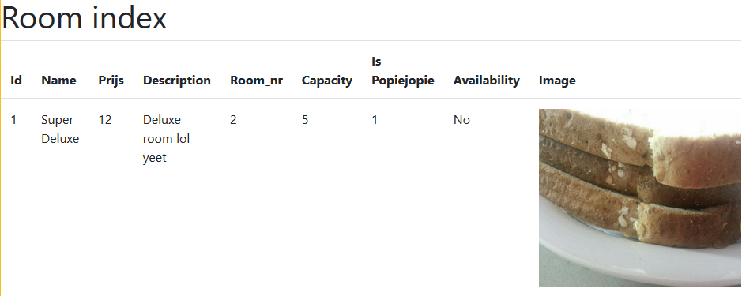

As an admin you can see each room listed as such. All of the rooms attributes are listed and a picture of the room is included. Admins can also edit and delete any given room.

## 

## 6 Security and Maintenance

### 6.1 Security

By Keeping Symfony up-to-date most of the work is done. The only other database security that has to be done is using roles to prohebit certain users to acces certains pages.

### 6.2 management

When a new, stable Symfony version is released we will update the site so that it remains up-to-date for as long as we support the website.

## 7 Slotconclusi

## 7.1 Verantwoording

* Problems have yet to be found

### 7.2 Brondocumentatie

No external sources have been used.