R Exercises Session 8

Introduction to R for Data Management and Analysis

# Setup

First, clone the [Assignment8](https://github.com/CUNYSPHCode/Assignment8) repository to your own GitHub account by forking. Look for the forking button on the GitHub repository page.

You can then modify the repository (namely the R_Exercises8.Rmd file) and complete the assignment by adding your answers in the appropriate place. Do **NOT** rename the file.

## Completing the assignment

Check your work by knitting the document.

1. Create a level 2 header below in Markdown with the name “Answer 1”.

## "Answer 1"

1. Add an unordered Markdown list of your favorite food dishes and add their ingredients as sub-items in the list. You should enter at least two dishes with two ingredients each.

food <- c("banana", "strawberry", "tomato", "squash", "pumpkin", "kiwi")  
class(food)

## [1] "character"

categ <- c("fruit", "fruit", "fruit", "veggie", "veggie", "fruit")  
market <- data.frame(  
 name = food, category = categ  
)

1. Insert an R code chunk below. Show the summary of the Orange dataset. Run a linear regression using the lm function to predict circumference from age and assign the result. Show the summary of the fit object that you assigned.

data("Orange")  
summary("Orange")

## Length Class Mode   
## 1 character character

circumference.lm <- lm(circumference ~ age, data = Orange)  
plot (circumference ~ age, data = Orange)  
abline(circumference.lm, lwd = 3)

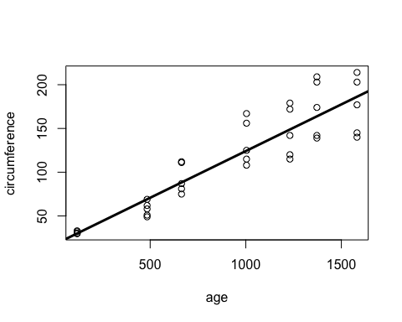

fitted (circumference.lm)

## 1 2 3 4 5 6 7 8   
## 29.99855 69.07649 88.29515 124.59706 148.83392 163.88854 186.31030 29.99855   
## 9 10 11 12 13 14 15 16   
## 69.07649 88.29515 124.59706 148.83392 163.88854 186.31030 29.99855 69.07649   
## 17 18 19 20 21 22 23 24   
## 88.29515 124.59706 148.83392 163.88854 186.31030 29.99855 69.07649 88.29515   
## 25 26 27 28 29 30 31 32   
## 124.59706 148.83392 163.88854 186.31030 29.99855 69.07649 88.29515 124.59706   
## 33 34 35   
## 148.83392 163.88854 186.31030

summary(circumference.lm)

##   
## Call:  
## lm(formula = circumference ~ age, data = Orange)  
##   
## Residuals:  
## Min 1Q Median 3Q Max   
## -46.310 -14.946 -0.076 19.697 45.111   
##   
## Coefficients:  
## Estimate Std. Error t value Pr(>|t|)   
## (Intercept) 17.399650 8.622660 2.018 0.0518 .   
## age 0.106770 0.008277 12.900 1.93e-14 ***  
## ---  
## Signif. codes: 0 '***' 0.001 '**' 0.01 '*' 0.05 '.' 0.1 ' ' 1  
##   
## Residual standard error: 23.74 on 33 degrees of freedom  
## Multiple R-squared: 0.8345, Adjusted R-squared: 0.8295   
## F-statistic: 166.4 on 1 and 33 DF, p-value: 1.931e-14

1. Add an RMarkdown weblink (in link format) below to your favorite R reference website.

<https://rmarkdown.rstudio.com/lesson-1.html>

1. Replace the author field in the yaml header with your name and then successfully knit the RMarkdown document into a Word document.
2. Follow the [Pull Request instructions on GitHub](https://help.github.com/en/github/collaborating-with-issues-and-pull-requests/creating-a-pull-request-from-a-fork) to submit your assignment via GitHub as a Pull Request to the [Assignment8](https://github.com/CUNYSPHCode/Assignment8) repository.