**NOJAVA**

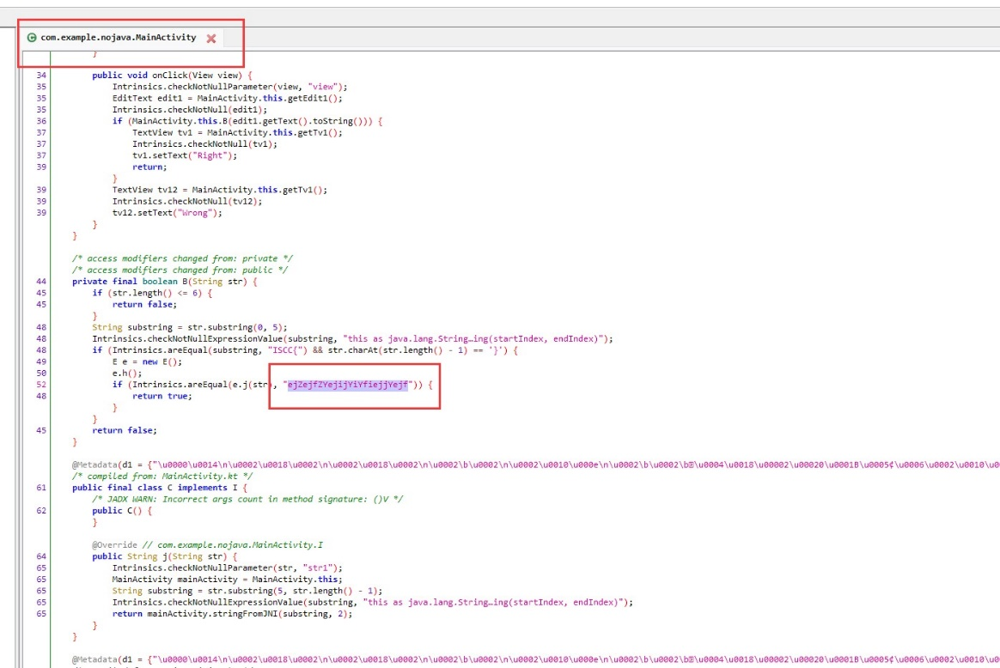

text='YffZeiijjjYfiYjjjejeeZYe'

binary = ''.join(format(ord(i), '08b') for i in text)

a = [binary[i:i+4] for i in range(0, len(binary), 4)]

# print(a)

payload=""

for i in a:

if i=="1001":

payload+="10"

elif i=="0110":

payload+="01"

elif i=="1010":

payload+="11"

elif i=="0101":

payload+="00"

else:

print("waaa")

result = ''.join(chr(int(payload[i:i+8], 2)) for i in range(0, len(payload), 8))

print('ISCC{'+result+'}')

**ManyJNI-3**

alpha = list("000000qwertyuiopasdfghjklzxcvbnm~@#!%&*()'/-_:;?<>&=ANM")

enc1 = "1986798057.1986798057.1986798057.1986798057.1986798057.1986798057.3713618273.132800239.2841218066.2460099397.734889408.3164894139.3121040253.3075111042.351048083.696150085.1083538065.709910699.428936951.3581263639.385403258.2421050068.1519023352.2156232310.2429787593.2858698525.3160675335.4027068562.2694837670.1336447878.654785657.3872134833.1158103192.19734539.1049530879.700813972.701073028.4097885373.1979386605.2696190145.4232898851.3126027666.891426205.406509623.2227920669.3113384841.2547227671.3896053831.3711461495.3747360752.4097885373.2853626980.1236282010.529156133.4075828588.4141497725.4141497725.4141497725.4141497725.4141497725.4141497725.3259647236.3878689771.780431097.287946231.680957602.2581098102.2415880190.1323776342.1823512614.2220172189.1130340170.3712210805.1911408410.1952078211.710806366.877129437.105877999.2823971181.619384622.3991735450.657981347.440012179.239856188.2775388247.4006927810.1068749546.2450550443.2637167118.4255690777.3680578651.312955233.4018178710.348865528.613662970.3300692563.2407112104.2766473378.2197974953.2827401366.1999610280.698153515.4135235691.3008240604.949414639.4018178710.607086523.4060431406.278213883.429489377".split(".")

etoa = {}

for i in range(len(alpha)):

etoa.update({enc1[i]:alpha[i]})

enc1 = "1986798057.64956337.166914849.924745076.666315003.930008935.4023341693.1808290711.1579951362.99771100.1236282010.1971216652.1462318326.933728663.3016651642.870221498.2666170697.4273244629.1184712308.4120373985.2965350987.2302105109.4075828588.529156133.4018804880.2954653653.3735675442.2381012008.3944223761.368955456.4067852839.4099300672.155280819.1964704696.3248176867.1935593237.1236282010.529156133.4075828588.4141497725.4234499210.75133536.1085575287.3369729975.2627182413.1586698450.212509551.2846238576.1051999332.4060431406.4016620168.3226159060.4036345491.1304626590.4165280671.1050538432.3478477188.807098365.112157582.46203785.2843567652.429489377.278213883.2724391126.1618611175.4106461569.4088810995.1040972928.3265704134.2777358486.1926520061.3054501475.30454558.998559740.368431450.4060431406.278213883.429489377".split(".")

alpha = list("0123456789ABCDEFGHIJKLMNOPQRSTUVWXYZ")

for i in range(len(alpha)):

etoa.update({enc1[i]:alpha[i]})

alpha = list("000000,.?!:/@...\";'~()<>([{<*&[]\`#$%^_+-={}|>}])ANM")

enc1 = "1986798057.1986798057.1986798057.1986798057.1986798057.1986798057.3330444070.986806734.3896053831.700813972.3113384841.891426205.19734539.986806734.986806734.986806734.3283987997.2547227671.3126027666.1158103192.2696190145.4232898851.3711461495.3747360752.2696190145.2477809142.1615466436.3711461495.1979386605.4097885373.2477809142.881206442.2870232400.2647754101.1049530879.2862766292.701073028.1392500071.2227920669.1463495029.406509623.2853626980.1615466436.4259959222.1802901715.3747360752.4259959222.881206442.4232898851.1236282010.529156133.4075828588.4141497725.4141497725.4141497725.4141497725.4141497725.4141497725.1174262214.2777299023.4135235691.3680578651.1999610280.2766473378.2637167118.2777299023.2777299023.2777299023.1614515444.698153515.2407112104.2450550443.613662970.3300692563.3008240604.949414639.613662970.443877620.2634553015.3008240604.348865528.4018178710.443877620.1709247634.3722498303.2230120467.4255690777.2381007417.312955233.2693188089.2827401366.1088610877.2197974953.607086523.2634553015.1144992995.704799359.949414639.1144992995.1709247634.3300692563.4060431406.278213883.429489377".split(".")

for i in range(len(alpha)):

etoa.update({enc1[i]:alpha[i]})

print(etoa)

enc2 = str(input("input encode:")).split(".")

result = ""

for a in enc2:

try:

result += etoa[a]

except BaseException:

if a != '':

print("FLAG WRONG!!!! => " + a)

continue

print("ISCC{" + result + "}")

print("ISCC{" + result[0:len(result) - 3] + "}")

05-08 10:31:12.293 29981 29981 D SYS-HOOK-30: 000000qwertyuiopasdfghjklzxcvbnm~@#!%&*()'/-_:;?<>&=ANM

05-08 10:31:12.293 29981 29981 D SYS-HOOK-30: .1986798057.1986798057.1986798057.1986798057.1986798057.1986798057.3713618273.132800239.2841218066.2460099397.734889408.3164894139.3121040253.3075111042.351048083.696150085.1083538065.709910699.428936951.3581263639.385403258.2421050068.1519023352.2156232310.2429787593.2858698525.3160675335.4027068562.2694837670.1336447878.654785657.3872134833.1158103192.19734539.1049530879.700813972.701073028.4097885373.1979386605.2696190145.4232898851.3126027666.891426205.406509623.2227920669.3113384841.2547227671.3896053831.3711461495.3747360752.4097885373.2853626980.1236282010.529156133.4075828588.4141497725.4141497725.4141497725.4141497725.4141497725.4141497725.3259647236.3878689771.780431097.287946231.680957602.2581098102.2415880190.1323776342.1823512614.2220172189.1130340170.3712210805.1911408410.1952078211.710806366.877129437.105877999.2823971181.619384622.3991735450.657981347.440012179.239856188.2775388247.4006927810.1068749546.2450550443.2637167118.4255690777.3680578651.312955233.4018178710.348865528.613662970.3300692563.2407112104.2766473378.2197974953.2827401366.1999610280.698153515.4135235691.3008240604.949414639.4018178710.607086523.4060431406.278213883.429489377

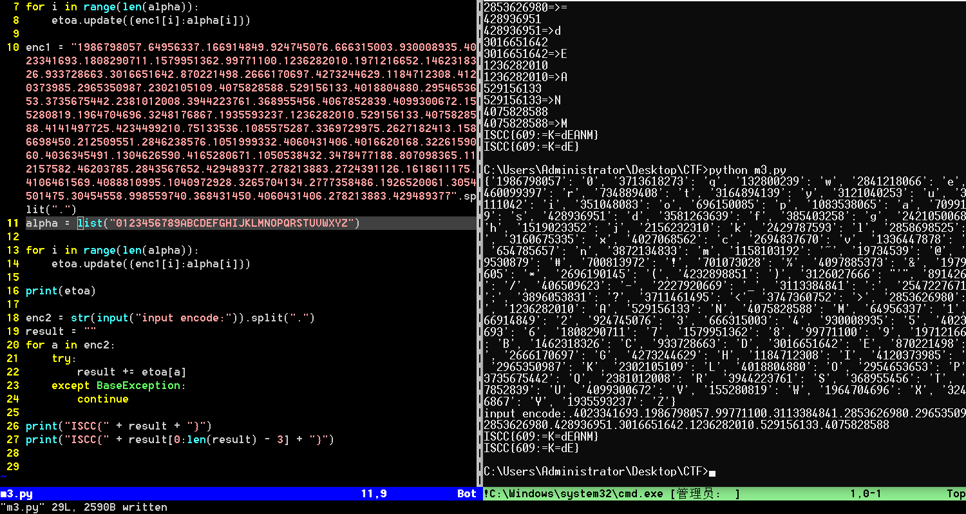

## ManyMany

# 解压附件，进lib/arm64-v8a文件夹，ida64开.so文件，搜stub函数，将下面说的字符填进去

s = "" #第一段密文 stub函数第170行

reversed_str = s[::-1]

print(reversed_str,end='')

str1 = "" #第二段密文 stub函数第225行

str2 = ''

map = {0:0, 4:1, 1:2, 5:3, 2:4, 6:5, 3:6, 7:7}

for i in range(8):

a = map[i]

# print(i,str1[a])

str2 += str1[a]

print(str2)