## 奇门遁甲

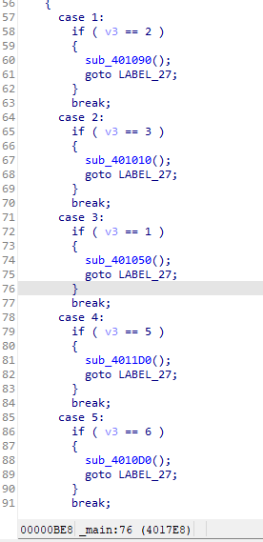

根据switch语句的顺序31284567

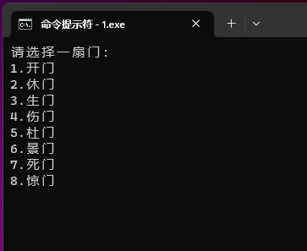

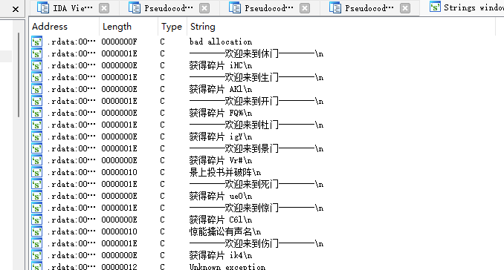

把所有碎片按顺序拼一块

## JustDoIt

#include <stdio.h>

int sub_499080(char *a1, char *a2, int a3) {

int result; // eax

char v4; // [esp+D0h] [ebp-20h]

int i; // [esp+E8h] [ebp-8h]

int j; // [esp+E8h] [ebp-8h]

int k; // [esp+E8h] [ebp-8h]

int l; // [esp+E8h] [ebp-8h]

for (l = a3 - 1; l > 0; --l)

{

a1[l] ^= *a2;

a1[l] -= a2[l % 4] % 5;

a1[l] = a1[l] + a2[2] % 6 + a2[3] / 6;

a1[l] -= a2[1] / 7 + *a2 % 7;

}

result = a3;

for (k = a3 - 1; k >= 1; --k)

a1[k] -= k;

v4 = a1[a3 - 1];

for (j = a3 - 1; j >= 0; --j)

a1[j] = a1[j - 1];

a1[0] = v4;

for (i = 0; i < a3; ++i)

a1[i] += 60;

return 0;

}

int main(int argc, char const *argv[]) {

int i;

// 这个v5数组即题中v8加密后的flag 只用替换这个就行

char v5[] = {0x17, 0x44, 0x44, 0x0F, 0x5E, 0x0A, 0x08, 0x0A, 0x06, 0x5F, 0x08, 0x18, 0x57, 0x03, 0x1A, 0x69};

int v6;

char v7[] = {'I', 'S', 'C', 'C'};

int v9;

v6 = 16;

sub_499080(v5, v7, v6);

printf("%s",v5);

}

// ISCC{Just~Do~It}p@

ISCC{Just~Do~It}

## 变形记

import base64

ss = "=UleCJzchJTezZXU5ZXVyknQ2NnQ" // 替换main函数中的字符串

res = ss[::-1]

re = ""

re += str(base64.b64decode(res).decode('utf-8'))

print(re)

result = ""

for i in range(0, len(re)):

if ord(re[i]) <= 57:

tmp = ord(re[i]) - 48 - 1

result += re[i - 1] * tmp

continue

result += re[i]

print("ISCC{" + result + "}")

## 狂飙1

附件解压看文件夹序号

mod = 30 // mod替换为文件夹序号

a1 = 0x50d7c32f4a659

a2 ="4-chloroisatin"

a3 ="Ammosamide B"

mod_out = (int((a1 % 100000) % mod)) ^ (mod * (int)(a1 % 100000))

flag = "ISCC{" + str(mod_out) + "_" + a2 + "_" + str(a1) + "_" +a3 + "}"

print(flag)