JustInTime – Sprint 1 Developer Documentation
Sprint Review 1 · 27 September 2026

Statement of Sprint Goal
Name | Role | Date assigned to role
[Name of Developer C] | Developer | 21/09/2026 – 27/09/2026

Establish a shared understanding of JustInTime and a technical foundation for the team: a baseline process model, architecture and data model traced to the stakeholder interviews, and a version-controlled, CI-tested code skeleton that the Sprint 2 developers can build on without re-work.

Sprint Backlog
ID | Item / job | Owner | Estimate (unit-days) | Status
SB1-01 | Analyse case study and six stakeholder interviews | All | 1.0 | Done
SB1-02 | Use Case diagram | Developer C | 1.0 | Done
SB1-03 | Layered architecture draft | Developer C | 1.0 | Done
SB1-04 | Technology stack selection and rationale | Developer C | 0.5 | Done
SB1-05 | ERD draft (20 entities) | Developer D | 1.5 | Done
SB1-06 | Repository skeleton and data-model code | Developer D | 1.0 | Done
SB1-07 | CI pipeline and branching rules | Developer D | 0.5 | Done
SB1-08 | Unit tests for skeleton | Developer D | 0.5 | Done

Developer C Documentation – Sprint 1
Name | Role | Date assigned to role
[Name of Developer C] | Developer | 21/09/2026 – 27/09/2026

Weekly Increment Report
Delivered the Use Case diagram, the layered architecture draft and the technology stack decision. All sources are stored in docs/diagrams/ in the repository so later Sprints can revise them under version control.

Business Process Analysis – Use Case Diagram
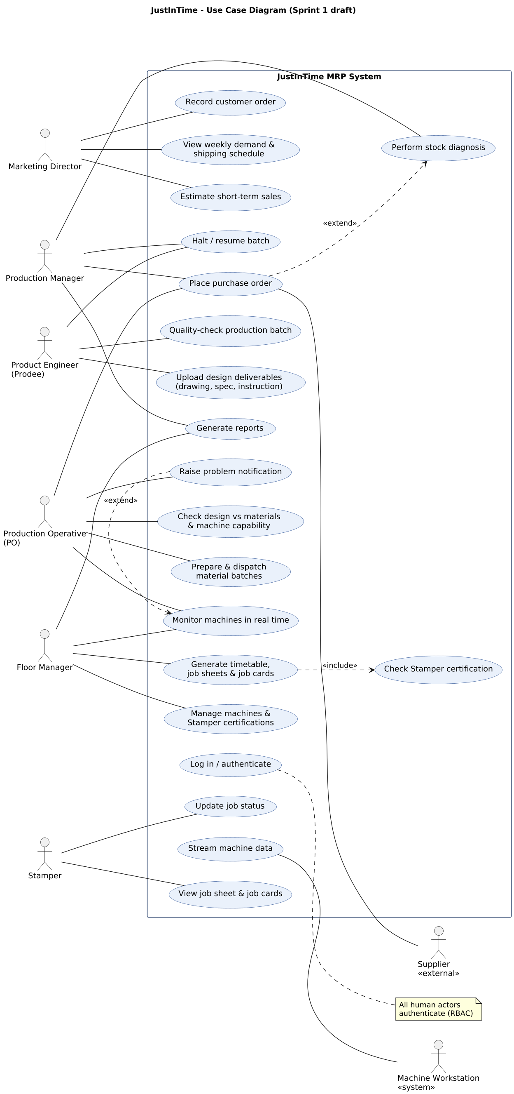
Figure 1. JustInTime Use Case diagram (Sprint 1 draft)
Six human actors come directly from the interviewed roles; two non-human actors were added: the Machine Workstation, because Abby and Mattie describe machines exchanging data over the network in real time, and the Supplier, because Annabel needs to place orders directly with suppliers. Key relationships:
- Generate timetable includes Check Stamper certification – only certified Stampers may operate a machine (Abby, Mattie).
- Place purchase order extends Perform stock diagnosis – an order is raised only when stock is insufficient (Annabel, Jakub).
- Raise problem notification extends Monitor machines – Jakub wants to alert his manager and team immediately.

Software Architecture – Layered Architecture Draft
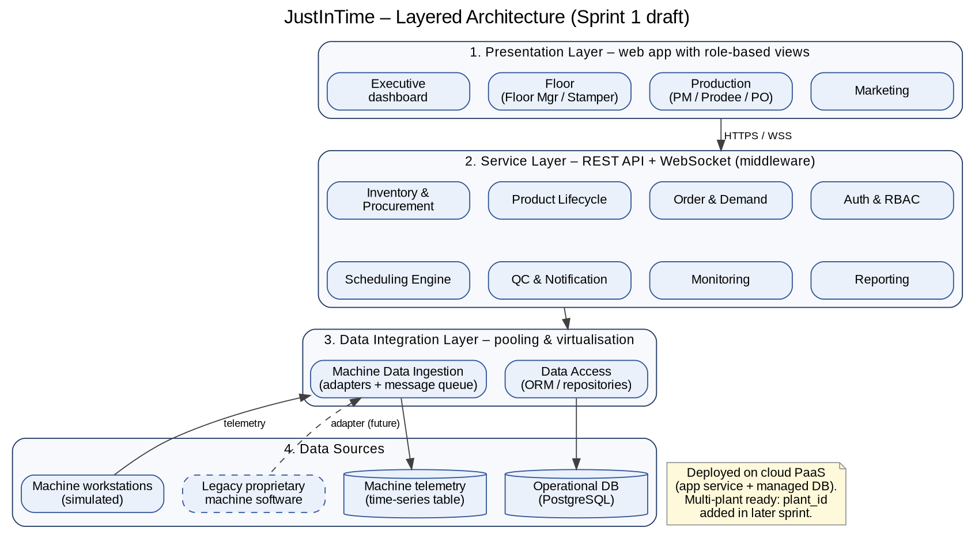
Figure 2. Four-layer architecture (Sprint 1 draft)
The four layers map onto David Float's stated needs: retrieve real-time machine data and legacy resources (data sources), pool the data and virtualise access (data integration), a middle layer for user data, tasks, timetabling and resources (service layer), and views for every user group (presentation). Separating machine telemetry from the operational database keeps high-frequency writes away from transactional data.

Technology Stack Decision
Concern | Choice | Rationale
Backend | Python + FastAPI | Native async and WebSocket support for real-time monitoring; auto-generated API documentation.
Database | PostgreSQL + SQLAlchemy | Relational structure suits orders, bills of material and scheduling; managed PaaS option available.
Frontend | React | Component-based role views reused across user groups.
Hosting | Cloud PaaS | No server management; scales to the planned additional plants (Q3 2027).
CI / VCS | GitHub + GitHub Actions | Branch protection and automated tests on every pull request.

Testing
No executable features were assigned to Developer C this Sprint. The Use Case diagram was walked through with the team against each interview to confirm every stated need maps to at least one use case.

Developer D Documentation – Sprint 1
Name | Role | Date assigned to role
[Name of Developer D] | Developer | 21/09/2026 – 27/09/2026

Weekly Increment Report
Delivered the ERD draft, the repository skeleton with the full data model implemented in SQLAlchemy, the CI pipeline and the branching rules (CONTRIBUTING.md). Five unit tests pass locally.

Data Analysis – Entity Relationship Diagram
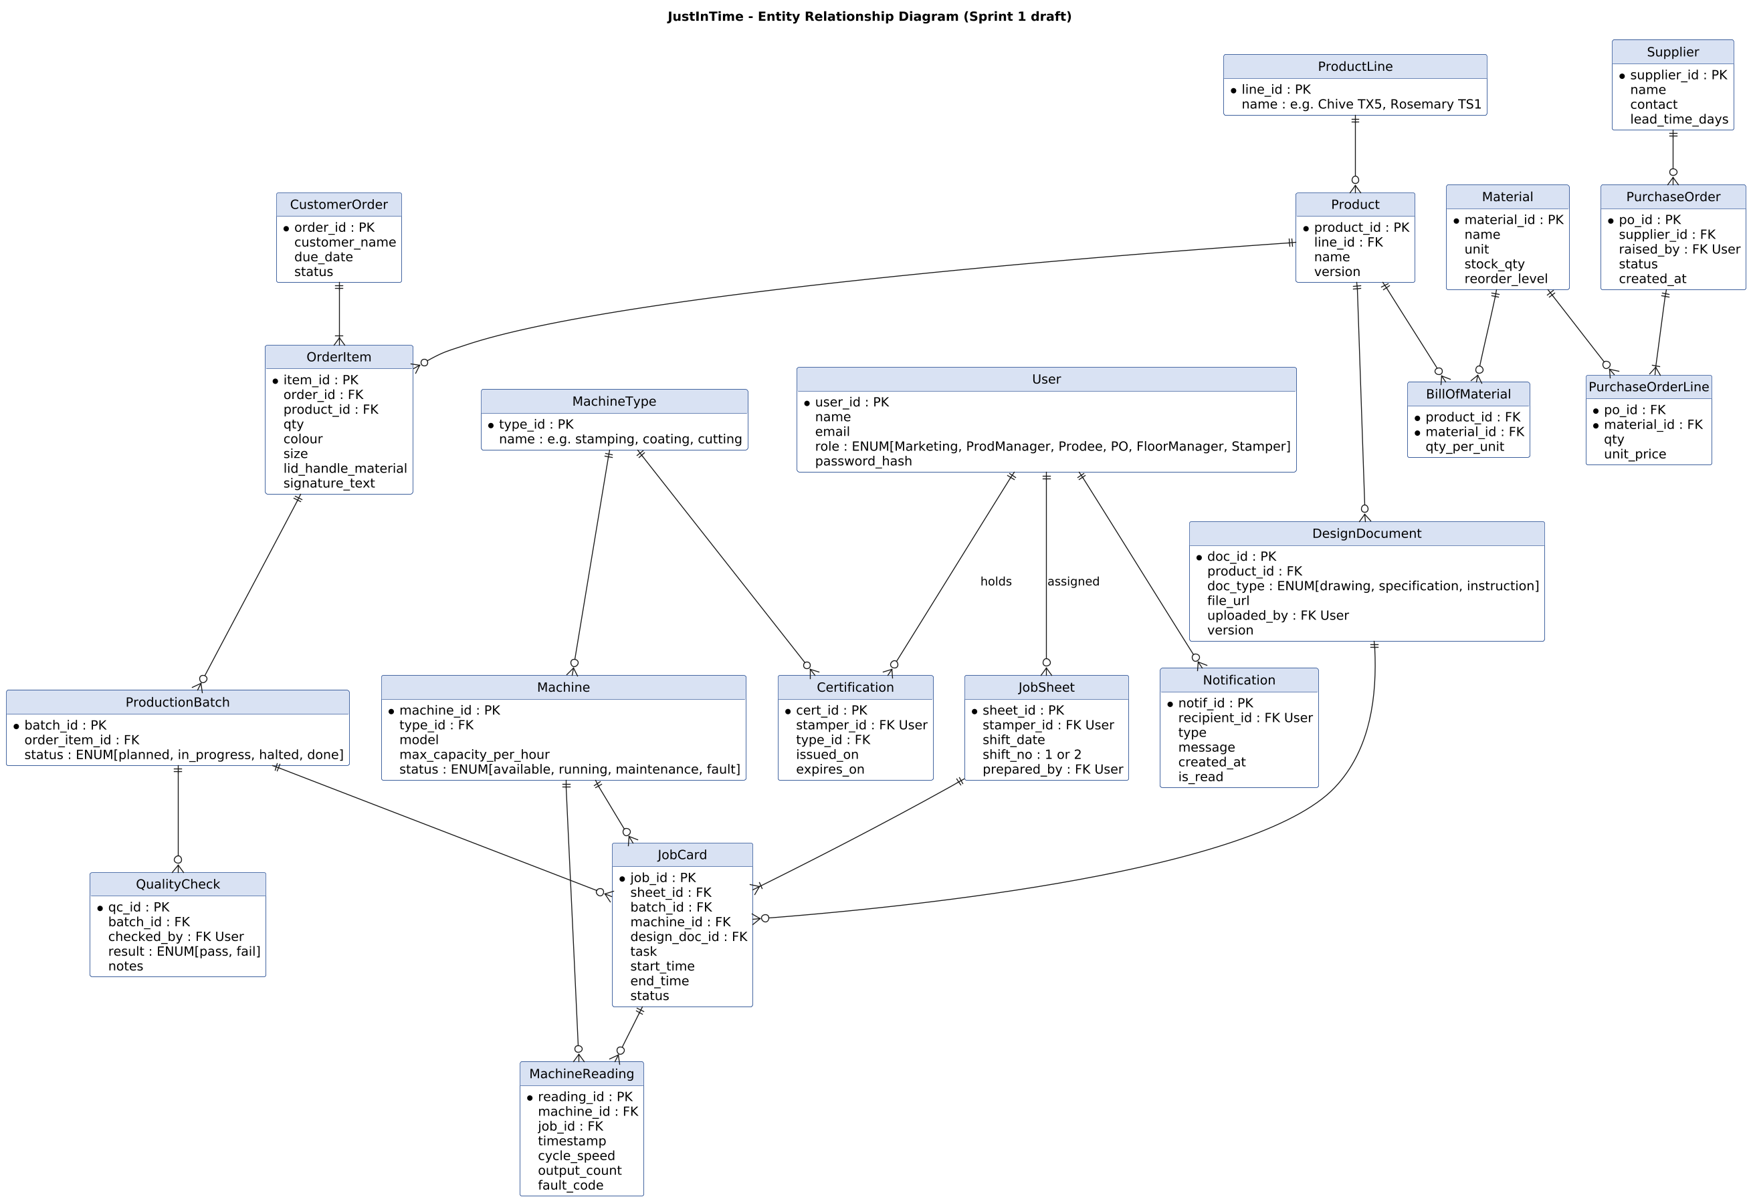
Figure 3. JustInTime ERD (Sprint 1 draft)
Each entity is traced to a stakeholder need:
Entity | Source and rationale
Certification | Abby and Mattie: a Stamper may only operate machine types they are certified for; each holds 3–4.
JobSheet, JobCard | Mattie: a job sheet per Stamper per shift (two 8-hour shifts), containing job cards with machine, time, design and materials.
DesignDocument | Ally: three deliverables – technical drawing, design specification, manufacturing instruction.
OrderItem | Ally: customers customise colour, size, lid and handle material, and signature.
BillOfMaterial, Material | Jakub and Annabel: check design specification against material availability before production.
Supplier, PurchaseOrder | Annabel: suppliers are now nationwide; lead time is a major concern.
MachineReading | Abby: job, start and end, cycle speed and faults are available in real time.
ProductionBatch, QualityCheck | Annabel: Prodees check each batch; production halts on failure.

Development – Repository and Data Model
Artefact | Content
backend/app/models.py | All 20 ERD entities implemented as SQLAlchemy models.
backend/app/main.py | FastAPI service with /health and /api/v1/roles endpoints.
.github/workflows/ci.yml | Runs the test suite on every push and pull request to main or develop.
CONTRIBUTING.md | Branching (main / develop / feature), commit convention linked to backlog IDs, one-reviewer PR rule, role handover note.
docker-compose.yml | Local PostgreSQL + API stack for development.

[Insert screenshot of the GitHub repository and a successful CI run here]

Testing – Test Cases and Results
Test environment: Python 3.11, in-memory SQLite, pytest; executed locally and in GitHub Actions.
TC ID | Test case | Expected result | Result
TC1-01 | Health endpoint responds | HTTP 200, status = ok | Pass
TC1-02 | Roles endpoint lists stakeholder roles | Exactly the six interviewed roles | Pass
TC1-03 | Schema contains all ERD entities | 20 tables created | Pass
TC1-04 | Stamper holds multiple certifications | Two certifications linked to one Stamper | Pass
TC1-05 | Order item stores customisation | Signature text persisted and retrieved | Pass

Handover to Sprint 2 Developers
Open questions for the Product Owner to confirm at Sprint Review 1:
- Sales estimation: is a simple moving average over recent weekly orders acceptable for the MVP?
- Supplier ordering: will purchase orders be sent by email or generated as a document for manual sending?
- Shift times: confirm the start times of the two 8-hour Stamper shifts used by the scheduler.
Planned for Sprint 2: finalise the ERD and add a Data Flow Diagram; architecture Class and Component diagrams; security design (RBAC matrix); authentication; managed-database deployment; machine and certification management.

