#### Pass-10 双写文件名绕过

双写文件名绕过，文件名改成10.pphphp等格式

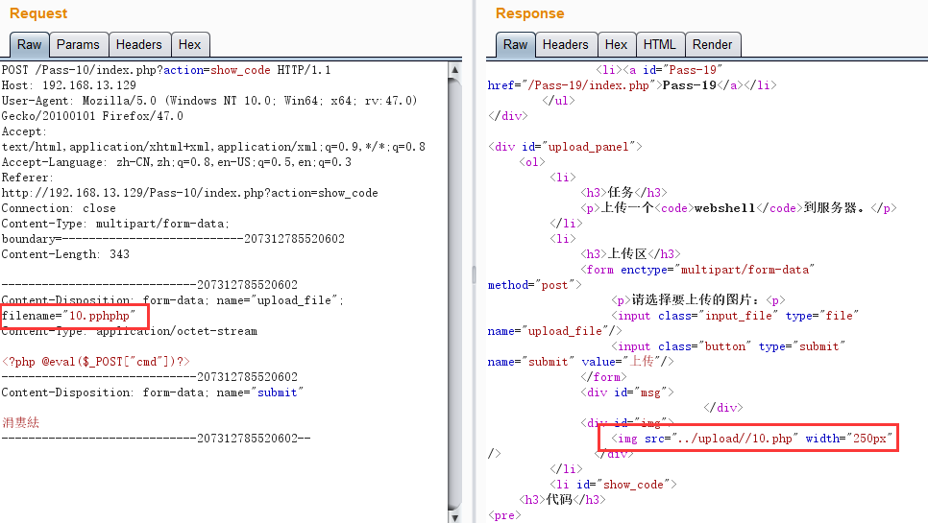

if (isset($_POST['submit'])) {

if (file_exists($UPLOAD_ADDR)) {

$deny_ext = array("php","php5","php4","php3","php2","html","htm","phtml","jsp","jspa","jspx","jsw","jsv","jspf","jtml","asp","aspx","asa","asax","ascx","ashx","asmx","cer","swf","htaccess");

$file_name = trim($_FILES['upload_file']['name']);

$file_name = str_ireplace($deny_ext,"", $file_name); //关键点，把上面出现过的都替换成空格

if (move_uploaded_file($_FILES['upload_file']['tmp_name'], $UPLOAD_ADDR . '/' . $file_name)) {

$img_path = $UPLOAD_ADDR . '/' .$file_name;

$is_upload = true;

}

} else {

$msg = $UPLOAD_ADDR . '文件夹不存在,请手工创建！';

}