~

~

~

~

Dear ~

Thank you for financing your ~ ______________________ with Austin Telco Federal Credit Union! This letter will confirm the interest rate, payment amount and the payment due date.

Amount of Loan:    ~

Interest Rate: ~

Term: ~

Payment Amount: ~

First Payment Due Date:    ~

Member # ~

Loan # ~

Routing# ~

Please use this notice to make your first payment; it can be mailed to the address listed below.

**~**

**~**

**~**

Scan the QR code for other important information, such as adding your insurance coverage, setting up automatic payments, and other member benefits we offer to account holders!

Thank you for choosing Austin Telco Federal Credit Union!

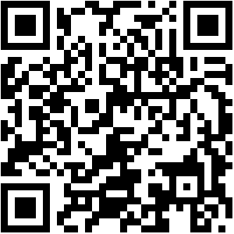

Sincerely,

Austin Telco Federal Credit Union

Loan Department

~