# Introduction

Wildfires play a vital role in various ecosystem, such as savannahs and boreal forests. They influence the development and sustainability of these ecosystems. Before the Anthropocene, the main cause of wildfires natural ignition has been lighting [1], however, the majority of fires are currently directly or indirectly ignited through human activities. A major contributor of direct human ignition is the clearing of land for agriculture activity and posture. They also actively suppress fires to mitigate and prevent negative impacts on climate, air pollution and protection for the regional population. The prevention measurements can cause accumulation of fuels in fire sensitive climates, which in turn can result in intense wildfires. All these causes and policies, have lead that agricultural land has expanded in savannah regions and active fire suppression have led to reductions of fires in the 2000s [2].

While a reduction of burned area is observed, the rise of the mean global temperature and the forthcoming climatological effects have increased. This has been increasing the risk of the fires over the last century. It also has changed the fire seasons and regimes in various regional climates. The increase of temperature is caused by the increasing concentration of several greenhouse gasses, such as methane and carbon dioxide, which are emitted by fossil fuelled human activity and high activity agricultural activity. The effects of these greenhouse gasses are observed in various atmospheric and biochemical cycles [3]. These changes can introduce fire regimes and fire seasons into currently low fire risk areas. The prediction is that climate change is going to make the duration of fire seasons longer, the frequency of fires increasing [4] and the risk of the fire is going to be higher in the 21th century. The climatological effects could be amplified by the changes in the local landcover as a response to the warmer and drier climate [5].

All these effects and consequences is going to impact the local population, environment, political stability in its surroundings and economic situation [6,7]. Various health issues related to respiratory systems have been related to forest fires and fires have already effected the local population for a short and/or long period of time where fires were prominent [8,9]. It results on various occasions that people riot, habitat is lost for wildlife and there is severe damage on structures and properties in the regions [6,10].

In Europe, around 70% of the fires and 85% of the burned surface area is in the Mediterranean Region. While wildfires and the consequences have been extensively researched in the Mediterranean area [7,11,12], global change is not only going to affect Southern Europe. The risk of fire is predicted to increase in currently wetter climates in temperate and northern Europe [5]. Therefore, it is important to get more insight about how these wildfires are burning, how these fire regimes have developed over the last decade and on which vegetation type these fires mostly have burned in a temperate European country.

The Netherlands is one of the countries in Western Europe, where an increase in risk of fires is predicted if the rise in temperature is going to continue over the 21th century [13]. The country has several unique spatial and population characteristics that could greatly impact how wildfires start. These characteristics give insight into how policy and population influence current and future wildfires. The spatial policy of this country has a rich history in spatial planning and in general water management. This lead in the 20th century to greatly improving the Dutch waterworks to protect cities and the various spatial policies to stimulate economic growth. These developments resulted in a highly fragmented landscape and high density transport infrastructure [14–16]. Another characteristic of the Netherlands is that it has the highest population density per square kilometre in Europe with 513 people / km2 ‑[14].

Besides the countries spatial policy, the European Union (EU) has impacted various spatial zones through a policy named the Bird and Habitats directives. The directives indicate that several designated landscapes are chosen to preserve the European biodiversity. These areas are found all over the EU and are part of a network, which named the Natura 2000 network. The implementation of these areas in the Netherlands were done by local and regional local instruments [17] and has contributed to the current Dutch fragmented landscape.

The fragmented landscape and the various small specific natural areas may affect or have already affected the current and future fire regimes of the Netherlands. Furthermore there have already been various indications about that most forest fires are indirectly/directly caused by human agents [7] and that the chance of wildfire is increased near infrastructure [11]. With the influence of human activity on wildfires and the natural areas near human activity and infrastructure, the amount of wildfires can be increasing in the Natura 2000 areas. The consequences of the increased wildfire can have ecological benefits or ecological damage in these areas.

Spatial and temporal information about these fire regimes can be useful for spatial policy, human health, and biodiversity. Governmental institutes can use the temporal and spatial information about the current fire regime to prevent ecological damage and effected human health is reduced [6,10]. Furthermore, it can be used as a starting point on how the fires are influenced by the regional effects of climate change.

This study is going to provide new insights about the temporal aspect of fires in heavily human influenced landscape, such as when the most fires are burning for the last decade and which years were most wildfires were burning. The spatial aspect is also researched with information in which natural areas were the fires burning, and what was the most effected land cover type by the fires. The combination of temporal and spatial information about these fires is going to give information about the simple question when, where and what the fires have burned.

# 2. Research Method

*2.1 Data*

*2.1.1 Research Area*

The Netherlands is the research area. The spatial dataset about the country is downloaded from a service, named the Public Services on the Map (NL: Publieke Dienstverlening op de Kaart; PDOK). It is an open data platform where people find various governmental related spatial datasets about the Netherlands and frequently updated. From the PDOK, the borders for the Netherlands is downloaded from https://www.pdok.nl/geo-services/-/article/administratieve-eenheden-inspire-geharmoniseerd (last accessed: 04-05-2020). Information about the infrastructure is also downloaded from PDOK downloaded from the national road file (Nationaal Wegen bestand; NWP). This file contains information about the Dutch infrastructure. It can been found from https://www.pdok.nl/introductie/-/article/nationaal-wegen-bestand-nwb- (last accessed: 17-08-2020).

*2.1.2 Fire dataset*

Various satellites observe active fires around the world. One of these satellites is the Suomi National Polar-orbiting Partnership (S-NPP), which has an instrument named the Visible Infrared Imaging Radiometer Suit (VIIRS).

The satellite itself orbits around the earth at an altitude of 829 km and crosses the twice equator when ascending around 13:30 (Greenwich time) and descending around (01:30). VIIRS-instrument measures the surface of the earth with 22 different spectral bands and has a swath width of 3060 km.

The instrument has 16 moderate resolution bands (M-bands), 5 imaging resolution bands (I-bands) and one panchromatic day night band (DNB). The DNB-and M-bands have a resolution of 750 meter, while the I-bands have a resolution of 375 meter. With an unique approach of pixel aggregation, VIIRS pixels are observed with a pixel size at 375m [20].

An algorithm for VIIRS has been developed to find active fire from the source data [21]. The most important input for this algorithm is the data from the I4 sensor. This sensor measures the mediumwave infrared (MIR) spectrum between 3.55 - 3.93 µm. Temperature of the electromagnetic radiation indicates if there is at time of measurement is an active fire or not. The other sensors from the I-bands are used to verify the active fire and quality of the measurement. With the help of the DNB, fires are also detected at day and night. The dataset is acquired for each month between 2012-01 and 2020-12 and saved in an ASCII file with the file name VNP14MLIMG. The aggregation scheme keeps the resolution of the dataset at 375 m and has a low commission error (< 1.2%). The detection of these firepixels by the algorithm varies between different land cover types, the fire sizes and time span of the observed fires. It can detect smaller (lower than 100 ha) fires and is improved on the detection of boreal fires and savannah fires but has a lower performance against agricultural fires. Overall, the dataset is suited for the detection of natural active fires [22] and therefore used to get information wildfires in natural areas in the Netherlands.

The files of the dataset is downloaded from [*ftp://fuoco.geog.umd.edu/VIIRS/VNP14IMGML*](ftp://fuoco.geog.umd.edu/VIIRS/VNP14IMGML) *(last accessed in May 2021)*. The data cover a period from 01-2012 up to 12-2020. More detailed information about the fire observation datasets and surrounding research are found on https://modis-fire.umd.edu/.

*2.1.3 Land cover datasets*

The Corine Land Cover (CLC) is the dataset, which is used to identify and specify the kind of wildfire. The dataset deducts the land cove with satellite date of the Sentinel 2 and Landsat-8. The Sentinels-2 is part of the European earth observation program that is used to acquire high resolution data about the land surface and identifying natural hazards in Europe [23]. The Landsat-8 is part of the Landsat-program and has the same purpose as the Sentinel-2 satellite [24]. The Sentinel-2 provides the main dataset, while the data of the LANDSAT-8 is used for to fill in the gaps. The used CLC 2018 dataset has been developed between 2017 to 2018. The datasets have both an equal and greater 85% thematic accuracy with a minimum mapping unit of the polygon of 25 ha. The minimum pixel size is 100 meters. Furthermore, all changes that are greater than 5 ha are mapped and updated in the dataset [25].

The datasets from 2012 and 2018 are used and are downloaded from [https://land.copernicus.eu/pan-euro pean/corine-land-cover/clc2018?tab=download](https://land.copernicus.eu/pan-euro%20pean/corine-land-cover/clc2018?tab=download) (last accessed in May 2020).

*2.1.4 Natura 2000 and National parks*

The European Union (EU) has developed a program to protect endangered species to ensure, sustain and increase European biodiversity through the Natura 2000 network. 162 of the areas are in the Netherland. It supports the biological diversity in various landscapes and protects breeding areas for various specious. The preservation of the natural processes and habitats strategies [26] in these areas have influenced the spatial distribution of wildfires in the Netherlands. The relationship between the Natura 2000 and the wildfire is that the preservation of the habitats could result in specific land cover which could be affected affect the frequency and size of these wildfires. With the quantification of fire pixels in these areas, it could give insight how the fire regime impacts the various landscapes and habitats and how it can be prevented.

The shapefile of this areas is downloaded from PDOK (*last accessed in September 2020)* as the administrative borders.

*2.2 Overview of the methods*

Two different methods, which are visualized in flowcharts (see figure 1) have been developed for this research. The first method is for acquiring the data from the VNL14ML, CLC-raster data and administrative borders of the Netherlands. For each method, there will be given an overview how and why each step in the flow chart has an impact on the filtering of active fires.

The data is inserted into a PostGreSQL database (version 13.2). PostGreSQL is an open source relational database engine (https://www.postgresql.org/ ) and is used in combination with the PostGIS plugin. The PostGIS database extender is extension for PostGreSQL, which helps to save raster and vector data is central location and easier to filter related pixels.

The data inserting and analysis is done with Python 3.9.2. There are various libraries used to calculate the geospatial characteristics of the fire pixel. They are citated in the requirements file in the github repository.

The scripts that are developed for parsing and analysing the VIIRS, CLC, and PDOK files can be found on <https://github.com/CUniversityaccount/ForestFireNetherlands>.

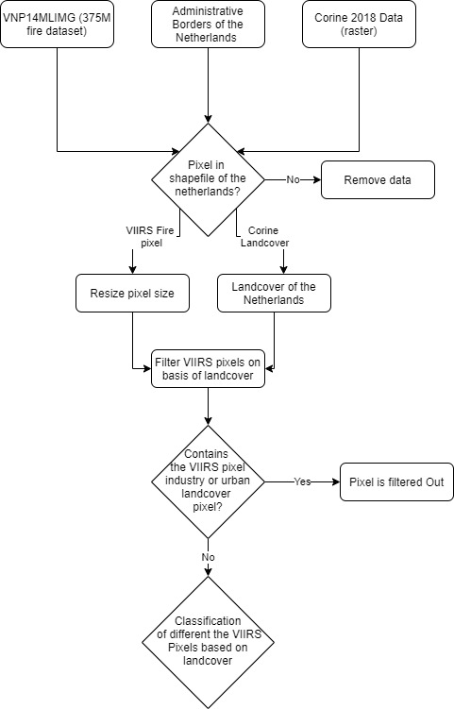

Figure 1 Flowchart on how the fire pixels derived from the active fire algorithm are filtered and classified based on CLC pixels

The general overview of the method for acquiring the data can be seen in figure 1.

*2.2.1 Filtering of the VIIRS Fire pixels based on location*

First, the data from the VIIRS dataset is filtered based on the location of the centre of the pixel. If the pixel is not within the administrative borders of the Netherlands then the pixel is filtered.

After the non-relevant pixels are filtered out, the size of the pixel is determined. This is done with the horizontal position of the pixel in the dataset, whereby the starting point of the observations is the nadir. It varies between 375 and 750 meters.

The change in angle, observation distance and curvature of the earth cause that size increase when the distance is increasing from the centre of the measurements. VIIRS compensates the factors with the help of multiple bands and aggregation scheme. It keeps the pixel sizes 375 meter up to the 960th observation .After this observation, the aggregations scheme and sensors only can compensate the pixel size up to 750 meter [20]. This effect is applied to the filtered pixels. All observations whereby the observation count is lower than 960 gets a pixel size 375 and after this observation it gets a pixel size of 750 meter. These values are already indicated in the dataset.

*2.2.2 Filter and classification of the fire pixels*

The algorithm classifies if the pixel is a vegetational fire (indicated with a 0), active volcano (1), other static land source (2) or an offshore detection (3). The pixels which are defined as a vegetational fire are used and the rest is filtered out

The same dataset has the attribute *conf*, which is representative for the confidence level of the observed fire pixel. This attribute has 3 options (low, nominal, high). Hereby, are the pixels with a low confidence filtered out, so the chance of using falsely identified pixels becomes lower.

The fire type classification of the pixels has two objectives. It filters out the pixels which are not classified or has any natural land covers and the CLC data is used for the classification of the fire type of the fire pixel. The used landcover dataset is the CLC dataset. The 2012 CLC dataset is developed between 2011 – 2012 and the 2018 CLC-dataset is developed in 2017-2018. The 2012 CLC dataset is used until 2016 and the 2018 dataset from 2016. This is to keep the land cover as accurate as possible. These datasets have a three levels hierarchy. These are levels are defined with three number code (head-class, sub-class, specific landcover number) [27].

A pixel is filtered if there is/are:

* A single industrial or urban pixel, because the exact origin of the fire, could be a mechanical or urban object (CLC pixels between 0 and 200).
* All landcover pixels in the fire pixel are from the waterbody headclass (values between 500 and 600).
* 50% or more of the CLC pixels are from agricultural origin, because these fire pixels could be identified because of greenhouses and human agricultural activity.

The output is classified by the most dominant natural CLC-type for the exception of combined nature because the origin of this fire pixel could not be exactly based on the classification in the table be determined. The names and the CLC value ranges to be classified can be seen in table 1:

|  |  |
| --- | --- |
| Classification | CLC ranges |
| Forest | 310 < CLC-pixel value < 320 |
| Heath | 320 < CLC-pixel value < 330 |
| Dune | CLC-pixel value == 331 |
| Peat | 410 < CLC-pixel value < 420 |
| Combined Nature | 300 < CLC-pixel value < 332 |

*2.2.3 Measuring the distance between the fire pixel and infrastructure*

The distance between the Dutch infrastructure NWB and the filtered pixels are calculated with the help of the program QGIS with the NNJOIN plugin. There is no clear distinction between the characteristics of the road such as road activity, size of the road, and general use of the road. These characteristics of the roads cannot be determined or are available in the NWB file. It results in the smallest between the polygons which are in this case between the roads and the fire pixels.

*2.2.4 Fires in natural designation areas*

The quantification of pixels based on location is done with datasets about the geolocations of the Nature 2000 areas and natural parks. The pixels are counted when they are in a Natura 2000 or natural park. So we get insight about how spatial policy decisions about designated natural areas has influenced the fire regimes in the Netherlands

Results

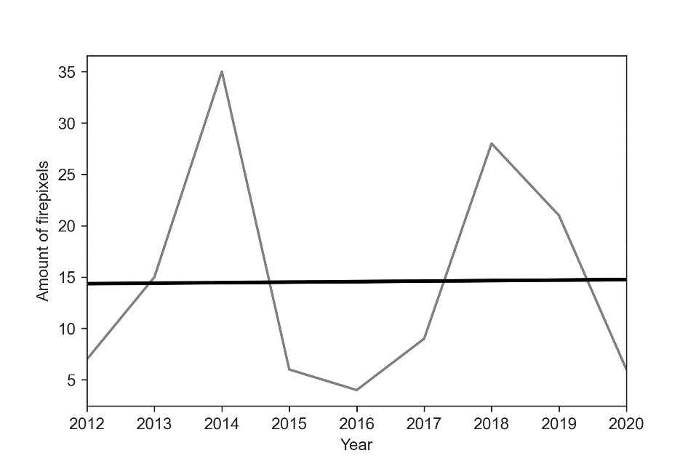

Figure 2 The amount of fire pixels per year with a linear regression line. The light grey line are the observed values, and the black line is the linear regression line. The χ2 value that result from the linear regression is 0.02%.

The total amount of observations is 131 pixels. Linear regression was applied to verify if the amount of fire pixels is increasing or decreasing in the studied years (see figure 2). It resulted that it seems that the number of fire pixels is increasing. However, the χ2-statistic illustrated that there was a very low correlation between the observed and the expected fire pixels. Therefore, it cannot be concluded that the occurrences of fire pixels are not increasing nor decreasing over the last decade.

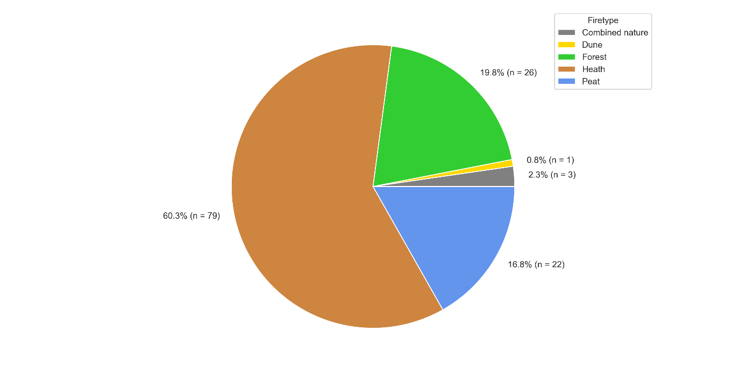

Figure 3 The distribution of fire pixels grouped by effected landcover by the fire pixel

The most effected landcover throughout the years is heath (see figure 3). Peat and forest fires are less common and are relatively equal in frequency occurrence. For 3 pixels, it was not possible to determine what kind of wildfire it is and there was a single observation whereby dune landcover was affected.

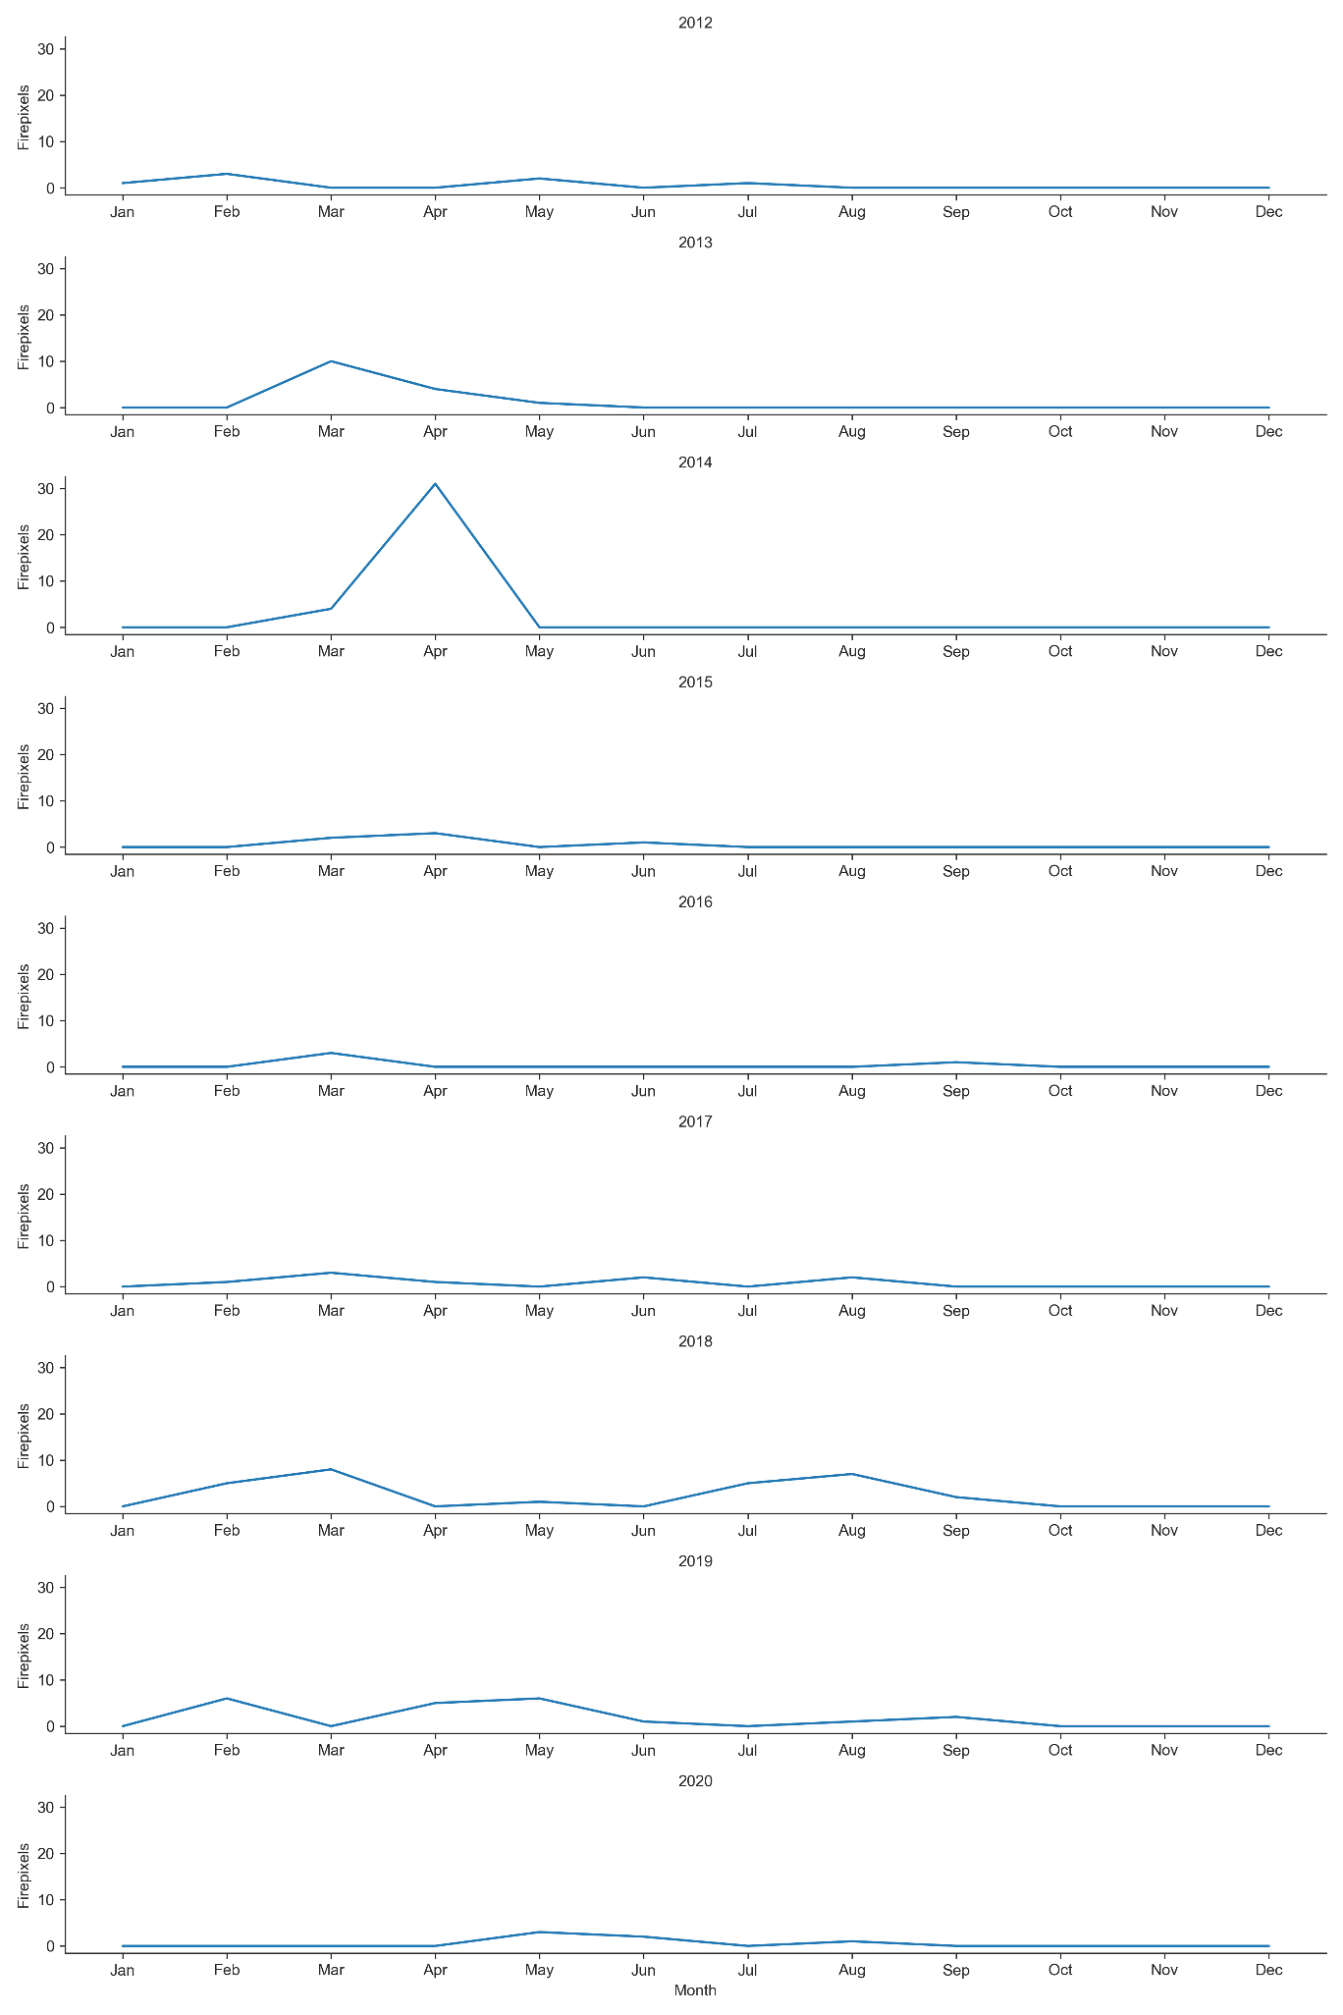

Figure 4 Monthly trend in observed fire pixels for each year

Most fire pixels occur in late winter and spring and at a less frequent rate, also in the summer. Ever year a fire pixel is observed in spring, but not in the summer. In 2014, were the most fire pixels observed. When combining this information presented in figure 5. It is seen that fire occur from February, it peaks in spring for the exception of forest fires and it fades out in the summer. Only for forest fires, it peaks in the late summer. The peak of heath fires in spring caused by the peak in April in 2014. Nonetheless, it still indicates that most fire pixels are in occurring over spring and the amount of fire pixels is relatively small over the years.

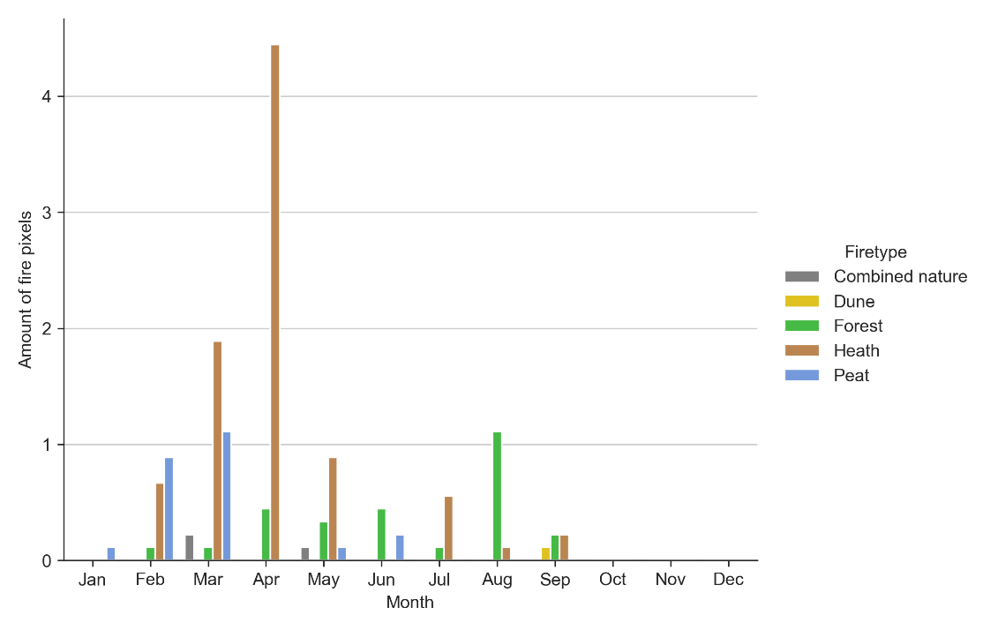

Figure 5 Average amount of observed fire pixels observed per month

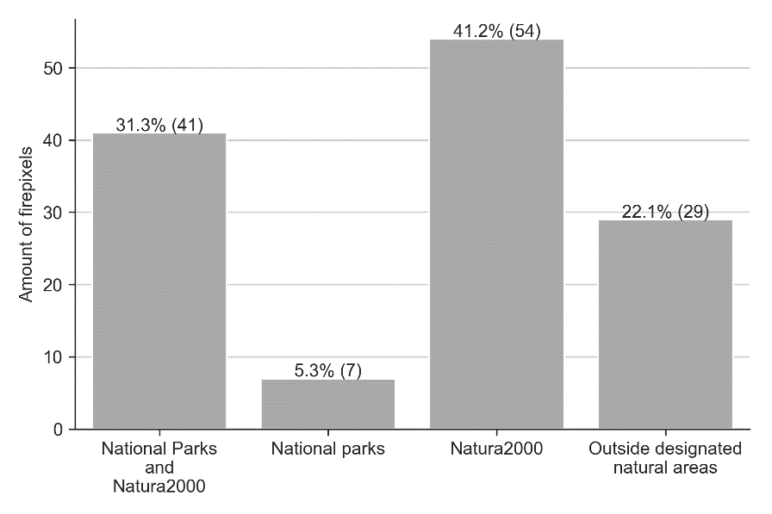

Figure 6 The amount of fire pixels (n=131) which are measured in National Parks and/or Natura 2000 areas. The format is (percentage fire pixels (total fire pixels))

Around 72.5% of these fire pixels were burning within Natura 2000 (including the firepixels that were burning in the national parks) (see figure 6). It demonstrates that the fire pixels and natural designated areas are related to each other and is affected by regional, country, and European spatial policies on a regional level. It also illustrates that these natural areas have a higher risk of fire in comparison of the non-designated natural areas.

Figure 7 Histogram which shows the relative distance between a fire pixel and the Dutch infrastructure.

Another spatial characteristic of the fire pixels is that most fires pixel occurred within 500 meters of a road. Considering that most fire are occurring in important and stated protected natural borders and national parks, concludes that human activity within these areas has an impact on the natural state. Therefore, the activity of humans (figure 4) relates to the frequency and location of occurrence of fires pixels. It could explain why there cannot be a cycle could be observed (figure 3).

Discussion

*Limitations and uncertainties in the dataset*

The dataset has several limitations in it that are linked with VIIRS. The influence of the limitation are seen in the results. Oliva and Schroeder (2015) demonstrated that the identification of fires in grassland and heath have a higher commission error in comparison with other land cover types. This statement is important for the chosen observation area, because, as stated in the results (see figure 3), the most effected landcover by these fires is heath. Therefore, some of the possible pixels could be false positives.

The temporal resolution of the satellite is another problem. The VIIRS instrument has a 12 hour gap between each observation on a specific location [28]. Fires that were active in the 12-hour gap between observations moments, are not observed and makes the dataset incomplete.

The exact location of the various fire pixels is also precisely be determined. VIIRS observes small fires up to the size of 25% of a LANDSAT-8 pixel (a spatial resolution of 30 meters) [21,22], but the size and location of the wildfire cannot be deducted or is in the given data of the VIIRS pixel. The combined nature fire pixels cannot be clearly distinguished which type of fire pixel is. These pixels are therefore not included in the seasonal effects foreach fire type. This implicates that some information is missing about the seasonal effects on the pixels.

At least, the daily temporal resolution of the measurements, temporal timeframe of the research and the quantification in terms of fire pixels instead of fires shows and gives no clear indication about the size, number and the duration and activity of the observed fires. These characteristics is important to get information about the local spatial pattern of the fire, the cause and timeframe of the fire and potentially the impact on the local population and infrastructure, which are used in risk management.

Some fires are small in surface area or were burning for a short time span, while other fires were burning for several days and were affecting large surface area. Therefore, the amount of detected fire pixels is an indication that one that location a fire has been observed but the pixel could be part of a fire which burns an area bigger than the observed pixel.

*Location of the fires*

Nonetheless, the figures are showing various details and findings about the fire pixels location, effected landcover, seasonal influences and the cause of these fire pixels. As seen in figure **X**, the **PERCENTAGE** of the pixels are in designated natural areas. The spatial policy of the European Union and Dutch government has influenced the fires in these regimes. The Natura 2000 are protected, as stated in the method, by the two directives. The spatial policy changes in these areas are rather difficult because [29] these spatial changes and policies in these areas need to be approved by the European Union [30]. The regional natural areas are governed by the provinces, but are still in development and researched in how this decentralized spatial policy has its effect on the natural spatial policy [31]. It could be related that there are more fires in the Natura 2000 areas than the Dutch natural parks.

*Abiotic and biotic effects on the fire regime*

Dryness, precipitation, and evaporation are increasing and influencing the risk of fires in specified natural areas. Lower soil moisture is potentially caused by the evaporation and plant transpiration and the high-pressure zones around Western Europe. The loss in evaporation is not made up with the precipitation and run-off from river systems and leads to lower soil moisture in the eastern Netherlands [32], which increase the risks of natural fires in spring. The phenomenon could show why there are no forest fires in the autumn, while there are fire pixels in the winter.

Figure 5 shows also that heath and peat fires are peaking in the spring and fades out in the late summer. While the frequency of these fire is limited to up to 4 fire pixels and the graph is influenced by the peak in April 2014, the high pressure zone is still a relevant explanation, about why these fire are occurring in the spring.

*Human influences*

While abiotic and biotic factors are impacting the risk of fires, the key to finding the driving force of the Dutch fire regime is the mapping and analysing human activity in the protected areas. As Pechony and Shindell [32] and Ganteaume *et al.*[8] have correlated that the higher population density effects and increases the occurrences of wildfires and observed that fire ignition and fire suppression is increasing with a higher population density. The results do not indicate that there is a reoccurring seasonal timeframe whereby the fire pixels are observed, has not been observed in the current climate in the Netherlands. However, the low distance between a fire pixel and a road indicates that these observations and relations are relevant for the main driving force of fire in the Netherlands. Elewa [33] has stated that a higher density infrastructure is related to the frequency of wildfires in the Mediterranean. This observation was related that an higher density of infrastructure resulted in a higher fire frequency in its surrounding [11]. While the Netherlands has a climate with a milder temperature and higher amount precipitation [35], these observations can be applied to this situation, because the country has one of the highest population densities in Europe [36], an high density infrastructure [14] and most of the observed fire pixels are in a radius of less than 500 meter.

Conclusion

The VIIRS fire detection algorithm dataset [21] and the CLC-dataset [25] are used to gain insight into the spatiotemporal aspect about natural fires in human-centred landscapes in northern temporal Europe. Furthermore, the occurrence and frequency of fires are related to the landcover type and a correlation between these fire pixels, human infrastructure and spatial policy has been observed.

The results have shown that most fires occur in spring and it fades out towards in the late summer, for the exception of forest fires, which peaks in the late summer. However, these fires are likely related to anthropogenic activities in the areas. Most of these fire are close to infrastructure, which also conforms earlier observations in earlier research [7,33] that dense infrastructure and human activity are related to the frequency of natural fires.

Besides the infrastructure, policy has impacted in the spatial distribution of fires (figure 5). Most fire pixels were observed in designated natural areas, such in Natura 2000 and national parks.

1. Komarek, E. V The natural history of lightning. *Proc. Tall Timbers Fire Ecol. Conf.* **1964**, *3*, 139–183.

2. Andela, N.; Morton, D.C.; Giglio, L.; Chen, Y.; van der Werf, G.R.; Kasibhatla, P.S.; DeFries, R.S.; Collatz, G.J.; Hantson, S.; Kloster, S.; et al. A human-driven decline in global burned area. *Science (80-. ).* **2017**, *356*, 1356–1362, doi:10.1126/science.aal4108.

3. Hartmann, D.L.; Klein Tank, A.M.G.; Rusticucci, M.; Alexander, L.V.; Brönnimann, S.; Charabi, Y.; Dentener, F.J. Dlugokencky, E.J.; Easterling, D.R.; Kaplan, A.; Soden, B.J.; et al. Observations: Atmosphere and Surface. In : *Climate Change 2013: The Physical Science Basis. Contribution of Working Group I to the Fifth Assessment Report of the Intergovernmental Panel on Climate Change*; Stocker, T.F., Qin, D., Plattner, G.-K., Tignor, M., Allen, S.K., Boschung, J., Nauels, A., Xia, Y., Bex, V., Midgley, P.M., Eds.; Cambridge University Press: Cambridge, United Kingdom and New York, NY, US, 2013; pp. 159–255.

4. Flannigan, M.D.; Krawchuk, M.A.; de Groot, W.J.; Wotton, B.M.; Gowman, L.M. Implications of changing climate for global wildland fire. *Int. J. Wildl. Fire* **2009**, *18*, 483, doi:10.1071/WF08187.

5. Liu, Y.; Stanturf, J.; Goodrick, S. Trends in global wildfire potential in a changing climate. *For. Ecol. Manage.* **2010**, *259*, 685–697, doi:https://doi.org/10.1016/j.foreco.2009.09.002.

6. Morton, D.C.; Roessing, M.E.; Camp, A.E.; Tyrrell, M.L. Assessing the Environmental , Social , and Economic Impacts of Wildfire. **2003**, 59.

7. Ganteaume, A.; Camia, A.; Jappiot, M.; San-Miguel-Ayanz, J.; Long-Fournel, M.; Lampin, C. A Review of the Main Driving Factors of Forest Fire Ignition Over Europe. *Environ. Manage.* **2013**, *51*, 651–662, doi:10.1007/s00267-012-9961-z.

8. Reid, C.E.; Brauer, M.; Johnston, F.H.; Jerrett, M.; Balmes, J.R.; Elliott, C.T. Critical Review of Health Impacts of Wildfire Smoke Exposure. *Environ. Health Perspect.* **2016**, *124*, 1334–1343, doi:10.1289/ehp.1409277.

9. Cascio, W.E. Wildland fire smoke and human health. *Sci. Total Environ.* **2018**, *624*, 586–595, doi:10.1016/j.scitotenv.2017.12.086.

10. San-Miguel-Ayanz, J.; Moreno, J.M.; Camia, A. Analysis of large fires in European Mediterranean landscapes: Lessons learned and perspectives. *For. Ecol. Manage.* **2013**, *294*, 11–22, doi:https://doi.org/10.1016/j.foreco.2012.10.050.

11. Oliveira, S.; Oehler, F.; San-Miguel-Ayanz, J.; Camia, A.; Pereira, J.M.C. Modeling spatial patterns of fire occurrence in Mediterranean Europe using Multiple Regression and Random Forest. *For. Ecol. Manage.* **2012**, *275*, 117–129, doi:10.1016/j.foreco.2012.03.003.

12. San-Miguel-Ayanz, J.; Camia, A. Forest fires. *Mapp. impacts Nat. hazards Technol. Accid. Eur. an Overv. last Decad. A Wehrli, J Herkendell, A Jol) EEA Tech. Rep. N* **2010**, *13*, 47–53.

13. Lung, T.; Lavalle, C.; Hiederer, R.; Dosio, A.; Bouwer, L.M. A multi-hazard regional level impact assessment for Europe combining indicators of climatic and non-climatic change. *Glob. Environ. Chang.* **2013**, *23*, 522–536, doi:10.1016/j.gloenvcha.2012.11.009.

14. CBS *Transport and mobility 2016*; 2016; ISBN 978-90-357-2056-5.

15. Janssen-Jansen, L. Taking national planning seriously: A challenged planning agenda in the Netherlands. *Administration* **2016**, *64*, 23–43, doi:10.1515/admin-2016-0023.

16. De Mulder, E.F.J. Landscapes. In *The Netherlands and the Dutch: A Physical and Human Geography*; Springer International Publishing: Cham, 2019; pp. 35–58 ISBN 978-3-319-75073-6.

17. Beunen, R.; Van Assche, K.; Duineveld, M. Performing failure in conservation policy: The implementation of European Union directives in the Netherlands. *Land use policy* **2013**, *31*, 280–288, doi:10.1016/j.landusepol.2012.07.009.

18. PDOK Beheer Dataset: Administratieve Eenheden (INSPIRE geharmoniseerd) Available online: https://www.pdok.nl/geo-services/-/article/administratieve-eenheden-inspire-geharmoniseerd- (accessed on May 1, 2020).

19. PDOK Beheer Nationaal Wegenbestand (NWB) Available online: https://www.pdok.nl/introductie/-/article/nationaal-wegen-bestand-nwb- (accessed on Aug 17, 2020).

20. Cao, C.; Xiaoxiong, X.; Wolfe, R.; DeLuccia, F.; Liu, Q. (Mark); Blonski, S.; Lin, G. (Gary); Nishihama, M.; Pogorzala, D.; Oudrari, H.; et al. NOAA Technical Report NESDIS 142 Visible Infrared Imaging Radiometer Suite (VIIRS) Sensor Data Record (SDR) User’s Guide Version 1.3. *NOAA Tech. Rep. NESDIS 142* **2017**.

21. Schroeder, W.; Oliva, P.; Giglio, L.; Csiszar, I.A. The New VIIRS 375m active fire detection data product: Algorithm description and initial assessment. *Remote Sens. Environ.* **2014**, *143*, 85–96, doi:10.1016/j.rse.2013.12.008.

22. Oliva, P.; Schroeder, W. Assessment of VIIRS 375m active fire detection product for direct burned area mapping. *Remote Sens. Environ.* **2015**, *160*, 144–155, doi:10.1016/j.rse.2015.01.010.

23. Sentinel-2 Team; European Space Agency Sentinel 2 Mission Requirements. **2007**.

24. U.S. Geological Survey Landsat 8 Data Users Handbook. *Nasa* **2016**, *8*, 97.

25. Büttner, G.; Kosztra, B.; Soukup, T.; Sousa, A.; Langanke, T. CLC2018 Technical Guidelines. **2017**, 60.

26. LNV Natura 2000 doelendocument. duidelijkheid bieden, richting geven en ruimte laten. **2006**.

27. Kosztra, B.; Büttner, G.; Hazeu, G.; Arnold, S. Updated CLC illustrated nomenclature guidelines. *Eur. Environ. Agency* **2017**, 1–124.

28. Schroeder, W.; Giglio, L. NASA VIIRS Land Science Investigator Processing System (SIPS) Visible Infrared Imaging Radiometer Suite (VIIRS) 375 m & 750 m Active Fire Products: Product User’s Guide Version 1.4. *Nasa* **2018**.

29. Hatcher, R.D.; Williams, H.; Zietz, I.; America., G.S. of; Geological Society of America Penrose Conference Geological Society of America Penrose Conference (1980 : Helen, G.. T.A.-T.T.- Contributions to the tectonics and geophysics of mountain chains 1983.

30. EEA *The State of Nature in the European Union - Results from reporting under the nature directives 2007–2012*; 2015; ISBN 9789279475924.

31. Folkert, R.; Boonstra, F. *Lerende evaluatie van het Natuurpact : naar nieuwe verbindingen tussen natuur, beleid en samenleving*; Planbureau voor de Leefomgeving (PBL), 2017;

32. van der Linden, E.C.; Haarsma, R.J.; van der Schrier, G. Impact of climate model resolution on soil moisture projections in central-western Europe. *Hydrol. Earth Syst. Sci.* **2019**, *23*, 191–206, doi:10.5194/hess-23-191-2019.

33. Pechony, O.; Shindell, D.T. Driving forces of global wildfires over the past millennium and the forthcoming century. *Proc. Natl. Acad. Sci.* **2010**, *107*, 19167–19170, doi:10.1073/pnas.1003669107.

34. Elewa, A.M.T.T.A.-T.T.- Mass extinction 2008.

35. Beck, H.E.; Zimmermann, N.E.; McVicar, T.R.; Vergopolan, N.; Berg, A.; Wood, E.F. Present and future Köppen-Geiger climate classification maps at 1-km resolution. *Sci. Data* **2018**, *5*, 180214, doi:10.1038/sdata.2018.214.

36. CBS Statline Available online: https://opendata.cbs.nl/statline/#/CBS/nl/dataset/37296ned/table?ts=1600865782793 (accessed on Sep 23, 2020).