Results

The fires from the VIIRS files are plotted in figure **X.** Hereby are several filters decisions made, which can be read in the method. **INLEIDING PAKKENDE MAKEN**

Another problem is that some terrains in identified natural areas are used for military training or fire training for the fire watch. These trainings can involve open fires, which the VIIRS fire algorithm identifies as a fire.

These problems also occur near greenhouses. They are emitting a lot of rest energy to maintain the optimal growing conditions for their product, but the radiation from the greenhouses are identified sometimes as fires. Therefore, the visualizations of agricultural fires are not going to be representative agricultural fires in the Netherlands.

All fires are plotted in figure **X.** Some of these fires are in agricultural or urban areas. The fires in the urban areas are not used, because forest fires can be from other material human made objects or buildings, which is not the goal of this research. There also is a social reason to include urban fires, which is that some events involve fires, such as the New Year Fires near The Hague (**bron vermelden),** therefore make the identified fires unreliable to use in the analysis of the identification of the spatial pattern of fires. Agricultural fires are also not used, because some of these fires contain greenhouses, which can be identified as a fire. This make these fires unreliable and not fit to be used in the analysis.

The spatial pattern of the dataset can be seen in figure 1. The fires that are classified near industry areas are not accurate for the natural fires, because this heat sources can be caused by large industry, which has high temperature sources. These sources can be identified as a fire by the fire algorithm (**IN DE DISCUSSION DIEPER INGAAN**).

For most nature fires, are in the Veluwe area (ONDERZOEK OVER DE VELUWE ZOEKEN) (INDICATIE OP LANDCOVERKAART TOEVOEGEN). The fires in the national park Utrechtse Heuvelrug has a concentrated reoccurring fires in around a single place. This is from a military zone named the Leusderheide, which is used for practise exercises of the Dutch army. However, these fires were active in a single month and there are no reoccurring fires over multiple years. Furthermore, local news sources have reported the fire, so the fire is going to be classified as a heath fire. (NIEUWSBRONNEN ERBIJ ZETTEN).

Most of the natural fires occur in the center and east of the Netherlands occur (figure 1). Most of these fires also occur in Natura 2000 areas.

Figure X shows that the most effected classified natural landscape is heath, but it shows that it is not increasing since 2014. However, the amount of forest and peat identified pixels over the last decade are increasing.

If you look at the

**TODO MAKE GRAPH DISTRIBUTION CLEARER AND MORE REPRESENTATIVE**

**TODO EXPLAIN THE RESULTS IN RELATION TO THE SPATIAL DISTRIBUTION OF THE FIRES (IN THE DISCUSSION EXPLAIN THE RELATION BETWEEN DISTANCE AND FOREST FIRE PIXEL)**

**TODO MAKE THE MEAN LANDCOVER MONTHLY MORE REPRESENTATIVE OF THE DATA**

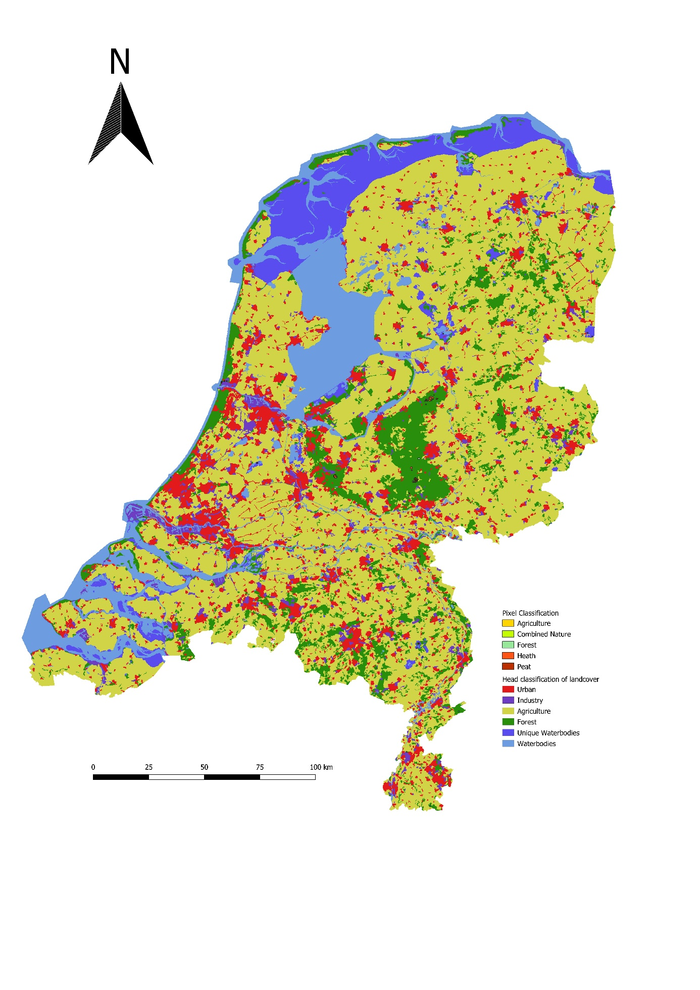

Figure Location and land cover map of the Netherlands

