To Whom It May Concern:
No: 00001/SIM-KL/0524/04

The Embassy of the Republic of Indonesia in Kuala Lumpur herewith certifies that the person mentioned is a holder of Indonesia Driving License (Surat Izin Mengemudi/SIM):

Name (Passport No.) | : | ERIC HERMAWAN (6666666), Indonesia
Driving Licence | : | SIM

According to Indonesian Government Regulation No. 22/2009 on Traffic and Land Transportation (Chapter VIII, Paragraph 3, Article 80), Indonesian Driving License is classified as follows:

A | To drive passenger’s car and freight vehicle with weight allowed not exceeding 3500 kg.
B1 | To drive passenger’s car and freight vehicle with weight allowed exceeding 3500 kg.
B2 | To drive tractor or vehicle coupled with carriage or trailer, Carriage or trailer weight which allowed is exceeding 1000kg.
C | To drive motorcycle
D | To drive specifically designed vehicle for the disabled

Note:
The word “UMUM” means that the holder is allowed to drive public vehicle.

The issuance of this letter refers to the 1985 Agreement on the Recognition of Domestic Driving License Issued by ASEAN Countries (Article 2 & 3) and the 2009 ASEAN Framework Agreement on the Facilitation of Inter-State Transport (Article 13)

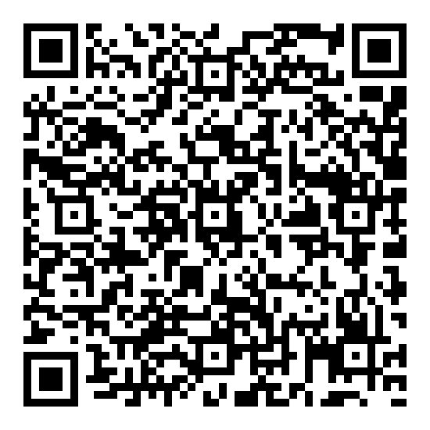 | Kuala Lumpur, May 28, 2024  For the Ambassador,  Ghilman Zukhair Assalam

