No /WN.03.04-01/01/24
This is to certify that the signature appears on this document is that of :
${nama_kemlu_malaysia}
Ministry of Foreign Affairs Malaysia
The Embassy of the Republic of Indonesia in Kuala Lumpur is not responsible of the accuracy of the information contained therein.

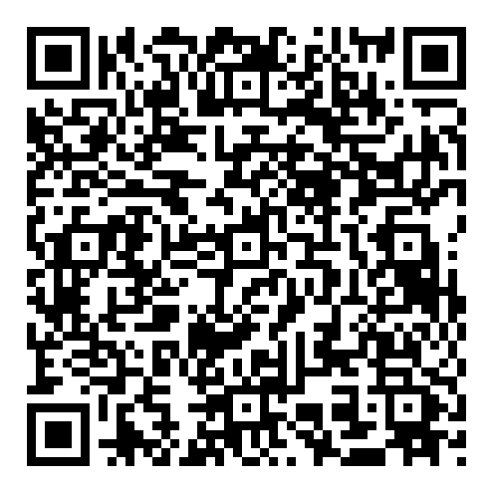 | Kuala Lumpur, 15 Januari 2024  Ghilman Zukhair Assalam  Pejabat Penanda Tangan

