No 001/WN.03.04-01/11/21
This is to certify that the signature appears on this document is that of :
Maimunah
Ministry of Foreign Affairs Malaysia
The Embassy of the Republic of Indonesia in Kuala Lumpur is not responsible of the accuracy of the information contained therein.

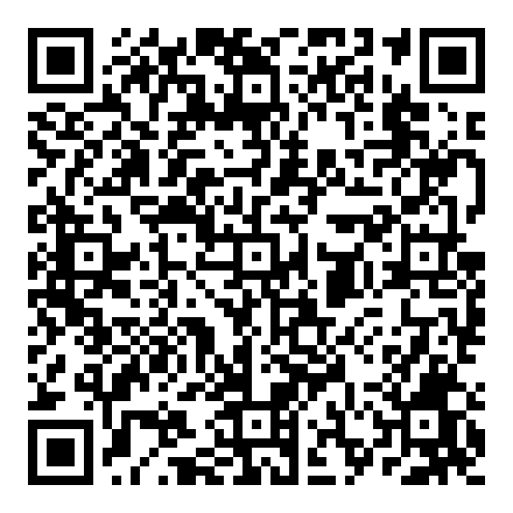 | Kuala Lumpur, Selasa, 02 November 2021  Pejabat Penanda Tangan  Pejabat Penanda Tangan

