No 001/WN.03.04-01/08/23
This is to certify that the signature appears on this document is that of :
JOHAN
Ministry of Foreign Affairs Malaysia
The Embassy of the Republic of Indonesia in Kuala Lumpur is not responsible of the accuracy of the information contained therein.

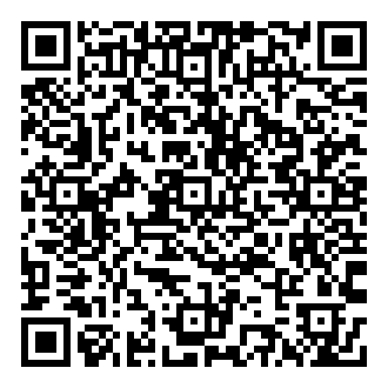 | Kuala Lumpur, Sabtu, 05 Agustus 2023  user_hs  -

