Table S1. List of terms in Abstract/Keywords/Title according to Dimension or Scope of Application

| **disseny** | **terme** |
| --- | --- |
| Case-control | Case-control |
|  | Case Control |
| Cohort | Cohort |
|  | Cohorts |
| Concordance study | Concordance study |
|  | Diagnosis test |
| Cross-sectional | Cross-sectional |
|  | Cross sectional |
|  | survey |
| Experimental | Experimental |
| Observational | Observational |
| Predictive study | predictive study |
|  | machine learning |
| Questionare validation | Questionnarie validation |
|  | test-retest |
|  | test retest |
| RCT | Clinical trial |
|  | Trial |
|  | RCT |
| Retrospective | retrospective study |
| Systematic review | Systematic review |
|  | Meta analysis |
|  | Meta-analysis |

Table S2. List of terms in Abstract/Keywords/Title according to Dimension or Scope of Application

| **dimensio** | **terme** |
| --- | --- |
| Usability | Usability |
|  | Usability testing |
|  | User experience |
|  | User satisfaction assessment |
|  | Human-computer interaction |
|  | User acceptance testing |
|  | User feedback analysis |
|  | Satisfaction |
|  | User interface evaluation |
|  | Ease of use assessment |
|  | Learnability evaluation |
|  | Accessibility testing |
|  | User friendliness |
|  | User engagement |
|  | Acceptability evaluation |
|  | Task efficiency assessment |
|  | User-perceived value |
|  | Accessibility |
| Security | Security |
|  | Security and privacy |
|  | Privacy |
|  | Clinical safety |
|  | Safety |
| Feasibility | Feasibility |
|  | Proof of concept |
|  | Proof-of-concept |
|  | Prototype Test |
|  | Prototype-Test |
|  | Concept Validation |
| Functionality | Functionality |
| Effectiveness | Effectiveness |
| Efficacy | Efficacy |
| Efficiency | Efficiency |
|  | Cost-efectivity |
|  | Cost-effectiveness |
|  | Cost-effective |
|  | Cost-utility |
|  | Cost efectivity |
|  | Cost effectiveness |
|  | Cost effective |
|  | Cost utility |
|  | Economic impact |
| Implementation | Implementation study |
|  | Standard of care |
|  | Adoption |
|  | hype cycle |



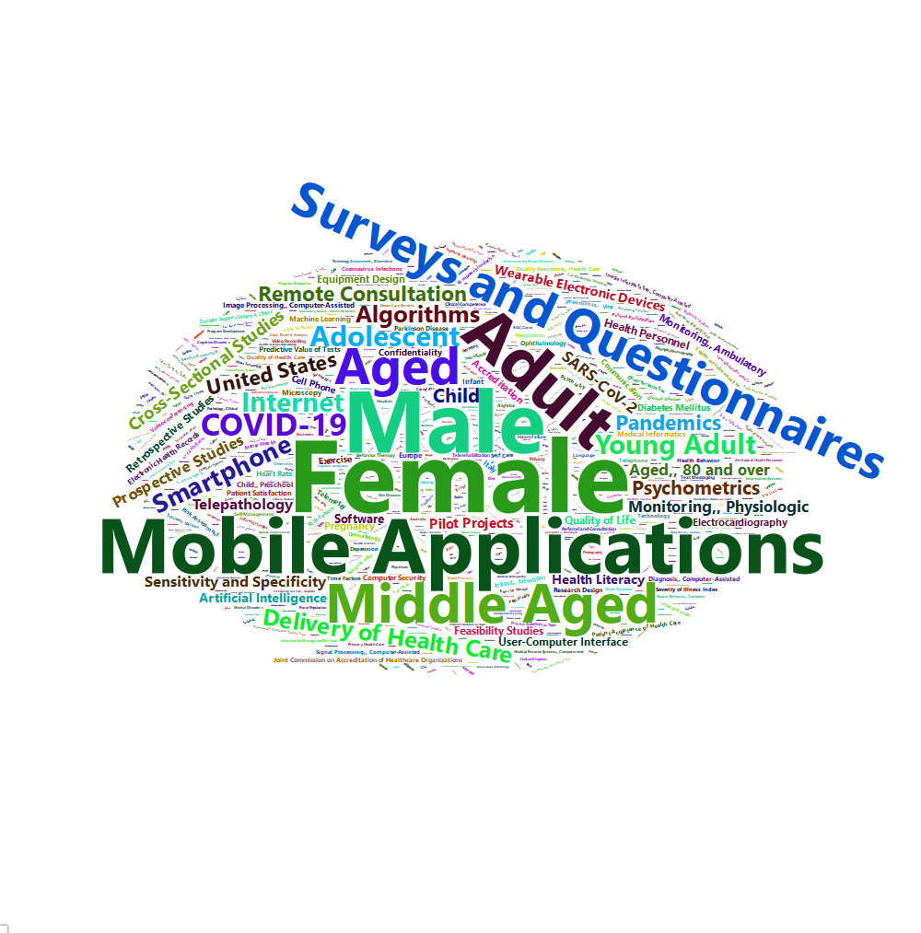

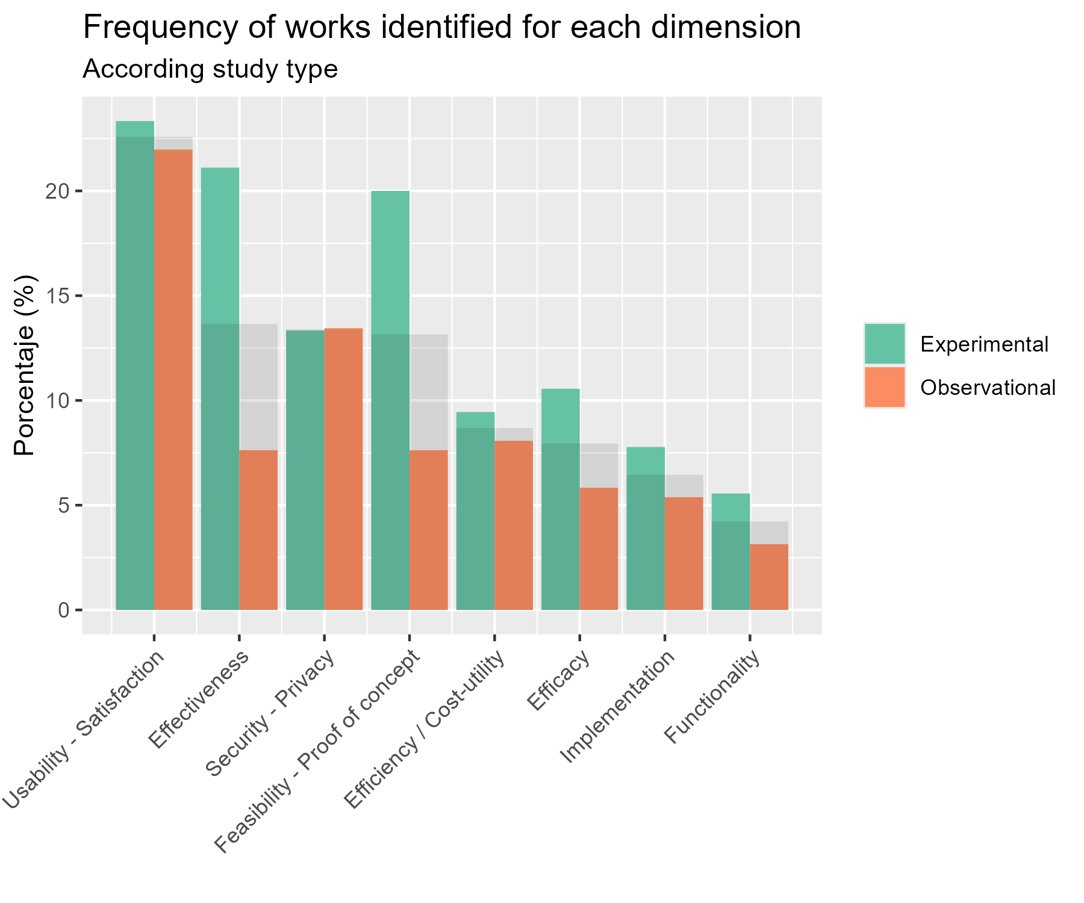

|  | Overall (N=1815) |
| --- | --- |
| **Journal** |  |
| HEALTH CARE SCIENCES | 392 (21.6%) |
| Others | 357 (19.7%) |
| MEDICAL INFORMATICS | 345 (19.0%) |
| PUBLIC, ENVIRONMENTAL & OCCUPATIONAL HEALTH | 159 (8.8%) |
| PSYCHIATRY | 67 (3.7%) |
| COMPUTER SCIENCE | 66 (3.6%) |
| ENGINEERING | 62 (3.4%) |
| MEDICINE, GENERAL & INTERNA | 39 (2.1%) |
| CARDIAC & CARDIOVASCULAR SYSTEMS | 36 (2.0%) |
| CLINICAL NEUROLOGY | 36 (2.0%) |
| PATHOLOGY - SCIE | 32 (1.8%) |
| HEALTH POLICY & SERVICES | 28 (1.5%) |
| ENVIRONMENTAL SCIENCES | 27 (1.5%) |
| NURSING | 27 (1.5%) |
| CHEMISTRY | 26 (1.4%) |
| INSTRUMENTS | 26 (1.4%) |
| NEUROSCIENCES | 26 (1.4%) |
| MEDICINE, RESEARCH & EXPERIMENTAL | 22 (1.2%) |
| MULTIDISCIPLINARY SCIENCES | 22 (1.2%) |
| PSYCHOLOGY | 20 (1.1%) |
| Others: frequency < 1% | |

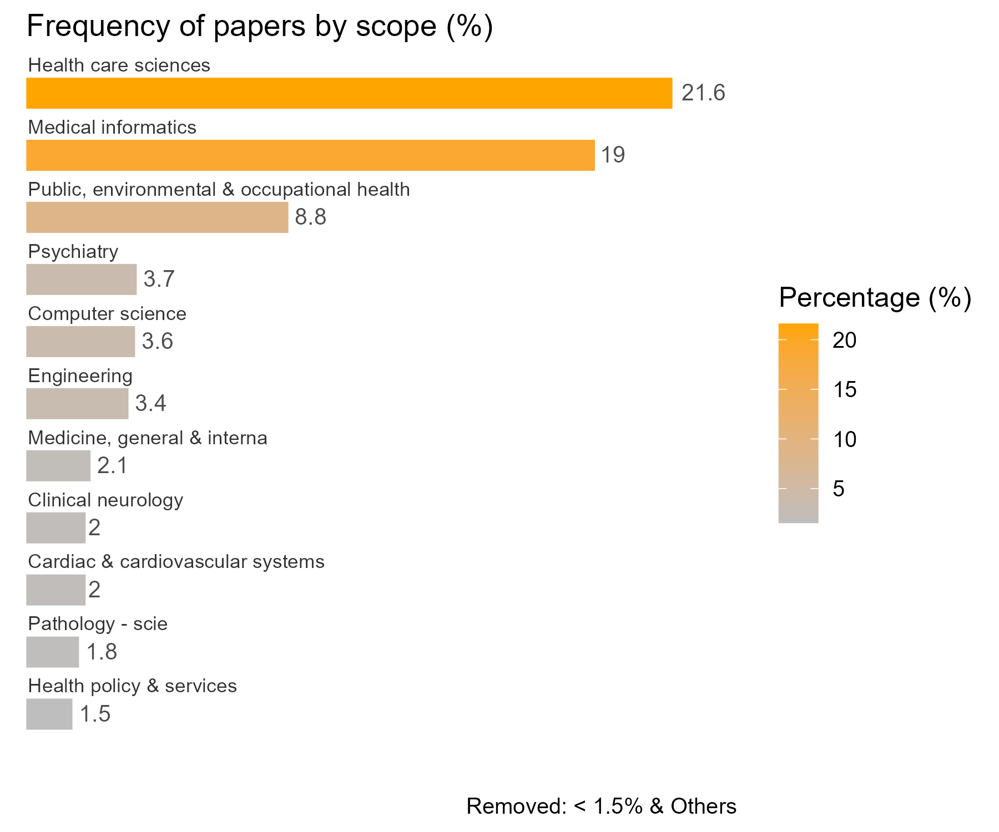

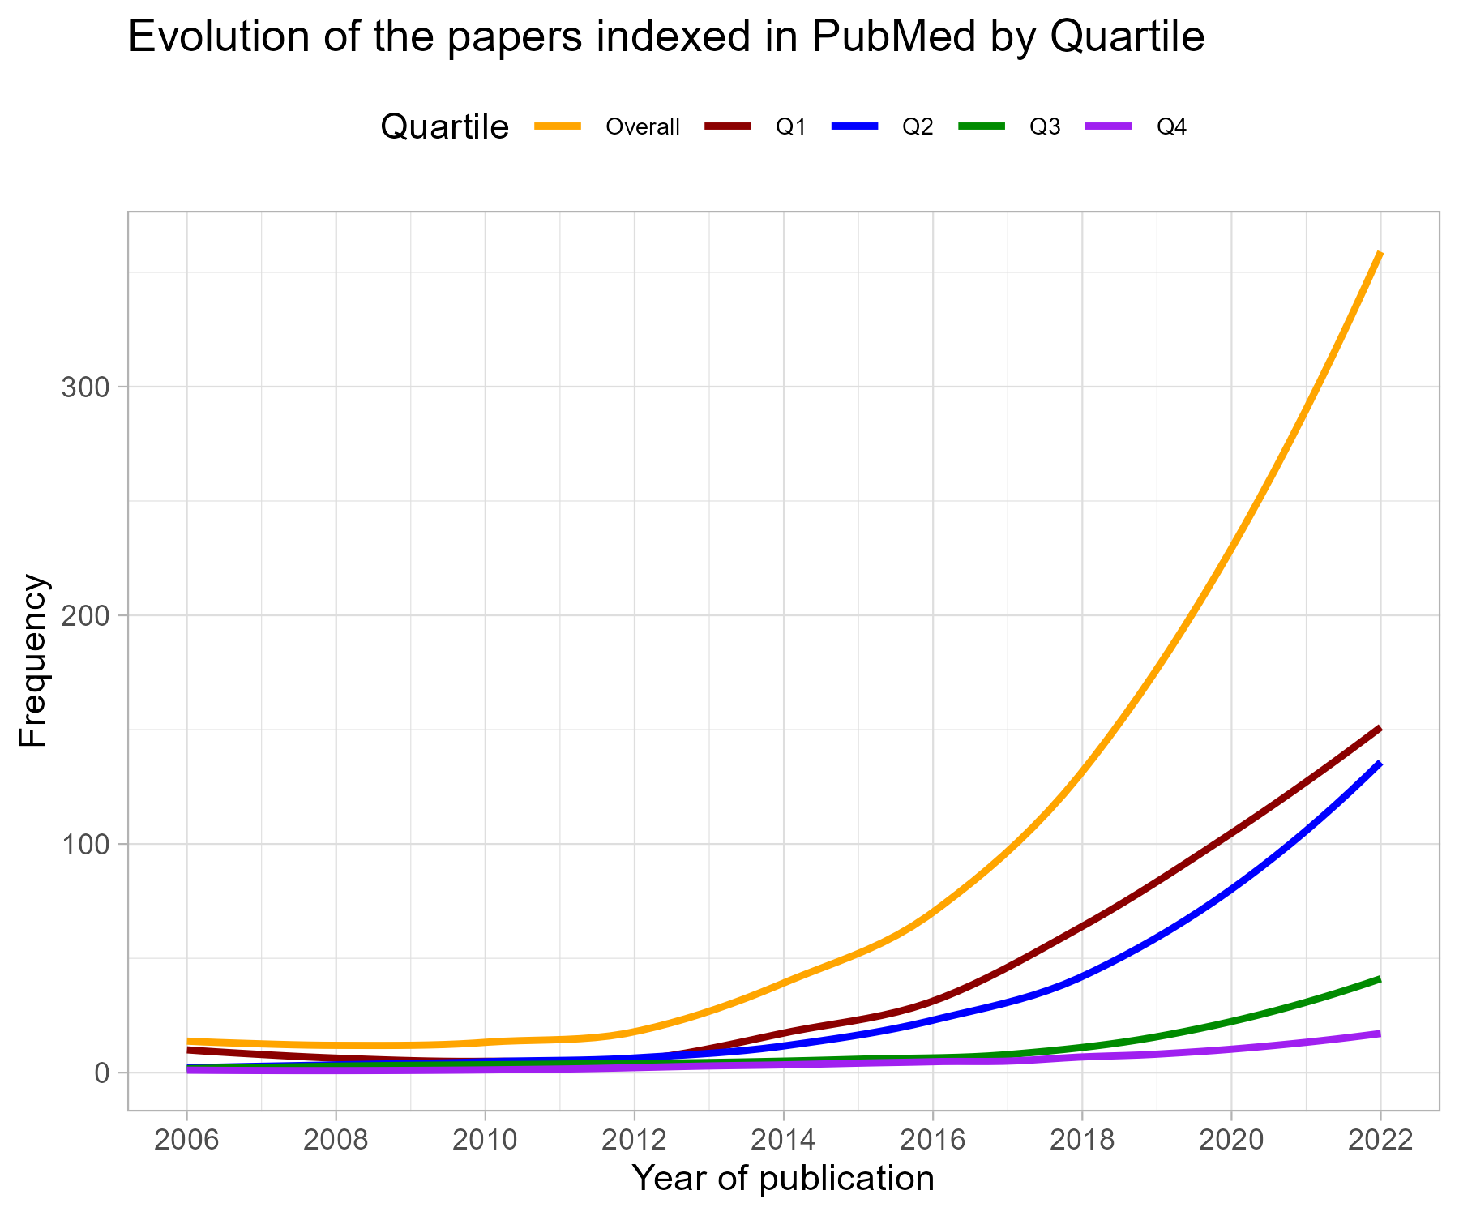

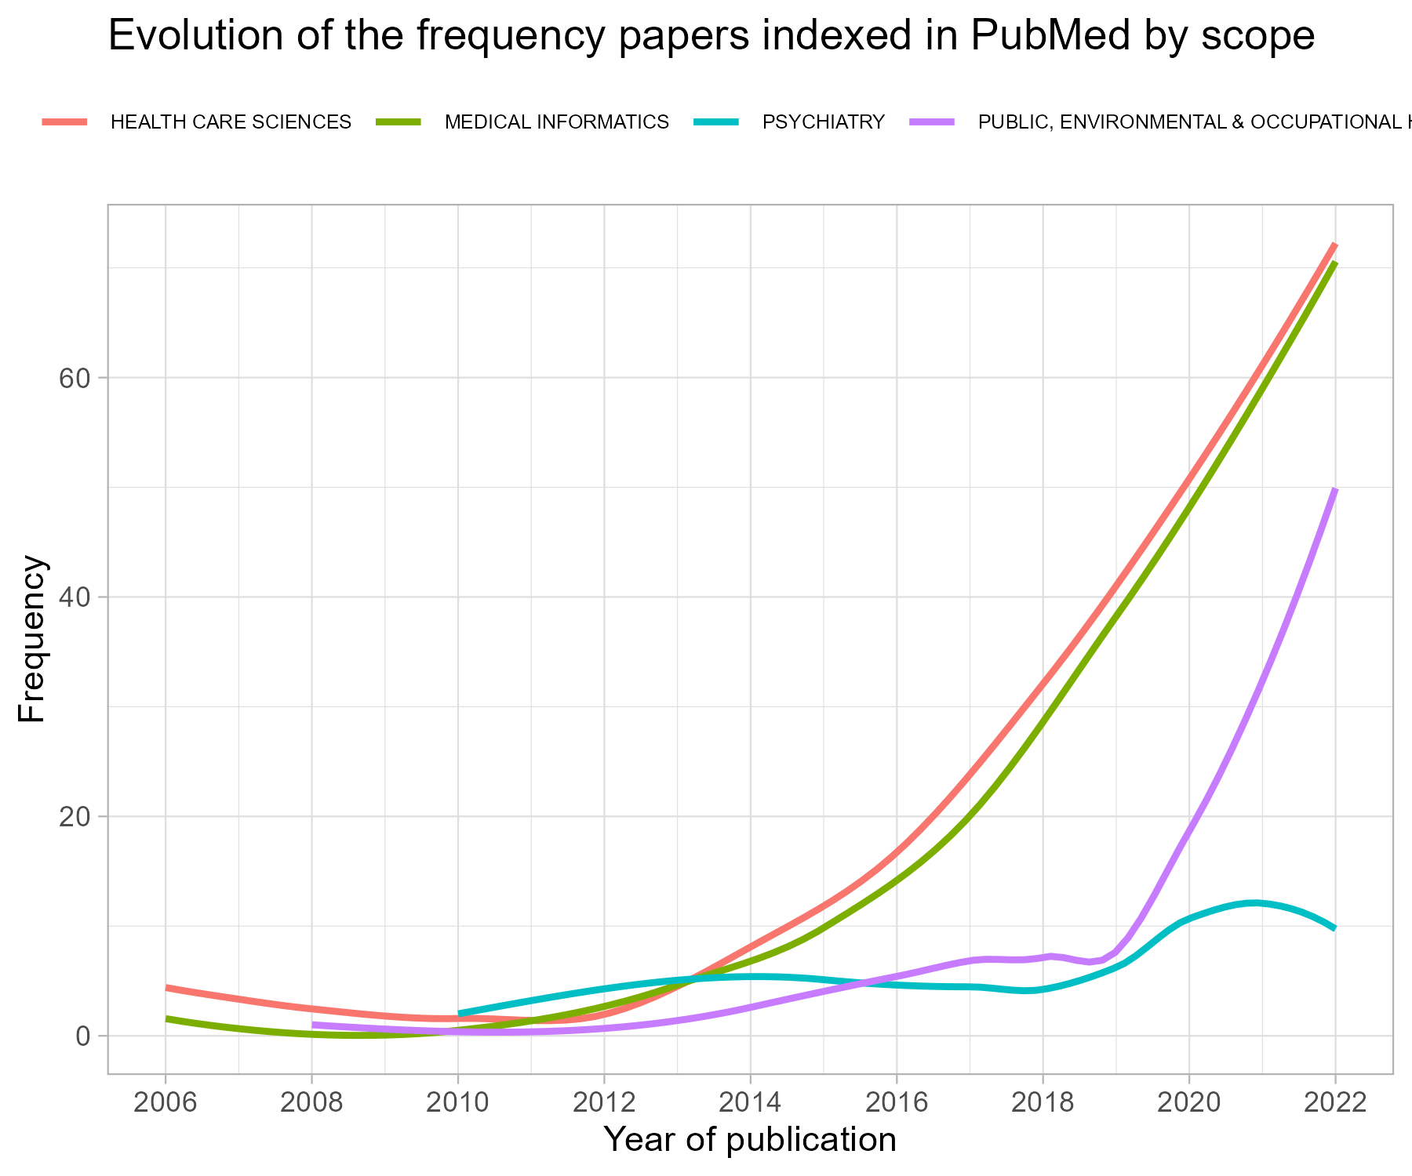

| **Author_country** | **n** | **%** |
| --- | --- | --- |
| UNITED STATES | 245 | 24.923703 |
| UNITED KINGDOM | 74 | 7.527976 |
| AUSTRALIA | 73 | 7.426246 |
| SPAIN | 62 | 6.307223 |
| GERMANY | 53 | 5.391658 |
| ITALY | 47 | 4.781282 |
| CANADA | 40 | 4.069176 |
| SWITZERLAND | 27 | 2.746694 |
| FRANCE | 26 | 2.644964 |
| THE NETHERLANDS | 26 | 2.644964 |
| INDIA | 25 | 2.543235 |
| BRAZIL | 23 | 2.339776 |
| CHINA | 23 | 2.339776 |
| NETHERLANDS | 19 | 1.932859 |
| SWEDEN | 16 | 1.627670 |
| REPUBLIC OF KOREA | 15 | 1.525941 |
| BELGIUM | 13 | 1.322482 |
| JAPAN | 12 | 1.220753 |
| MALAYSIA | 12 | 1.220753 |

|  | Overall (N=1250) |
| --- | --- |
| **subregion** |  |
| Australia and New Zealand | 80 (6.4%) |
| Eastern Asia | 49 (3.9%) |
| Eastern Europe | 12 (1.0%) |
| Latin America and the Caribbean | 40 (3.2%) |
| Northern Africa | 2 (0.2%) |
| Northern America | 285 (22.8%) |
| Northern Europe | 127 (10.2%) |
| South-eastern Asia | 25 (2.0%) |
| Southern Asia | 33 (2.6%) |
| Southern Europe | 131 (10.5%) |
| Sub-Saharan Africa | 22 (1.8%) |
| Western Asia | 30 (2.4%) |
| Western Europe | 147 (11.8%) |
| Missing | 267 (21.4%) |
| **region** |  |
| Africa | 24 (1.9%) |
| Americas | 325 (26.0%) |
| Asia | 137 (11.0%) |
| Europe | 417 (33.4%) |
| Oceania | 80 (6.4%) |
| Missing | 267 (21.4%) |

