Note interne / Internal memo

Industry Business

Industrial Control & Drive

|  |  |  |  |
| --- | --- | --- | --- |
|  | | | |
| **de / from :** | **François Malrait** | **date :** | **05/12/2018** |
| tel : |  | ref : |  |
| fax : |  | | |
| e-mail : | francois.malrait@schneider-electric.com | | |
|  | | | |
| **à / to :** |  | | |
|  | | | |
| pour info / copy to : |  | | |
|  | | | |
| **dossier / subj. :** |  | | |
|  | | | |

Table of Contents

Simulation presentation 1

Repetitive machine use-case 1

Process use-case 1

# Simulation presentation

4b

4a

3

2

1

1. Definition of trajectories

2. Definition of simulation parameters

3. Definition of key data to monitor

4. Simulation inputs: reference speed, load torque

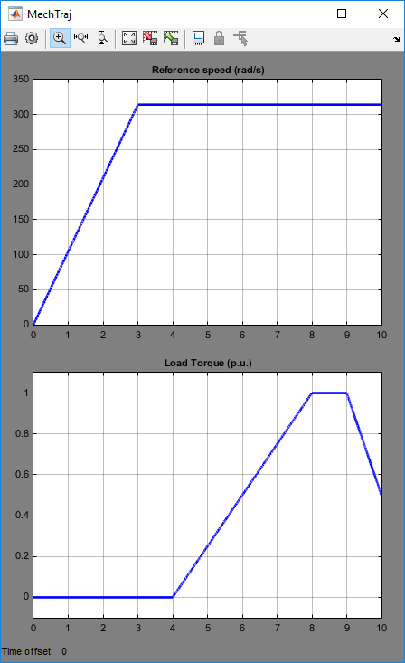

# Repetitive machine use-case

We may use the default model.

Speed trajectory corresponds to rapid transients between different constant speeds

Torque trajectory corresponds to rapid transients, correlated to speed trajectory.

A mat file DATACSdet.mat has been generated.

It contains

t (s)

Speed (p.u. to be multiplied by Wn)

TorqueLoad (p.u. to be multiplied by Tn)

Let’s define Wn equals to 2 pi 50 rad/s.

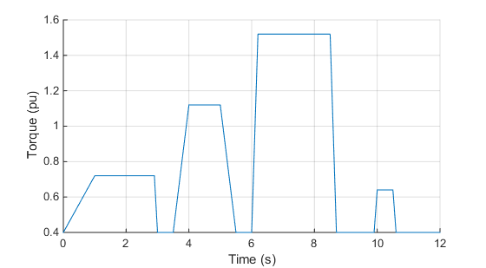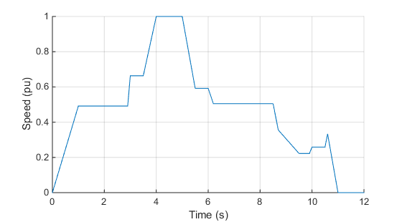Let’s define Tn equalts to 25 Nm.

***ModelMotS_dq_V2.slx*** to be modified to interconnect with data from workspace, loaded from mat file.

# Process use-case

We may use a model, in which we link the load torque to the actual speed (quadratic load).

Speed trajectory corresponds to slow transients between different constant speeds

Quadratic load coefficient trajectory corresponds to slow transients.

A mat file DATACSuc2.mat has been generated.

It contains

t (s)

Speed (p.u. to be multiplied by Wn)

Kvalv (p.u.)

***ModelMotS_dq_V3.slx*** to be modified to interconnect with data from workspace, loaded from mat file.