1. Open the command prompt Press WIN+R , type cmd

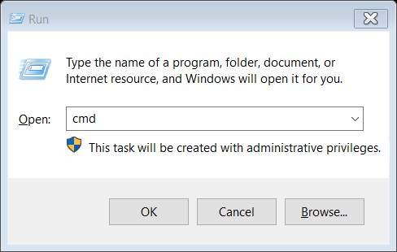

1. Create user with your id number and grant all privileges.

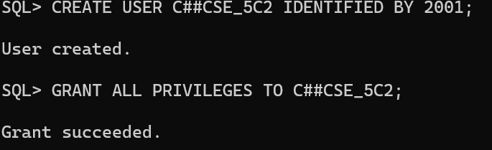

1. Now sign in with the new user.

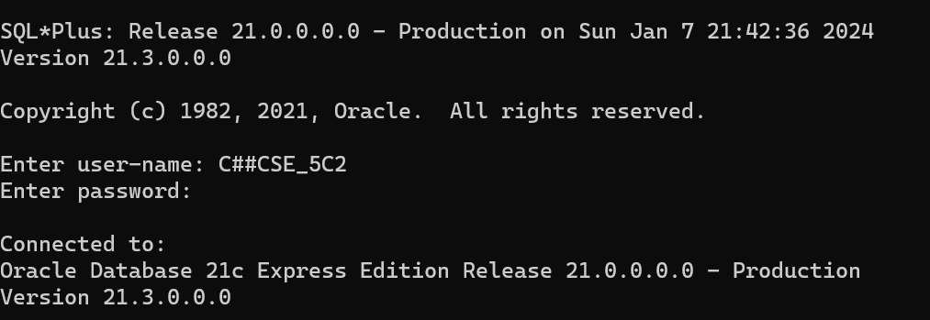

1. DDL COMMANDS

Write SQL queries to CREATE TABLES for various databases using DDL commands (i.e. CREATE, ALTER, DROP, TRUNCATE).

CREATE TABLE

Syntax:

CREATE TABLE tablename (

column1 data_ type [constraint]

[, column2 data_ type [constraint] ] [,

PRIMARY KEY (column1 [, column2]) ]

[, FOREIGN KEY (column1 [, column2]) REFERENCES tablename] [,CONSTRAINT constraint]);

Example:

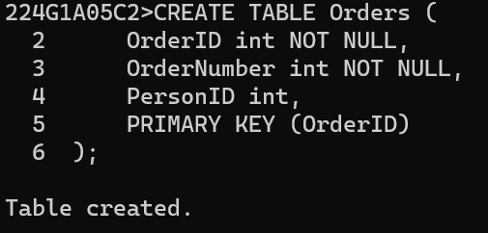

ALTER TABLE

Syntax 1:

ALTER TABLE tablename

{ADD | MODIFY} (column_name data_type [ {ADD|MODIFY}

Column_name data_type]);

Syntax 2;

ALTER TABLE tablename

ADD constraint [ADD constraint];

Syntax 3:

ALTER TABLE tablename

DROP {PRIMARY KEY | COLUMN column_name | CONSTRAINT constraint_name);

Syntax 4:

ALTER TABLE tablename

ENABLE CONSTRAINT constraint_name;

Example:

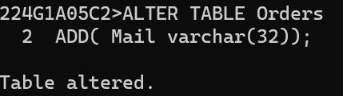

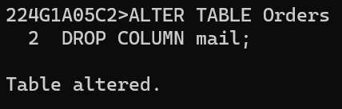

DESC Orders:

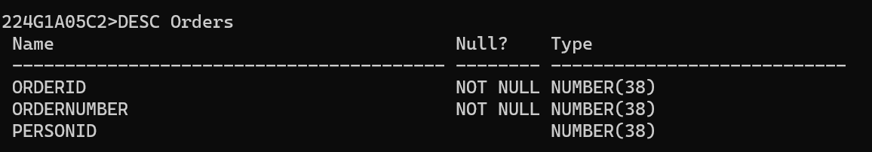

DROP TABLE

Syntax:

DROP TABLE table_name;

Example:

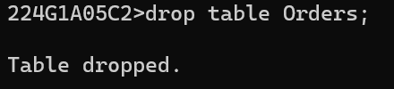

TRUNCATE TABLE

Syntax:

TRUNCATE TABLE table_name;

Example:

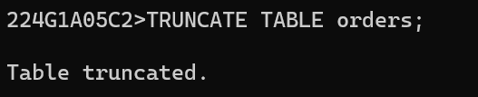

2.DML COMMANDS

Write SQL queries to MANIPULATE TABLES for various databases using DML commands (i.e. INSERT, SELECT, UPDATE, DELETE,)

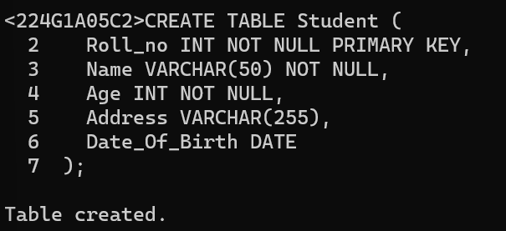

INSERT

Syntax:

INSERT INTO tablename

VALUES (value1,value2,...,valuen);

Syntax 2:

INSERT INTO tablename

(column1, column2,…,column) VALUES (value1, value2,...,valuen);

Example:

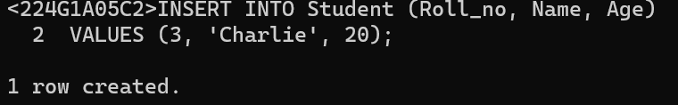

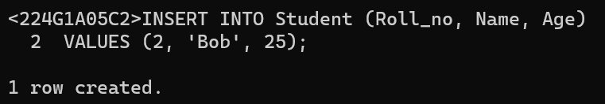

SELECT

Syntax:

SELECT *

DROM <table_name>;

Example:

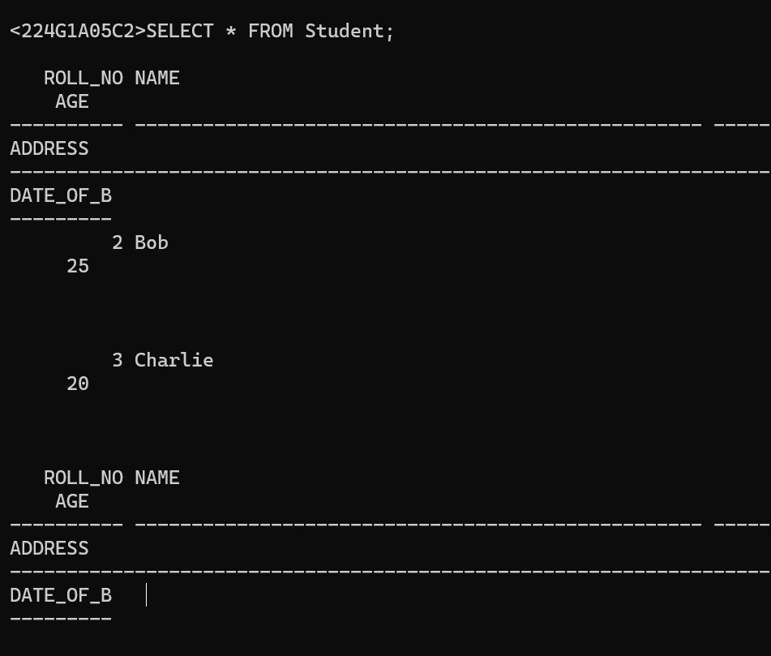

UPDATE

Syntax:

UPDATE table_name SET [column_name1= value_1, column_name2= value_2,...]

WHERE CONDITION;

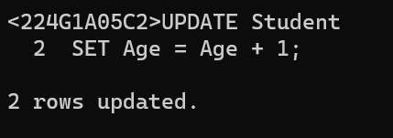

DELETE

Syntax:

DELETE FROM table_Name WHERE condition;

Example:

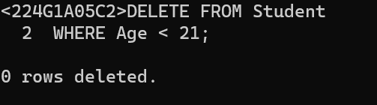

3.VIEWS

Write SQL queries to create VIEWS for various databases (i.e. CREATE VIEW, UPDATE VIEW, ALTER VIEW, and DELETE VIEW).

View syntax:

CREATE VIEW VIEW_NAME AS <QUERY EXPRESSION>

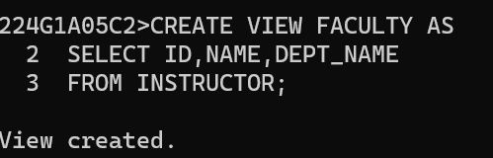

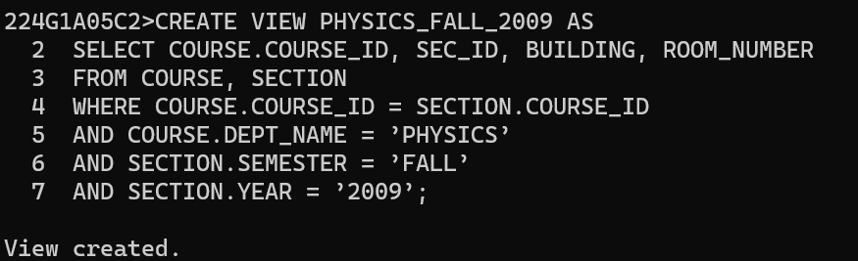

An equivalent relation of view without using view as original relation

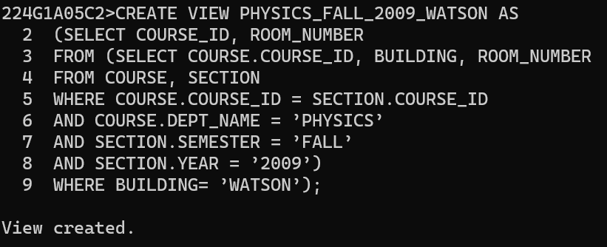

Commands to insert, Delete and update view

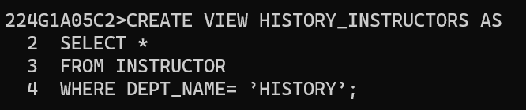

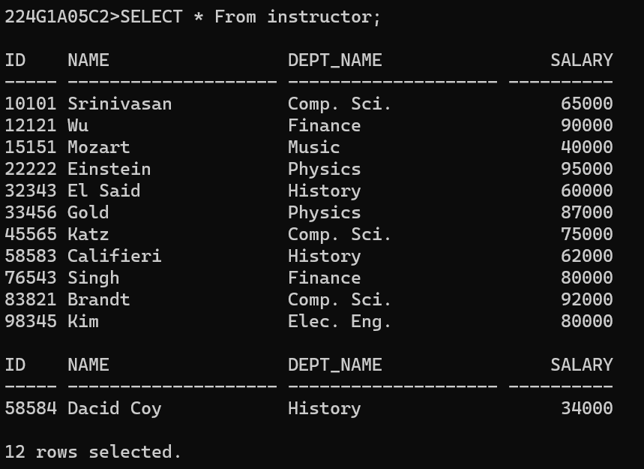

DELETE VIEW:

DROP VIEW view_name;

1. RELATIONAL SET OPERATIONS

Write SQL queries to perform RELATIONAL SET OPERATIONS (i.e. UNION, UNION ALL, INTERSECT, MINUS, CROSS JOIN, NATURAL JOIN)

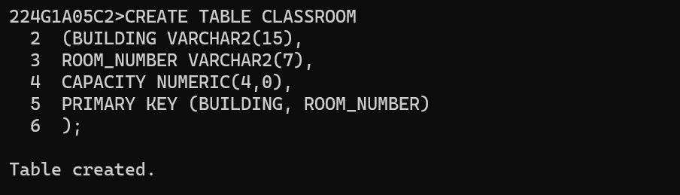

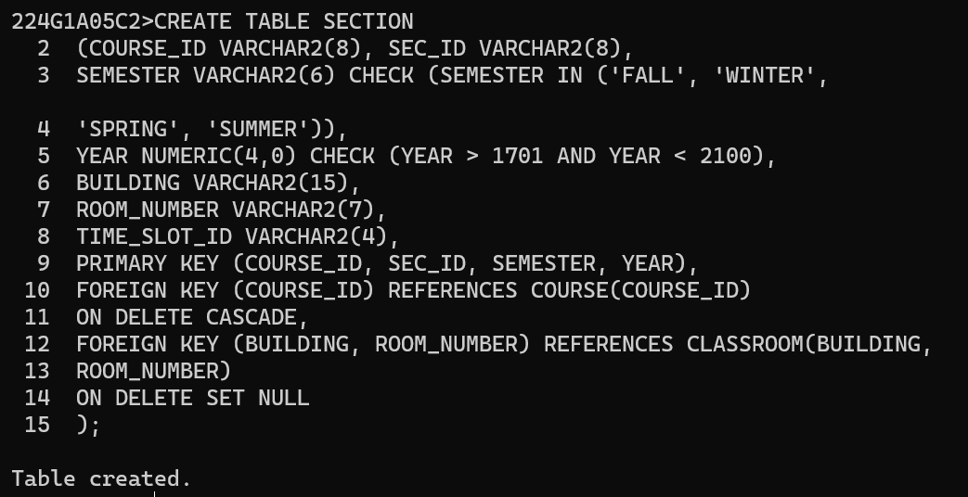

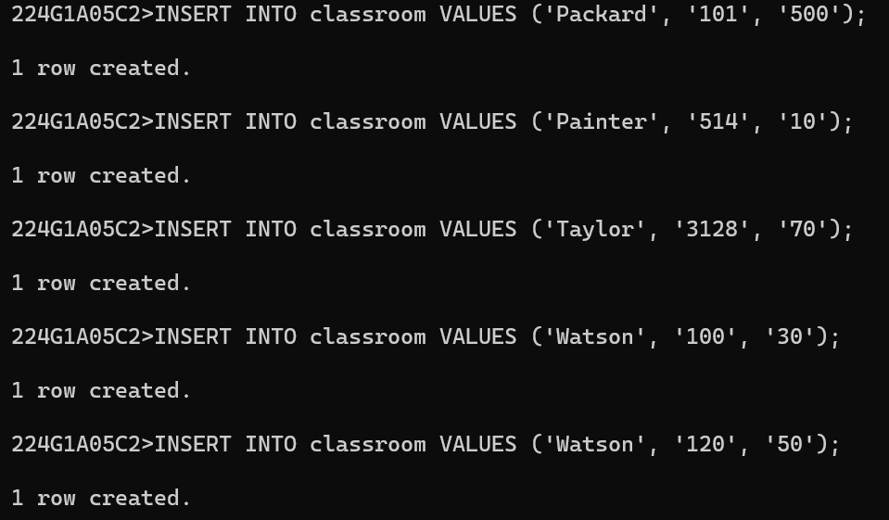

Union operation:

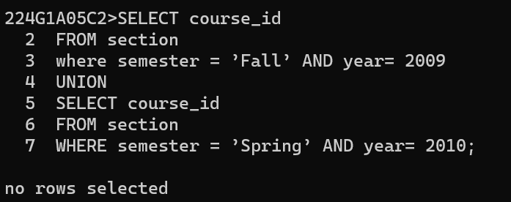

Union all Operation:

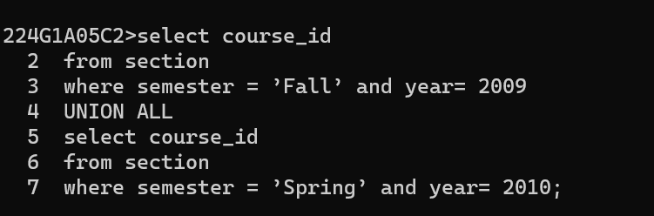

Intersect Operation:

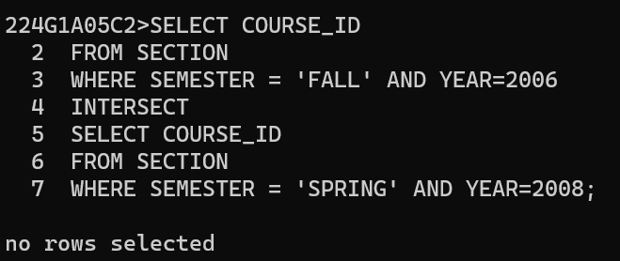

Intersect all operation:

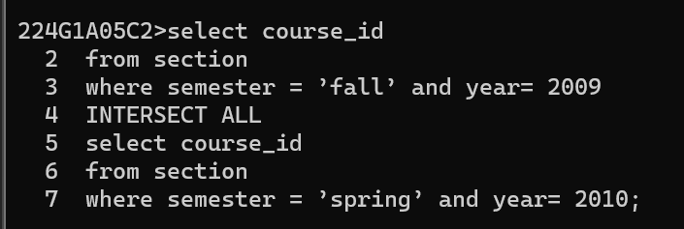

except or minus operation:

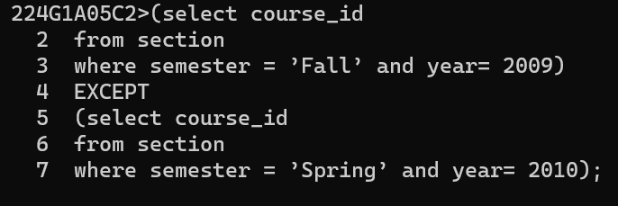

except all or minus all operations:

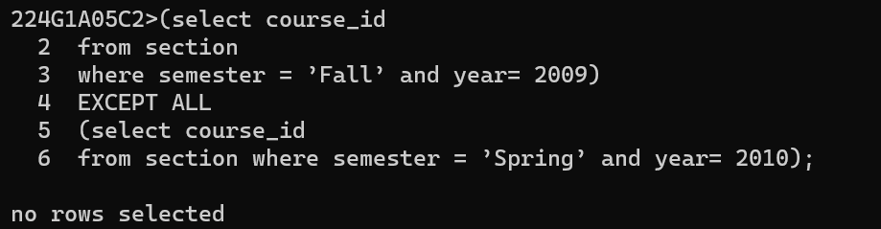

5.SPECIAL OPERATIONS

Write SQL queries to perform SPECIAL OPERATIONS (i.e. ISNULL, BETWEEN, LIKE, IN, EXISTS).

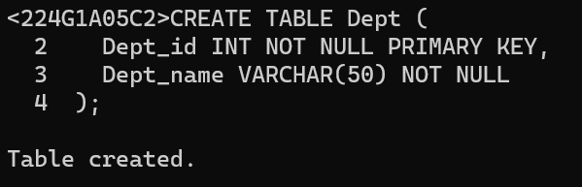

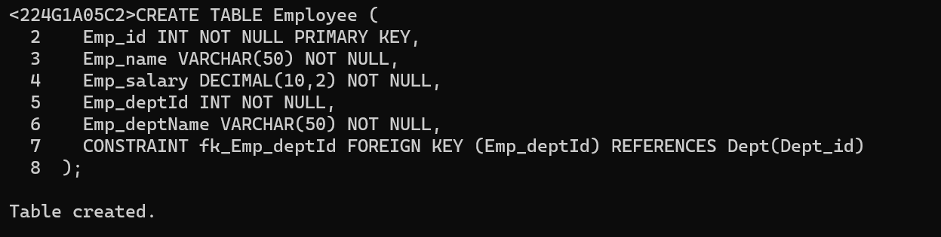

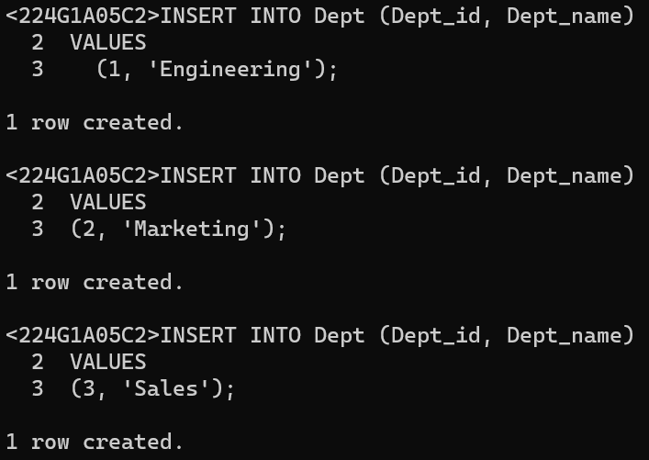

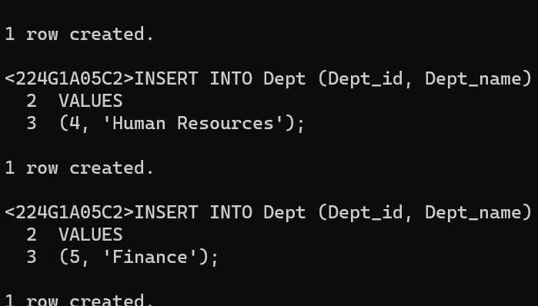

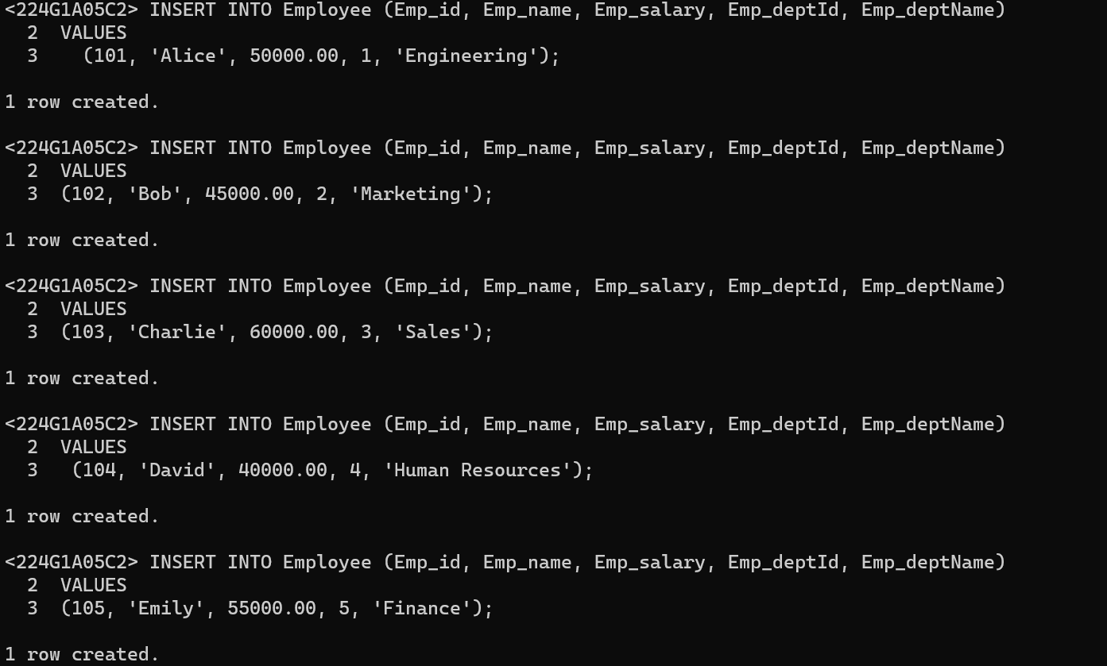

ISNULL

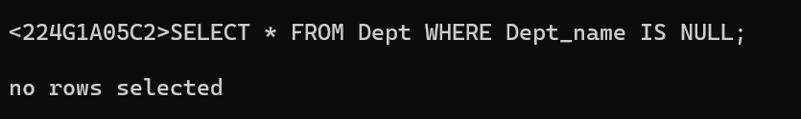

BETWEEN

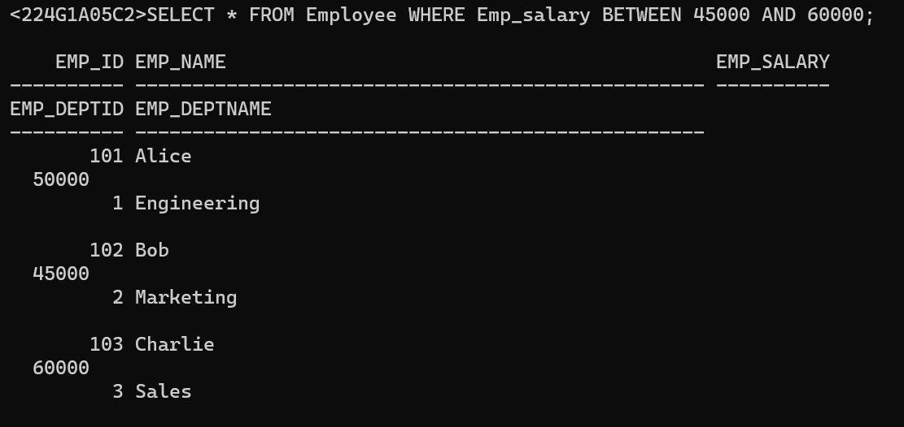

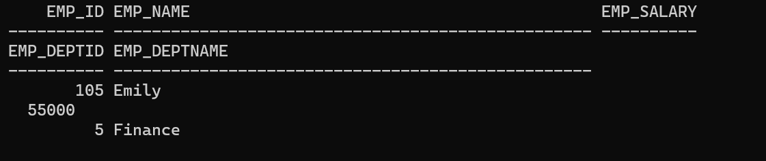

LIKE

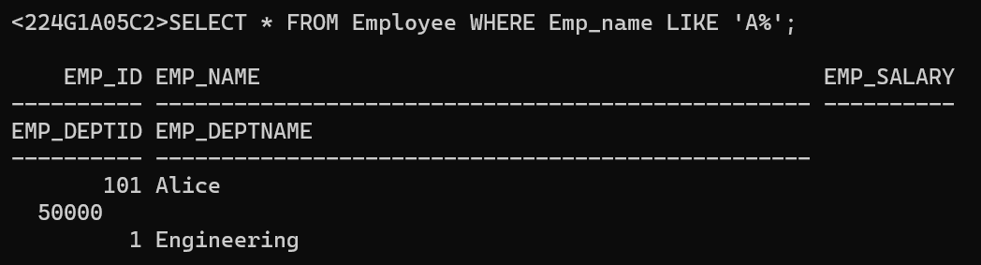

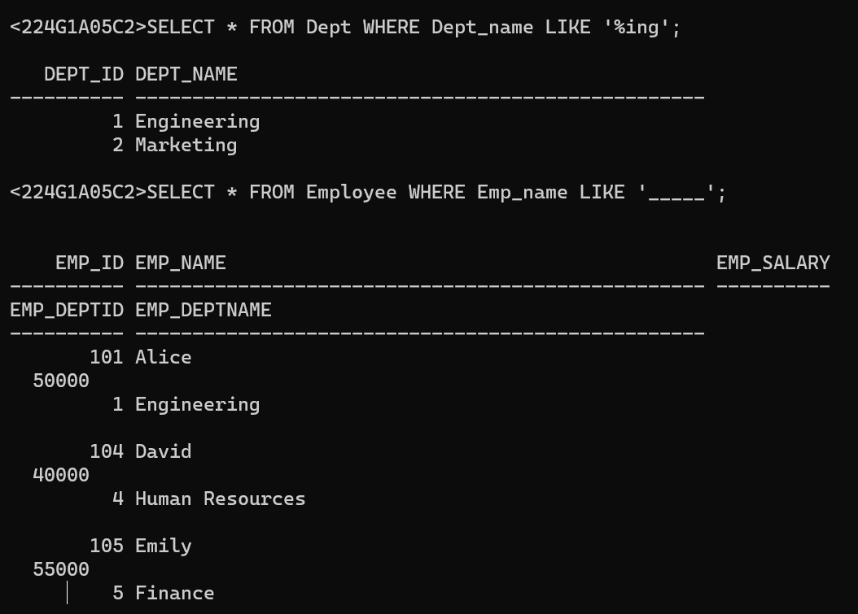

IN

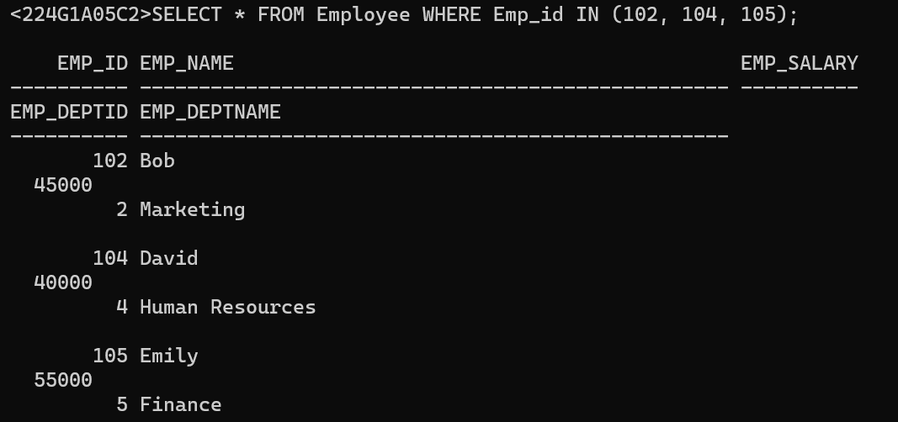

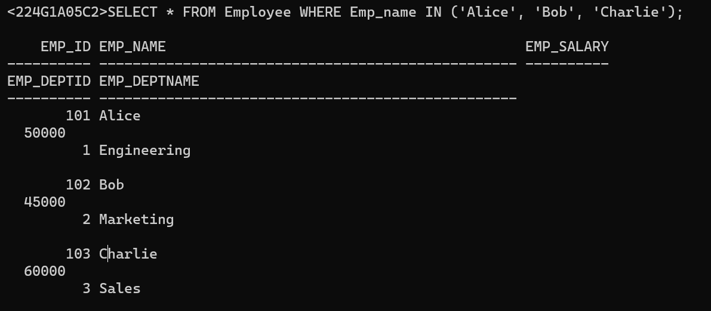

EXISTS

syntax

SELECT <columns> FROM <table>

WHERE EXISTS (<subquery>);

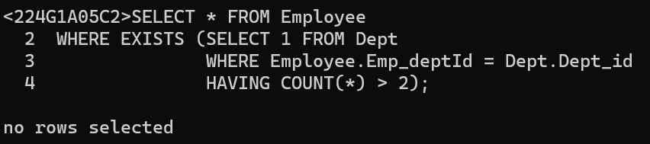

6.JOIN OPERATIONS

Write SQL queries to perform JOIN OPERATIONS (i.e. CONDITIONAL JOIN, EQUI JOIN, LEFT OUTER JOIN, RIGHT OUTER JOIN, FULL OUTER JOIN)

Natural JOIN

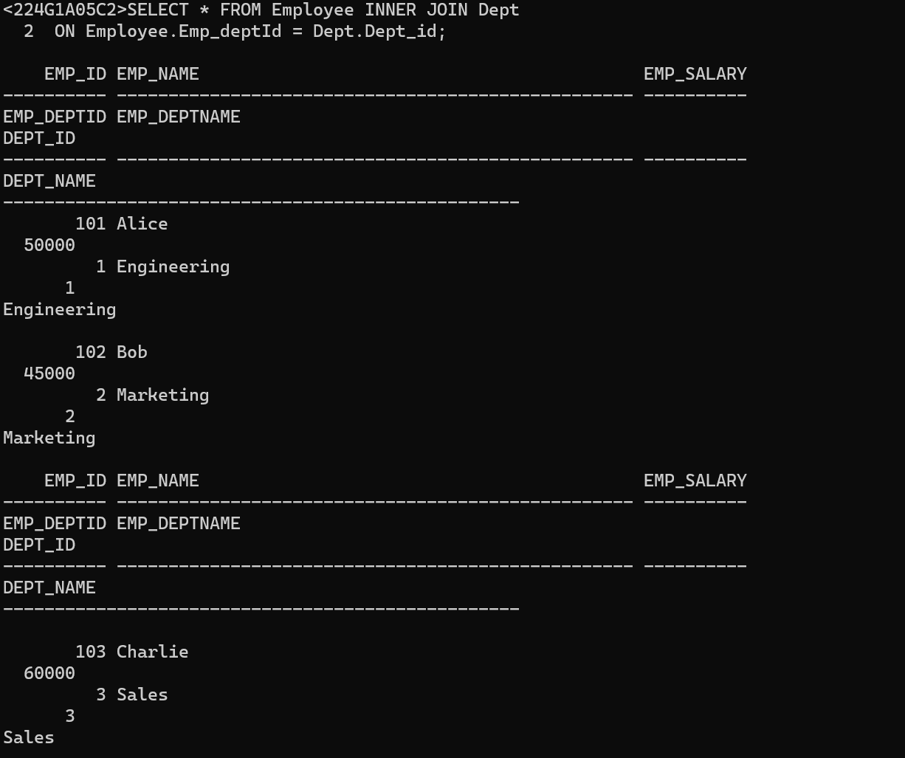

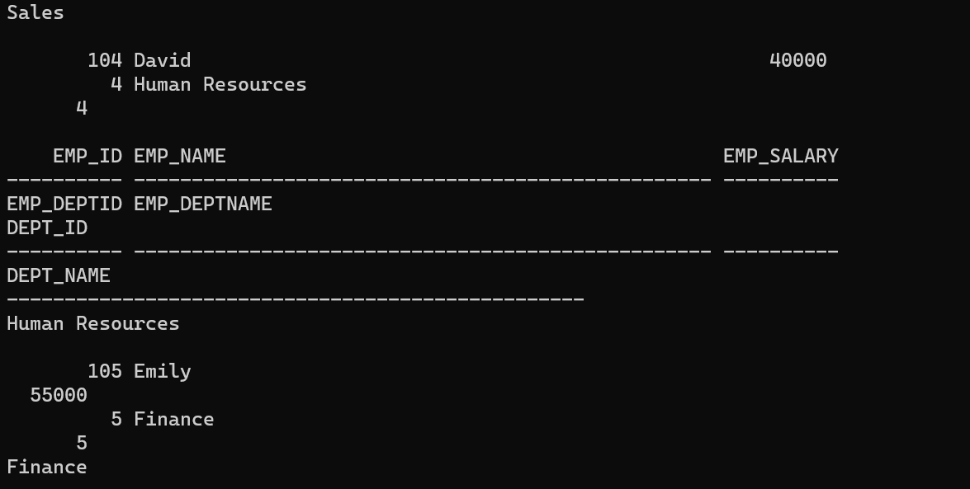

CONDITIONAL JOIN

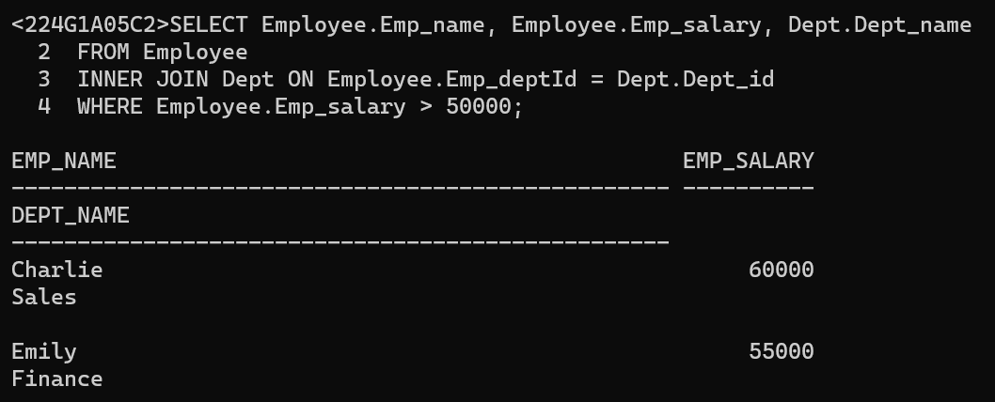

RIGHT OUTER JOIN

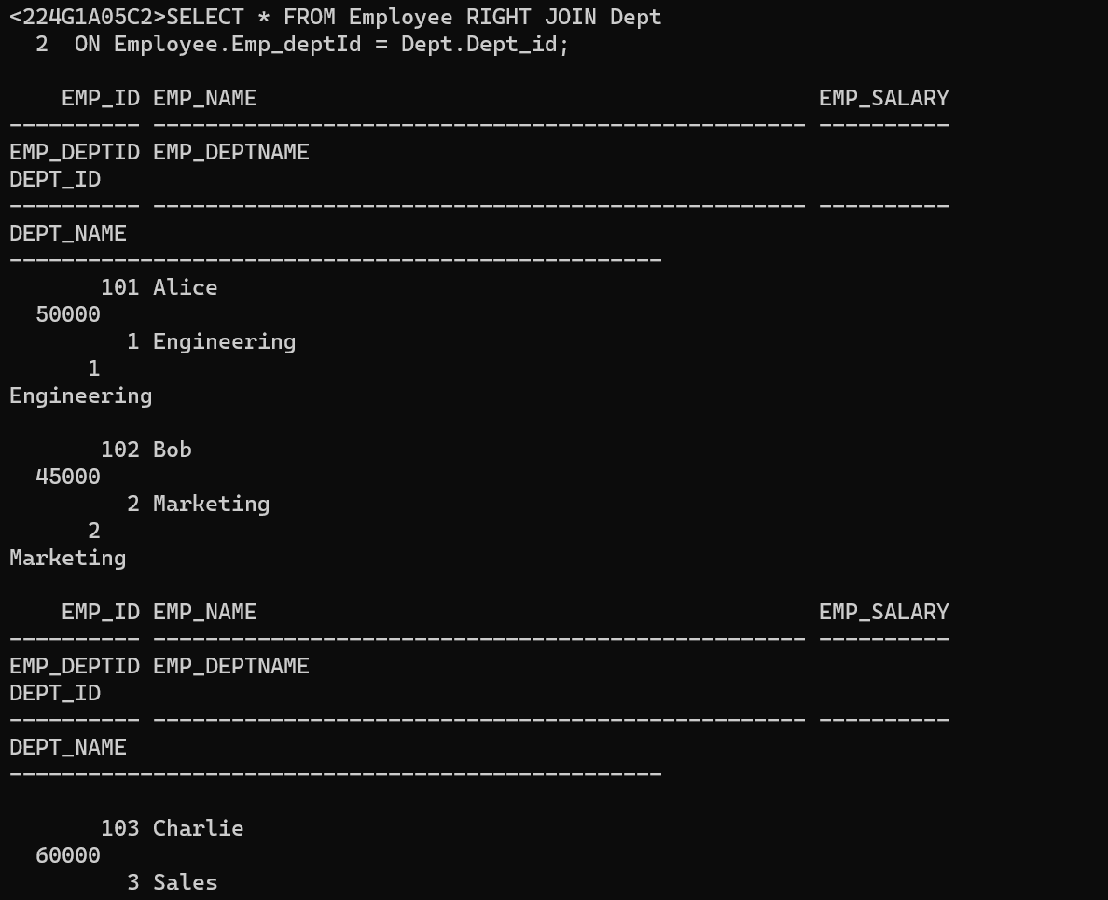

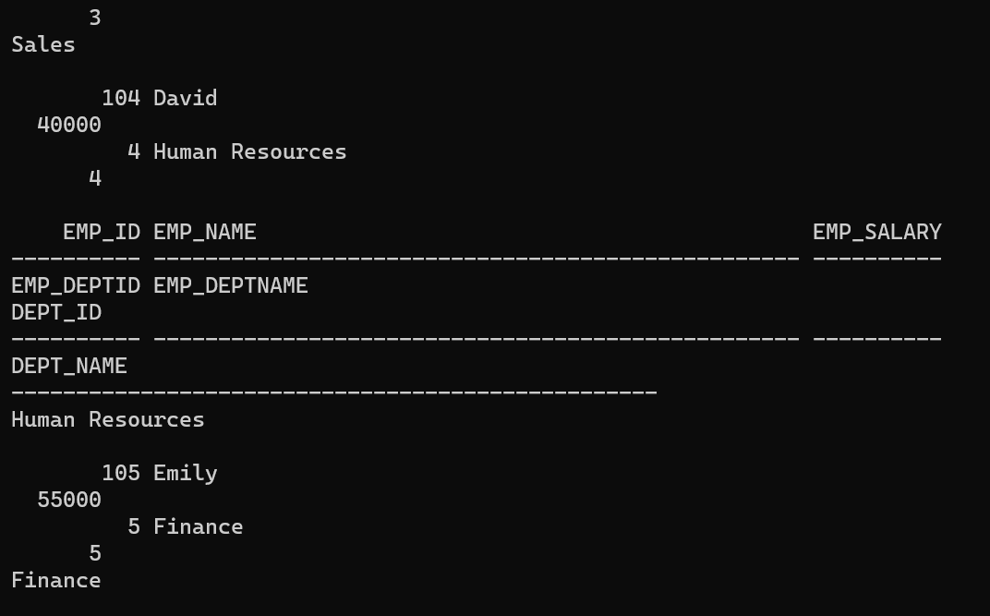

LEFT OUTER JOIN

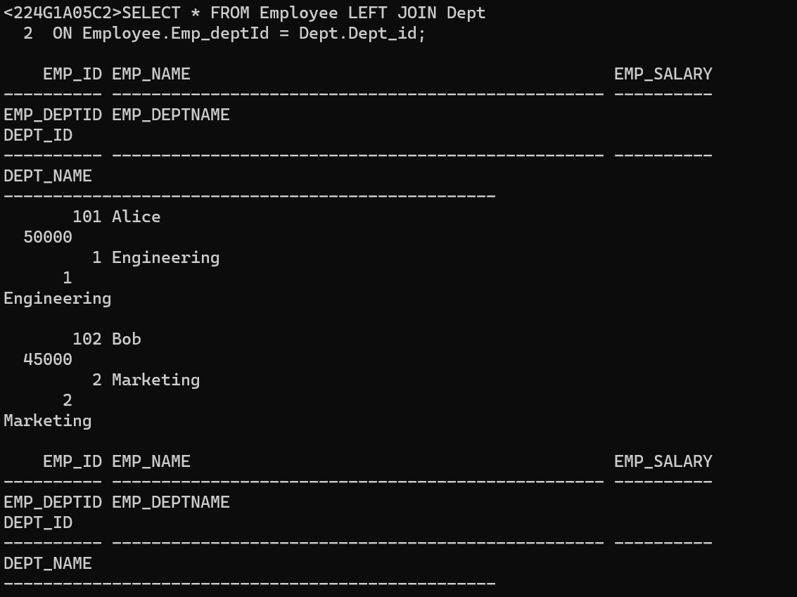

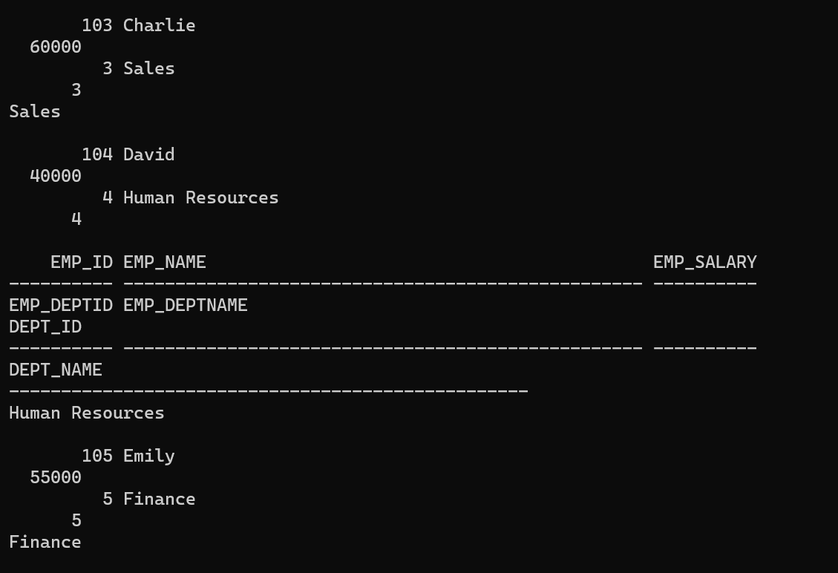

FULL OUTER JOIN

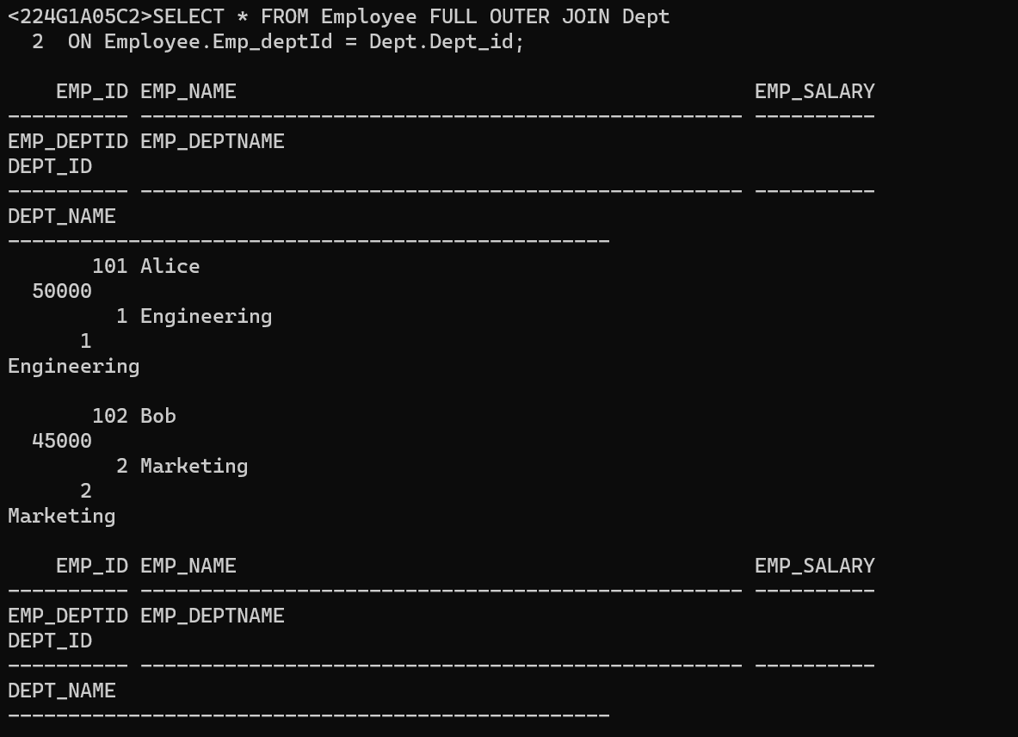

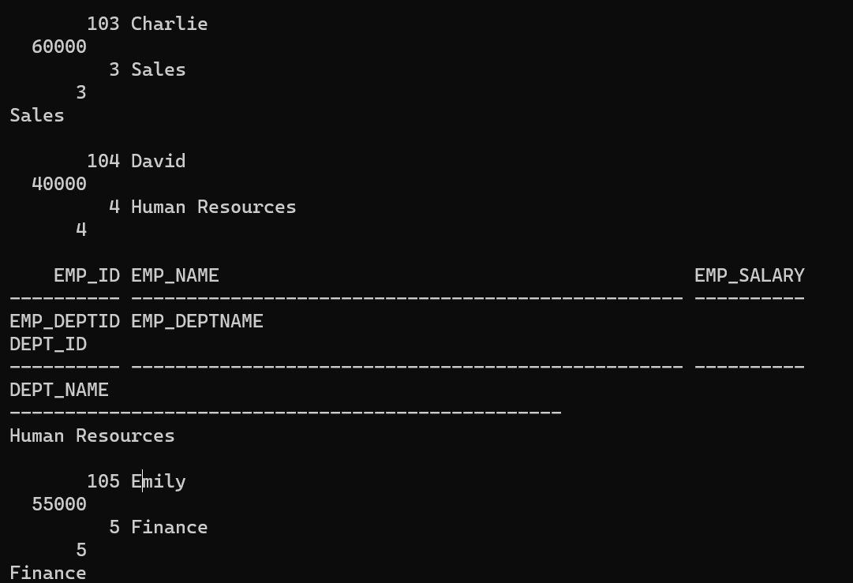

7. AGGREGATE OPERATIONS

Write SQL queries to perform AGGREGATE OPERATIONS (i.e. SUM, COUNT, AVG, MIN, MAX).

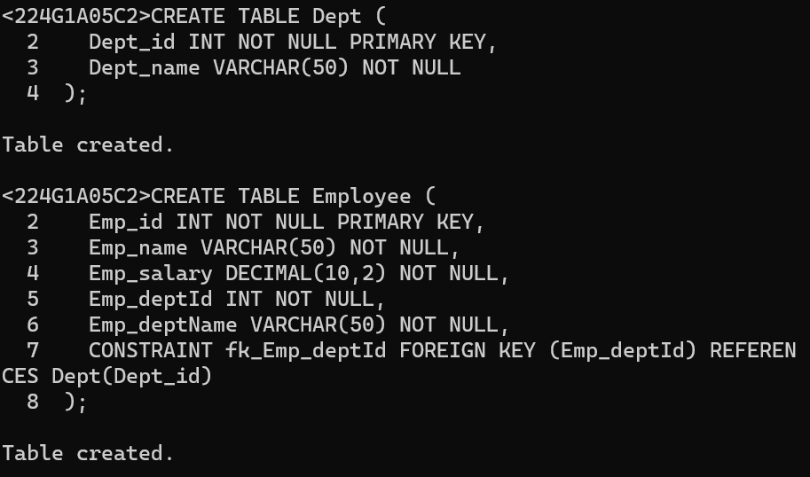

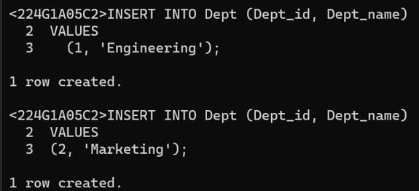

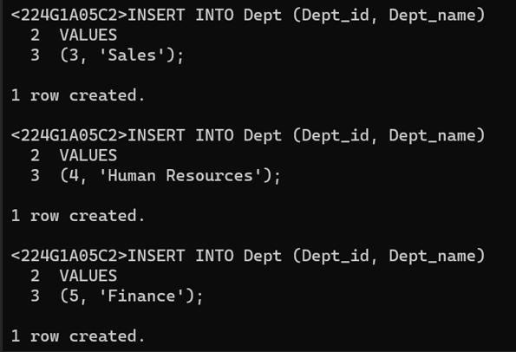

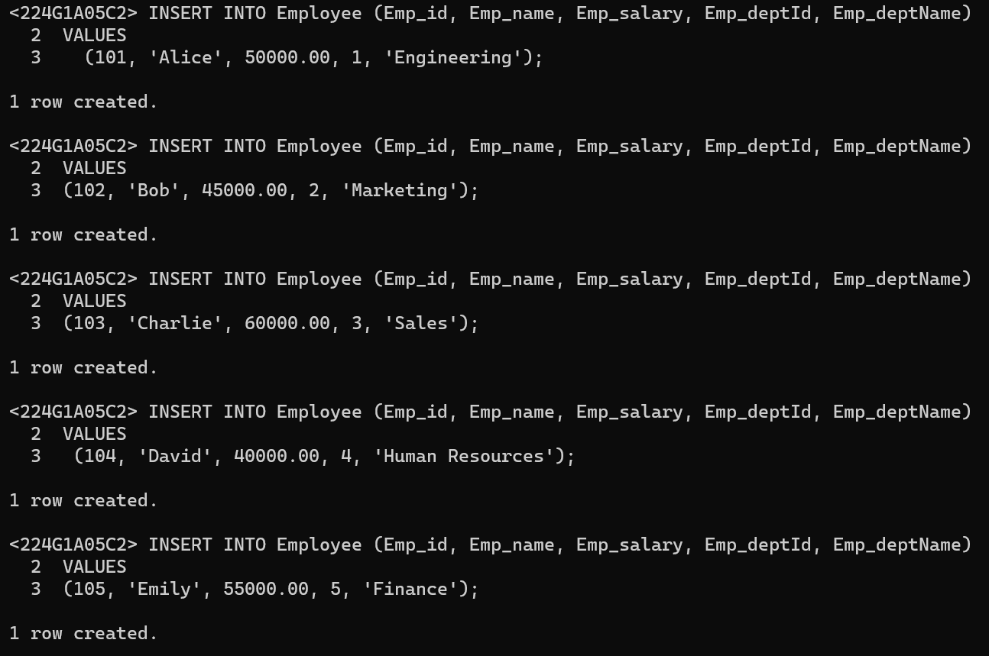

COUNT:

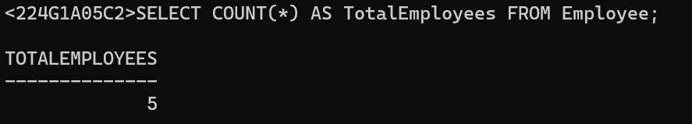

SUM:

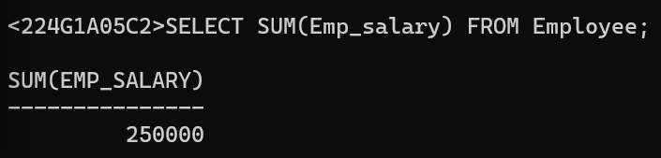

MIN:

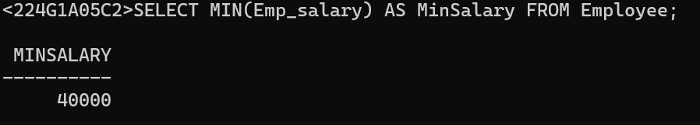

MAX:

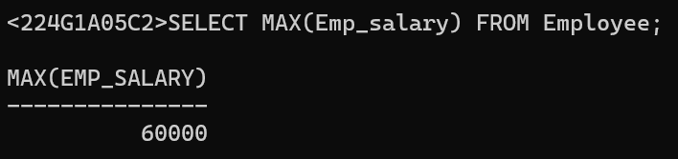

AVG: 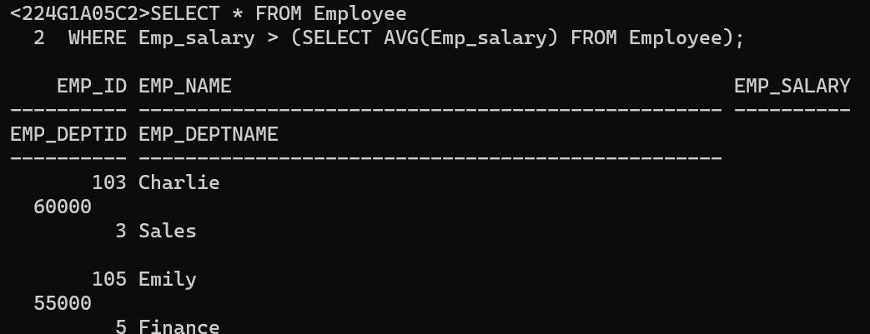

8. ORACLE BUILT-IN FUNCTIONS

Write SQL queries to perform ORACLE BUILT-IN FUNCTIONS (i.e. DATE, TIME)

case-conversion functions:

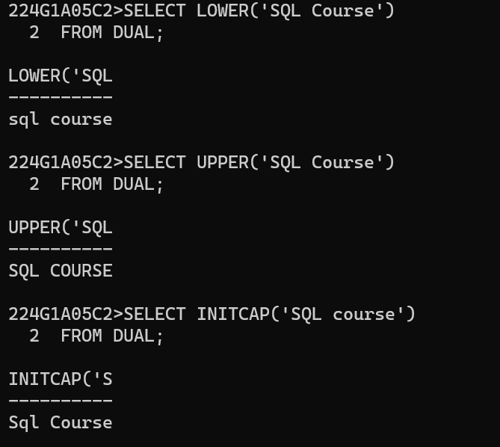

character manipulation functions:

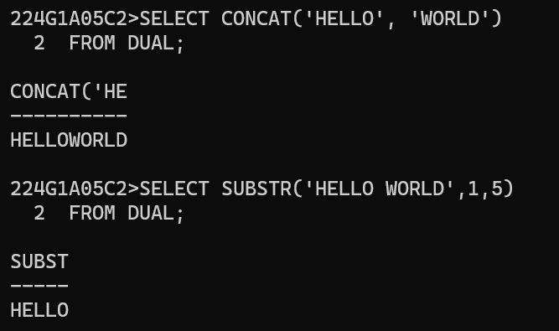

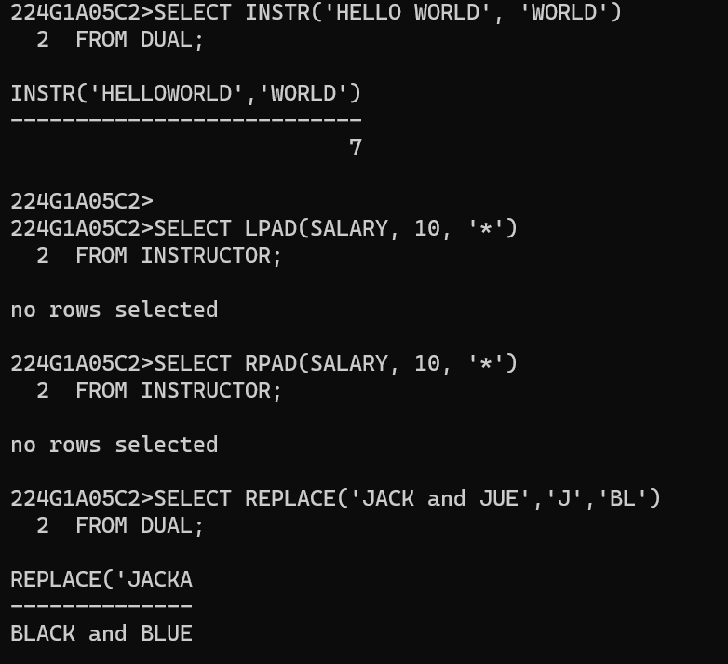

Number Functions:

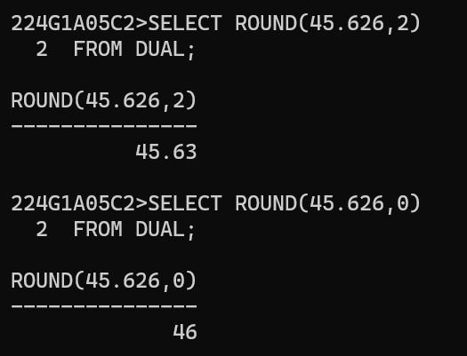

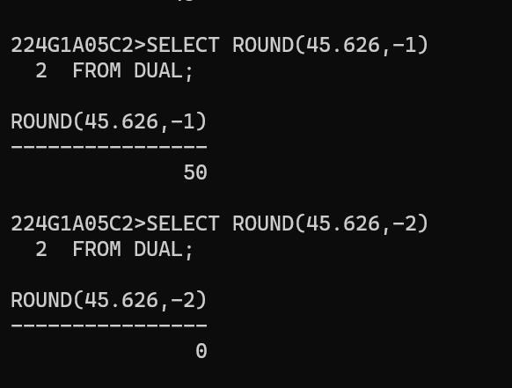

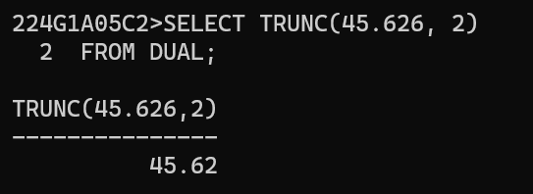

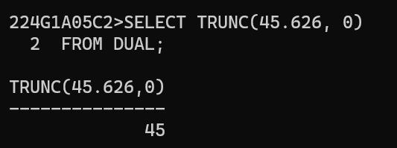

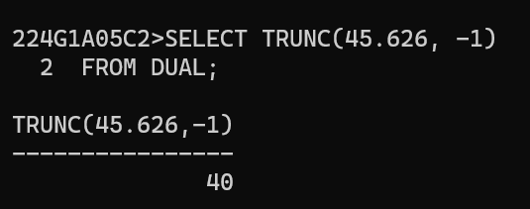

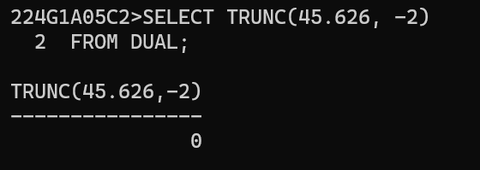

Date functions:

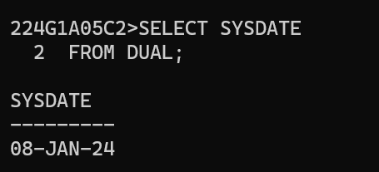

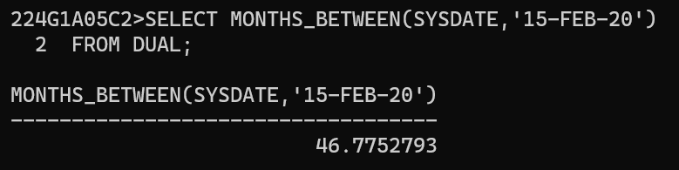

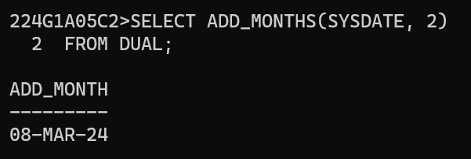

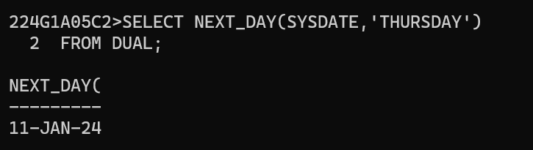

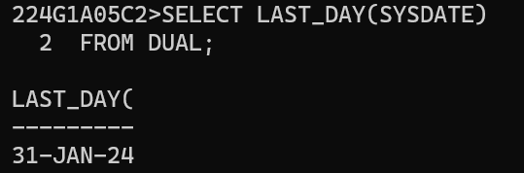

9.KEY CONSTRAINTS

Write SQL queries to perform KEY CONSTRAINTS (i.e. PRIMARY KEY, FOREIGN KEY, UNIQUE NOT NULL, CHECK, DEFAULT)

NOT NULL COnstraint Example

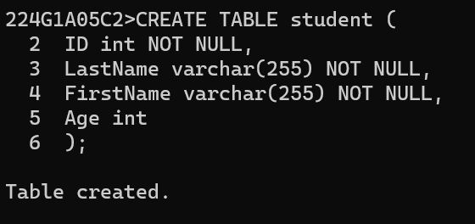

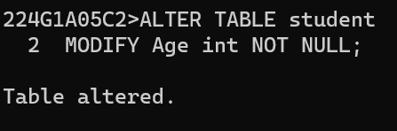

UNIQUE CONSTRAINT Example

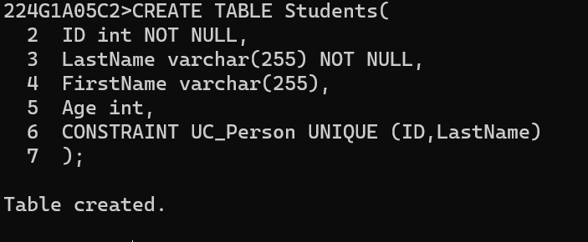

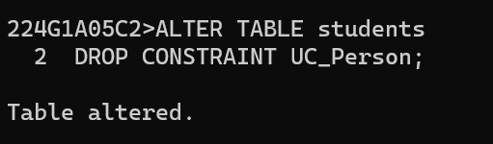

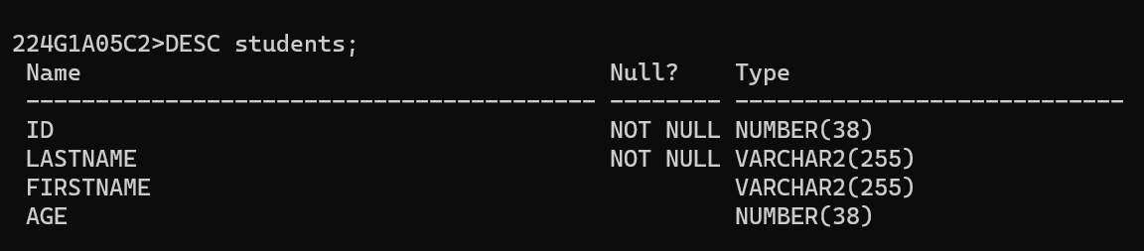

PRIMARY KEY CONSTRAINT Example:

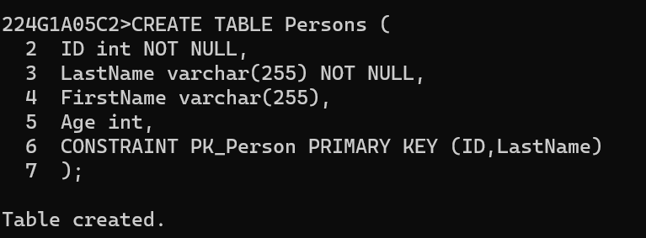

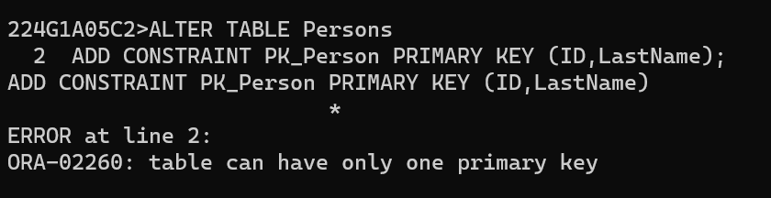

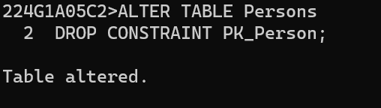

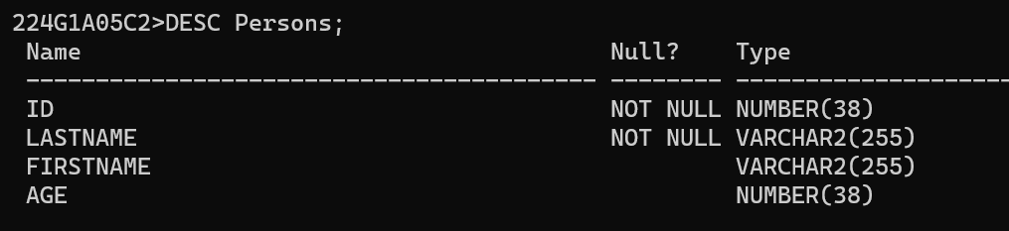

CHECK CONSTRAINTS Example:

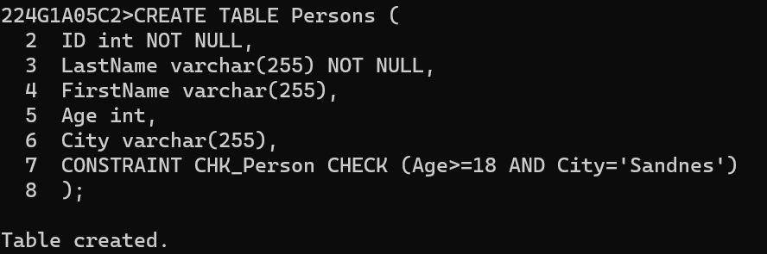

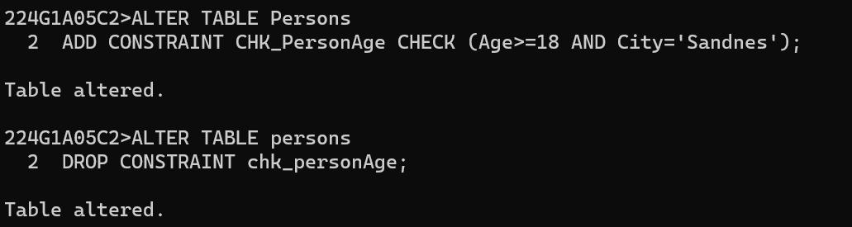

DEFAULT CONSTRAINTS Example:

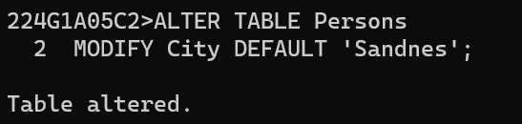

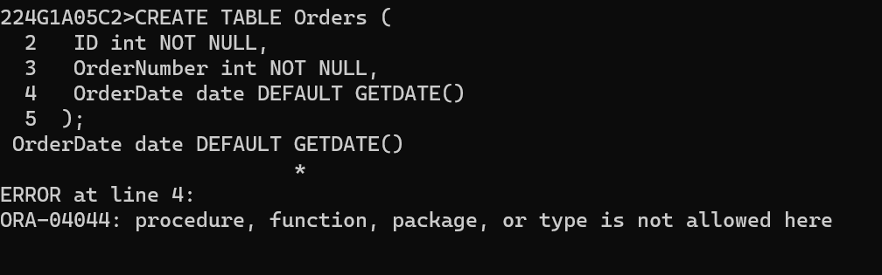

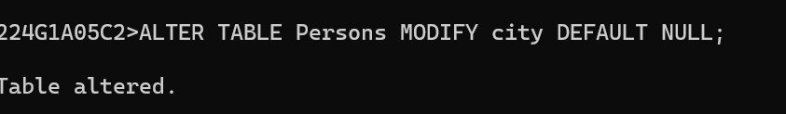

10. FACTORIAL

Write a PL/SQL program for calculating the factorial of a given number

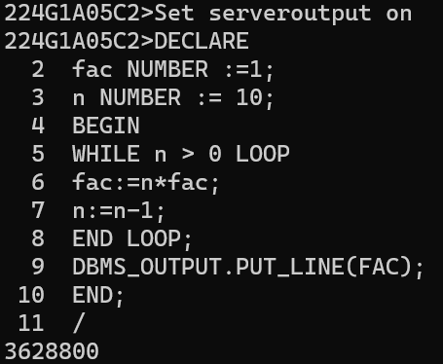

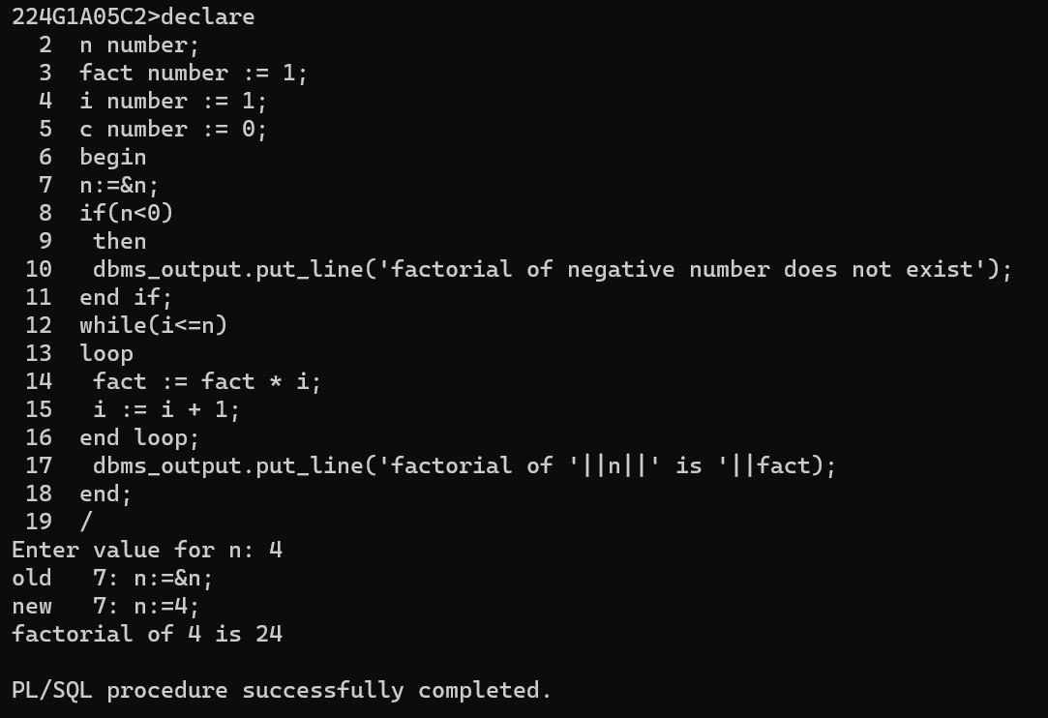

11.PRIME NUMBER OR NOT

Write a PL/SQL program for finding the given number is prime number or not.

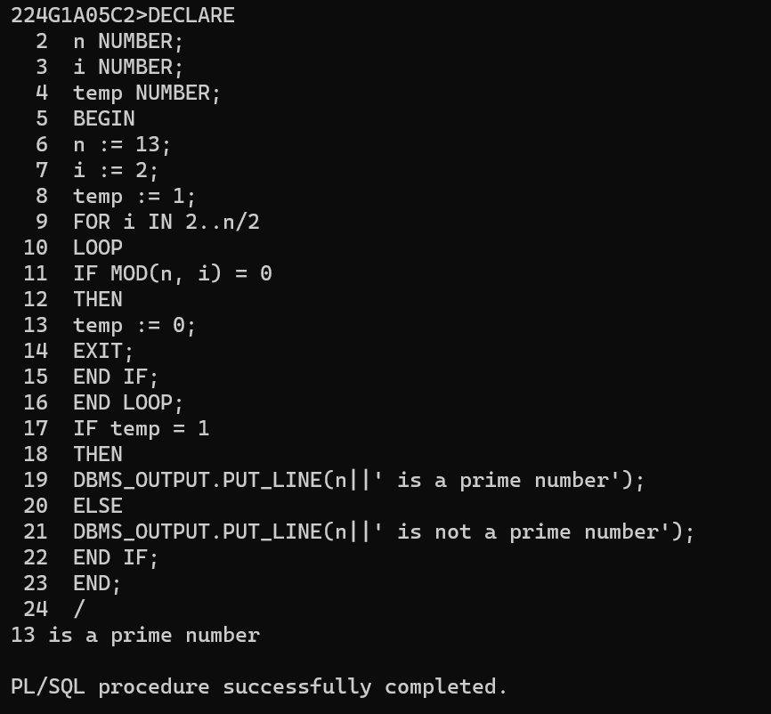

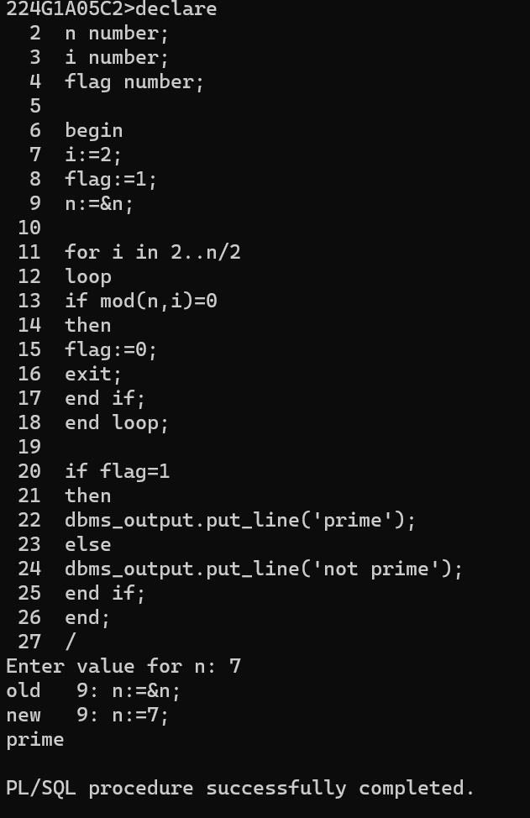

12.FIBONACCI

Write a PL/SQL program for displaying the Fibonacci series up to an integer

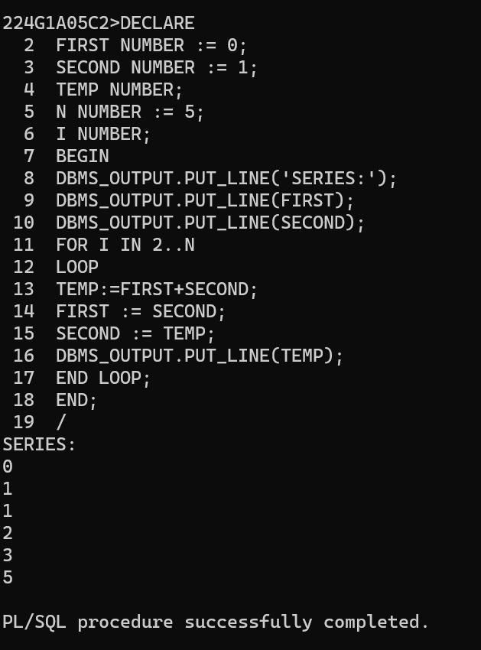

13.STORED PROCEDURE

Write PL/SQL program to implement Stored Procedure on table.

SYNTAX:

CREATE [OR REPLACE] PROCEDURE procedure_name

[ (parameter [,parameter]) ]

(IS | AS)

[declaration_section]

BEGIN

executable_section

[EXCEPTION exception_section]

END [procedure_name];

Example:

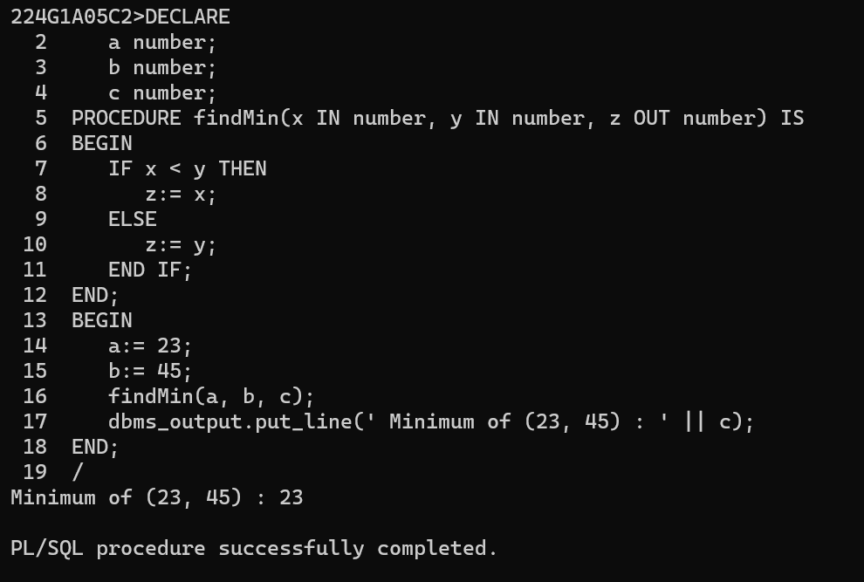

14.STORED FUNCTION

Write PL/SQL program to implement Stored Function on table.

SYNTAX:

CREATE [OR REPLACE] FUNCTION function_name

[ (parameter [,parameter]) ]

RETURN return_datatype

(IS | AS)

[declaration_section]

BEGIN executable_section

[EXCEPTION exception_section]

END [procedure_name];

Example:

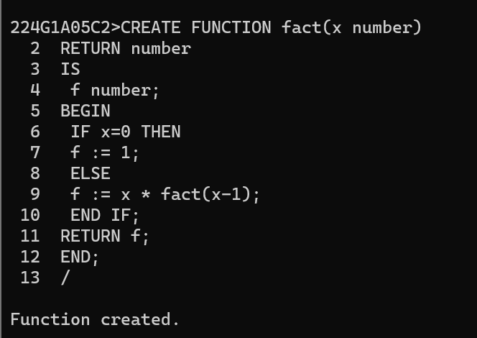

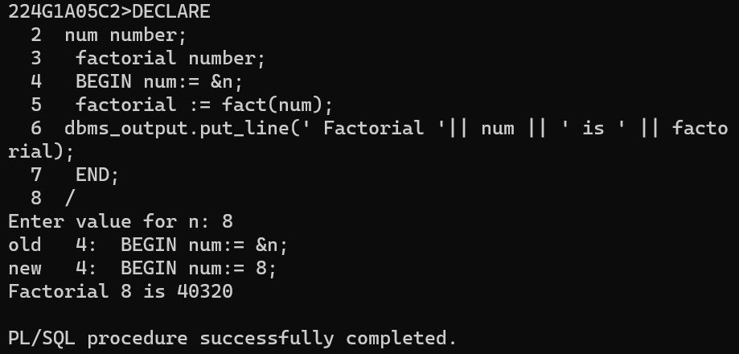

15.IMPLEMENT TRIGGER

Write PL/SQL program to implement Trigger on table

Syntax:

CREATE [OR REPLACE ] TRIGGER TRIGGER_NAME

{BEFORE | AFTER | INSTEAD OF }

{INSERT [OR] | UPDATE [OR] | DELETE}

[OF COL_NAME]

ON TABLE_NAME

[REFERENCING OLD AS O NEW AS N]

[FOR EACH ROW]

WHEN (CONDITION)

DECLARE

DECLARATION-STATEMENTS

BEGIN

EXECUTABLE-STATEMENTS

EXCEPTION

EXCEPTION-HANDLING-STATEMENTS

END;

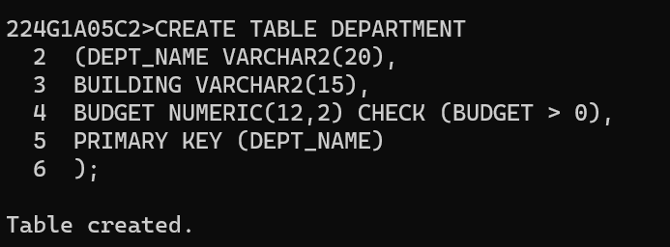

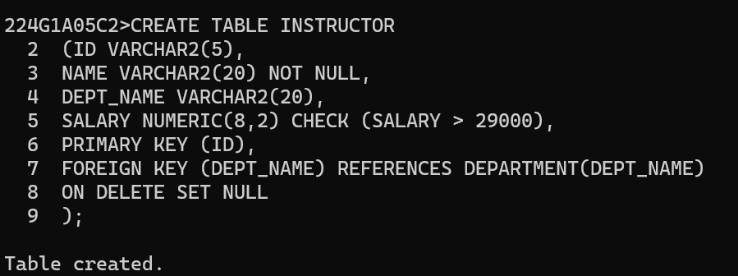

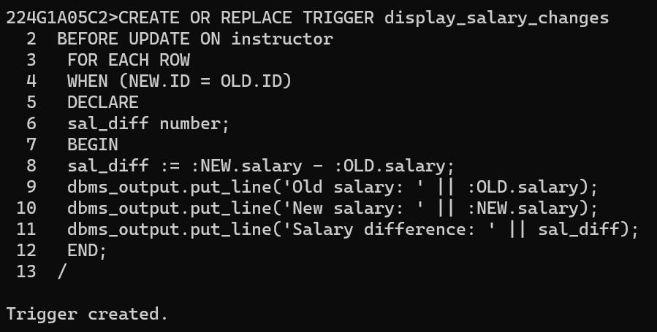

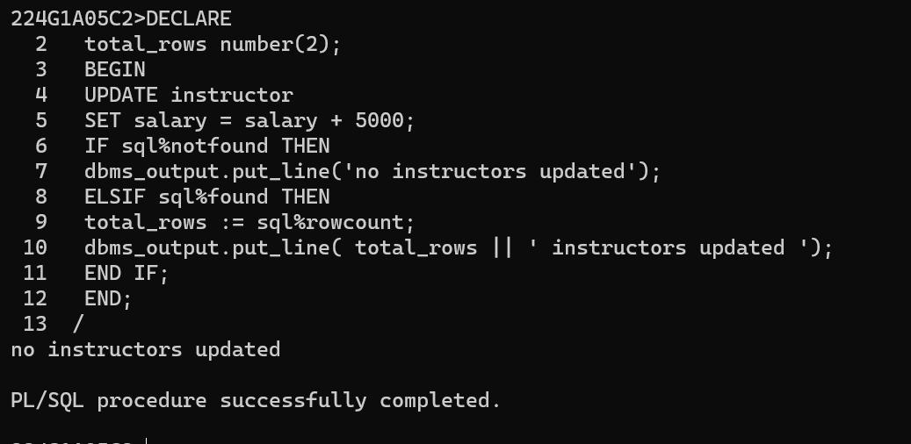

16.IMPLEMENT CURSOR

Write PL/SQL program to implement Cursor on table

Declare the cursor:

SYNTAX:

CURSOR cursor_name IS select_statement;

Open the cursor

SYNTAX:

OPEN cursor_name;

Fetch the cursor

SYNTAX:

FETCH cursor_name INTO variable_list;

Close the cursor:

SYNTAX:

Close cursor_name;

