Activity 1 ToDo List API + UI (NestJS + React)

A simple task manager with NestJS (SQLite) backend and React + Vite frontend. Create, read, update, delete tasks with priority, due dates, completion status, bulk actions, theme toggle, animations, and Swagger docs.

## Tech Stack

* Backend: NestJS, TypeORM, SQLite
* Frontend: React + Vite, TypeScript, Framer Motion
* Tooling: Axios, Swagger

## Features

* Add/edit/delete tasks
* Completion toggle with auto completedAt
* Due date with overdue highlighting
* Priority: low, medium, high
* Search + filters (status, priority)
* Sorting (newest, recently updated, AZ)
* Select mode with bulk complete/delete
* Light/dark theme toggle
* Spring animations and delete confirmation modal

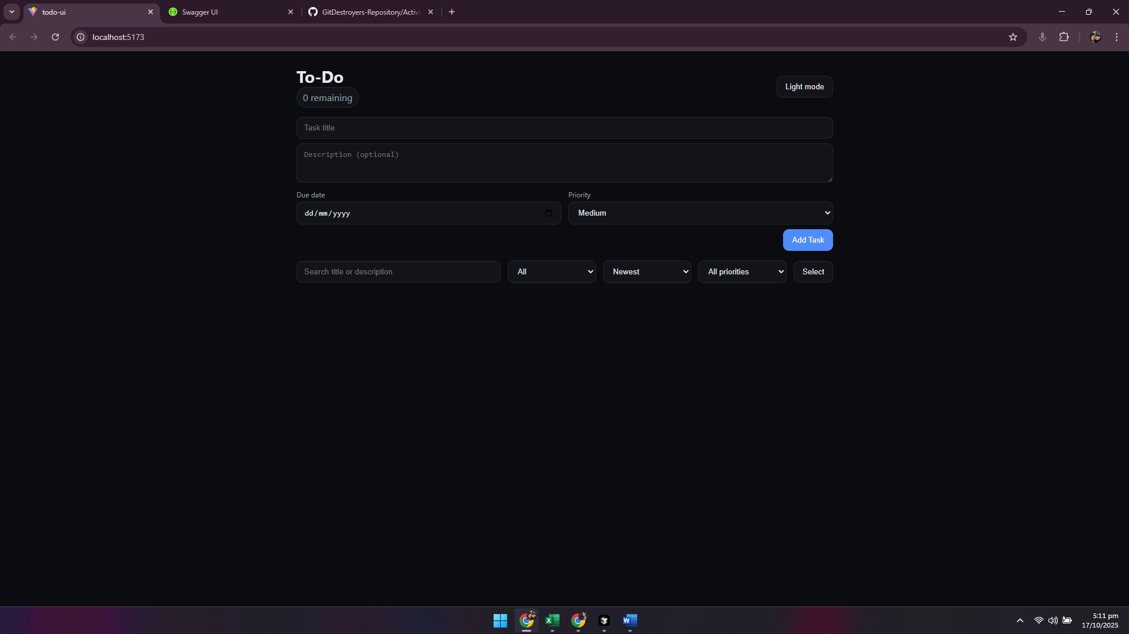

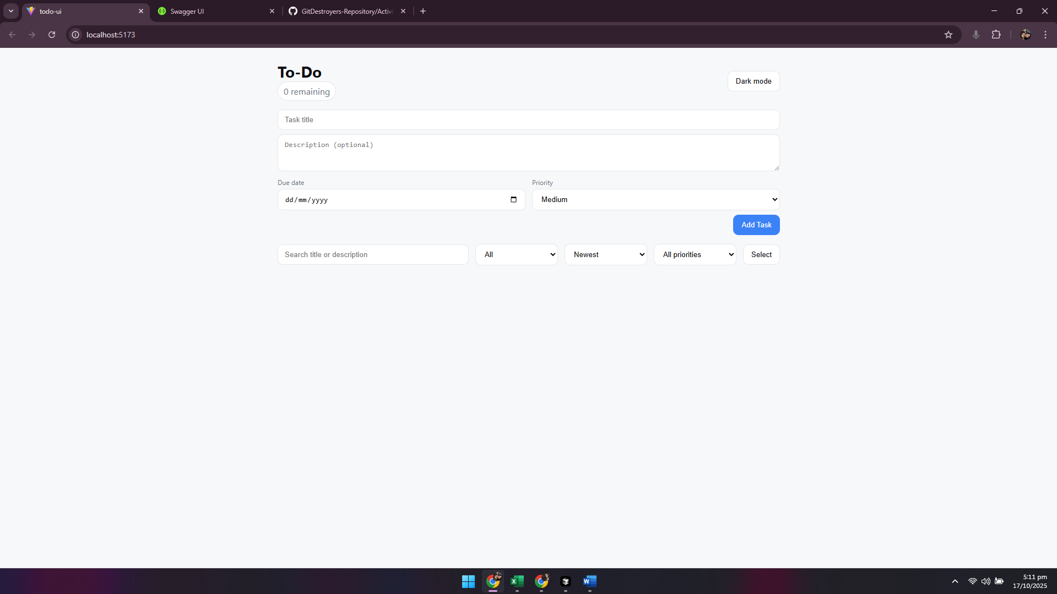

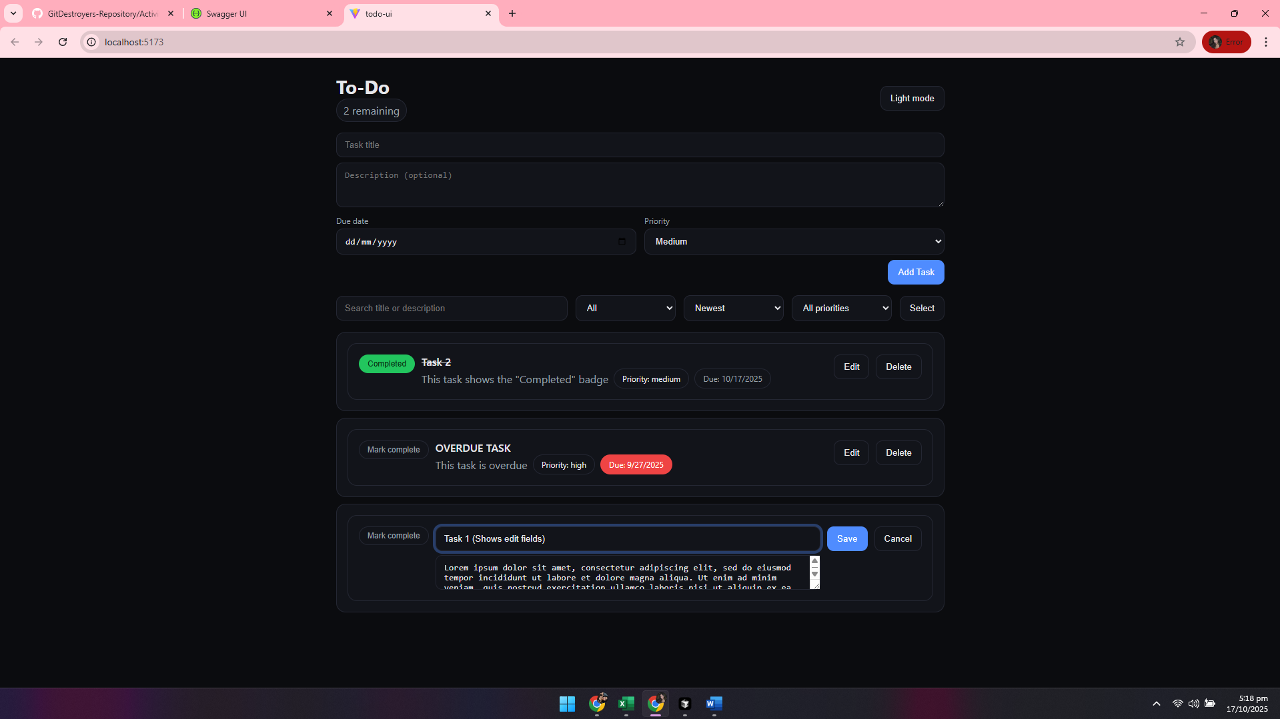

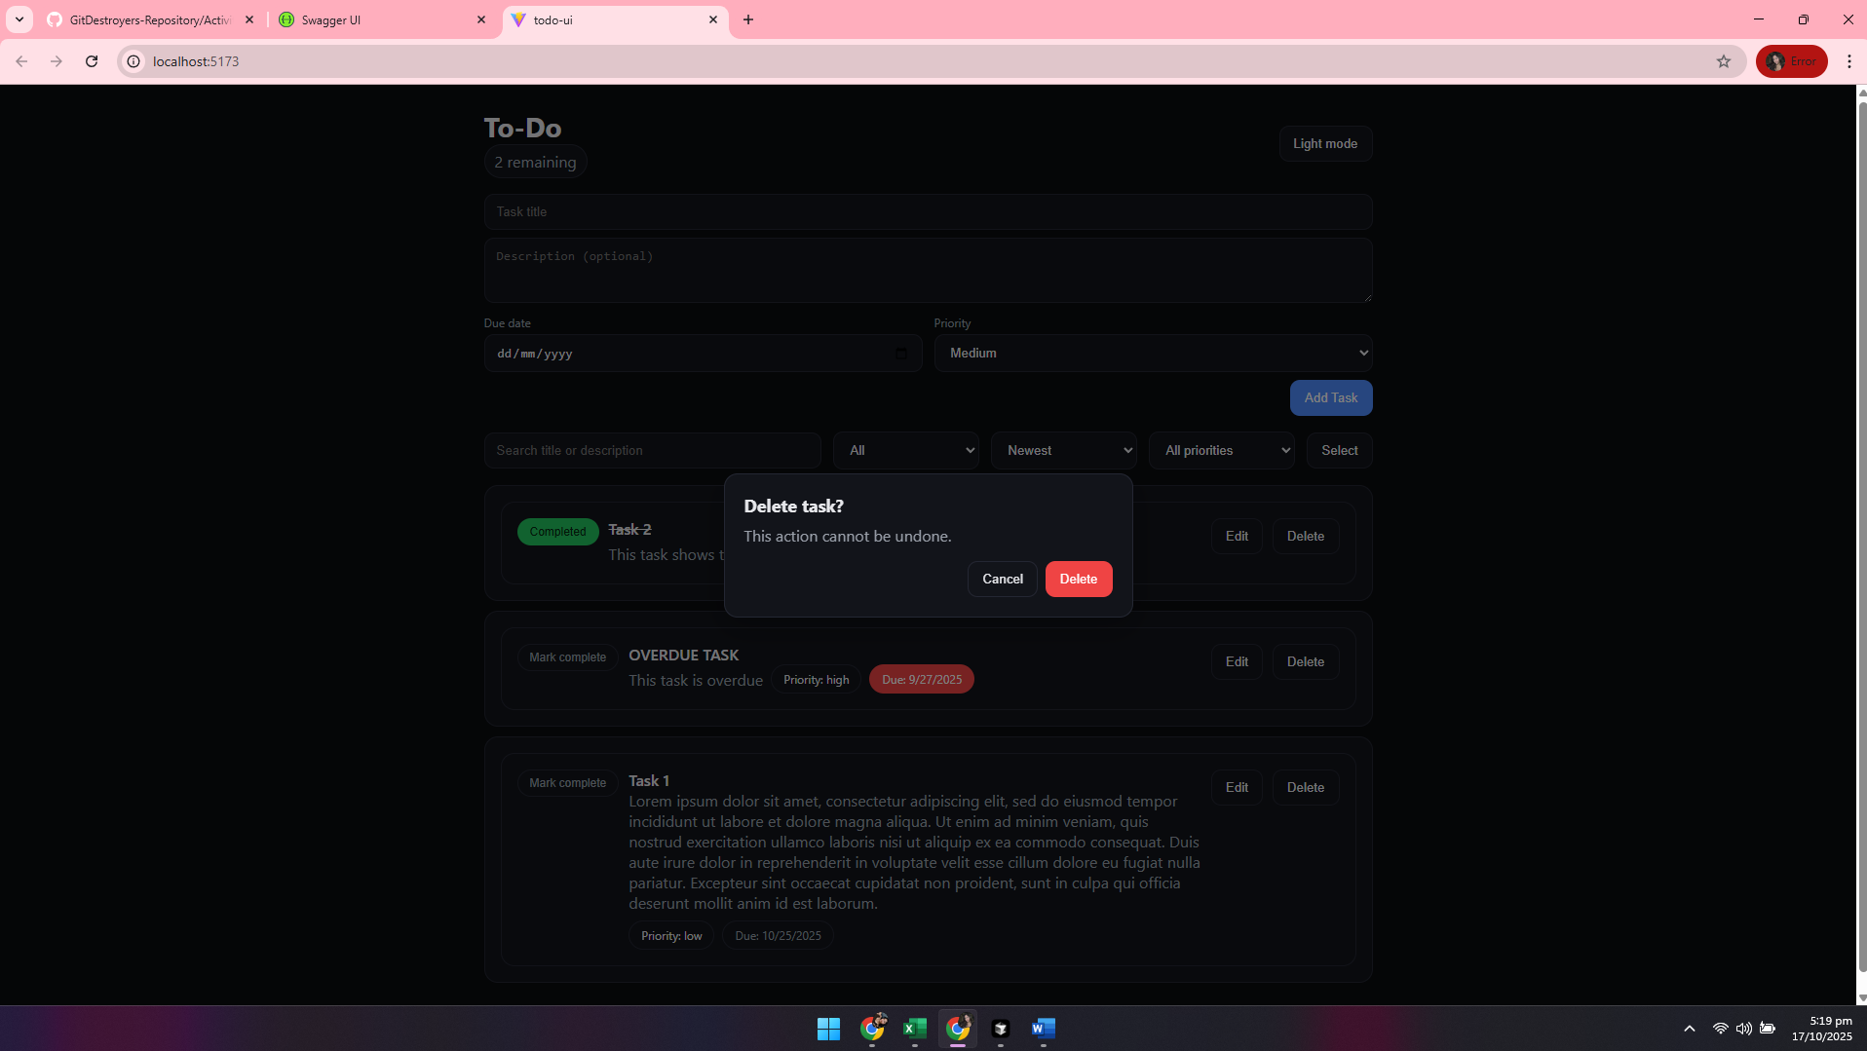

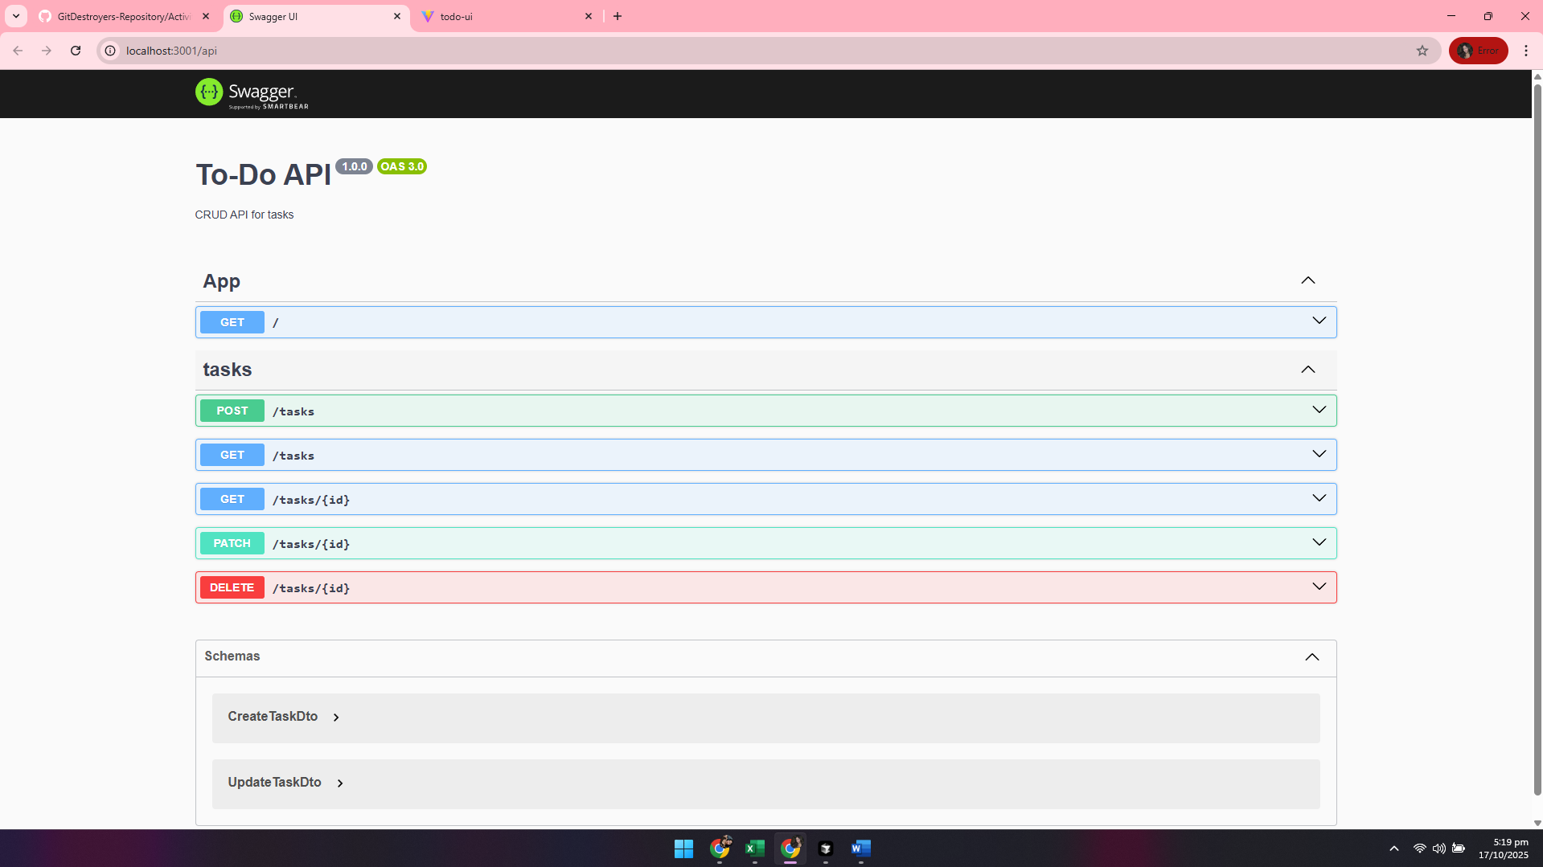

## How to Run

### Backend (NestJS)

* cd Activity1/backend/todo-api
* npm install
* npm run start:dev
* API: http://localhost:3001 | Swagger: http://localhost:3001/api

### Frontend (React + Vite)

* cd Activity1/frontend/todo-ui
* npm install
* npm run dev
* Open the printed Vite URL (e.g., http://localhost:5173)

## API Endpoints

* POST /tasks create task
* GET /tasks list tasks
* GET /tasks/:id get a task
* PATCH /tasks/:id update task
* DELETE /tasks/:id delete task

## Submission Links

* Activity1 folder: https://github.com/CVSU-IMUS-BSIT-4A/GitDestroyers-Repository/tree/main/Activity1
* Repository root: <https://github.com/CVSU-IMUS-BSIT-4A/GitDestroyers-Repository>

**MEMBERS:**

* **BUNAG, PERCY S.**
* **AGUILON, ADRIANE**
* **IRENEA, JOHN MICHAEL A.**
* **FACTOR, FRANCIS C.**
* **FORTALIZA, DESTINE APRIL D.**
* **DELA CRUZ, JOHN MARK C.**