Activity 5: Blog Platform API + UI

Title: SocialApp
Technologies: NestJS, React, TypeScript, SQLite, JWT Authentication

Description

This application is a complete social media platform that allows users to register, login, create posts, and comment on posts. The system features a modern dark-themed UI with glassmorphism effects, user authentication using JWT tokens, and a complete CRUD (Create, Read, Update, Delete) system for posts and comments.

Key Features:
- User Authentication - Secure registration and login system
- Post Management - Create, view, edit, and delete posts
- Comment System - Add comments to posts
- Modern UI - Dark theme with glassmorphism effects
- Responsive Design - Works on all devices
- Real-time Updates - Dynamic content loading
- Database Integration - SQLite database with TypeORM

Screenshots

1. Login Page
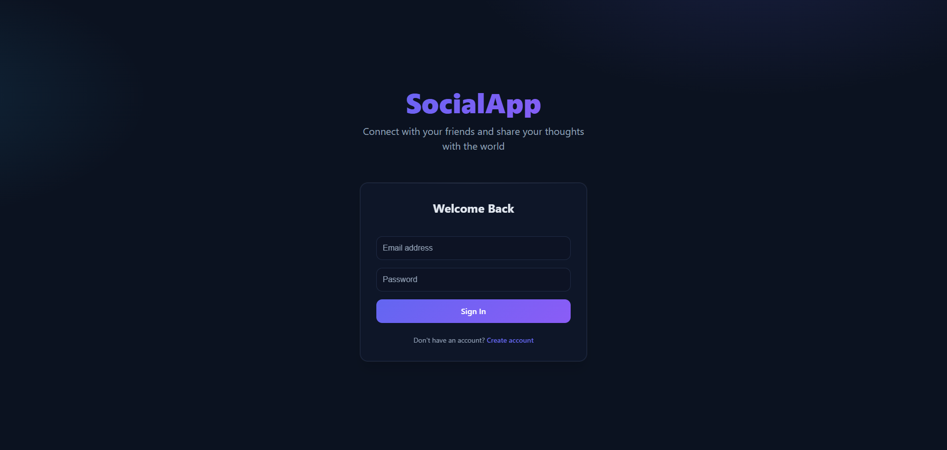
This is where the user logs in.

2. Registration Page
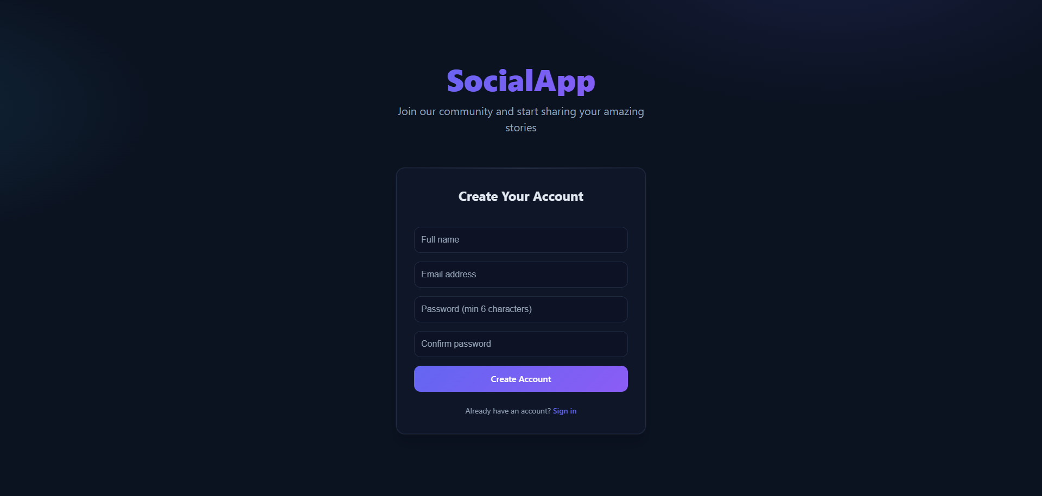
This is where the user creates their account.

3. Dashboard/Posts View
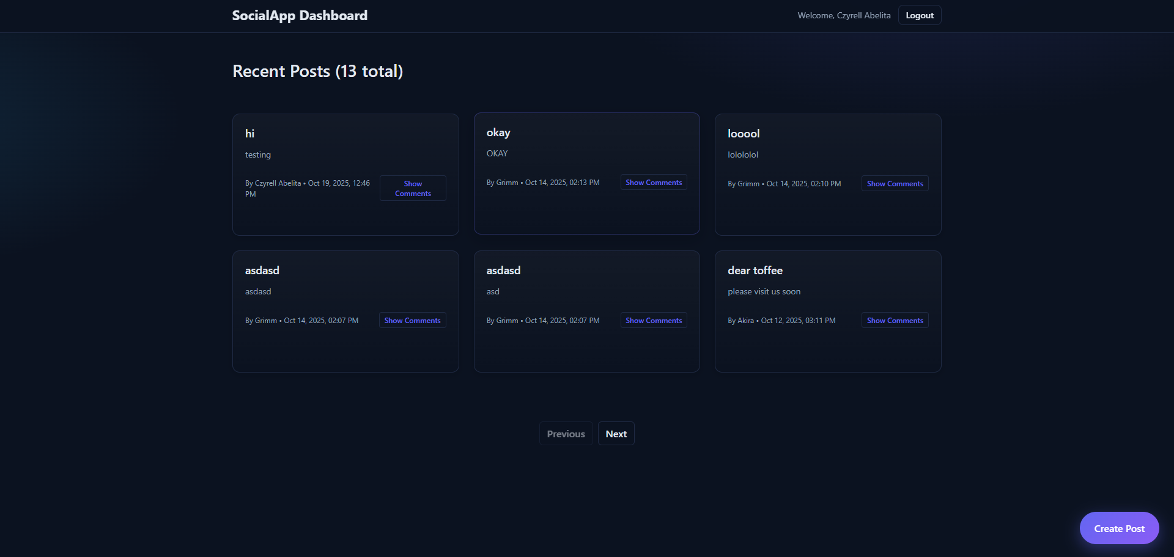
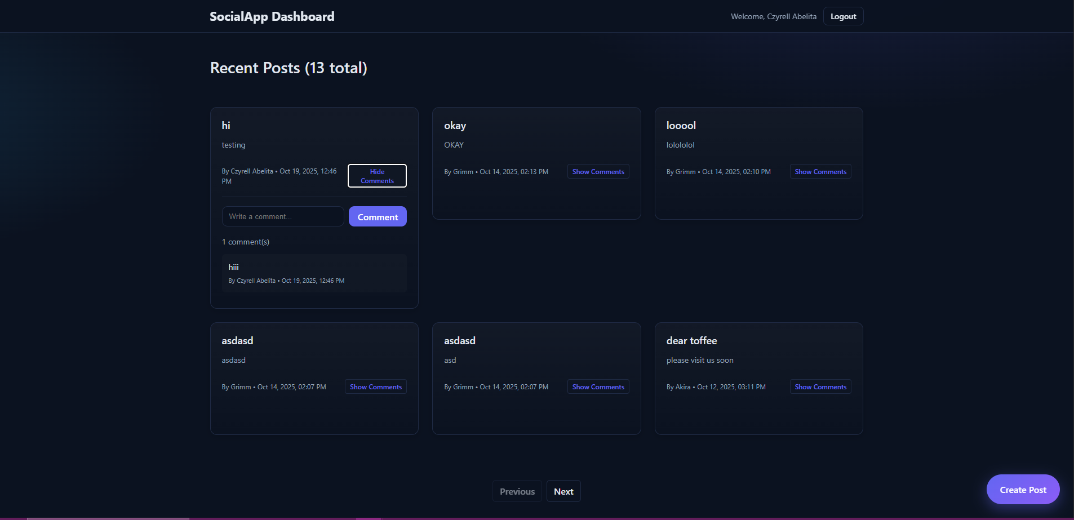

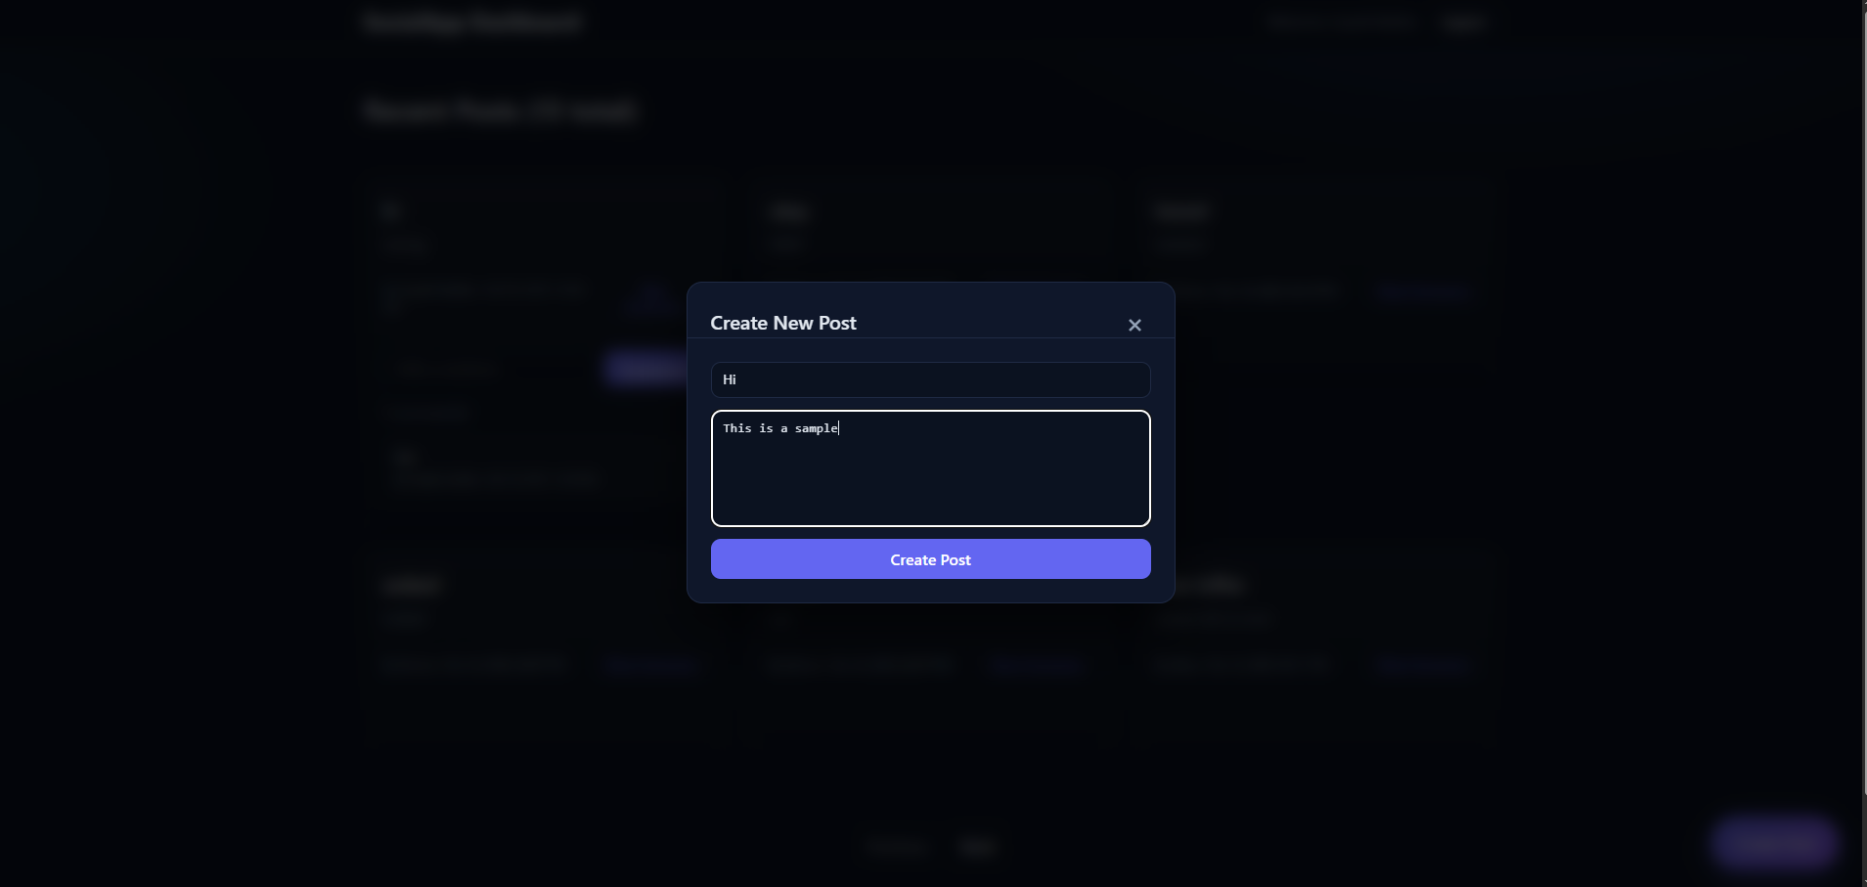

This is the dashboard, where the users can edit, comment, and see posts.

4. API Documentation (Swagger)
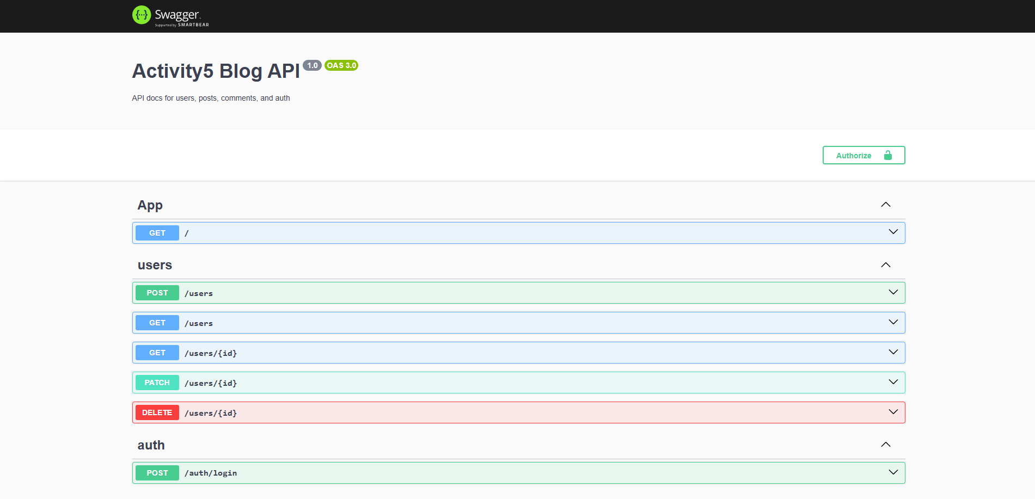

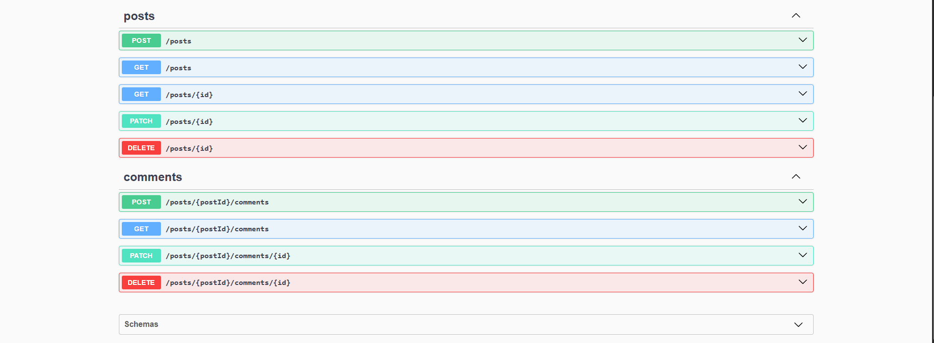

This is the backend through swagger that is composed of CRUD for users, posts, comments, JWT auth, and pagination.

How to Run the Project

Prerequisites
- Node.js (v16 or higher)
- npm (v8 or higher)
- Git

Step 1: Clone the Repository
```bash
git clone <repository-url>
cd ACTIVITY-5
```

Step 2: Backend Setup
```bash
# Navigate to backend directory
cd backend

# Install dependencies
npm install

Start the development server
npm run start:dev
```

Backend will run on: http://localhost:3000
API Documentation: http://localhost:3000/api

Step 3: Frontend Setup (New Terminal)
```bash
# Navigate to frontend directory
cd frontend

# Install dependencies
npm install

# Start the development server
npm run dev
``

Frontend will run on: http://localhost:5173

Step 4: Access the Application
1. Open your browser
2. Navigate to http://localhost:5173
3. Register a new account or login
4. Start creating posts and comments!

MEMBERS

ABELITA, CZYRELL GWEN R.
ARANZASU, DARRYL
ARANZASU, DARRYLENE
MORAL, ANDREI
GANGAN, DEMROSE CARLA
RELOX, NATHANIEL

