Republic of the Philippines


CAVITE STATE UNIVERSITY
Imus Campus
Cavite Civic Center, Palico IV, City of Imus, Cavite
(046) 471-6607 / (046) 436-6584
www.cvsu-imus.edu.ph

ACTIVITY 1: TODO LIST API + UI

Group Members:
- Aguilon, Adriane
- Bunag, Percy S.
- Dela Cruz, John Mark C.
- Factor, Francis C.
- Fortaliza, Destine April D.
- Irenea, John Michael A.

A full-stack to-do list manager built with NestJS and React. Users can create, manage, and organize tasks with priority levels, due dates, and completion tracking. Features include advanced filtering, bulk operations, theme switching, and smooth animations for an enhanced user experience.

Tech Stack
- Frontend: Vite (React + TypeScript), Axios, Framer Motion, modular CSS with responsive utilities
- Backend: NestJS, TypeORM with SQLite, class-validator, Swagger (OpenAPI)

Key Features
- Task CRUD: Create, read, update, and delete tasks with validation
- Task Properties: Title, description, completion status, due date, and priority (low/medium/high)
- Search & Filter: Search by title/description, filter by status (all/active/completed), priority, and due date (overdue/due soon)
- Sorting: Sort by newest, recently updated, or alphabetical order
- Bulk Operations: Select mode with bulk complete and bulk delete functionality
- Inline Editing: Edit task title and description directly in the task list
- Completion Tracking: Toggle task completion with automatic timestamp tracking
- Theme Toggle: Switch between light and dark themes with smooth transitions
- Animations: Spring-based animations using Framer Motion for smooth UI interactions
- Delete Confirmation: Modal confirmation dialog before permanent deletion
- API Docs: Swagger UI with all task endpoints documented

Screenshots of Working System
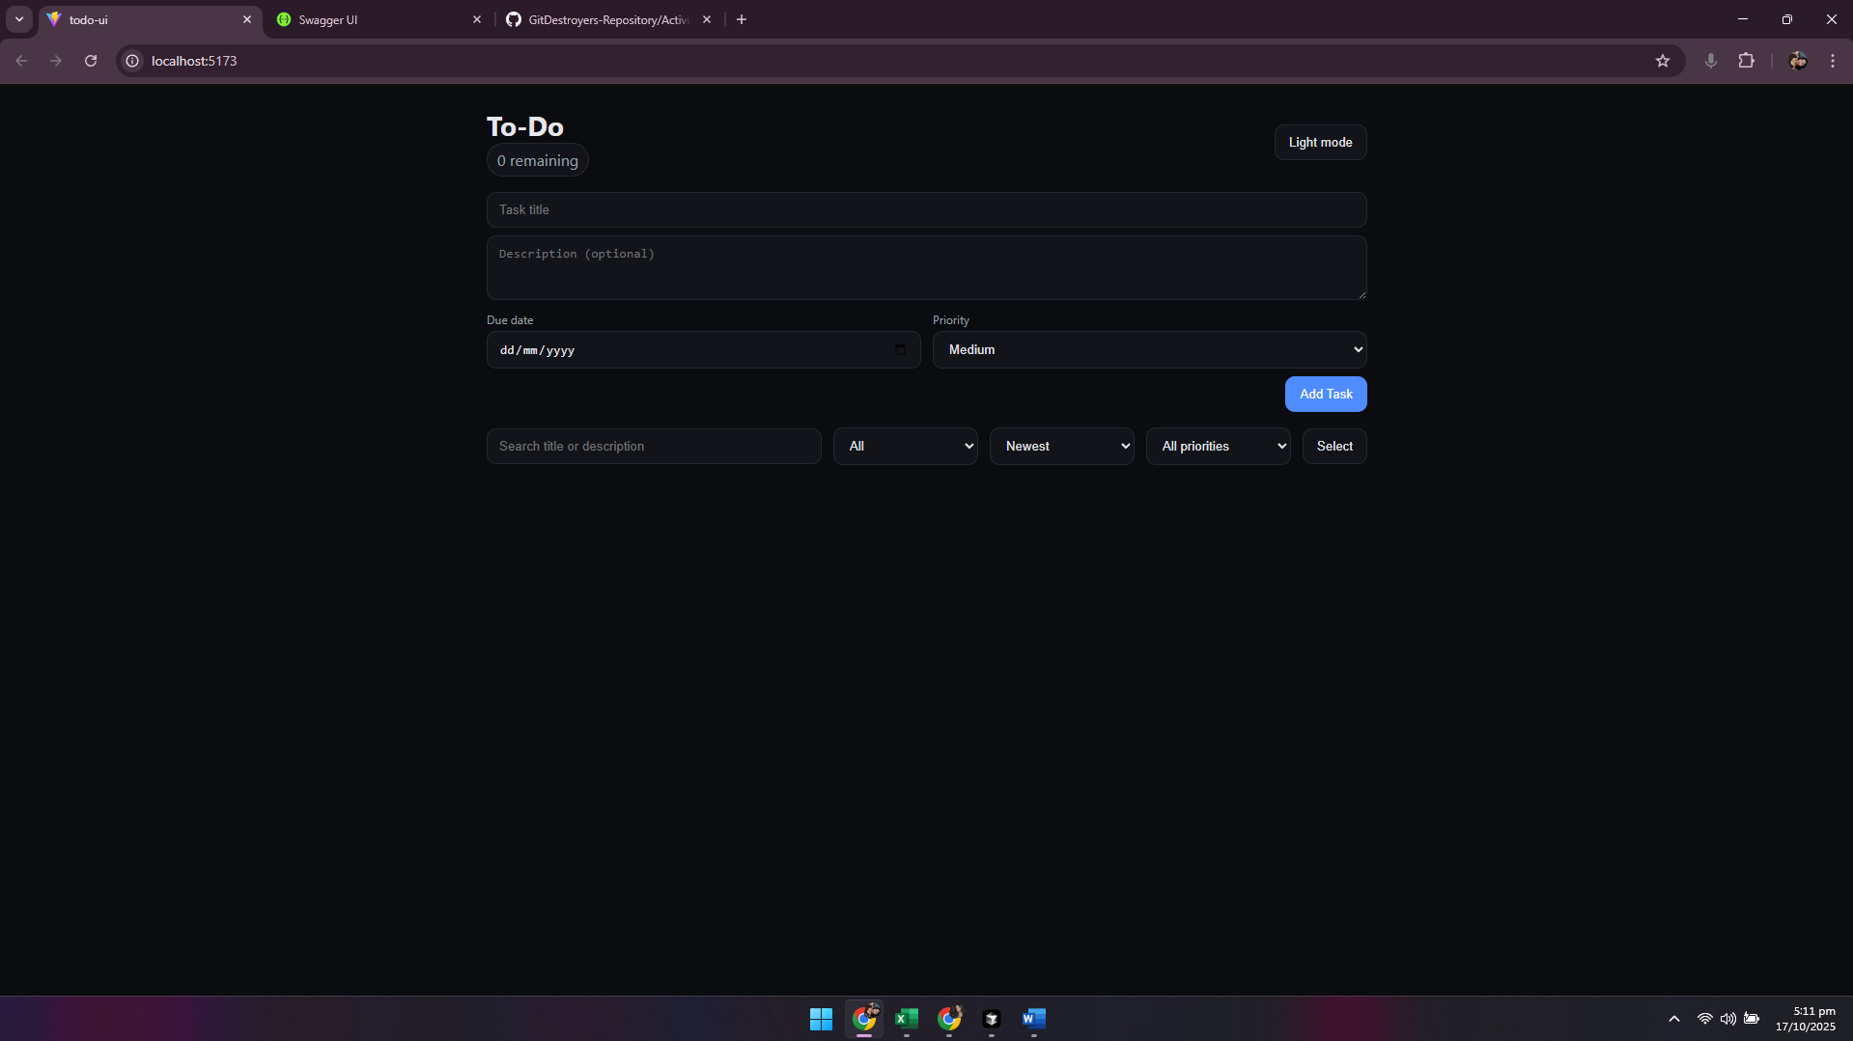
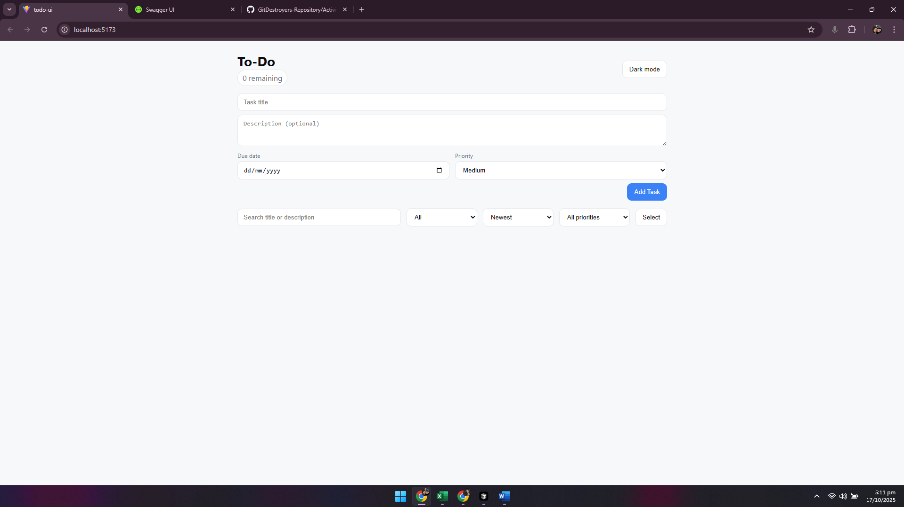
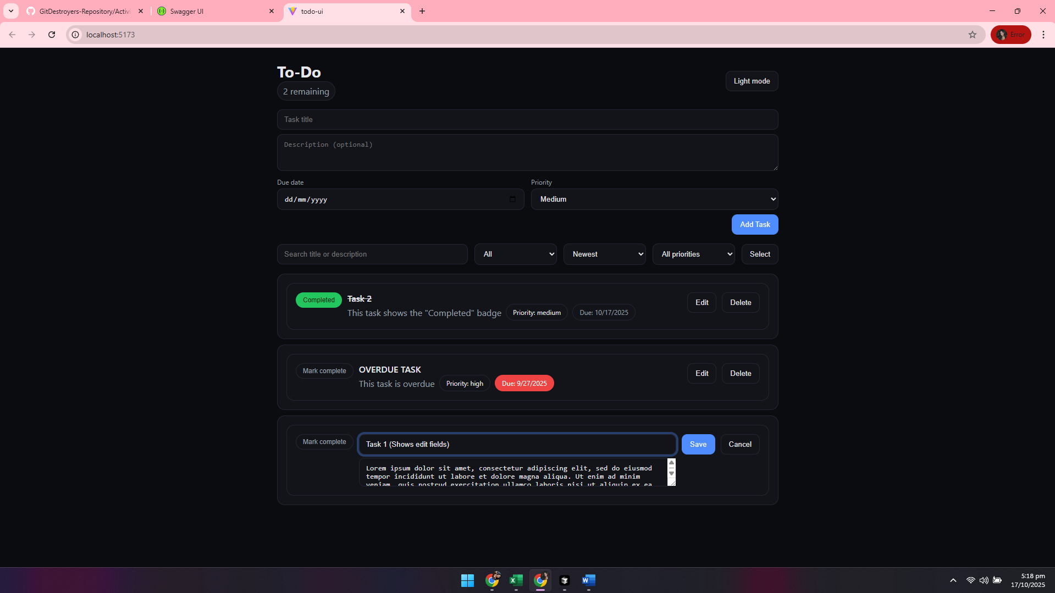
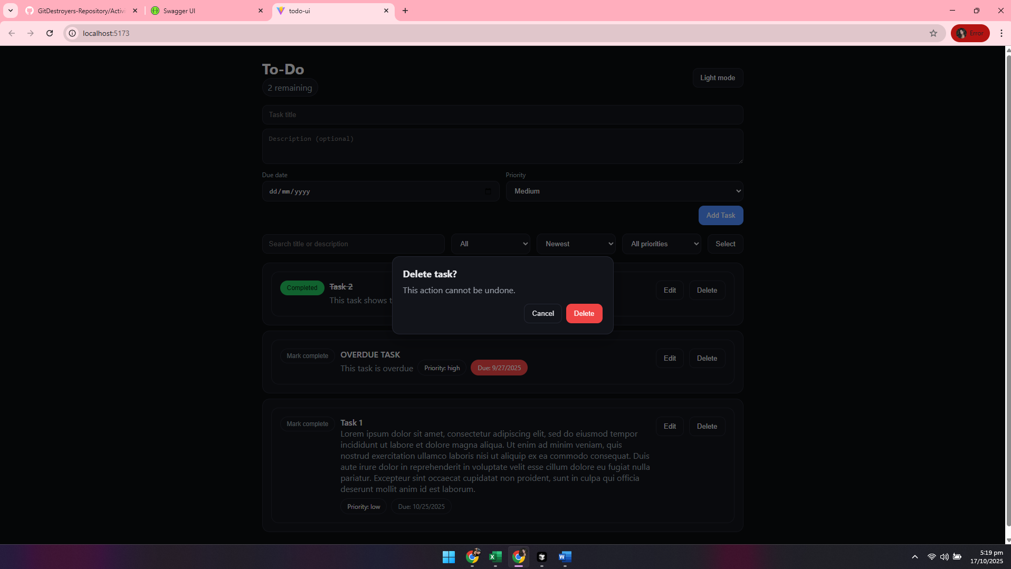
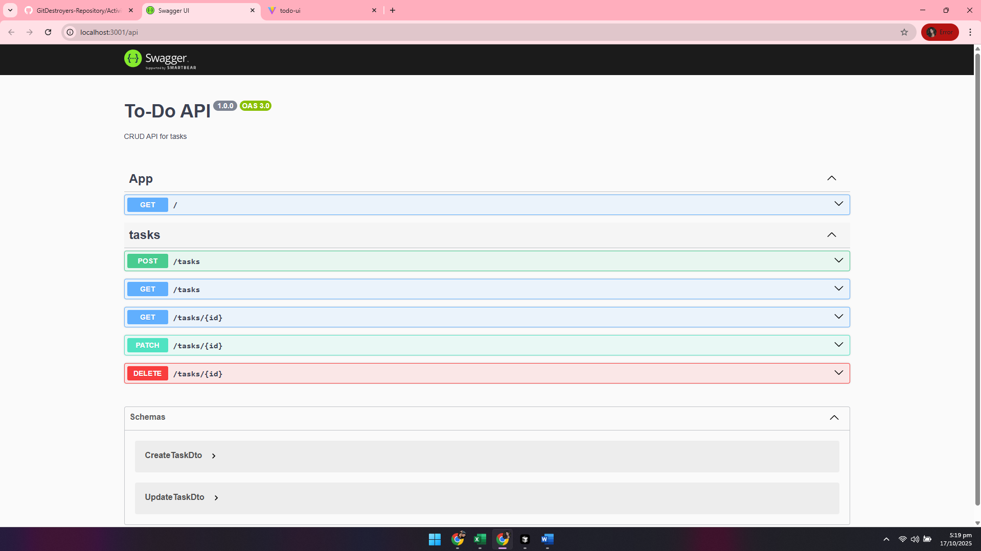

Instructions on How to Run the Project

Prerequisites:
• Node.js v18+ and npm v9+
• Git (if the repository hasn’t been cloned)

Clone and Install:
1. Clone the repository (skip if already cloned):
git clone https://github.com/CVSU-IMUS-BSIT-4A/GitDestroyers-Repository.git
cd Activity1
2. Install backend dependencies:
cd backend/todo-api
npm install
3. Install frontend dependencies:
cd ../../frontend/todo-ui
npm install

Run the Backend:
1. From `Activity1/backend/todo-api`:
npm run start:dev
2. Backend listens at http://localhost:3001
3. Swagger docs available at http://localhost:3001/api

Run the Frontend:
1. From `Activity1/frontend/todo-ui`:
npm run dev
2. Open http://localhost:5173 in a browser

Optional Production Builds:
• Frontend:
cd Activity1/frontend/todo-ui
npm run build
npm run preview
• Backend:
cd Activity1/backend/todo-api
npm run build
npm run start:prod

